**BSC 181 Exam Two**

Each question has one correct answer. Please read each question carefully before responding.

1. Apocrine sweat glands
2. are most common in the armpit and groin
3. respond only to elevated body temperature
4. are located in the palms of the hand and soles of the feet
5. are associated with mucus
6. produce a conditioning oil for the skin
7. Red bone marrow is responsible for
   1. fat storage
   2. formation of red and white blood cells
   3. formation of white blood cells only
   4. formation of red blood cells only
   5. carbohydrate storage
8. As epidermal cells are pushed toward the surface, strands of tough water-proof protein called _____ develop in their cytoplasm
9. stratum germinativum
10. collagen
11. keratin
12. elastin
13. myofibrils

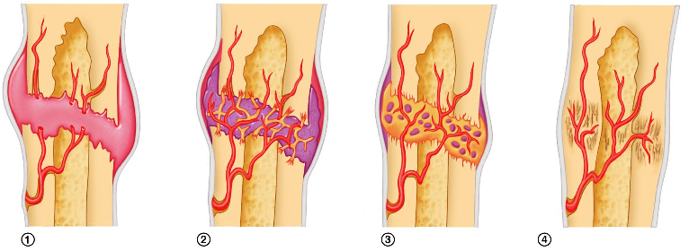

1. The image above demonstrates bone repair. In which one would you find the hematoma?
   1. Image 1
   2. Image 2
   3. Image 3
   4. Image 4
   5. The hematoma is present in all stages
2. Which cell type is NOT present in the epidermis?
   1. Melanocytes
   2. Langerhans cells
   3. Merkel Cells
   4. Keratinocytes
   5. Kuppfer cells
3. The type of articular cartilage that is found at the end of joints as well as the soft portions of the nose is
4. keratin
5. 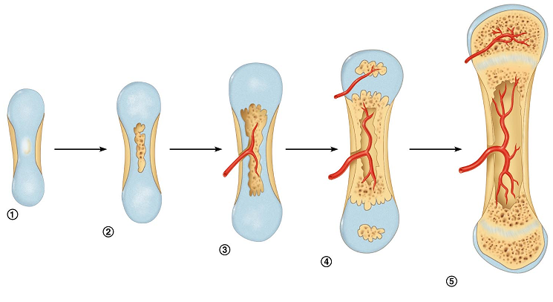elastic
6. hyaline
7. fibrocartilage
8. myocartilage

1. Which process is represented above?
   1. Interosseus calcification
   2. Endochondral ossification
   3. Osteogenesis
   4. Intramembranous ossification
   5. Osteopoesis
2. Which layer of epidermis is the deepest layer and responsible for growth?
   1. Stratum basale
   2. Stratum corneum
   3. Stratum spinosum
   4. Stratum lucidum
   5. Stratum granulosum
3. Osteoblasts are ____________________; whereas osteoclasts are _______________.
4. mature bone cells; immature bone cells
5. immature bone cells; mature bone cells
6. 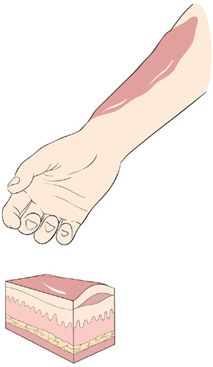bone destroying cells; bone building cells
7. bone repairing cells; bone repairing cells
8. bone building cells; bone destroying cells
9. What type of burn is described?

**Epidermis and some dermis affected; presence of blisters**

1. first degree burn
2. second degree burn
3. third degree burn
4. fourth degree burn
5. fifth degree burn
6. The presence of an epiphyseal disk indicates
7. the marrow has ruptured out of its cavity
8. the bone is still growing
9. the bone has matured
10. 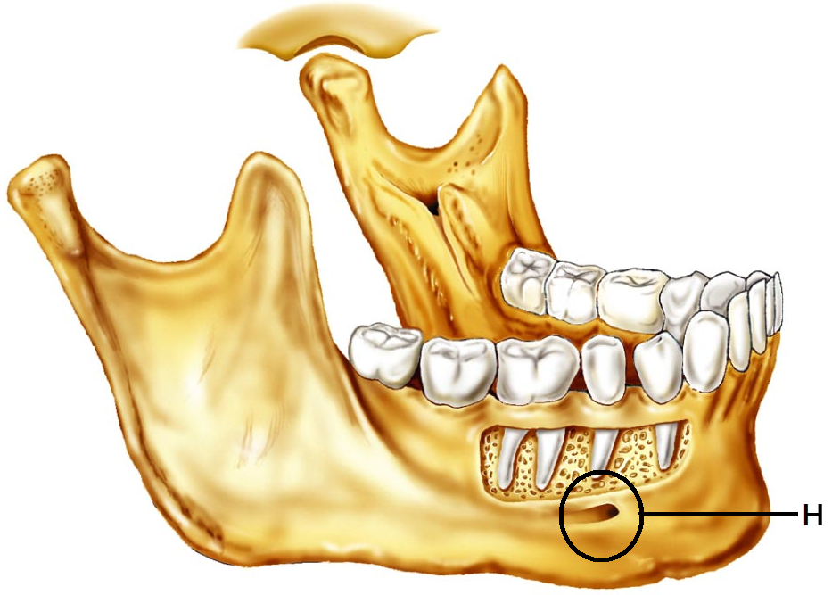the person is over 30 years old
11. the bone diameter is increasing
12. Identify the bone to the right
    1. Mandible
    2. Maxilla
    3. Sphenoid bone
    4. Vomer
    5. Temporal bone
13. Identify “H”
    1. Maxillary meatus
    2. Mandibular fossa
    3. Apical suture
    4. Mental foramen
    5. Gomphoid process
14. Which type of hair would be found in both children and in adult females?
15. lanugo
16. alopecia
17. vellus
18. terminal
19. axillary
20. Exposure to ultraviolet light causes the skin to darken by stimulating the production of
21. keratin
22. carotene
23. melatonin
24. seratonin
25. melanin
26. Which of the ABC’s of skin cancer are **incorrectly** paired?
    * 1. A: Appearance
      2. B: Border
      3. C: Color
      4. D: Darkness
    1. 1 and 2 are incorrect
    2. 2 and 3 are incorrect
    3. 3 and 4 are incorrect
    4. 1 and 4 are incorrect
    5. 4 is the only incorrect option
27. Which three pigments are responsible for skin color?
    * + 1. Melanin
        2. Biliverdin
        3. Carotene
        4. Hemoglobin
        5. Myoglobin
           1. 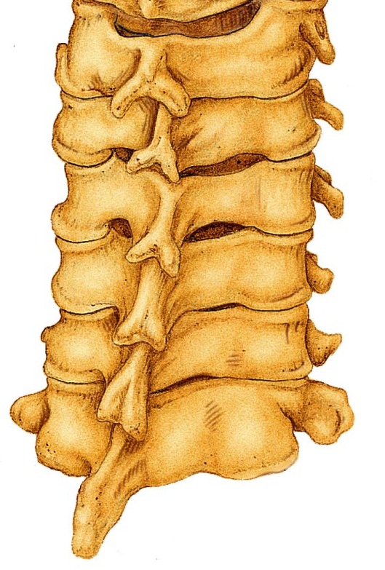1, 4, 5
    1. 2, 4, 5
    2. 1, 2, 3
    3. 1, 2, 5
    4. 1, 3, 4

1. Which **region** are these vertebrae from?
   1. Cervical
   2. Thoracic
   3. Lumbar
   4. Sacral
   5. Coccygeal
2. Which of the following is **NOT** an **exocrine** gland?

a. salivary glands

b. sweat glands

c. sebaceous glands

d. digestive glands

e. pituitary gland

1. Which skin cancer is being described: Arises from keratinocytes of stratum spinosum; most often appears on scalp, ears, and lower lip; fast growing; treated by removal or radiation
2. Basal cell carcinoma
3. Squamous cell carcinoma
4. Small cell carcinoma
5. Melanoma
6. The description fits both basal cell and squamous cell carcinomas

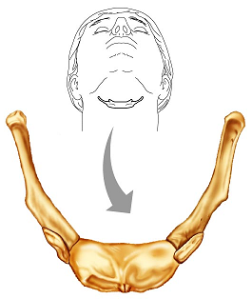

1. Which bone is shown in the image to the right? This bone does not articulate with other bones.
2. C1, atlas
3. C2, axis
4. First rib
5. hyoid
6. patella

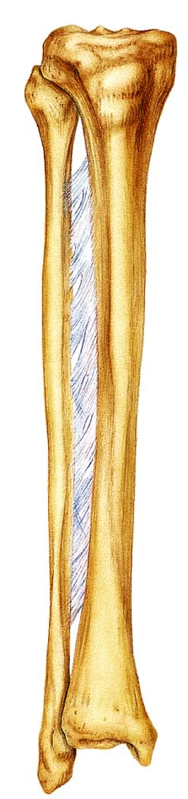

1. Match the term to the following definition:   
   “narrow, slit like opening”
2. Trochanter
3. Tuberosity
4. Fissure
5. Foramen
6. Fossa
7. The thinner and more slender of these two bones is the
   1. Radius
   2. Ulna
   3. Tibia
   4. Fibula
   5. Femur
8. Match the term to the following definition:   
   “a rounded articular projection”
   1. Head
   2. Facet
   3. Condyle
   4. Turburcle
   5. Meatus
9. Within an osteon, what is the **function** of the canaliculi?
10. Provides structural support for the bone
11. Provides a pathway between the lacunae and the central canal
12. Clears out the debris within the central canal
13. Acts as an attachment site for muscles
14. Provides small cavities or nests that house osteocytes
15. Which type of ossification starts with a thin, fibrous tissue that gets filled in with bone: seen in the skull
16. synchondesmal ossification
17. syndesmosis ossificiation
18. chondrocartilaginous ossification
19. endochondral ossification
20. intramembranous ossification
21. Where are the **secondary** ossification centers located in long bones?
22. epiphysis
23. diaphysis
24. enuresis
25. syndesmosis
26. most long bones will not have secondary ossification centers
27. Which “law” relates to bony growth and adaptation to stresses?
    1. Wolff’s Law
    2. Weirneke’s Law
    3. The law of osseous hyperplasia
    4. Starling’s Law
    5. Cole’s Law
28. In which bones are we most likely to observe a **depression** fracture?
29. Vertebra
30. Skull
31. Femur
32. Rib
33. Sternum
34. In which bones are we most likely to observe a **compression** fracture?
    1. Femur
    2. Vertebra
    3. Skull
    4. Rib
    5. Sternum
35. Which ribs have **no** attachment to the sternum
36. all of the ribs are attached to the sternum
37. floating ribs
38. true ribs
39. flying ribs
40. ribs one through seven
41. The half-moon shaped structure at the base of the nail is called
    1. Moonula
    2. Lateral fold
    3. Lunula
    4. Eponychium
    5. Hyponychium
42. Which of these bones of the skull is **NOT** a bone found in the **cranium**?
    1. Parietal
    2. Occipital
    3. Sphenoid
    4. Vomer
    5. Frontal
43. The epidermis has four or five layers, depending on its location. One layer is present in thick skin that is not present in any other location. Which is it?
    1. Stratum germinativum
    2. Stratum granulosum
    3. Stratum corneum
    4. Stratum spinosum
    5. Stratum lucidum
44. Which of the following statements is **correct** regarding spinal curves?
45. The cervical kyphosis is formed after the infant holds up his/her own head
46. The cervical lordosis is a primary curve
47. The thoracic kyphosis is a primary curve
48. The lumbar kyphosis is a secondary curve
49. The sacral lordosis is formed after an infant begins to walk upright
50. Which of these is **NOT** a carpal bone?
51. lunate
52. 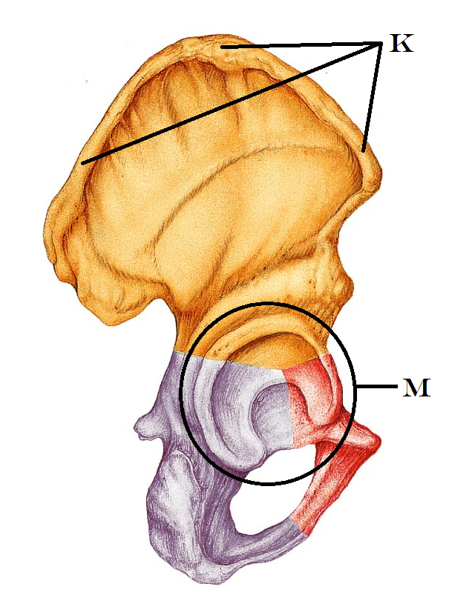hamate
53. cuneiform
54. scaphoid
55. capitate
56. Identify “K”
    1. Obdurator Foramen
    2. Sacral Ala
    3. Linea Aspera
    4. Iliac Crest
    5. Posterior Superior Iliac Spine
57. Identify “M”
    1. Obdurator Foramen
    2. Ischial spine
    3. Pubic ramus
    4. Acetabulum
    5. Sacral notch
58. Which of the vertebrae have a transverse foramina?

a. all of the cervical vertebrae

b. all of the thoracic vertebrae

c. all of the lumbar vertebrae

d. all of the vertebrae

e. some of the cervical and some of the thoracic vertebrae

1. Which of the following is correct of the female pelvis when comparing it with the male pelvis?
2. there are no anatomical differences
3. distance between the female ischial spines is less
4. the female pelvis is tall and narrow
5. the angle of the female pubic arch is smaller
6. distance between the female ischial spines is greater
7. Calculate how many bones there are in the hand **(not including the carpals)**
8. fourteen
9. twenty
10. nineteen
11. twenty five
12. twenty four
13. The ceruminous gland produces cerumin. What is cerumin?
    1. Breast milk
    2. Mucus
    3. Sweat
    4. Ear wax
    5. Conditioning oil
14. Which pelvic structure is responsible for supporting your weight as you sit? (The “sitting bones”)
    1. Pubic rami
    2. Iliac crest
    3. Ischial tuberosity
    4. Sacral ala
    5. Posterior inferior iliac spine
15. The periosteum is
16. the cartilage that covers the articular surface of a bone
17. a layer of epithelium that covers bone
18. a layer of connective tissue that covers bone
19. tissue that covers the medullary cavity
20. closely associated with yellow bone marrow
21. In the epiphyseal plate, what is the osteogenic zone responsible for?

a. meiosis

b. mitosis

c. destruction (cavitation) of cartilage

d. producing the periosteum

e. producing the new bone material

1. This type of break in bone occurs when there is a complete break 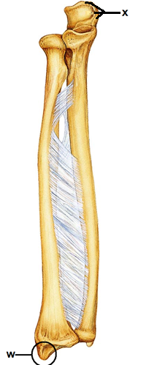  
   that causes the bone to **shatter**.

a. comminuted

b. greenstick

c. spiral

d. compound

e. oblique

1. Identify the “x”
   1. Tibial head
   2. Olecranon Process
   3. Ulnar condyle
   4. Head of radius
   5. Capitulum
2. Identify the structure “w”
   1. Styloid process of radius
   2. Styloid process of ulna
   3. Lateral malleolus
   4. Medial malleolus
   5. Medial condyle
3. The fibula is
4. short and thick
5. 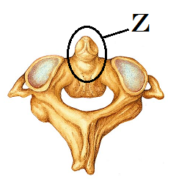located on the medial aspect of the lower leg
6. articulates with the radius bone in the forearm
7. forms the lateral malleolus (ankle bone)
8. often absent after skeletal maturation
9. Identify the structure “Z”
10. Spinous Process
11. Pedicle
12. Centrum
13. Transverse process
14. Odontoid process

**Please turn in your exam.**

Put your name and set it in a separate pile ONLY if you have made a comment for me to read on the exam.

Please double check to see that your name and ID# are correctly entered and bubbled-in on the Opscan form

**Turn in your Opscan**

Enjoy the rest of your day.

Grades should be posted late tonight or early tomorrow.