BSC 181 Exam Six

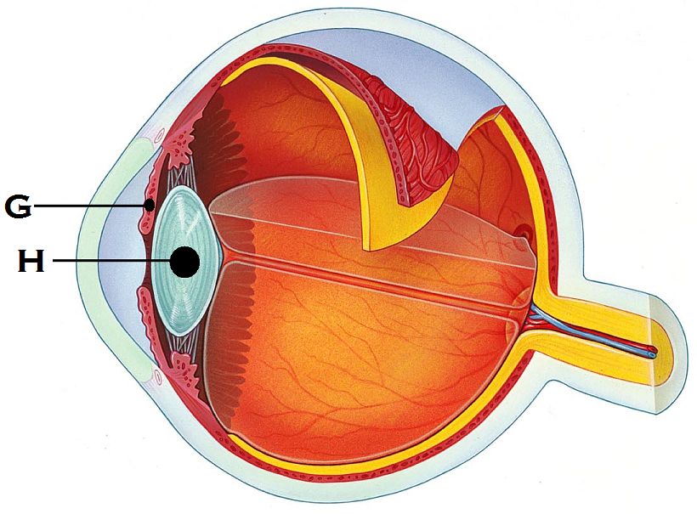

1. Identify “G”
   1. Sclera
   2. Pupil
   3. Iris
   4. Choroid
   5. Suspensory ligament
2. Identify “H”
   1. Cornea
   2. Lens
   3. Sclera
   4. Aqueous humor
   5. Suspensory ligament

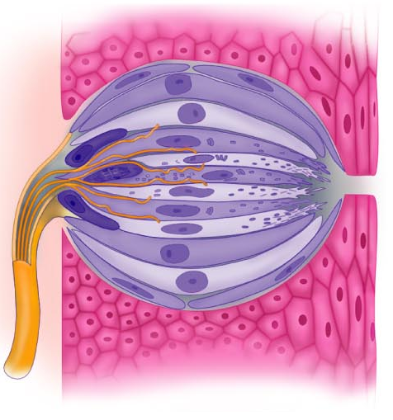

1. The image to the right represents
   1. Basilar hairs in cochlea
   2. Olfactory epithelium
   3. Saccule and utricle
   4. Pacinian corpuscle
   5. Taste bud
2. Which muscles move the **eyebrows** medially?
   1. Palpebral muscles
   2. Orbicularis oculi muscle
   3. Superior rectus muscle
   4. Corrugator muscle
   5. Medial rectus
3. Which of the following glands are **not** accessory structures to the eye?
   1. Lacrimal glands
   2. Meibonian glands
   3. Ciliary glands
   4. Canthi glands
   5. All of the above are glands associated with the eye
4. Which is the **drainage site** for the lacrimal gland? (takes tears away from the eye)
   1. Lacrimal puncta
   2. Inferior lacrimal canthus
   3. Lateral epicanthus
   4. Conjunctival meatus
   5. Canal of Schlemm
5. Which two muscles will be responsible for making the left eye look up?
   * + 1. Lateral rectus
       2. Inferior oblique
       3. Superior oblique
       4. Inferior rectus
       5. Superior rectus
   1. 1 and 2
   2. 2 and 5
   3. 3 and 5
   4. 2 and 4
   5. 3 and 4
6. 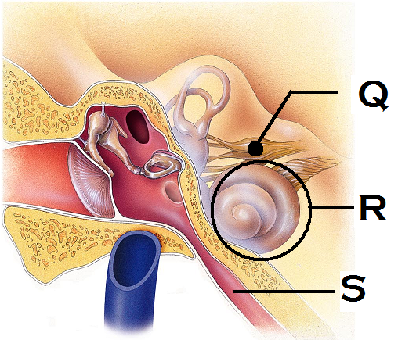Identify the structure “Q”
   1. Coclear nerve
   2. Vestibular nerve
   3. Vestibulocochlear nerve
   4. Tympanic nerve
   5. Auditory nerve
7. Identify the structure “R”
   1. Vestibule
   2. Semilunar canal
   3. Ossicles
   4. Tympanic membrane
   5. Cochlea
8. Identify the structure “S”
   1. Hypotympanic recess
   2. Vestibular tube
   3. Pharyngotympanic tube
   4. External auditory meatus
   5. Otic foramina
9. Which portion of the vascular tunic of the eye is responsible for supplying blood to all eye tunics?
   1. Conjunctiva
   2. Choroids
   3. Iris
   4. Ciliary body
   5. Sclera
10. Rods respond to ____ while cones respond to ___
    1. Light waves of short wavelength; light waves of high frequency
    2. Dim light; bright light
    3. Bright light; dim light
    4. Light waves of high frequency; light waves of short wavelength
    5. Pitch; volume
11. The orbicularis oculi muscle will be responsible for which of the following movements?
    1. Elevating the eyebrow
    2. Elevating the eyelid
    3. Looking left
    4. Looking up
    5. Depressing the eyebrow
12. Which structure in the anterior chamber of the eye is responsible for draining the aqueous humor?
    1. Lacrimal puncta
    2. Ocular aqueduct
    3. Canal of Schlemm
    4. Orbital sinus
    5. Anterior foramina
13. Jacob shifts his eyes from looking at a tree on the distant horizon to looking at his watch. What changes would you expect to see if you were observing his eyes?
    1. Pupils get larger
    2. Iris changes color
    3. The effects of the contraction of the medial rectus muscles
    4. The effects of the contraction of the lateral rectus muscles
    5. Activation of the lacrimal gland
14. What is the name for the change you noticed in Jacob’s eyes? (Your answer from #15 is called…)
    1. Pupillary constriction
    2. Pupillary dilation
    3. Accommodation
    4. Convergence
    5. Ocular divergence
15. This vision deficit results in the light’s focal point not landing on the retina because the eye is too short. It can be corrected by convex lenses.
    1. Hyperopia
    2. Myopia
    3. Superopia
    4. Emmetropia
    5. Utopia
16. The ____ fibers of the optic nerve **decussate** at ___
    1. Lateral; optic tracts
    2. Medial; optic radiation
    3. Lateral: geniculate nucleus
    4. Medial; optic chiasm
    5. Lateral: Occipital lobe
17. What is the function of the lacrimal caruncle?
    1. Produces and oily, whitish secretion
    2. Produces enzymes to break down proteins
    3. Produces granzymes to destroy pathogens
    4. Releases IgM to protect the surface of the eye
    5. Produces and releases tears
18. The function of the lateral geniculate nucleus is
    1. To relay information regarding movement
    2. To assist in depth perception
    3. To accentuate cone input
    4. To sharpen contrast
    5. All of the above
19. Why does a small amount of odor information cause a large response in terms of perception?
    1. First messenger system amplifies the response
    2. Second messenger system amplifies the response
    3. Huge cortex regions associated with smell
    4. Release of enzymes inhibit adaptation
    5. Due to the proximity of the olfactory receptors to the brain itself
20. Which of the following cells would you expect to see in a taste bud?
    1. Sustentacular cells
    2. Areolar cells
    3. Gustatory cells
    4. Photoreceptor cells
    5. Otoliths
21. Which cranial nerves carry taste information to the brain?
    1. Glossopharyngeal and hypoglossal
    2. Facial and trigeminal
    3. Vagus and spinal accessory
    4. Glossopharyngeal and facial
    5. Vagus and hypoglossal
22. The helix and lobule are part of the
    1. Posterior tongue
    2. Anterior eye
    3. Outer ear
    4. Olfactory epithelium
    5. Semicircular canals
23. The saccule and utricle are associated with
    1. Vision
    2. Smell
    3. Hearing
    4. Balance
    5. Taste
24. Which structure in the ear houses the receptors for hearing?
    1. Tympanic membrane
    2. Vestibule
    3. Organ of Corti
    4. Otoliths
    5. Ampulla
25. Elizabeth has been having difficulty hearing things lately. When observed with an otoscope, she was found to have an abundance of earwax that affected her hearing. What type of diagnosis would she receive?
    1. Upper motor neuron damage
    2. Sensorinerual deafness
    3. Tinnitus
    4. Conduction deafness
    5. Meniers disease
26. Which muscle in the list below is **not** controlled by the Oculomotor nerve?
    1. Superior rectus
    2. Inferior rectus
    3. Medial rectus
    4. Lateral rectus
    5. Inferior oblique
27. Which of the following **does not contribute** to our sense of balance?
    1. Proprioception
    2. Vision
    3. 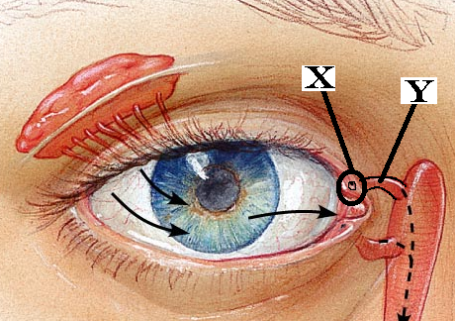Vestibule
    4. Gestation
28. Identify “X”
    1. Nasolacrimal gland
    2. Nasolacrimal duct
    3. Superior lacrimal puncta
    4. Inferior canaliculi
    5. Haversian canaliculi
29. Identify “Y”
    1. Lateral canthus
    2. Superior canaliculi
    3. Epiploic appendage
    4. Inferior lacrimal puncta
    5. Lacrimal gland
30. What are the tiny stone-like structures that are responsible for moving the cilia in the vestibular system?
    1. Otoliths
    2. Stereoliths
    3. Monoliths
    4. Coproliths
    5. Rhodopsins
31. If a person has an emmetropic eye, what type of vision would you expect?
    1. Red/Green color blindness
    2. 20/20 vision
    3. 20/15 vision
    4. 20/40 vision
    5. Peripheral vision only
32. The structure labeled at “N” is responsible for connecting the scala tympani and scala vestibule
    1. 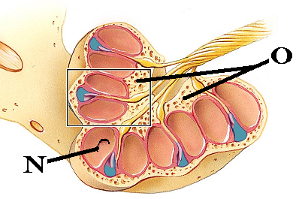Modiolus
    2. Helicotrema
    3. Membranous labrynth
    4. Saccule
    5. Maculae
33. Identify “O”. This structure is the bony pillar that the cochlea is wound around
    1. Modiolus
    2. Helicotrema
    3. Bony labrynth
    4. Saccule
    5. Maculae
34. The differing frequencies between 20 and 20,000 Hz gives us a sense of
    1. Loudness
    2. Volume
    3. Pitch
    4. Amplitude
    5. Discord
35. Which structure is not part of the visual pathway?
    1. Optic chiasm
    2. Supraolivary nucleus
    3. Lateral geniculate nucleus
    4. Superior colliculus
    5. Pretectal nucleus
36. What is the crista ampullaris?
    1. Region in the eye with the greatest concentration of cones
    2. Region in the taste bud in which the taste cells are housed
    3. Region in the nasal cavity where the perforated bone allows access to the brain
    4. Region in the ear that is sensitive to dynamic equilibrium
    5. Region in the tongue innervated by cranial nerve VII
37. Which structure is **not** part of the auditory pathway?
    1. Superior gentian nucleus
    2. Spiral ganglion
    3. Cochlear nuclei
    4. Superior olivary nuclei
    5. Inferior colliculus
38. This structure in the eye becomes less elastic and responsive as we age
    1. Cornea
    2. Lens
    3. Retina
    4. Optic nerve
    5. Rods
39. Which of the following terms can be objectively measured in terms of decibels?
    1. Frequency
    2. Amplitude
    3. Pitch
    4. Loudness
    5. Discord
40. The olfactory neurons will be what shape?
    1. Pyramidal
    2. Star-shaped
    3. Bipolar
    4. 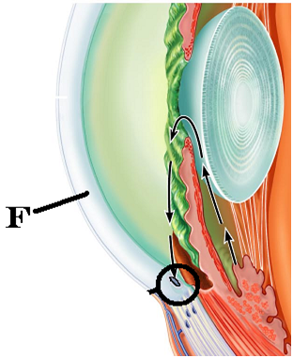Unipolar
    5. Multipolar
41. Which structures are located in the middle ear?
    1. Otoliths
    2. Saccule
    3. Semicircular canals
    4. Helix
    5. Ossicles
42. Identify “F”
    1. Sclera
    2. Cornea
    3. Lens
    4. Iris
    5. Retina
43. Which disorder results in loss of balance, vertigo, nausea, and hearing loss?
    1. Tinnitus
    2. Meniere’s disease
    3. Bell’s Palsy
    4. Conduction deafness
    5. Acoustic neuroma
44. Which option best describes where the utricle and maculae are housed (where are they located)
    1. Within the scala media
    2. Within the vestibule
    3. Within the cochlea
    4. Within the epitympanic recess
    5. Within the ciliary body
45. Which of the structures listed is filled with endolymph?
    1. Scala vestibule
    2. Scala tympani
    3. Scala media
    4. Epitympanic recess
    5. Middle ear
46. Which part of the fibrous tunic is clear and allows light to enter the eye?
    1. Lens
    2. Ciliary body
    3. Cornea
    4. Sclera
    5. Macula densa
47. Where in the eye is the blind spot located?
    1. Macula lutea
    2. Fovea centralis
    3. Fossa ovale
    4. Optic disc
    5. Canal of Schlemm
48. In a myopic eye, where does the light come to a focal point?
    1. In front of the retina
    2. Behind the retina
    3. Directly on the retina
    4. At the fovea centralis
    5. At the lens

**Still can’t get enough?**

Below are several questions from previous exams. These next questions are **entirely optional**. If you miss them, there will be **no penalty**. If you get a question correct, **one point** will be added into your lecture grade.

1. The three nitrogenous bases that are “read” as a unit to determine the amino acid needed are referred to as
   1. Codex
   2. Codon
   3. Nucleotide
   4. Triplex
   5. Homologue
2. Chondroblasts are responsible for
   1. Production of red blood cells
   2. Production of bone
   3. Production of cartilage
   4. Production of fibers
   5. Production of chondrates
3. Which layer of epidermis is the deepest layer and responsible for growth?
   1. Stratum basale
   2. Stratum spinosum
   3. Stratum lucidum
   4. Stratum corneum
   5. Stratum granulosum
4. Where is the hyoid bone located?
5. It’s a carpal bone
6. It’s a tarsal bone
7. In the neck between the lower jaw and larynx
8. In the inner ear
9. The floating bone near the big toe
10. Which type of ossification starts with a thin, fibrous tissue that gets filled in with bone: seen in the skull
11. chondrocartilaginous ossification
12. endochondral ossification
13. intramembranous ossification
14. synchondesmal ossification
15. syndesmosis ossificiation
16. The perimysium can be found
17. Wrapped around a muscle like the triceps
18. Wrapped around a fascicle
19. Wrapped around a motor unit
20. Wrapped around an individual muscle fiber
21. Wrapped around a myosin
22. Which arthritis is being described: This type of arthritis commonly presents as pain in the big toe. It can be aggravated by dietary factors and if left untreated, the bones can fuse together.
    1. Rheumatoid arthritis
    2. Gouty arthritis
    3. Bursitis
    4. Osteoarthritis
    5. Synoarthritis
23. This highly branched glial cell has a star-shaped appearance. It is associated with capillaries and help with neuron nutrition.
    1. Astrocyte
    2. Schwann cell
    3. Oligodendrocyte
    4. Ependymal cell
    5. Microglial cell
24. In the PNS, the ______ produces the myelin surrounding an axon while in the CNS, the _____ produces it.
    1. Schwann cell; schwann cell
    2. Schwann cell; Nissl body
    3. Nissl body; Microglia
    4. Oligodendrocyte; Schwann cell
    5. Schwann cell; Oligodendrocyte
25. In the medulla oblongata, what are the two longitudinal ridges that are formed by the corticospinal tracts?
    1. Gyri
    2. Sulcus
    3. Tranverse fissure
    4. Longitudinal fissure
    5. Pyramids

**Grades:**

I will try to have your exams graded in the next few days and your scores posted on Blackboard. You will be able to find your exam six score as well as your class grade there.

**Well wishes:**

Congratulations on making it through BSC 181! I enjoyed working with you as a class. I look forward to seeing you around on campus or in BSC 182 next semester. Good luck during Finals Week. Have a happy, healthy, and safe holiday break.

~Dr. Wargo

Turn in opscan

Turn in exam