**BSC 181 Exam Two**

Each question has one correct answer. Please read each question carefully before responding.

1. Eccrine sweat glands
2. are associated with hair follicles
3. produce a conditioning oil for the skin
4. are most common in the armpit and groin
5. respond only to elevated body temperature
6. are located in the palms of the hand and soles of the feet
7. Red bone marrow is responsible for
   1. formation of white blood cells only
   2. formation of red and white blood cells
   3. carbohydrate storage
   4. formation of red blood cells only
   5. fat storage
8. As epidermal cells are pushed toward the surface, strands of tough water-proof protein called _____ develop in their cytoplasm
9. stratum germinativum
10. collagen
11. elastin
12. myofibrils
13. keratin

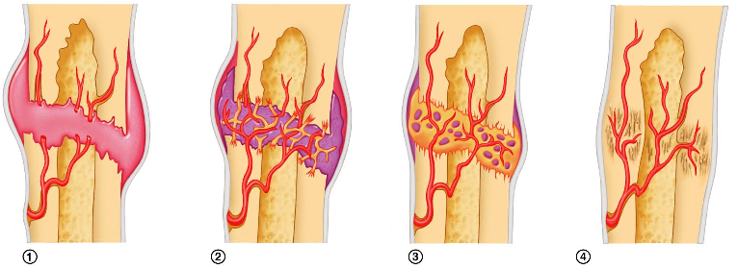

1. The image above demonstrates bone repair. Which image represents the formation of the soft callus?
   1. Image 1
   2. Image 2
   3. Image 3
   4. Image 4
   5. The soft callus is present in all stages
2. Which cell type is NOT present in the epidermis?
   1. Merkel Cells
   2. Melanocytes
   3. Kuppfer cells
   4. Langerhans cells
   5. Keratinocytes
3. The type of articular cartilage that is found at the end of joints as well as the soft portions of the nose is
4. elastic
5. hyaline

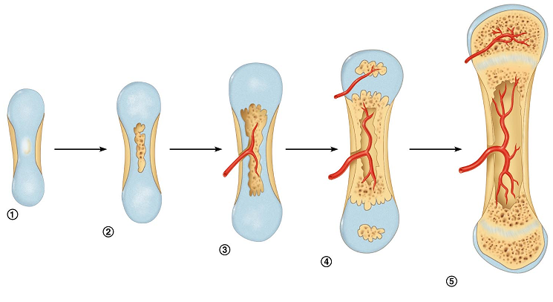

1. fibrocartilage
2. myocartilage
3. keratin
4. Which process is represented above?
   1. Endochondral ossification
   2. Intramembranous ossification
   3. Interosseus calcification
   4. Osteogenesis
   5. Osteopoesis
5. Which layer of epidermis is the deepest layer and responsible for growth?
   1. Stratum basale
   2. Stratum spinosum
   3. Stratum lucidum
   4. Stratum corneum
   5. Stratum granulosum
6. Osteoblasts are ____________________; whereas osteoclasts are _______________.
7. bone destroying cells; bone building cells
8. mature bone cells; immature bone cells
9. immature bone cells; mature bone cells
10. bone repairing cells; bone repairing cells
11. bone building cells; bone destroying cells

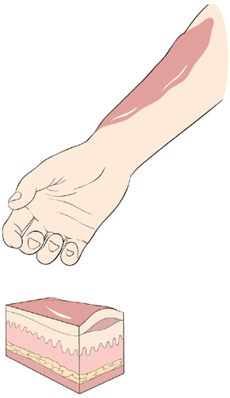

1. What type of burn is described?

**Epidermis and some dermis affected; presence of blisters**

1. first degree burn
2. second degree burn
3. third degree burn
4. fourth degree burn
5. fifth degree burn
6. The presence of an epiphyseal disk indicates
7. the bone diameter is increasing
8. the marrow has ruptured out of its cavity
9. the bone is still growing
10. the bone has matured
11. the person is over 30 years old

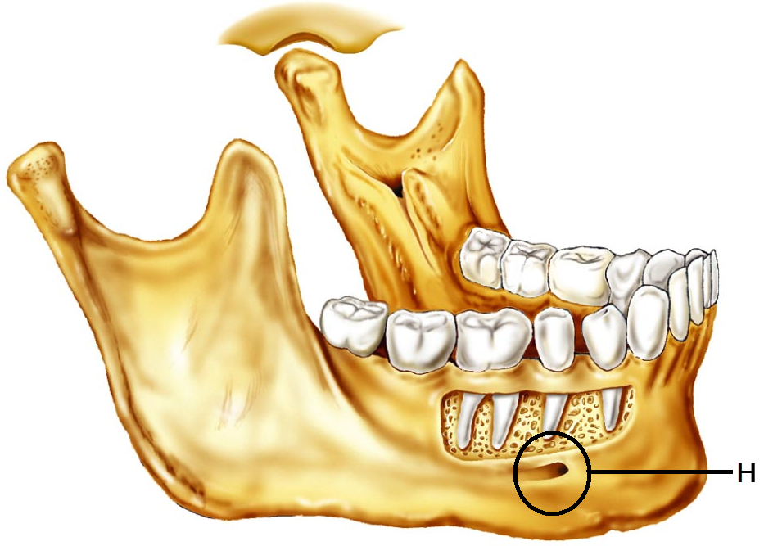

1. Identify the image to the right
   1. Mandible
   2. Maxilla
   3. Sphenoid bone
   4. Vomer
   5. Temporal bone
2. Identify “H”
   1. Maxillary meatus
   2. Mental foramen
   3. Gomphoid process
   4. Mandibular fossa
   5. Apical suture
3. Which type of hair would be found in both children and in adult females?
4. axillary
5. alopecia
6. lanugo
7. terminal
8. vellus
9. Exposure to ultraviolet light causes the skin to darken by stimulating the production of
10. collagen
11. keratin
12. carotene
13. myoma
14. melanin
15. Which of the ABC’s of skin cancer are **incorrectly** paired?
    * 1. A: Appearance
      2. B: Border
      3. C: Color
      4. D: Darkness
    1. 1 and 2 are incorrect
    2. 2 and 3 are incorrect
    3. 3 and 4 are incorrect
    4. 1 and 4 are incorrect
    5. 4 is the only incorrect option
16. Which three pigments are responsible for skin color?
    * + 1. Melanin
        2. Biliverdin
        3. Carotene
        4. Hemoglobin
        5. Myoglobin
           1. 1, 3, 5
    1. 2, 4, 5
    2. 1, 2, 5
    3. 1, 3, 4

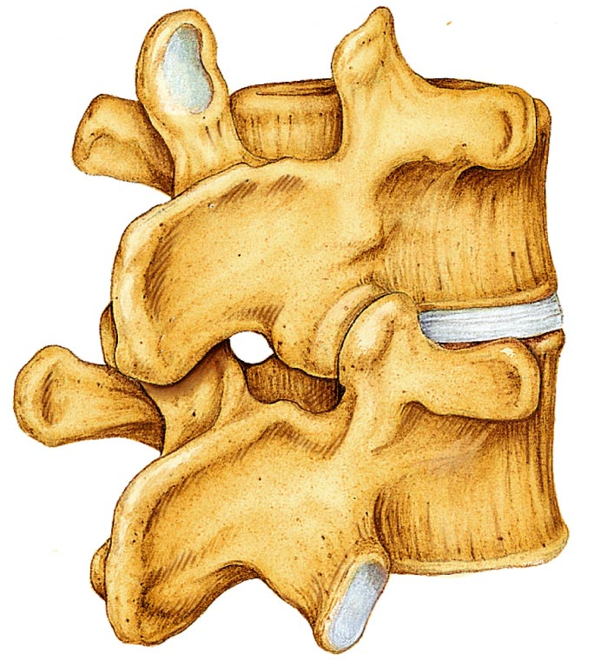

* 1. 2, 4, 5

1. Which region are these vertebrae from?
   1. Cervical
   2. Thoracic
   3. Lumbar
   4. Sacral
   5. Coccygeal
2. Which of the following is **NOT** an **exocrine** gland?

a. salivary glands

b. sweat glands

c. sebaceous glands

d. digestive glands

e. pituitary gland

1. Which skin cancer is being described: Arises from keratinocytes of stratum spinosum; most often appears on scalp, ears, and lower lip; fast growing; treated by removal or radiation
2. Basal cell carcinoma
3. Squamous cell carcinoma
4. Small cell carcinoma
5. Melanoma
6. The description fits both basal cell and squamous cell carcinomas
7. Where is the hyoid bone located?
8. It’s a carpal bone
9. It’s a tarsal bone
10. In the neck between the lower jaw and larynx
11. In the inner ear
12. The floating bone near the big toe

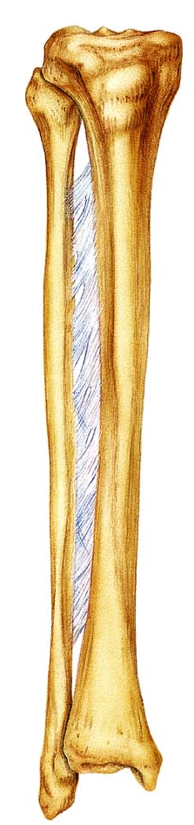

1. Match the term to the following definition:   
   “Shallow, basin-like depression”
2. Trochanter
3. Groove
4. Fissure
5. Foramen
6. Fossa
7. The larger/thicker of these two bones is the
   1. Radius
   2. Ulna
   3. Tibia
   4. Fibula
   5. Femur
8. Match the term to the following definition:   
   “Smooth, nearly flat articular surface”
   1. Head
   2. Facet
   3. Condyle
   4. Turburcle
   5. Meatus
9. Within an osteon, what is the **function** of the canaliculi?
10. Provides structural support for the bone
11. Provides a pathway between the lacunae and the central canal
12. Clears out the debris within the central canal
13. Acts as an attachment site for muscles
14. Provides small cavities or nests that house osteocytes
15. Which type of ossification starts with a thin, fibrous tissue that gets filled in with bone: seen in the skull
16. chondrocartilaginous ossification
17. endochondral ossification
18. intramembranous ossification
19. synchondesmal ossification
20. syndesmosis ossificiation
21. Where are the **secondary** ossification centers located in long bones?
22. epiphysis
23. diaphysis
24. enuresis
25. syndesmosis
26. most long bones will not have secondary ossification centers
27. Which “law” relates to bony growth and adaptation to stresses?
    1. Wolff’s law
    2. Weirneke’s law
    3. The law of osseous hyperplasia
    4. Starling’s Law
    5. McCoy’s law
28. In which bones are we most likely to observe a **depression** fracture?
29. Femur
30. Rib
31. Sternum
32. Vertebra
33. Skull
34. In which bones are we most likely to observe a **compression** fracture?
    1. Femur
    2. Rib
    3. Sternum
    4. Vertebra
    5. Skull
35. Which ribs have no attachment to the sternum
36. all of the ribs are attached to the sternum
37. floating ribs
38. true ribs
39. flying ribs
40. ribs one through seven
41. The half-moon shaped structure at the base of the nail is called
    1. Eponychium
    2. Hyponychium
    3. Lateral fold
    4. Lunula
    5. Moonula
42. Which of these bones of the skull is **NOT** a bone found in the **cranium**?
    1. Parietal
    2. Vomer
    3. Frontal
    4. Occipital
    5. Sphenoid
43. The epidermis has four or five layers, depending on its location. One layer is present in thick skin that is not present in any other layer. Which is it?
    1. Stratum germinativum
    2. Stratum spinosum
    3. Stratum lucidum
    4. Stratum granulosum
    5. Stratum corneum
44. Which of the following statements is **correct** regarding spinal curves?
45. The cervical kyphosis is formed after the infant holds up his/her own head
46. The cervical lordosis is a primary curve
47. The thoracic kyphosis is a primary curve
48. The lumbar kyphosis is a secondary curve
49. The sacral lordosis is formed after an infant begins to walk upright
50. Which of these is **NOT** a carpal bone?
51. lunate
52. hamate
53. hyoid
54. scaphoid
55. capitate
56. The Atlas
57. Is the second cervical vertebra
58. Has an altered body called the odontoid process
59. Is the only vertebra to lack a transverse foramina
60. located in the soft tissue between the lower jaw and larynx
61. articulates with the Occiput
62. Which of the vertebrae have a transverse foramina?

a. all of the cervical vertebrae

b. all of the thoracic vertebrae

c. all of the lumbar vertebrae

d. all of the vertebrae

e. some of the cervical and some of the thoracic vertebrae

1. Which of the following is correct of the female pelvis when comparing it with the male pelvis?
2. distance between the female ischial spines is less
3. the female pelvis is tall and narrow
4. the angle of the female pubic arch is smaller
5. distance between the female ischial spines is greater
6. there are no anatomical differences
7. Calculate how many bones there are in the hand (**not including carpals**)
8. fourteen
9. twenty
10. nineteen
11. twenty five
12. twenty four
13. The ceruminous gland produces cerumin. What is cerumin?
    1. Breast milk
    2. Mucus
    3. Protective enzyme
    4. Ear wax
    5. Conditioning oil
14. Which pelvic structure is responsible for supporting your weight as you sit? (The “sitting bones”)
    1. Pubic rami
    2. Iliac crest
    3. Ischial tuberosity
    4. Sacral ala
    5. Posterior inferior iliac spine
15. Which type of cell can produce cartilage?

a. chondrocyte

b. fibroblast

c. astrocyte

d. adipocyte

e. osteoblast

1. The periosteum is
2. the cartilage that covers the articular surface of a bone
3. a layer of epithelium that covers bone
4. a layer of connective tissue that covers bone
5. tissue that covers the medullary cavity
6. closely associated with yellow bone marrow
7. Which of the following would be considered a “flat” classification for bone?

a. Mandible

b. Patella

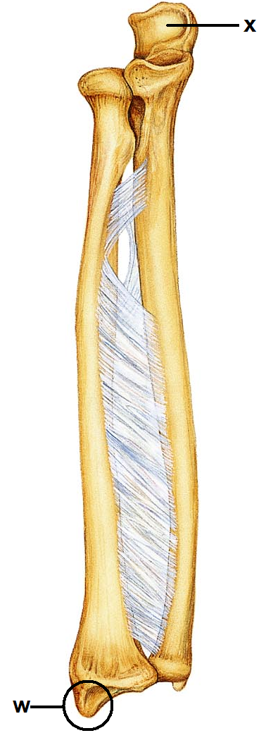

c. Sternum

d. Humerus

e. Metacarpal

1. This type of break in bone occurs when there is a complete break   
   that causes the bone to shatter.

a. comminuted

b. greenstick

c. spiral

d. compound

e. oblique

1. Identify the “x”
   1. Humeral head
   2. Olecranon process
   3. Ulnar condyle
   4. Head of radius
   5. Capitulum
2. Identify the structure “w”
   1. Styloid process of radius
   2. Styloid process of ulna
   3. Lateral malleolus
   4. Medial malleolus
   5. Medial condyle
3. The fibula is
4. short and thick
5. located on the medial aspect of the lower leg
6. articulates with the radius bone in the forearm
7. forms the lateral malleolus (ankle bone)
8. often absent after skeletal maturation
9. Identify the structure “S”

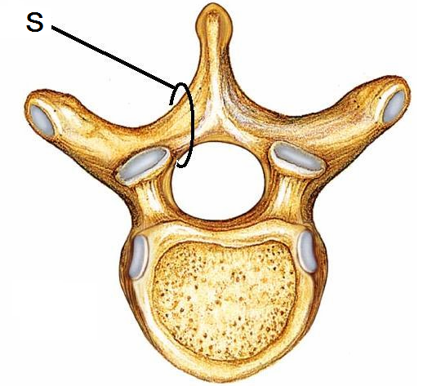

* 1. Lamina
  2. Pedicle
  3. Centrum
  4. Transverse process
  5. Facet