Exam Three: Chapters 9 and 10

1. Which of the following is **not** a synovial joint?
2. saddle
3. condyloid
4. ball and socket
5. suture
6. gliding
7. In which **two** places would you find a **synchondrosis**?
   * 1. where the first rib articulates with the sternum
     2. between the tibia and fibula
     3. between vertebral bodies
     4. in the long bones at the growth plates
     5. at the pubic symphysis
   1. 1 and 2
   2. 2 and 3
   3. 3 and 5
   4. 2 and 5
   5. 1 and 4
8. Which of the following tendons or ligaments would **not** be found at the knee joint?
9. Quadriceps femoris tendon
10. Lateral fiblular collateral ligament
11. Calcaneal ligament
12. Tibial collateral ligament
13. Patellar ligament
14. The elbow is
15. synovial joint
16. hinge joint
17. gliding joint
18. a and b
19. a and c
20. The fibula is
21. short and thick
22. located on the medial aspect of the lower leg
23. articulates with the radius bone in the forearm
24. forms the lateral malleolus
25. often absent after skeletal maturation
26. Which of the following is a gomphosis?
27. intervertebral disc
28. elbow joint
29. knee
30. teeth
31. pubic symphysis

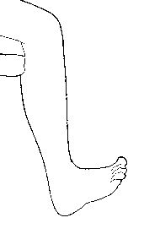

1. This motion of the foot is
2. plantarflexion
3. inversion
4. elevation
5. dorsiflexion
6. protraction
7. The connective tissue that covers each myofiber is
   1. endomysium
   2. epimysium
   3. perimysium
   4. sarcolemma
   5. sarcoplasmic reticulum
8. A sheet like extension of the epimysium that connects muscle to muscle is
9. aponeurosis
10. fascicle
11. sarcoplasmic reticulum
12. tendon
13. ligament
14. The term “ankylosis” was used in describing a result of Rhematoid arthritis. What does ankylosis mean?
    1. Inflammation of the synovium

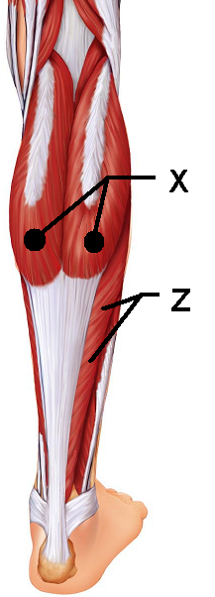

* 1. Flattened sheets of tissue
  2. Erosion of bone
  3. Dislocation
  4. Fusion of bone

1. This muscle “X” is responsible for plantar flexion
   1. Soleus
   2. Gastrocnemius
   3. Fibularis posterior
   4. Semitendinosus
   5. Semimembranosus
2. This muscle “Z” lies deep to the muscle in question 11.   
   It is also responsible for plantar flexion
3. Soleus
4. Gastrocnemius
5. Fibularis posterior
6. Semimembranosus
7. Semitendinosus
8. In a resting muscle cell the myosin binding sites are blocked by ________
9. actin
10. myosin
11. titin
12. calcium
13. tropomyosin
14. A single contraction in response to a single threshold stimulus is defined as _________.
15. summation
16. tetany
17. calmodulation
18. treppe
19. twitch
20. The joint between C1 and C2 uses the dens to create which type of joint motion
    1. Circumduction
    2. Rotation
    3. Flexion
    4. Extension
    5. supination
21. This muscle “Q” is one of the muscles of the rotator cuff
22. Subscapularis

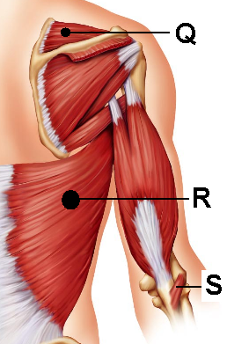

1. Supraspinatus
2. Infraspinatus
3. Teres Major
4. Levator Scapulae
5. This muscle “R” is responsible for extension   
   at the shoulder and medial rotation
6. Trapezius
7. Latissimus Dorsi
8. Quadratus Lumborum
9. Teres Major
10. Rhomboid major
11. This muscle “S” helps to stabilize the   
    elbow during flexion
12. Triceps brachii
13. Popliteus
14. Perinius
15. Anconeus
16. Deltorum
17. Smooth muscle cells can contract as a unit due to the presence of
18. dense bodies
19. gap junctions
20. diffuse junctions
21. motor end plates
22. intercalated discs
23. The perimysium can be found
24. Wrapped around a muscle like the triceps
25. Wrapped around a fascicle
26. Wrapped around a motor unit
27. Wrapped around an individual muscle fiber
28. Wrapped around a myosin
29. What is SR: Sarcoplasmic reticulum?
30. The region in muscle responsible for the production of ATP
31. Smooth endoplasmic reticulum in a muscle cell responsible for the distribution of calcium
32. Rough endoplasmic reticulum in a muscle cell responsible for high energy outputs
33. Endoplasmic reticulum in a muscle cell responsible for creating mitochondria
34. The shortest functional unit within a muscle fiber
35. What unique characteristic of smooth muscle allows your stomach to stretch as you eat and not contract immediately to expel food?
36. Hyperplasia
37. peristalsis
38. slow contraction
39. single unit contraction
40. stress-relaxation response
41. Synergistic muscles that immobilize a joint are also classified as ________.

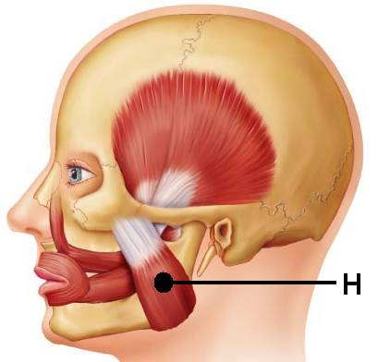

1. agonists
2. fixators
3. prime movers
4. antagonists
5. agonists
6. This muscle “H” is one of the   
   prime movers for mastication.
7. Temporalis
8. Zygomaticus
9. Buccinator
10. Masseter
11. Mentalis
12. Which muscles are part of the hamstring group?
13. Biceps femoris
14. Gracilis
15. Semimembranosus
16. Semitendinosus
17. Vastus Lateralis
    1. 1, 2, 5
    2. 1, 3, 4
    3. 3, 4, 5
    4. 2, 4
    5. 1, 2, 4, 5
18. A motor unit is
    1. The distance between sarcomeres
    2. The distance between Z lines
    3. The skeletal muscle fibers that are innervated by a single nerve fiber
    4. The bundle of nerve fibers that run to smooth muscle
    5. The bundle of muscle cells surrounded by epimysium
19. Calveoli are present in
20. T tubules
21. Mitochondria of cardiac muscles
22. The dorsum of the foot and are responsible for toe flexion
23. The plasma membranes of smooth muscle cells
24. Actin and myosin arrangements
25. A fascicle is defined as
26. An individual muscle fiber
27. A muscle fiber innervated by the somatic nervous system
28. The membrane that surrounds a large muscle group
29. A small bundle of muscle fibers
30. The functional unit of the myofibril
31. This type of joint uses both concave and convex joint surfaces to create a large range of motion. It is seen at the thumb.
    1. Condyloid
    2. Elliptical
    3. Hinge
    4. Ball and socket
    5. Saddle
32. The prime mover in abduction of the arm is __________.
33. Triceps brachii
34. Deltoid
35. Biceps brachii
36. Latissimus dorsi
37. Levator scapulae
38. A muscle that allows us to shrug our shoulders is __________.
39. Latissimus dorsi
40. Subclavius
41. Trapezius
42. Pectoralis major
43. Teres major
44. Which muscle is the prime mover for flexion of the arm?
45. pectoralis major
46. biceps brachii
47. triceps brachii
48. brachialis
49. brachioradialis
50. Which arthritis is being described: This type of arthritis commonly presents as pain in the big toe. It can be aggravated by dietary factors and if left untreated, the bones can fuse together.
    1. Rheumatoid arthritis
    2. Gouty arthritis
    3. Bursitis
    4. Osteoarthritis
    5. Synoarthritis
51. This muscle “J” is responsible for head flexion when activated bilaterally or lateral flexion if activated alone.

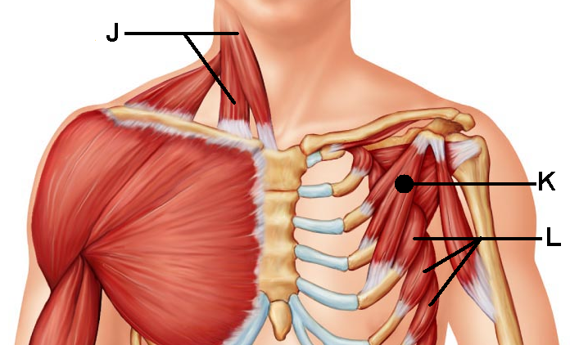

1. Suprascapularis
2. Sternocleidomastoid
3. Splenius capitis
4. Anterior scalene
5. Flexor mentalis profundus
6. This muscle “K” shares its   
   name with a larger counterpart
7. Deltoid
8. Subscapularis
9. Pectoralis minor
10. Omohyoid
11. External intercostals
12. This muscle “L” can help to stabilize the scapula as well as pull the scapula forward. Its jagged appearance contributes to its name.
13. Teres minor
14. Stylohyoid
15. Internal intercostals
16. Subscapularis

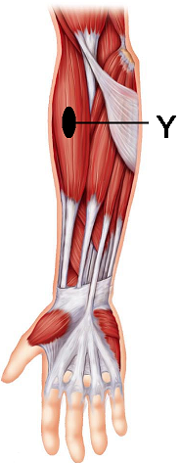

1. Serratus Anterior
2. This muscle “Y” acts as a synergist that helps to stabilize the   
   elbow during flexion
3. Brachialis
4. Biceps brachii
5. Palmaris longus
6. Brachioradialis
7. Extensor carpi digitorum
8. When does the latent period occur with regards to muscle contraction
9. Prior to neural stimulation
10. Immediately after the stimulation is givin
11. After the muscle contracts, but before it relaxes
12. Immediately following muscle relaxation
13. As soon as the cross-bridges form
14. Threshold stimulation for a muscle contraction is
15. The maximum amount of neural stimulation needed for contraction
16. The minimal amount of stimulation needed for contraction
17. Dependant entirely on the location of the muscle
18. The same for cardiac, smooth, and skeletal muscles
19. The average amount of neurotransmitters released post-synaptically
20. Carla is doing bicep curls. What type of contraction is being demonstrated by her biceps?
21. Myotonic
22. Hyperplastic
23. Hypertrophic
24. Isotonic
25. Isometric
26. Identify the true statement
27. Muscle contractions are an efficient process that result in minimal heat production
28. Muscle contraction releases more work energy than heat
29. Muscle contraction release more heat than work energy
30. Work energy and heat are produced equally by muscle contractions
31. Muscle contractions use heat to produce work energy
32. Peristalsis is
33. Seen only in skeletal muscles
34. Seen only in cardiac muscles
35. Seen only in smooth muscles
36. Related to the diagonal muscle arrangement of the fibers
37. Related to the irregularly space muscle fibers

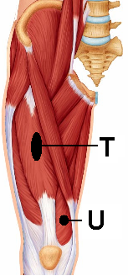

1. This muscle “T” is responsible for thigh flexion
2. Iliocostalis
3. Iliopsoas
4. Biceps femoris
5. Rectus femoris
6. Quadriceps
7. This muscle “U” assists in leg extension
8. Vastus Lateralis
9. Vastus intermedius
10. Gluteus medius
11. Vastus medialis
12. Sartorius
13. Smooth muscles lack ____ but they have ____
14. Actin; myosin
15. Troponin; calmodulin
16. Sarcoplamic reticulum; calveoli
17. Myosin; ATP
18. Nuclei; nucleoli
19. Which type of muscular dystrophy is being described: The disorder is sex-linked and presents between the ages of 2 and 10. The muscle groups most affected are the legs/extremities; victims often die from respiratory failure in their early 20’s

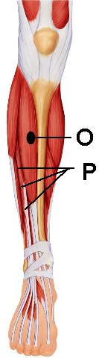

1. Myotonic dystrophy
2. Myocardial dystrophy
3. Duchenne’s dystrophy
4. Fascioscapulohumeral dystrophy
5. Dirksen’s dystrophy
6. This muscle “O” is found in the anterior compartment and is   
   responsible for dorsiflexion
7. Fibularis Anterior
8. Fibularis
9. Tibialis Anterior
10. Sartorius
11. Extensor digitorum longus
12. This muscle “P” is located in the anterior compartment   
    and is responsible for extension of the second   
    through the fifth toes.
13. Extensor carpi ulnaris
14. Extensor fibularis
15. Extensor hallicus longus
16. Extensor digitorum longus
17. Extensor tibialis brevis
18. Which of the following is **not** an intrinsic muscle of the hand?
19. Flexor digiti minimi brevis
20. Opponens digiti minimi
21. Opponens hallicus
22. Palmar interossei
23. Lumbricals
24. What term is used for muscle fibers that have a circular arrangement?
25. Pennate
26. Scaphoid
27. Orbicularis
28. Ocular
29. Simplex

Turn in Scan-tron

Turn in Exam packet

Enjoy your weekend.