BSC 181Exam Three:

Chapters 8, 9, and 10

1. Which of the following is a gomphosis?
2. intervertebral disc
3. elbow joint
4. knee
5. teeth
6. pubic symphysis
7. The connective tissue that covers each skeletal muscle cell (muscle fiber) is
   1. endomysium
   2. epimysium
   3. perimysium
   4. sarcolemma
   5. sarcoplasmic reticulum
8. Which of the following is **not** a synovial joint?
9. saddle
10. condyloid
11. ball and socket
12. suture
13. gliding
14. In which **two** places would you find a **synchondrosis**?
    * 1. where the first rib articulates with the sternum
      2. between the tibia and fibula
      3. between vertebral bodies
      4. in the long bones at the growth plates
      5. at the pubic symphysis
    1. 1 and 2
    2. 2 and 3
    3. 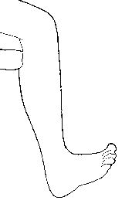3 and 5
    4. 2 and 5
    5. 1 and 4
15. This motion of the foot is
16. plantarflexion
17. inversion
18. elevation
19. dorsiflexion
20. protraction
21. What is the function of a bursa?
    1. Promotes nutrition to the synovium
    2. Prevents overheating of the pannus
    3. Reduces the amount of friction at a joint
    4. Increases the activity of the chondrocytes
    5. Encourages synovial expansion
22. A sheet like extension of the epimysium that connects muscle to muscle is
23. aponeurosis
24. fascicle
25. sarcoplasmic reticulum
26. tendon
27. ligament
28. The term “ankylosis” was used in describing a result of Rhematoid arthritis. What does ankylosis mean?
    1. 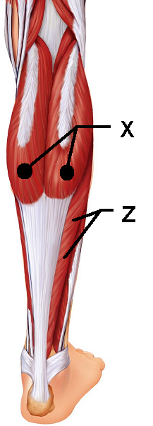Inflammation of the synovium
    2. Flattened sheets of tissue
    3. Erosion of bone
    4. Dislocation
    5. Fusion of bone
29. This muscle “X” is responsible for plantar flexion
    1. Soleus
    2. Gastrocnemius
    3. Fibularis posterior
    4. Semitendinosus
    5. Semimembranosus
30. This muscle “Z” lies deep to the muscle in question 9.   
    It is also responsible for plantar flexion
31. Soleus
32. Gastrocnemius
33. Fibularis posterior
34. Semimembranosus
35. Semitendinosus
36. In a resting muscle cell the myosin binding sites are blocked by ________
37. actin
38. myosin
39. calcitonin
40. calcium
41. tropomyosin
42. A single contraction in response to a single threshold stimulus is defined as _________.
43. summation
44. tetany
45. calmodulation
46. treppe
47. twitch
48. The joint between C1 and C2 uses the dens to create which type of joint motion
    1. Circumduction
    2. Rotation
    3. Flexion
    4. Extension
    5. supination
49. This muscle “Q” is one of the muscles of the rotator cuff
50. 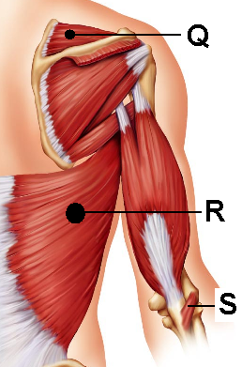Subscapularis
51. Supraspinatus
52. Infraspinatus
53. Teres Major
54. Levator Scapulae
55. This muscle “R” is responsible for extension   
    at the shoulder and medial rotation
56. Trapezius
57. Latissimus Dorsi
58. Quadratus Lumborum
59. Teres Major
60. Rhomboid major
61. This muscle “S” helps to stabilize the   
    elbow during flexion
62. Triceps brachii
63. Popliteus
64. Perinius
65. Anconeus
66. Deltorum
67. Smooth muscle cells can contract as a unit due to the presence of
68. dense bodies
69. gap junctions
70. dystrophin
71. motor end plates
72. intercalated discs
73. The perimysium can be found
74. Wrapped around a muscle like the triceps
75. Wrapped around a fascicle
76. Wrapped around a motor unit
77. Wrapped around an individual muscle fiber
78. Wrapped around a myosin
79. What is SR: Sarcoplasmic reticulum?
80. The region in muscle responsible for the production of ATP
81. Smooth endoplasmic reticulum in a muscle cell responsible for the distribution of calcium
82. Rough endoplasmic reticulum in a muscle cell responsible for high energy outputs
83. Endoplasmic reticulum in a muscle cell responsible for creating mitochondria
84. The shortest functional unit within a muscle fiber
85. What unique characteristic of smooth muscle allows your stomach to stretch as you eat and not contract immediately to expel food?
86. Hyperplasia
87. peristalsis
88. slow contraction
89. single unit contraction
90. stress-relaxation response
91. 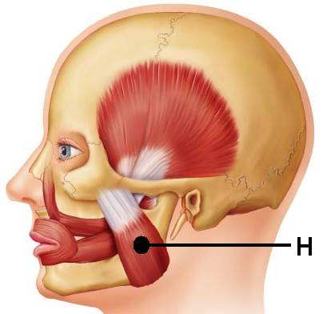Synergistic muscles that immobilize a joint are also classified as ________.
92. agonists
93. fixators
94. prime movers
95. antagonists
96. agonists
97. This muscle “H” is one of the   
    prime movers for mastication.
98. Temporalis
99. Zygomaticus
100. Buccinator
101. Masseter
102. Mentalis
103. Which muscles are part of the hamstring group?
104. Biceps femoris
105. Gracilis
106. Semimembranosus
107. Semitendinosus
108. Vastus Lateralis
     1. 1, 2, 5
     2. 1, 3, 4
     3. 3, 4, 5
     4. 2, 4
     5. 1, 2, 4, 5
109. As the actin and myosin filaments slide past one another, they generate a contraction. The smallest contractile unit in a skeletal muscle is called
     1. T tubule
     2. Sarcomere
     3. Myoplex
     4. Sarcoplasmic reticulum
     5. Z band
110. Calveoli are present in
111. T tubules
112. Mitochondria of cardiac muscles
113. The dorsum of the foot and are responsible for toe flexion
114. The plasma membranes of smooth muscle cells
115. Actin and myosin arrangements
116. A fascicle is defined as
117. An individual muscle fiber
118. A muscle fiber innervated by the somatic nervous system
119. The membrane that surrounds a large muscle group
120. A small bundle of muscle fibers
121. The functional unit of the myofibril
122. The prime mover in **abduction** of the arm is __________.
123. Triceps brachii
124. Deltoid
125. Biceps brachii
126. Latissimus dorsi
127. Levator scapulae
128. A muscle that allows us to shrug our shoulders is __________.
129. Latissimus dorsi
130. Subclavius
131. Trapezius
132. Pectoralis major
133. Teres major
134. Which arthritis is being described: This type of arthritis commonly presents as pain in the big toe. It can be aggravated by dietary factors and if left untreated, the bones can fuse together.
     1. Rheumatoid arthritis
     2. Gouty arthritis
     3. Bursitis
     4. Osteoarthritis
     5. Synoarthritis
135. 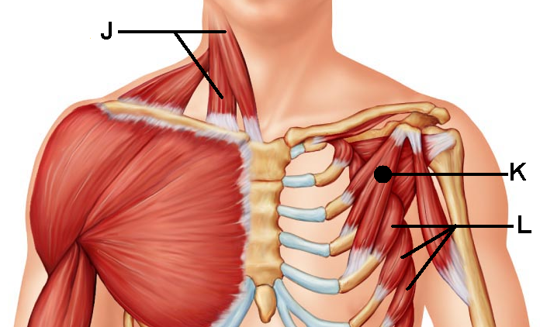This muscle “J” is responsible for head flexion when activated bilaterally or lateral flexion if activated alone.
136. Suprascapularis
137. Sternocleidomastoid
138. Splenius capitis
139. Anterior scalene
140. Flexor mentalis profundus
141. This muscle “K” shares its   
     name with a larger counterpart
142. Deltoid
143. Subscapularis
144. Pectoralis minor
145. Omohyoid
146. External intercostals
147. This muscle “L” can help to stabilize the scapula as well as pull the scapula forward. Its jagged appearance contributes to its name.
148. Teres minor
149. Stylohyoid
150. Internal intercostals
151. Subscapularis
152. Serratus Anterior
153. A motor unit is
     1. The distance between sarcomeres
     2. The distance between Z lines
     3. The skeletal muscle fibers that are innervated by a single nerve fiber
     4. The bundle of nerve fibers that run to smooth muscle
     5. 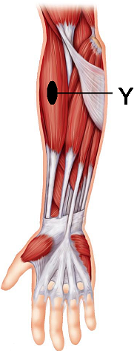The bundle of muscle cells surrounded by epimysium
154. This muscle “Y” acts as a synergist that helps to stabilize the   
     elbow during flexion
155. Brachialis
156. Biceps brachii
157. Palmaris longus
158. Brachioradialis
159. Extensor carpi digitorum
160. When does the latent period occur with regards to muscle contraction
161. Prior to neural stimulation
162. Immediately after the stimulation is givin
163. After the muscle contracts, but before it relaxes
164. Immediately following muscle relaxation
165. As soon as the cross-bridges form
166. This type of joint uses both concave and convex joint surfaces to create a large range of motion. It is seen at the thumb.
     1. Condyloid
     2. Elliptical
     3. Hinge
     4. Ball and socket
     5. Saddle
167. Threshold stimulation for a muscle contraction is
168. The maximum amount of neural stimulation needed for contraction
169. The minimal amount of stimulation needed for contraction
170. Dependant entirely on the location of the muscle
171. The same for cardiac, smooth, and skeletal muscles
172. The average amount of neurotransmitters released post-synaptically
173. Carla is doing bicep curls. What type of contraction is being demonstrated by her biceps?
174. Myotonic
175. Hyperplastic
176. Hypertrophic
177. Isotonic
178. Isometric
179. Which muscle is the prime mover for **flexion** at the shoulder?
180. pectoralis major
181. biceps brachii
182. triceps brachii
183. brachialis
184. brachioradialis
185. Identify the true statement
186. Muscle contractions are an efficient process that result in minimal heat production
187. Muscle contraction releases more work energy than heat
188. Muscle contraction release more heat than work energy
189. Work energy and heat are produced equally by muscle contractions
190. Muscle contractions use heat to produce work energy
191. Peristalsis is
192. Seen only in skeletal muscles
193. Seen only in cardiac muscles
194. Seen only in smooth muscles
195. Related to the diagonal muscle arrangement of the fibers
196. Related to the irregularly space muscle fibers

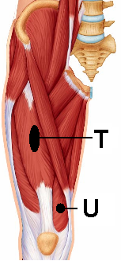

1. This muscle “T” is responsible for thigh flexion
2. Iliocostalis
3. Iliopsoas
4. Biceps femoris
5. Rectus femoris
6. Quadriceps
7. This muscle “U” assists in leg extension
8. Vastus Lateralis
9. Vastus intermedius
10. Gluteus medius
11. Vastus medialis
12. Sartorius
13. Smooth muscles lack ____ but they have ____
14. Actin; myosin
15. Troponin; calmodulin
16. Sarcoplamic reticulum; calveoli
17. Myosin; ATP
18. Nuclei; nucleoli
19. Which type of muscular dystrophy is being described: The disorder is sex-linked and presents between the ages of 2 and 10. The muscle groups most affected are the legs/extremities; victims often die from respiratory failure in their early 20’s
20. Myotonic dystrophy
21. Myocardial dystrophy
22. Duchenne’s dystrophy
23. Fascioscapulohumeral dystrophy
24. Dirksen’s dystrophy
25. 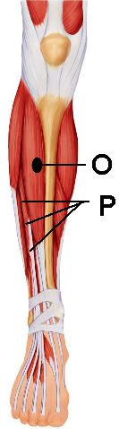This muscle “O” is found in the anterior compartment and is   
    responsible for dorsiflexion
26. Fibularis Anterior
27. Fibularis
28. Tibialis Anterior
29. Sartorius
30. Extensor digitorum longus
31. This muscle “P” is located in the anterior compartment   
    and is responsible for extension of the second   
    through the fifth toes.
32. Extensor carpi ulnaris
33. Extensor fibularis
34. Extensor hallicus longus
35. Extensor digitorum longus
36. Extensor tibialis brevis
37. Which of the following is **not** an intrinsic muscle of the hand?
38. Flexor digiti minimi brevis
39. Opponens digiti minimi
40. Opponens hallicus
41. Palmar interossei
42. Lumbricals
43. What term is used for muscle fibers that have a circular arrangement?
44. Pennate
45. Scaphoid
46. Orbicularis
47. Ocular
48. Simplex
49. The metacarpophalangeal joint is composed of an ovoid surface that fits into a depression to create which joint type?
    1. Saddle joint
    2. Condyloid joint
    3. Ball and socket joint
    4. Suture
    5. Synchondrosis

Turn in Scan-tron

Turn in Exam packet

If you have not turned in your assignment, be sure to do so before leaving.