**Exam Four**

Please read all questions carefully. There is one best answer for each question.

1. A motor neuron described as visceral afferent
   1. Would be found in the spinal cord only
   2. Would be taking impulses from the organs to the central nervous system
   3. Would be taking impulses from the muscles to the central nervous system
   4. Would be taking impulses from the central nervous system to the skeletal muscles
   5. Would be taking impulses from the central nervous system to the organs
2. This highly branched glial cell has a star-shaped appearance. It is associated with capillaries and help with neuron nutrition.
   1. Astrocyte
   2. Schwann cell
   3. Oligodendrocyte
   4. Ependymal cell
   5. Microglial cell
3. Which neuroglial cells are associated with cerebrospinal fluid production?
   1. Astrocyte
   2. Schwann cell
   3. Oligodendrocyte
   4. Ependymal cell
   5. Microglial cell
4. Neurons are described as “amitotic.” What does this mean
   1. They lack a nucleus
   2. They are unable to repair minor damage
   3. They are filled with fluid
   4. They absorb toxins
   5. They do not undergo cellular division
5. An axon that runs through the central nervous system is referred to as a ___ while an axon that runs in the peripheral nervous system is a ____.
   1. Fiber; process
   2. Axon; dendrite
   3. Afferent; efferent
   4. Tract; nerve
   5. Primary fiber; secondary fiber
6. Regarding dendrites, indicate the answer that is a **false** statement
   1. All nerves have at least one extension that functions as a dendrite
   2. Dendrites convey action potentials towards the cell body
   3. Dendrites are often short and diffuse
   4. Dendrites are the input region of the neuron
   5. Most dendrites are highly branched
7. In the PNS, the ______ produces the mylenation surrounding an axon while in the CNS, the _____ produces it.
   1. Schwann cell; schwann cell
   2. Schwann cell; Nissl body
   3. Nissl body; Microglia
   4. Oligodendrocyte; Schwann cell
   5. Schwann cell; Oligodendrocyte

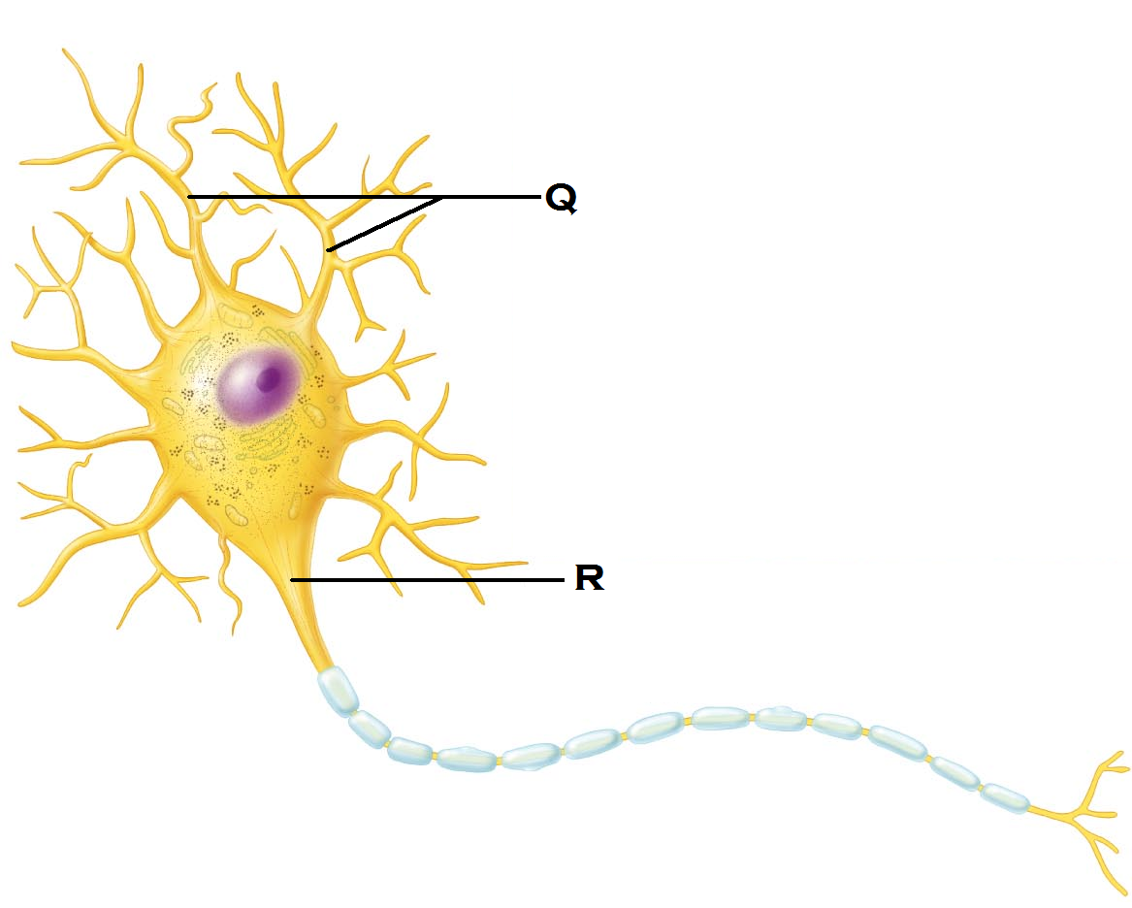

1. Identify the structure indicated by “Q”
   1. Dendrite
   2. Soma
   3. Axonal hillock
   4. Axon
   5. Nissl body
2. Identify the structure indicated by “R”
   1. Dendrite
   2. Soma
   3. Axonal hillock
   4. Axon
   5. Nissl body
3. The above image represents
   1. A nerve commonly found in the olfactory tissues
   2. A nerve commonly found in the retina
   3. A nerve commonly found in the ear
   4. The most common nerve type in the CNS
   5. The most common nerve type in the PNS
4. With a resting membrane,
   * 1. There are more positive ions inside the membrane than outside the membrane
     2. The voltage gates are triggered to move the anions
     3. There are positive ions outside the membrane than inside the membrane
     4. The overall charge across the membrane is negative
     5. The overall charge across the membrane is positive
   1. 1 and 2
   2. 3 and 2
   3. 1, 2, and 4
   4. 2, 3, and 5
   5. 3 and 4
5. At -55 mV threshold becomes self-generating. During the ensuing **depolarization**, which event takes place?
   1. Voltage gates open and Na+ rushes into the membrane
   2. Voltage gates open and Na+ rushes out of the membrane
   3. Voltage gates open and K+ rushes into the membrane
   4. Voltage gates open and K+ rushes out of the membrane
   5. Voltage gates open and Cl- rushes into the membrane
6. During **repolarization**,
   1. Voltage gates open and Na+ rushes into the membrane
   2. Voltage gates open and Na+ rushes out of the membrane
   3. Voltage gates open and K+ rushes into the membrane
   4. Voltage gates open and K+ rushes out of the membrane
   5. Voltage gates open and Cl- rushes into the membrane
7. At which stage does the membrane potential become positive?
   1. Resting
   2. Depolarization/Action Potential
   3. Repolarization
   4. Hyperpolarization
   5. The membrane potential never becomes positive
8. Which axon would have the **greatest** rate of conduction?
   1. A small, myelinated axon
   2. A small unmyelinated axon
   3. A large unmyelinated axon
   4. A large myelinated axon
   5. All axons will conduct their impulses at the same rate.
9. Which of the following means are used to inactivate neurotranmitters once they’ve bound to the dendritic receptors?
   1. Acids are released to change the conformation of protein-based neurotransmitters
   2. Enzymes are released to break down neurotransmitters
   3. The axon terminal blocks the neurotransmitters from being reabsorbed
   4. The neurotransmitters can be reabsorbed by oligodendrocytes
   5. Only inhibitory neurotranmitters need to be degraded, and they break away naturally.
10. The function of a divergent neuronal pool is to
    1. Simplifiy the signal
    2. Modify the signal
    3. Amplify the signal
    4. Suppress the signal
    5. Convert the signal
11. Which structures are found in the telencephalon?
    1. Cerebrum
    2. Thalamus
    3. Medulla oblongata
    4. Midbrain
    5. Pons
12. Where are the pyramidal cells found? (The cell bodies for the corticospinal tract)
    1. Precentral gyrus
    2. Postcentral gyrus
    3. Prefrontal cortex
    4. Precentral sulcus
    5. Postcentral sulcus
13. This auditory association area permits the perception of sound and can store sound memories
    1. Prefrontal cortex
    2. Broca’s area
    3. Wernicke’s area
    4. Occiptial association area
    5. Limbic region
14. This area is present usually in the left hemisphere and helps to control the muscles of speech.
15. Prefrontal cortex
16. Broca’s area
17. Wernicke’s area
18. Occiptial association area
19. Limbic region
20. In which region is the auditory cortex located?
    1. Temporal region
    2. Parietal region
    3. Frontal region
    4. Insular region
    5. Occiptal region
21. The corpus collosum connects right and left hemispheres. What type of white fibers are expected to be seen?
    1. Radiation fibers
    2. Commisural fibers
    3. Striation fibers
    4. Projection fibers
    5. Association fibers
22. Which three structures compose the basal nuclei?
    1. Retinacular nucleus, Orbis, Putamen
    2. Globus pallidin, putamen, caudate nucleus
    3. Cephalad nucleus, caudate nucleus, Lentiform
    4. Globus pallidin, putamen, cephalad nucleus
    5. Tertiary nucleus, lateral nucleus, choroid nucleus
23. Which fibers will pass through the thalamus
    1. Olfactory
    2. Somatic motor fibers
    3. Autonomic motor fibers
    4. All motor fibers
    5. All spinal ascending fibers
24. The Pineal gland
    * + 1. Produces melatonin
        2. Produces melanin
        3. Produces CSF
        4. Is an exocrine gland
        5. Is part of the epithalamus
    1. 1 and 3
    2. 2 and 3
    3. 1, 3, 4
    4. 2, 4, 5
    5. 1 and 5
25. Identify “S”

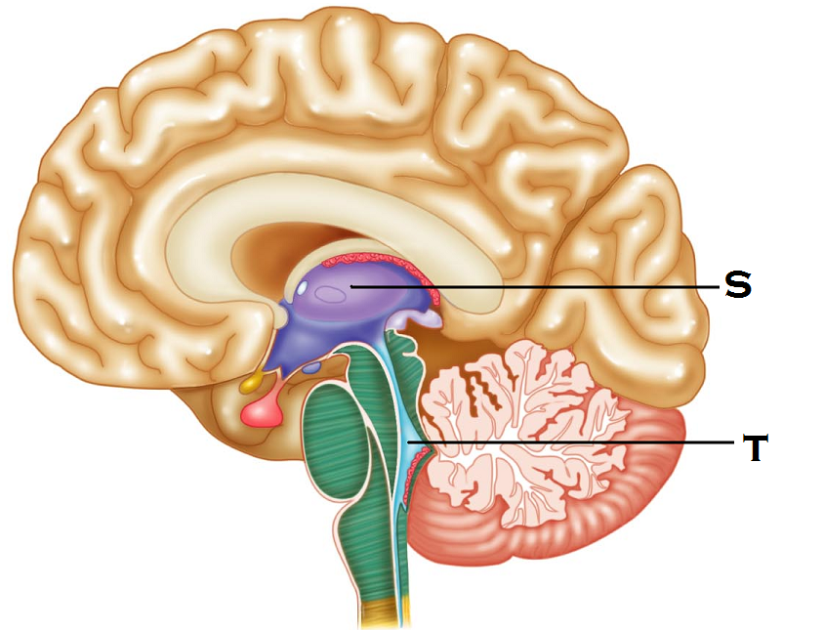

* 1. Corpus callosum
  2. Infindibulum
  3. Hypothalamus
  4. Basal nuclei
  5. Thalamus

1. Identify “T”
   1. Pons
   2. Third ventricle
   3. Fourth ventricle
   4. Central canal
   5. Medulla oblongata
2. This midbrain structure connects the   
   third ventricle to the fourth ventricle
   1. Interventricular foramen
   2. Lateral foramina
   3. Central canal
   4. Cerebral aqueduct
   5. Ventricular bridge
3. In the medulla oblongata, what are the two longitudinal ridges that are formed by the corticospinal tracts?
   1. Gyri
   2. Sulcus
   3. Tranverse fissure
   4. Longitudinal fissure
   5. Pyramids
4. The falx cerebri is made up of _____ and is located _
   1. Pia mater; within the longitudinal fissure
   2. Dura mater; within the longitudinal fissure
   3. Arachnoid mater: along the vermis of the cerebellum
   4. Dura mater: within the transverse fissure
   5. Pia mater: along the cerebellum
5. Which the following is true of the lateral spinothalamic tracts?
6. It is an ascending tract
7. It is a descending tract
8. It conveys motor impulses
9. It conveys pain and touch
10. It conveys stretch sensations from the viscera
    1. 1, 3, and 5
    2. 2, 3, and 5
    3. 2 and 4
    4. 3 and 5
    5. 1 and 4
11. Identify “x”
    1. Ventral root
    2. Spinal nerve

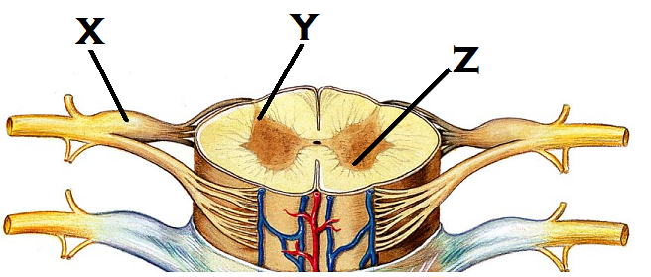

* 1. Dorsal root
  2. Motor pathway
  3. Dorsal root ganglion

1. Identify “Y”
   1. Posterior column
   2. Anterior column
   3. Posterior horn
   4. Anterior horn
   5. Lateral horn
2. Identify “Z”
   1. Posterior column
   2. Anterior column
   3. Posterior horn
   4. Anterior horn
   5. Lateral horn
3. What happens if there is damage to the lower motor neurons
   1. Sensory information fails to reach the brain
   2. Spastic paralysis results
   3. Flaccid paralysis results
   4. Muscles display an irregular stimulation pattern
   5. Involuntary control of the muscle remains intact
4. What are the receptor types that are pain receptors?
   1. Myoceptors
   2. Exteroceptors
   3. Rhabdoceptors
   4. Nociceptors
   5. Thermoceptors
5. Which of the following cranial nerves is sensory only?
   1. Hypoglossal
   2. Trigeminal
   3. Optic
   4. Oculomotor
   5. Trochear
6. Which of the following cranial nerves is mixed?
   1. Olfactory
   2. Optic
   3. Oculomotor
   4. Facial
   5. Vestibulocochlear
7. The motor portion of this cranial nerve innervates tongue muscles and salivary glands while the sensory portion is responsible for taste.
   1. Vestibulocochlear
   2. Glossopharyngeal
   3. Vagus
   4. Spinal accessory
   5. Facial
8. From the brachial plexus, which nerve innervates the extensor muscles?
   1. Radial nerve
   2. Musculocutaneous nerve
   3. Axillary nerve
   4. Ulnar nerve
   5. Median nerve
9. The sciatic nerve comes from the ____ plexus and is compose of these two nerves:
   1. Cervical: tibial and peroneal
   2. Brachial: tibial and fibular nerves
   3. Lumbar: tibial and peroneal
   4. Sacral: tibial and fibular
   5. Coccygeal: tibial and peroneal
10. A Golgi Tendon Organ will be activated by
    1. Carbon dioxide concentrations
    2. Muscle stretch
    3. Tissue damage
    4. Temperature changes
    5. Muscle contraction
11. Which of the following is true about the lateral horn of the spinal cord
    1. The lateral horn contains cell bodies for sensory fibers
    2. The lateral horn contains cell bodies of motor fibers running to skeletal muscle
    3. The lateral horn contains cell bodes of motor fibers running to smooth muscle and glands
    4. The lateral horn contains ascending nerve tracts
    5. The lateral horn contains descending nerve tracts
12. With muscle spindle activation, which of the following are true,
    * 1. The primary muscle has been contracted
      2. The primary muscle has been stretched
      3. The antagonistic muscle receives an impulse to contract
      4. The antagonistic muscle receives an impulse to relax
    1. 1 and 3
    2. 1 and 4
    3. 2 and 3
    4. 2 and 4
    5. 1, 3, and 4
13. A spinal nerve usually contains
    1. Ascending fibers only
    2. Efferent fibers only
    3. Autonomic fibers only
    4. Mixed sensory and motor nerve fibers
    5. Non-myelinated fibers
14. Which option below describes the function of the choroid plexus?
    1. A network of nerves coming from C1 – C4 that innervate the face
    2. An area of cell bodies located outside of the central nervous system
    3. The location for the autonomic nerve cell bodies
    4. The cells responsible for producing and filtering CSF
    5. Nerve tracts that run within hemispheres
15. What do the gray commisure of the spinal cord and the corpus callosum have in common?
    1. Both are ascending tracts
    2. Both carry pain and temperature
    3. Both structures link the left and right sides of their respective structures
    4. Both contain a predominantly unipolar type neuron within their structures
    5. Both are considered association areas.
16. Which of the following is **NOT** an extrapyramidal tract
    1. Rubrospinal
    2. Corticospinal
    3. Tectospinal
    4. Reticulospinal
    5. Vestibulospinal
17. Which branch of the spinal nerve would you expect to see innervate the dura mater?
    1. Ventral rami
    2. Ventral root
    3. Dorsal rami
    4. Dorsal root
    5. Meningeal rami

Turn in Opscan

Turn in Exam packet