**BSC 181 Exam Four**

Please read all questions carefully. There is one best answer for each question.

1. A neuron described as visceral afferent
   1. Would be found in the spinal cord only
   2. Would be taking impulses from the organs to the central nervous system
   3. Would be taking impulses from the muscles to the central nervous system
   4. Would be taking impulses from the central nervous system to the skeletal muscles
   5. Would be taking impulses from the central nervous system to the organs
2. 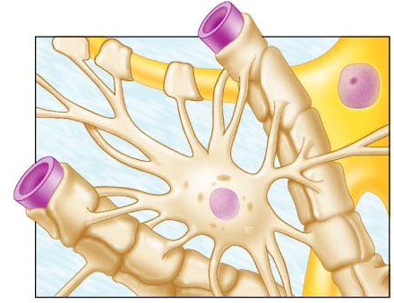This highly branched glial cell has a star-shaped appearance. It is associated with capillaries and help with neuron nutrition.
   1. Astrocyte
   2. Schwann cell
   3. Oligodendrocyte
   4. Ependymal cell
   5. Microglial cell
3. Neurons are described as “amitotic.” What does this mean
   1. They lack a nucleus
   2. They are unable to repair minor damage
   3. They are filled with fluid
   4. They absorb toxins
   5. They do not undergo cellular division
4. Which neuroglial cells are associated with cerebrospinal fluid production?
   1. 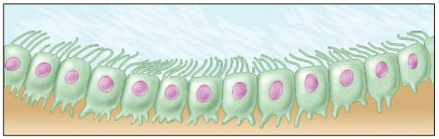Astrocyte
   2. Schwann cell
   3. Oligodendrocyte
   4. Ependymal cell
   5. Microglial cell
5. An axon bundle that runs through the central nervous system is referred to as a ___ while an axon bundle that runs in the peripheral nervous system is a ____.
   1. Fiber; process
   2. Axon; dendrite
   3. Afferent; efferent
   4. Tract; nerve
   5. Primary fiber; secondary fiber
6. Regarding dendrites, indicate the answer that is a **false** statement
   1. All nerves have at least one extension that functions as a dendrite
   2. Dendrites convey action potentials towards the cell body
   3. Dendrites are often short and diffuse
   4. Dendrites are the input region of the neuron
   5. Most dendrites are highly branched
7. What is the function of the choroid plexus?
   1. Oxygenates blood within the brain tissue
   2. Provides nutrients for glial cells
   3. It acts as a chemoreceptor sensitive to H+
   4. Filters the cerebrospinal fluid
   5. Regulates the blood flow through the ventricles
8. In the PNS, the ______ produces the mylenation surrounding an axon while in the CNS, the _____ produces it.
   1. Schwann cell; schwann cell
   2. Schwann cell; Nissl body
   3. Nissl body; Microglia
   4. Oligodendrocyte; Schwann cell
   5. 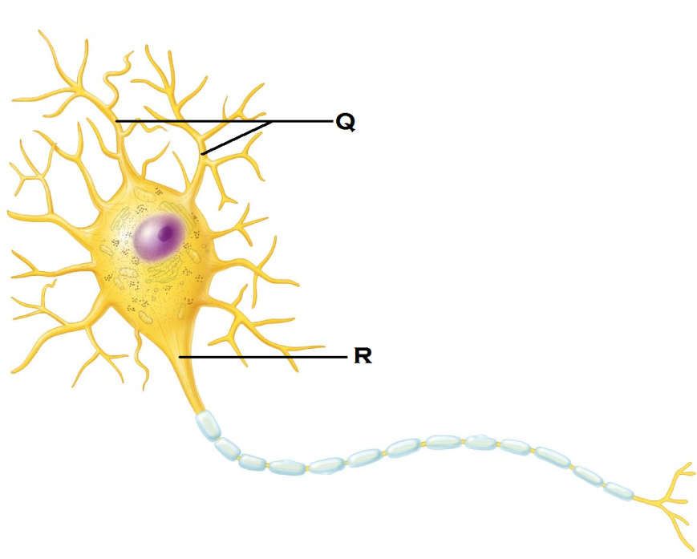Schwann cell; Oligodendrocyte
9. Identify the structure indicated by “Q”
   1. Dendrite
   2. Soma
   3. Axonal hillock
   4. Axon
   5. Nissl body
10. Identify the structure indicated by “R”
    1. Dendrite
    2. Soma
    3. Axonal hillock
    4. Axon
    5. Nissl body
11. The above image represents
    1. A nerve commonly found in the olfactory tissues
    2. A nerve commonly found in the retina
    3. A nerve commonly found in the ear
    4. The most common nerve type in the CNS
    5. The most common nerve type in the PNS
12. With a resting membrane,
    * 1. There are more positive ions inside the membrane than outside the membrane
      2. The voltage gates are triggered to move the anions
      3. There are more positive ions outside the membrane than inside the membrane
      4. The overall charge across the membrane is negative
      5. The overall charge across the membrane is positive
    1. 1 and 2
    2. 3 and 2
    3. 1, 2, and 4
    4. 2, 3, and 5
    5. 3 and 4
13. Where would one find the tentorium cerebelli?
    1. Along the central canal of the spinal cord
    2. Separating cerebrum and cerebellum
    3. Attached to the posterior median sulcus
    4. Separating right and left cerebral hemispheres
    5. Tightly adhered to the brainstem
14. At -55 mV threshold becomes self-generating. During the ensuing **action potential**, which event takes place?
    1. Voltage gates open and Na+ rushes into the membrane
    2. Voltage gates open and Na+ rushes out of the membrane
    3. Voltage gates open and K+ rushes into the membrane
    4. Voltage gates open and K+ rushes out of the membrane
    5. Voltage gates open and Cl- rushes into the membrane
15. During **repolarization**,
    1. Voltage gates open and Na+ rushes into the membrane
    2. Voltage gates open and Na+ rushes out of the membrane
    3. Voltage gates open and K+ rushes into the membrane
    4. Voltage gates open and K+ rushes out of the membrane
    5. Voltage gates open and Cl- rushes into the membrane
16. At which stage does the membrane potential become positive?
    1. Resting
    2. Depolarization/Action Potential
    3. Repolarization
    4. Hyperpolarization
    5. The membrane potential never becomes positive
17. Which neuroglial cells are described as small and phagocytic?
    1. Ependymal cells
    2. Astrocytes
    3. Oligodendrocytes
    4. Neuron
    5. Microglia
18. Which axon would have the **greatest** rate of conduction?
    1. A small, myelinated axon
    2. A small unmyelinated axon
    3. A large unmyelinated axon
    4. A large myelinated axon
    5. All axons will conduct their impulses at the same rate.
19. Which of the following means are used to inactivate neurotranmitters once they’ve bound to the dendritic receptors?
    1. Acids are released to change the conformation of protein-based neurotransmitters
    2. Enzymes are released to break down neurotransmitters
    3. The axon terminal blocks the neurotransmitters from being reabsorbed
    4. The neurotransmitters can be reabsorbed by oligodendrocytes
    5. Only inhibitory neurotranmitters need to be degraded, and they break away naturally.
20. The function of a **divergent** neuronal pool is to
    1. Simplifiy the signal
    2. Modify the signal
    3. Amplify the signal
    4. Suppress the signal
    5. Convert the signal
21. Which structures are found in the telencephalon?
    1. Cerebrum
    2. Thalamus
    3. Medulla oblongata
    4. Midbrain
    5. Pons
22. Where are the pyramidal cells found? (The pyramidal cells are the cell bodies for the motor neurons in the corticospinal tract)
    1. Precentral gyrus
    2. Postcentral gyrus
    3. Prefrontal cortex
    4. Precentral sulcus
    5. Postcentral sulcus
23. Which of the neurotransmitters listed below shares a similar function to the endorphins and enkephalins?
    1. Substance P
    2. Nitric oxide
    3. Acetylcholine
    4. GABA
    5. Dopamine
24. The diencephalon
    1. Is composed of the pineal gland and the endothalamus
    2. Is composed of thalamus, hypothalamus, and epithalamus
    3. Is composed of the fourth ventricle and the cerebellum
    4. Is composed of the pituitary gland and the parietal lobe
    5. Is the transition site between pons and medulla oblongata
25. This auditory association area permits the perception of sound and can store sound memories
    1. Prefrontal cortex
    2. Broca’s area
    3. Wernicke’s area
    4. Occiptial association area
    5. Limbic region
26. This area is present usually in the left hemisphere and helps to control the muscles of speech.
27. Prefrontal cortex
28. Broca’s area
29. Wernicke’s area
30. Occiptial association area
31. Limbic region
32. Which option best describes the function of the cerebellum?
    1. Integration of sensory input and coordination of motor input
    2. Generates delta waves during sleep
    3. Origination of all conscious motor control
    4. Provides physical support for the occipital lobe
    5. Modifies and relays incoming visceral impulses.

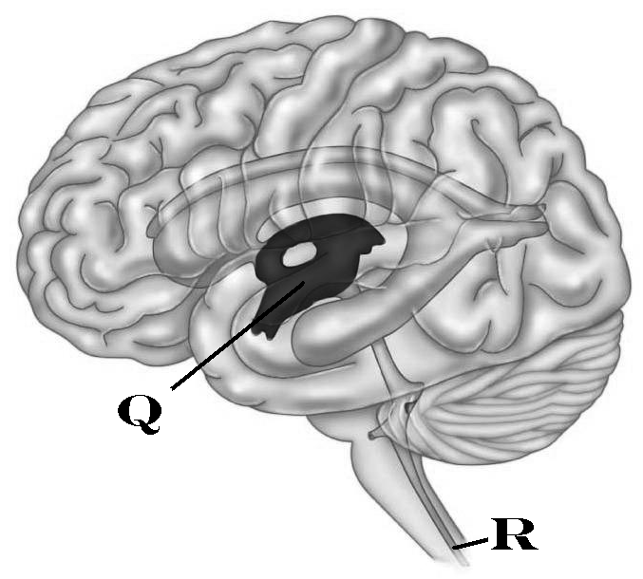

1. Identify “Q”
   1. Lateral Ventricle
   2. Third Ventricle
   3. Homunculus
   4. Corpus Callosum
   5. Fourth Ventricle
2. Identify “R”
   1. Central Canal
   2. Canal of Schlemm
   3. Cerebral Aqueduct
   4. Interventricular foramina
   5. Sylvar Canal
3. In which region is the auditory cortex located?
   1. Temporal region
   2. Parietal region
   3. Frontal region
   4. Insular region
   5. Occiptal region
4. In which time frame will a stimulated neuron be unable to respond
   1. During its resting state
   2. During the absolute refractory period
   3. During the relative refractory period
   4. During the hyperpolarized period
   5. During the initial depolarizing period
5. Which fibers will pass through the thalamus
   1. Olfactory
   2. Somatic motor fibers
   3. Autonomic motor fibers
   4. All motor fibers
   5. All spinal ascending fibers
6. 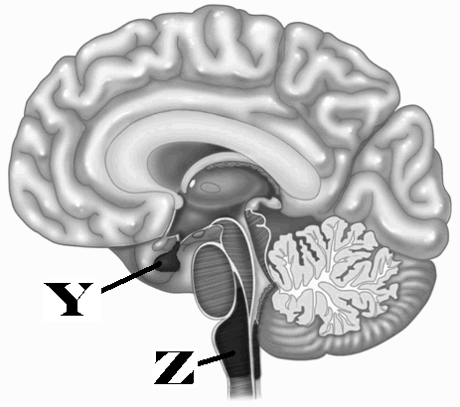Identify “Y”
   1. Corpus callosum
   2. Pituitary gland
   3. Optic Chiasma
   4. Olfactory bulb
   5. Pons
7. Identify “Z”
   1. Pons
   2. Third ventricle
   3. Fourth ventricle
   4. Central canal
   5. Medulla oblongata
8. This midbrain structure connects the   
   third ventricle to the fourth ventricle
   1. Interventricular foramen
   2. Lateral foramina
   3. Central canal
   4. Cerebral aqueduct
   5. Ventricular bridge
9. In the medulla oblongata, what are the two longitudinal ridges that are formed by the corticospinal tracts?
   1. Gyri
   2. Sulcus
   3. Tranverse fissure
   4. Longitudinal fissure
   5. Pyramids
10. A dendrite receives, in rapid succession, several excitatory subthreshold stimulations that add up and trigger an action potential. What is the process called?
    1. Temporal summation
    2. Spatial summation
    3. Bilateral summation
    4. Repetitive summation
    5. Recurrent summation
11. The corpus collosum connects right and left hemispheres. What type of white fibers is expected to be seen?
    1. Radiation fibers
    2. Commisural fibers
    3. Striation fibers
    4. Projection fibers
    5. Association fibers
12. The falx cerebri is made up of _____ and is located _
    1. Pia mater; within the longitudinal fissure
    2. Dura mater; within the longitudinal fissure
    3. Arachnoid mater: along the vermis of the cerebellum
    4. Dura mater: within the transverse fissure
    5. Pia mater: along the cerebellum
13. A fiber in the white matter of the brain that originates in the right side of the thalamus and then runs to the cortex on the right side of the brain would fall into which category?
    1. Radiation fibers
    2. Commisural fibers
    3. Striation fibers
    4. Projection fibers
    5. Association fibers
14. This region of the brain is associated with intellect, recall, and personality. It is also linked to the limbic system. Which region is it?
    1. Temporal region
    2. Postcentral cortex
    3. Prefrontal cortex
    4. Insula of Reil
    5. Lemnitic nuclei
15. Which division is created by the lateral sulcus on the surface of the brain?
    1. Separates precentral from postcentral regions
    2. Separates occipital lobe from cerebellum
    3. Separates motor cortex from sensory cortex
    4. Separates parietal lobe and temporal lobe
    5. Separates white matter from gray matter
16. Which of the following is true with regards to a graded potential
    1. Graded potentials occur only in the axons
    2. Graded potentials are almost always inhibitory
    3. Graded potentials are able to travel long distances without degrading
    4. Graded potentials degrade quickly
    5. 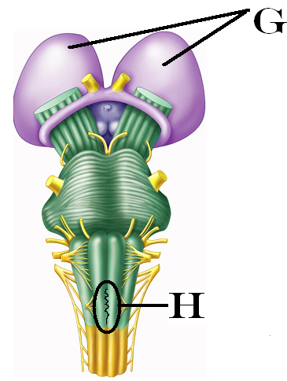Graded potentials can cross the synapse
17. Identify “G”
    1. Thalamus
    2. Pons
    3. Epithalamus
    4. Olfactory lobe
    5. Cerebral peduncle
18. Identify “H”
    1. Decussation of the Pyramids
    2. Pons
    3. Epithalamus
    4. Cerebral peduncle
    5. Arbor Vitae
19. Where are the satellite cells found?
    1. At the axon terminus
    2. Surrounding the soma of a neuron
    3. In the white matter of the spinal cord
    4. In the white matter of the brain
    5. Within the ventricles of the brain
20.  This type of neuron is commonly found as a sensory neuron. Based on its structure, how would it be classified?
    1. Efferent
    2. Multipolar
    3. Bipolar
    4. Unipolar
    5. Northpolar
21. In which region of the brain is the general (common) interpretation area located?
    1. Parietal
    2. Temporal
    3. Occipital
    4. All of the above
22. In which area of the brain is the blood-brain barrier lacking or incomplete in order to allow the chemical composition of the blood to be evaluated?
    1. Pineal gland
    2. Hypothalamus
    3. Pons
    4. Cerebellum
    5. Prefrontal cortex
23. Which meningeal tissue is composed of two layers that occasionally separate to create spaces called sinuses?
    1. Pia mater
    2. Arachnoid mater
    3. Dura mater
    4. Doesn’t mater

Turn in Opscan

Turn in Exam packet

If you have a comment or would like to reserve your exam to look at later, put your name

on it and place it in a separate pile at the front.