BSC 181 Exam Five

1. Most of the **effectors** in the autonomic nervous system are
   1. Skeletal muscles
   2. Sensory organs
   3. Postganglionic neurons
   4. Ganglia
   5. Viscera
2. (Fill in the blanks with the options below to make the sentence correct.)

**In terms of pathways, the somatic nervous system has ___ while the autonomic nervous system has ___**

* 1. One unmyelinated motor neuron that runs from CNS to effector; two heavily myelinated motor neurons that run from CNS to effector
  2. One heavily myelinated motor neuron that runs from CNS to effector; lightly myelinated preganglionic and postganglionic fibers that run from the CNS to the effector
  3. Several unmyelinated motor neurons that run from CNS to effector; two postsynaptic fibers that run from the CNS to the effector
  4. One heavily myelinated afferent motor neuron that runs from CNS to effector; One lightly myelinated motor neuron that runs from CNS to effector
  5. Several unmyelinated sensory neurons that run from CNS to effector; Several unmyelinated motor neurons that run from the CNS to effector

1. Which of the following fiber types are able to release the neurotransmitter acetylcholine?
   * + 1. Somatic fibers running to skeletal muscles
       2. Preganglionic fibers in the parasympathetic system
       3. Preganglionic fibers in the sympathetic system
       4. Postganglionic fibers of the sympathetic system
       5. None of the above are correct
   1. 1 and 2
   2. 2 and 3
   3. 1, 2, and 3
   4. 1, 2, 3, and 4
   5. 5 only
2. The “D” activities are linked to the ____ system and include _____
   1. Sympathetic system; dieting
   2. Parasympathetic system; digestion
   3. Sympathetic system; diuresis
   4. Parasympathetic system; diapedesis
   5. Somatic system: dilation
3. The “E” activities are linked to the ____ system and include _____
   1. Sympathetic system; exercise
   2. Parasympathetic system: erection
   3. Sympathetic system; enjoyment
   4. Parasympathetic system: energy
   5. Somatic system: emergency
4. This system has **long** **preganglionic** fibers and **short postganglionic** fibers
   1. Somatic
   2. Afferent
   3. Sympathetic
   4. Parasympathetic
   5. Both sympathetic and parasympathetic
5. This system has also been referred to as “**cranio-sacral**” based on the origins of its fibers
   1. Somatic
   2. Afferent
   3. Sympathetic
   4. Parasympathetic
   5. Both sympathetic and parasympathetic
6. Where are the **cell bodies** for the sympathetic system housed?
   1. Anterior horn of spinal cord
   2. Posterior horn of spinal cord
   3. Lateral horn of spinal cord
   4. Precentral cortex
   5. Postcentral cortex
7. What type of fibers would you expect to see in a **gray ramus** (rami)?
   1. Sympathetic preganglionic
   2. Parasympathetic preganglionic
   3. Sympathetic postganglionic
   4. Parasympathetic postganglionic
   5. Somatic
8. The superior cervical ganglion
   1. Consists of sympathetic preganglionic fibers from the upper thoracic region
   2. Consists of sympathetic preganglionic fibers from the lower thoracic region
   3. Consists of parasympathetic preganglionic fibers from the upper lumbar region
   4. Contains the origin of the splanchnic nerves
   5. Serves the skin and blood vessels in the lower limbs
9. Identify “G”

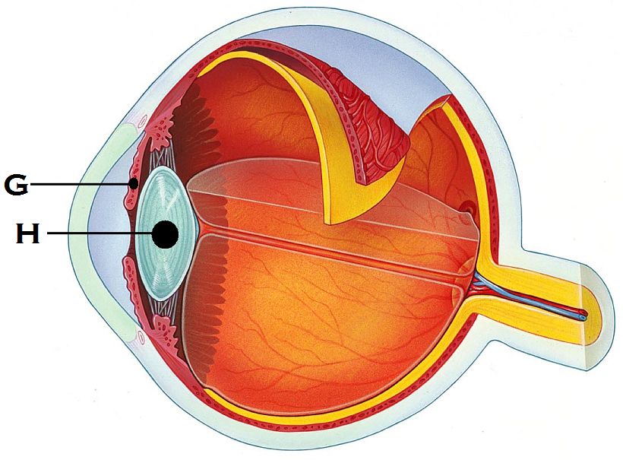

* 1. Sclera
  2. Choroid
  3. Suspensory ligament
  4. Pupil
  5. Iris

1. Identify “H”
   1. Cornea
   2. Lens
   3. Sclera
   4. Aqueous humor
   5. Suspensory ligament
2. Which of the following are true?
3. Splanchnic nerves contain sympathetic fibers
4. Splanchnic nerves contain parasympathetic fibers
5. Splanchnic nerves contain both sympathetic and parasympathetic fibers
6. Postganglionic fibers from the lumbar and sacral plexes innervate the reproductive organs
7. Postganglionic fibers from the lumbar and sacral plexes innervate the spleen
   1. 1, 3, 5
   2. 2 and 3
   3. 3 and 4
   4. 2 and 5
   5. 1 and 4
8. Other than in the left arm, where might cardiac referral pain be felt?
   1. Cheeks
   2. Fingertips
   3. Knees
   4. Around the umbilicus
   5. Right neck region
9. Adrenergic fibers release
   1. Acetylcholine
   2. Nitric oxide

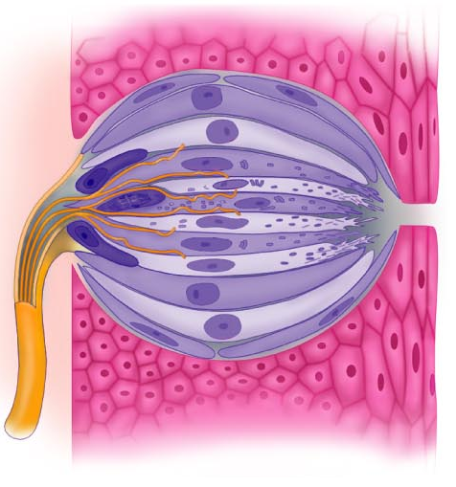

* 1. Dopamine
  2. Serotonin
  3. Norepinephrine

1. The image to the right represents
   1. Basilar hairs in cochlea
   2. Olfactory epithelium
   3. Saccule and utricle
   4. Pacinian corpuscle
   5. Taste bud
2. Which receptors are associated with cholinergic fibers
   * + 1. Muscarinic
       2. Nicotinic
       3. Beta adrenergic
       4. Alpha adrenergic
       5. Delta adrenergic
   1. 1 and 2
   2. 3 and 4
   3. 1 and 5
   4. 2 and 4
   5. 1, 2, and 3
3. Which type of response is always stimulatory?
   1. ACh binding to nicotinic receptors
   2. ACh binding to muscarinic receptors
   3. ACh binding to beta adrenergic receptors
   4. ACh binding to alpha adrenergic receptors
   5. ACh binding to delta adrenergic receptors
4. Sympathetic tone is responsible for ___; while parasympathetic tone is responsible for ___
   1. Blood vessel constriction/dilation; heart rate
   2. Heart rate; blood vessel constriction/dilation
   3. Urination; digestive peristalsis
   4. Sweat gland output; blushing
   5. Digestive peristalsis; reproductive peristalsis
5. Identify the true statement
   1. Parasympathetic system controls sweat glands
   2. Parasympathetic responses are localized
   3. Sympathetic system controls adrenal gland output
   4. Sympathetic responses are rapid and short lived
   5. Norepinephrine is broken down much more quickly than ACh.
6. Which muscles move the **eyebrows** medially?
   1. Palpebral muscles
   2. Orbicularis oculi muscle
   3. Superior rectus muscle
   4. Corrugator muscle
   5. Medial rectus
7. Which of the following glands are **not** accessory structures to the eye?
   1. Lacrimal glands
   2. Meibonian glands
   3. Ciliary glands
   4. Canthi glands
   5. All of the above are glands associated with the eye
8. Which is the **drainage site** for the lacrimal gland? (takes tears away from the eye)
   1. Lacrimal puncta
   2. Inferior lacrimal canthus
   3. Lateral epicanthus
   4. Conjunctival meatus
   5. Canal of Schlemm
9. Which two muscles will be responsible for making the eyes look up?
   * + 1. Lateral rectus
       2. Inferior oblique
       3. Superior oblique
       4. Inferior rectus
       5. Superior rectus
   1. 1 and 2
   2. 2 and 5
   3. 3 and 5
   4. 2 and 4
   5. 3 and 4
10. Identify the structure “Q”

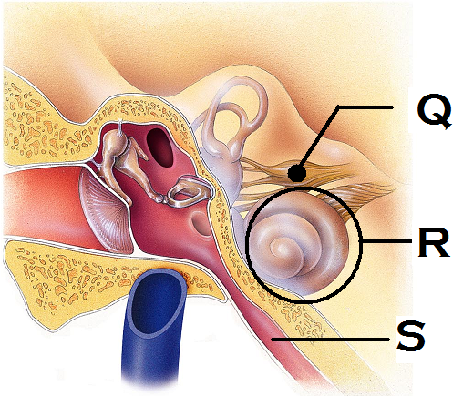

* 1. Coclear nerve
  2. Vestibular nerve
  3. Vestibulocochlear nerve
  4. Tympanic nerve
  5. Auditory nerve

1. Identify the structure “R”
   1. Vestibule
   2. Semilunar canal
   3. Ossicles
   4. Tympanic membrane
   5. Cochlea
2. Identify the structure “S”
   1. Auditory tube
   2. Vestibular tube
   3. Pharyngotympanic tube
   4. External auditory meatus
   5. Otic foramina
3. Which portion of the vascular tunic of the eye is responsible for supplying blood to all eye tunics?
   1. Conjunctiva
   2. Choroids
   3. Iris
   4. Ciliary body
   5. Sclera
4. Rods respond to ____ while cones respond to ___
   1. Light waves of short wavelength; light waves of high frequency
   2. Dim light; bright light
   3. Bright light; dim light
   4. Light waves of high frequency; light waves of short wavelength
   5. Pitch; volume
5. Which structure in the anterior chamber of the eye is responsible for draining the aqueous humor?
   1. Lacrimal puncta
   2. Ocular aqueduct
   3. Canal of Schlemm
   4. Orbital sinus
   5. Anterior foramina
6. Jacob shifts his eyes from looking at a tree on the distant horizon to looking at his watch. What changes would you expect to see if you were observing his eyes?
   1. Pupils get larger
   2. Iris changes color
   3. The effects of the contraction of the medial rectus muscles
   4. The effects of the contraction of the lateral rectus muscles
   5. Activation of the lacrimal gland
7. What is the name for the change you noticed in Jacob’s eyes? (Your answer from #31 is called…)
   1. Pupillary constriction
   2. Pupillary dilation
   3. Accommodation
   4. Convergence
   5. Ocular divergence
8. This vision deficit results in the light’s focal point not landing on the retina because the eye is too short. It can be corrected by convex lenses.
   1. Hyperopia
   2. Myopia
   3. Superopia
   4. Emmetropia
   5. Utopia
9. The ____ fibers of the optic nerve **decussate** at ___
   1. Lateral; optic tracts
   2. Medial; optic radiation
   3. Lateral: geniculate nucleus
   4. Medial; optic chiasm
   5. Lateral: Occipital lobe
10. The function of the lateral geniculate nucleus is
    1. To relay information regarding movement
    2. To assist in depth perception
    3. To accentuate cone input
    4. To sharpen contrast
    5. All of the above
11. Why does a small amount of odor information cause a large response in terms of perception?
    1. First messenger system amplifies the response
    2. Second messenger system amplifies the response
    3. Huge cortex regions associated with smell
    4. Release of enzymes inhibit adaptation
    5. Due to the proximity of the olfactory receptors to the brain itself
12. Which of the following cells would you expect to see in a taste bud?
    1. Sustentacular cells
    2. Areolar cells
    3. Gustatory cells
    4. Photoreceptor cells
    5. Otoliths
13. Which cranial nerves carry taste information to the brain?
    1. Glossopharyngeal and hypoglossal
    2. Facial and trigeminal
    3. Vagus and spinal accessory
    4. Glossopharyngeal and facial
    5. Vagus and hypoglossal
14. The helix and lobule are part of the
    1. Posterior tongue
    2. Anterior eye
    3. Outer ear
    4. Olfactory epithelium
    5. Semicircular canals
15. The saccule and utricle are associated with
    1. Vision
    2. Smell
    3. Hearing
    4. Balance
    5. Taste
16. Which structure in the ear houses the receptors for hearing?
    1. Tympanic membrane
    2. Vestibule
    3. Organ of Corti
    4. Otoliths
    5. Ampulla
17. Elizabeth has been having difficulty hearing things lately. When observed with an otoscope, she was found to have an abundance of earwax that affected her hearing. What type of diagnosis would she receive?
    1. Upper motor neuron damage
    2. Sensorinerual deafness
    3. Tinnitus
    4. Conduction deafness
    5. Meniers disease
18. Which of the following **does not contribute** to our sense of balance?
    1. Proprioception
    2. Vision
    3. Vestibule
    4. Gestation
19. What are the tiny stone-like structures that are responsible for moving the cilia in the vestibular system?
    1. Otoliths
    2. Stereoliths
    3. Monoliths
    4. Coproliths
    5. Rhodopsins
20. Which structure is not part of the visual pathway?
    1. Optic chiasm
    2. Supraolivary nucleus
    3. Lateral geniculate nucleus
    4. Superior colliculus
    5. Pretectal nucleus
21. What is the crista ampullaris?
    1. Region in the eye with the greatest concentration of cones
    2. Region in the taste bud in which the taste cells are housed
    3. Region in the nasal cavity where the perforated bone allows access to the brain
    4. Region in the ear that is sensitive to dynamic equilibrium
    5. Region in the tongue innervated by cranial nerve VII
22. Which structure is **not** part of the auditory pathway?
    1. Superior gentian nucleus
    2. Spiral ganglion
    3. Cochlear nuclei
    4. Superior olivary nuclei
    5. Inferior colliculus
23. This structure in the eye becomes less elastic and responsive as we age
    1. Cornea
    2. Lens
    3. Retina
    4. Optic nerve
    5. Rods
24. The olfactory neurons will be what shape?
    1. Pyramidal
    2. Star-shaped
    3. Bipolar
    4. Unipolar
    5. Multipolar
25. Which structures are located in the middle ear?
    1. External auditory meatus
    2. Saccule
    3. Semicircular canals
    4. helix
    5. Ossicles

**Still can’t get enough?**

Below are several questions from previous exams. These next questions are **entirely optional**. If you miss them, there will be **no penalty**. If you get a question correct, **one point** will be added into your lecture grade.

1. The three nitrogenous bases that are “read” as a unit to determine the amino acid needed are referred to as
   1. Codex
   2. Codon
   3. Nucleotide
   4. Triplex
   5. Homologue
2. Chondroblasts are responsible for
   1. Production of red blood cells
   2. Production of bone
   3. Production of cartilage
   4. Production of fibers
   5. Production of chondrates
3. Which layer of epidermis is the deepest layer and responsible for growth?
   1. Stratum basale
   2. Stratum spinosum
   3. Stratum lucidum
   4. Stratum corneum
   5. Stratum granulosum
4. Where is the hyoid bone located?
5. It’s a carpal bone
6. It’s a tarsal bone
7. In the neck between the lower jaw and larynx
8. In the inner ear
9. The floating bone near the big toe
10. Which type of ossification starts with a thin, fibrous tissue that gets filled in with bone: seen in the skull
11. chondrocartilaginous ossification
12. endochondral ossification
13. intramembranous ossification
14. synchondesmal ossification
15. syndesmosis ossificiation
16. The perimysium can be found
17. Wrapped around a muscle like the triceps
18. Wrapped around a fascicle
19. Wrapped around a motor unit
20. Wrapped around an individual muscle fiber
21. Wrapped around a myosin
22. Which arthritis is being described: This type of arthritis commonly presents as pain in the big toe. It can be aggravated by dietary factors and if left untreated, the bones can fuse together.
    1. Rheumatoid arthritis
    2. Gouty arthritis
    3. Bursitis
    4. Osteoarthritis
    5. Synoarthritis
23. This highly branched glial cell has a star-shaped appearance. It is associated with capillaries and help with neuron nutrition.
    1. Astrocyte
    2. Schwann cell
    3. Oligodendrocyte
    4. Ependymal cell
    5. Microglial cell
24. In the PNS, the ______ produces the mylenation surrounding an axon while in the CNS, the _____ produces it.
    1. Schwann cell; schwann cell
    2. Schwann cell; Nissl body
    3. Nissl body; Microglia
    4. Oligodendrocyte; Schwann cell
    5. Schwann cell; Oligodendrocyte
25. In the medulla oblongata, what are the two longitudinal ridges that are formed by the corticospinal tracts?
    1. Gyri
    2. Sulcus
    3. Tranverse fissure
    4. Longitudinal fissure
    5. Pyramids

**Grades:**

During finals week, the Evaluation Center (the place that scores the opscans) gets very busy. It may be a few days before I have your grades back. Also, during finals week, the Evaluation Center will not print out individual papers like the ones that I usually give back to you. Please give me a few days to tabulate final grades, and then you may email me at the end of the week if you want to know your overall score.

**Well wishes:**

Congratulations on making it through BSC 181! I enjoyed working with you as a class. I look forward to seeing you around on campus or in BSC 182 next semester. Have a happy, healthy, and safe semester break.

Dr. Wargo

Turn in opscan

Turn in exam