Instructor Set-up

**Station One:**

**Bone**: Choose One: Tibia, Ulna, Radius, Fibula

**Station Two:**

**Muscle**: Choose One: Trapezius, Latissimus Dorsi, Deltoid, or Infraspinatus image

Question: Actin/myosin

**Station Three**

**Bone:** Choose one: 1st Cervical vertebrae, 2nd Cervical Vertebrae, any of the remaining Cervical vertebrae, the Thoracic vertebrae, or Lumbar Vertebrae

**Marker:** Look at the options for question four. Choose one of the options that coordinates with the bone you’ve chosen for #4 and place the marker there.

**Station Four**

Choose one of the three images: Gluteus Maximus, Biceps femoris, or Gastrocnemius

**Station five:**

**Microscope: Choose:** Smooth muscle tissue or cardiac tissue or skeletal tissue. Make sure the multiple choice question that follows relates to the image.

**Station six: Images provided. Choose Rectus abdominus or Transverse abdominus**

**Station seven**

Bone: Choose one (different than from station one): Radius (marker at Head), Femur: (Marker at Greater trochanter), or Tibia (marker at Tibial Tuberosity)

**Station eight**

Images provided for biceps brachii (flexion at the elbow) or triceps brachii (extension at the elbow)

**Station nine**

**Microscope**: Choose one of the muscle tissues that you DID NOT use in station five

**Station ten:**

**Bone:** Scapula Marker at any one of the following locations: Scapular Spine, Genoid cavity, Infraspinous fossa, Acromion Coracoid Process

**Station Eleven:**

**Bone:** Choose one of the vertebrae from a region you did NOT use in station three

**Station Twelve**

Rectus femoris (provided)

**Station Thirteen**

**Bone:** Pelvis (accept “pelvis” “hip” or “coxae” as an answer for this one

Choose Marker location: Iliac crest, Ishial tuberosity, Pubic symphysis, or acetabulum

(be forgiving on the spelling on these.)

**Station Fourteen**

Foot: Marker at either Calcaneus, 1st metatarsal, or 5th distal phalange

**Station One:**

1. Identify this bone

**Station Two**

1. Identify this muscle
   1. Trapezius
   2. Triquetrum
   3. Latissimus Dorsi
   4. Longissimus
   5. Rhomboid major

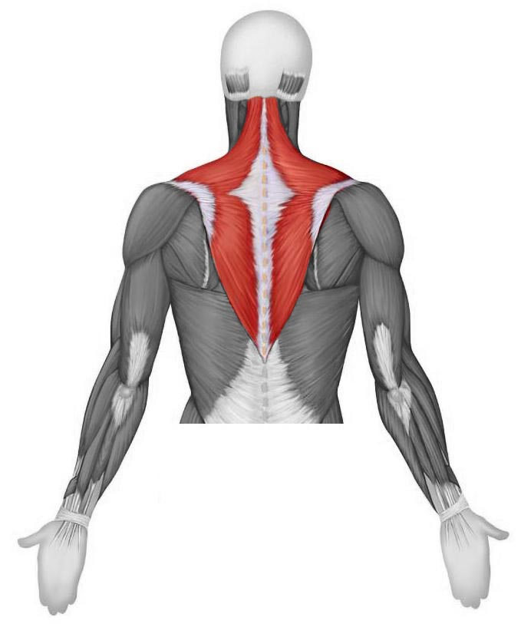

1. What are the names of the protein fibers within the muscle cell that are responsible for muscle contraction? They are sometimes referred to as **thick** and **thin** fibers, and they take part   
   in the **sliding filament** process for muscle contraction. **Name both proteins.**

**Station Two**

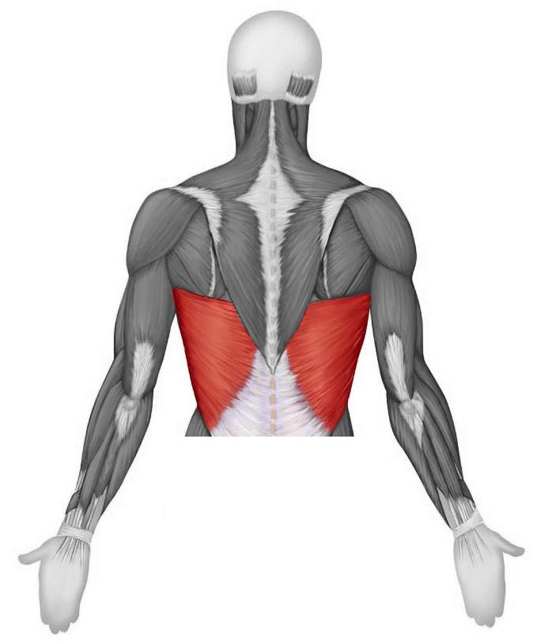

1. Identify this muscle
   1. Trapezius
   2. Triquetrum
   3. Latissimus Dorsi
   4. Longissimus
   5. Rhomboid major
2. What are the names of the protein fibers within the muscle cell that are responsible for muscle contraction? They are sometimes referred to as **thick** and **thin** fibers, and they take part in the **sliding filament** process for muscle contraction. Name both proteins.

**Station Two**

1. Identify this muscle:
   1. Supraspinatus
   2. Biceps brachii
   3. Deltoid
   4. Triceps brachii
   5. Sartorius

1. What are the names of the protein fibers within the muscle cell that are responsible for muscle contraction? They are sometimes referred to as **thick** and **thin** fibers, and they take part in the **sliding filament** process for muscle contraction. Name both proteins.

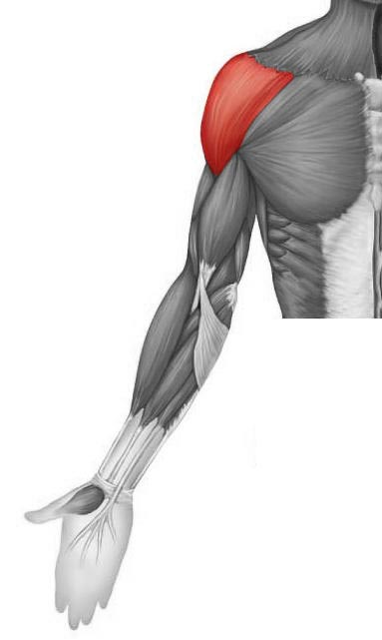

**Station Three**

1. Identify this bone
   1. Atlas (C1)
   2. Axis (C2)
   3. Cervical Vertebra
   4. Thoracic Vertebra
   5. Lumbar Vertebra
2. Identify the feature of the bone indicated by the marker
   1. Spinous process
   2. Anterior turbercle
   3. Transverse foramina
   4. Dens
   5. Body

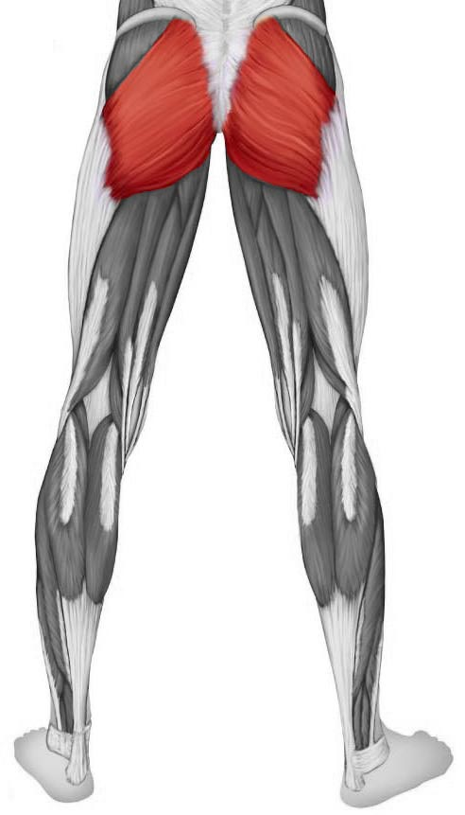**Station Four**

1. This muscle is responsible for thigh extension  
   Which muscle is it?
   1. Gluteus Maximus
   2. Gluteus Medius
   3. Gluteus Minimus
   4. Obdurator
   5. Adductor Magnus

**Station Four**

6. This muscle is 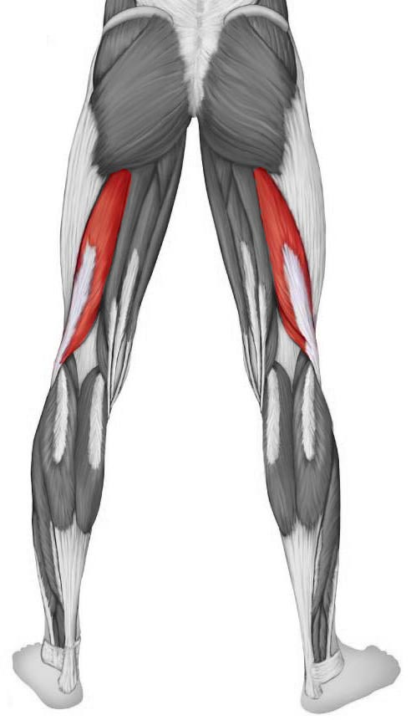responsible for flexion at the knee. What is it.

1. Adductor Magnus
2. Biceps femoris
3. Femoris longus
4. Rectus femoris
5. Vastus Minimi

**Station Four**

6. This muscle is responsible for plantarflexion. What is it?

1. Soleus
2. Gastrocnemius
3. Fibularis Longus
4. Tibialis Posterior
5. Semitendinosus

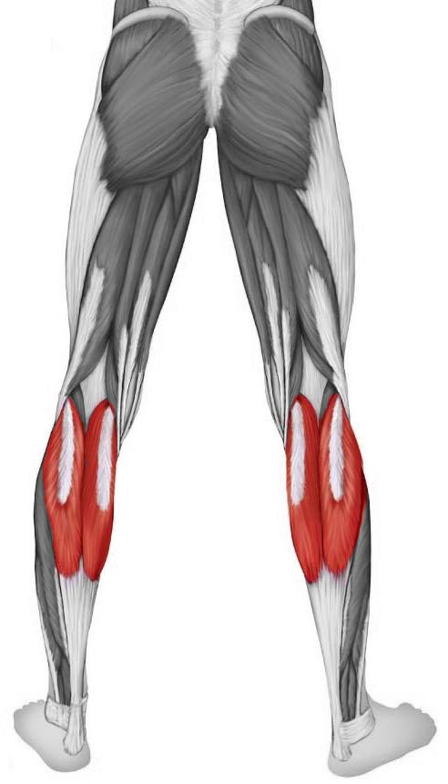

**Station Five**

1. **Microscope**: Identify the tissue present in the field of view
2. What is true of the tissue type in the field of view for #7?
   1. The cells are unusually long
   2. The cells are multinucleate
   3. The cells lack striations
   4. The cells have a “y” shaped appearance
   5. The cells have intercalated discs

**Station Five**

1. **Microscope**: Identify the tissue present in the field of view
2. What are the structures present (in the tissue from #7) that allow a rapid communication between cells?
   1. Desmosomes
   2. Tight junctions
   3. Sarcomeres
   4. Calveoli
   5. Intercalated discs

**Station Five**

1. **Microscope**: Identify the tissue present in the field of view
2. What is true of the tissue type in the field of view for #7?
   1. The cells are uninuclete
   2. The cells are short and tapered
   3. The cells are striated
   4. The cells generate their own impulses to contract
   5. The cells have intercalated discs for rapid communication

**Station Six**

1. 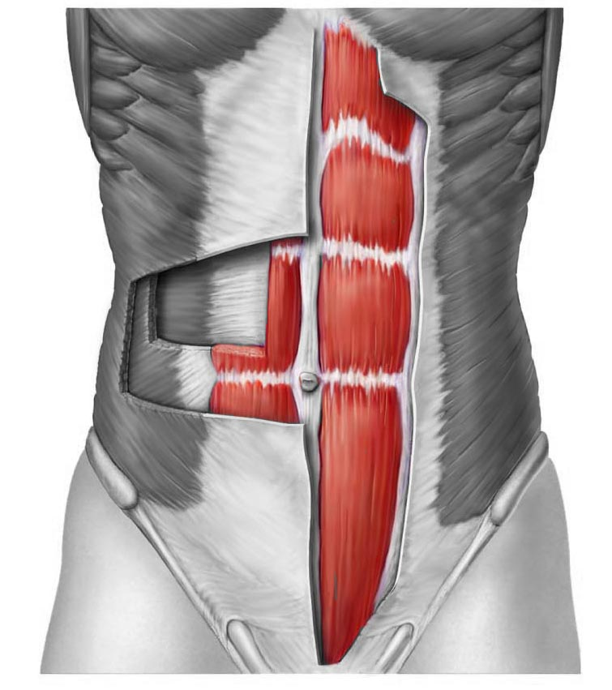 Identify the muscle
   1. Rectus abdominus muscle
   2. Transversus abdominus muscle
   3. External oblique muscle
   4. Internal oblique muscle
   5. Soleus muscle
2. What type of motion can we expect   
   to see with a contraction of this muscle?
   1. Flexion of the spine
   2. Dorsiflexion
   3. Circumduction
   4. Adduction
   5. Extension of the thigh

**Station Six**

1. Identify the muscle
   1. Rectus abdominus muscle
   2. Transversus abdominus muscle
   3. External oblique muscle
   4. Internal oblique muscle
   5. Soleus muscle

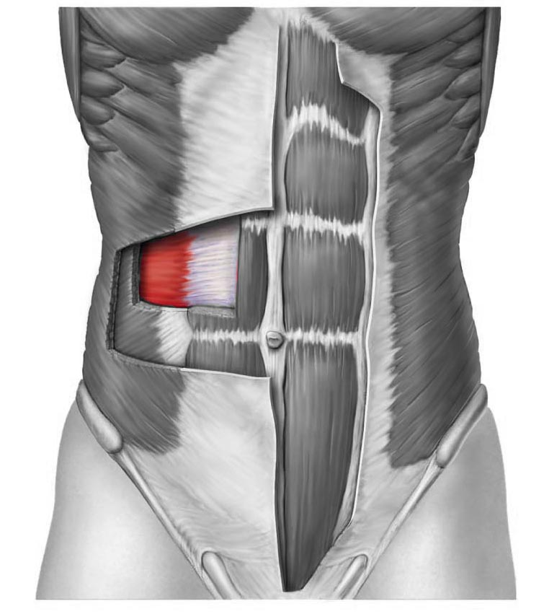

1. What type of motion can we expect   
   to see with a contraction of this muscle?
   1. Increased abdominal pressure
   2. Plantarflexion
   3. circumduction
   4. Adduction
   5. Opposition

**Station Seven**

1. Identify this bone
2. Which feature is marked?
   1. Epicondyle
   2. Head
   3. Greater Trochanter
   4. Fovea Capitis
   5. Tibial tuberosity

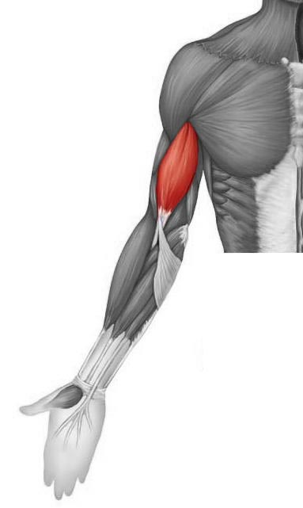**Station Eight**

1. Identify this muscle
2. What is the function/action of this muscle?
   1. Extension at the elbow
   2. Flexion at the elbow
   3. Flexion of the shoulder
   4. Abduction of the elbow
   5. Circumduction

**Station Eight**

13. Identify this muscle

14. What is the function/action of this muscle?

* 1. Extension at the elbow
  2. Flexion at the elbow
  3. Flexion of the shoulder
  4. Abduction of the elbow
  5. Circumduction

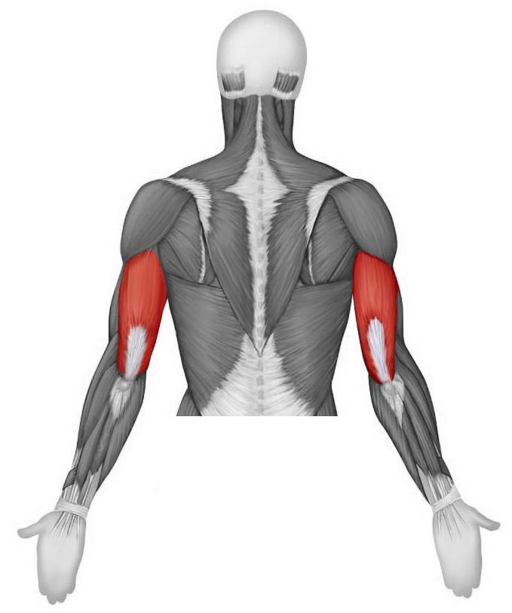

**Station Nine**

1. Microscope: Identify the tissue type
2. Which region of the spine will have a vertebra that has **costal facets (demifacets)**?
   1. Cervical
   2. Thoracic
   3. Lumbar
   4. Sacral
   5. Coccygeal

**Station Ten**

1. Identify this bone
2. Identify the structure at the marker
   1. Glenoid fossa
   2. Spine
   3. Infraspinous fossa
   4. Acromion
   5. Coracoid Process

**Station Eleven**

1. Which region is this vertebrae from
2. Which area would have a motor unit with hundreds of nerve fibers attaching to muscles?
   1. Low back muscles
   2. Fingers
   3. Eyes
   4. Heart
   5. Small intestine

**Station Twelve**

1. Identify this muscle
2. What is the superior-most point of the sternum?
   1. Styloid process
   2. Manubrium
   3. Body
   4. Sternal spine
   5. Xiphoid process

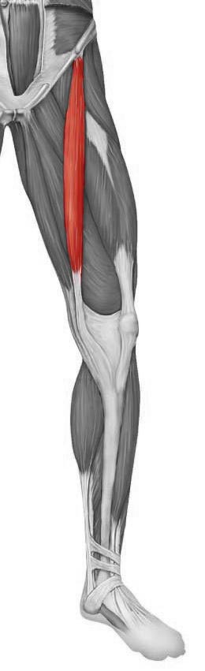

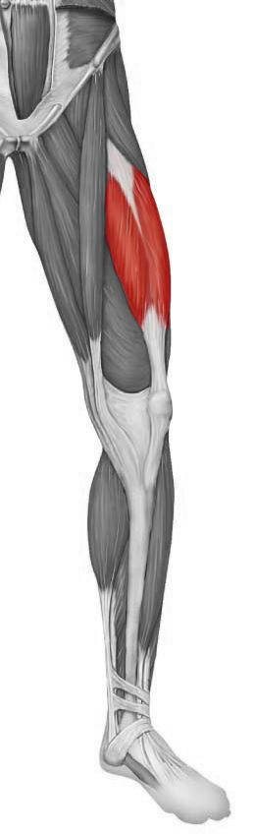**Station Twelve**

1. Identify this muscle
2. What is the inferior-most point of the sternum?
   1. Styloid process
   2. Manubrium
   3. Body
   4. Sternal spine
   5. Xiphoid process

**Station Thirteen**

1. Identify this bone
2. Identify the structure indicated by the marker

**Station Fourteen**

1. Identify the structure indicated by the marker
   1. First metatarsal
   2. Fifth metatarsal
   3. Calcaneus
   4. First proximal phalange
   5. Fifth distal phalange

Name________________________________

1. Bone: ___________________________________________
2. Circle one: a b c d e
3. _________________________________________________
4. Circle one: a b c d e
5. Circle one: a b c d e
6. Circle one: a b c d e
7. ________________________________________________
8. Circle one: a b c d e
9. Circle one: a b c d e
10. Circle one: a b c d e
11. ­­­­­­­­­­­­­­­ Bone: __________________________________________
12. Circle one: a b c d e
13. _______________________________________________
14. Circle one: a b c d e
15. _______________________________________________
16. Circle one: a b c d e
17. Bone: __________________________________________
18. Circle one: a b c d e
19. _______________________________________________
20. Circle one: a b c d e
21. ________________________________________________
22. Circle one: a b c d e
23. Bone: ___________________________________________
24. ________________________________________________
25. Circle one: a b c d e