Instructor Set-up:

**Station One:**

**Bone: Tibia**

**Station Two:**

Trapezius muscle image (provided)

Question: Actin/myosin

**Station Three**

**Bone: 1st Cervical vertebrae**

Identify bone

**Marker:** transverse foramina

**Station Four**

Pectoralis major

**Station five:**

**Microscope: Smooth muscle tissue**

**Station six:**

Deltoid (provided)

**Station seven**

Bone: Radius

Marker: Head of radius

**Station eight**

Biceps brachii (provided)

**Station nine**

**Microscope**: Skeletal muscle

**Station ten:**

**Bone: Humerus**

**Station Eleven:**

**Bone: thoracic vertebrae**

**Station Twelve**

Rectus femoris (provided)

**Station Thirteen**

**Bone: patella**,

**Station Fourteen**

Marker: Ischial tuberosity

TA Answer key

1. (c) Lat. dorsi
2. Actin and myosin (must have both for full credit. No partial credit for a partial response.)
3. C2 or Axis
4. (c) odontoid process
5. SCM or sternocleidomastoid (be forgiving on the spelling)
6. Cardiac muscle
7. (e) intercalated discs
8. (a) gastrocs
9. (c) plantarflexion
10. Fibula
11. (d) lateral malleolus
12. Triceps brachii (just triceps is fine)
13. (a) elbow extension with a weighted object
14. Smooth muscle
15. (a) cervical
16. Femur
17. (d) acetabulum
18. Lumbar region
19. Spine, or scapular spine
20. Sartorius muscle
21. (e) xiphoid process
22. Sacrum
23. Anterior
24. (a) trochlea

**Station One:**

1. Identify this bone

**Station Two**

1. Identify this muscle
   1. Trapezius
   2. Triquetrum
   3. Latissimus Dorsi
   4. Longissimus
   5. Rhomboid major

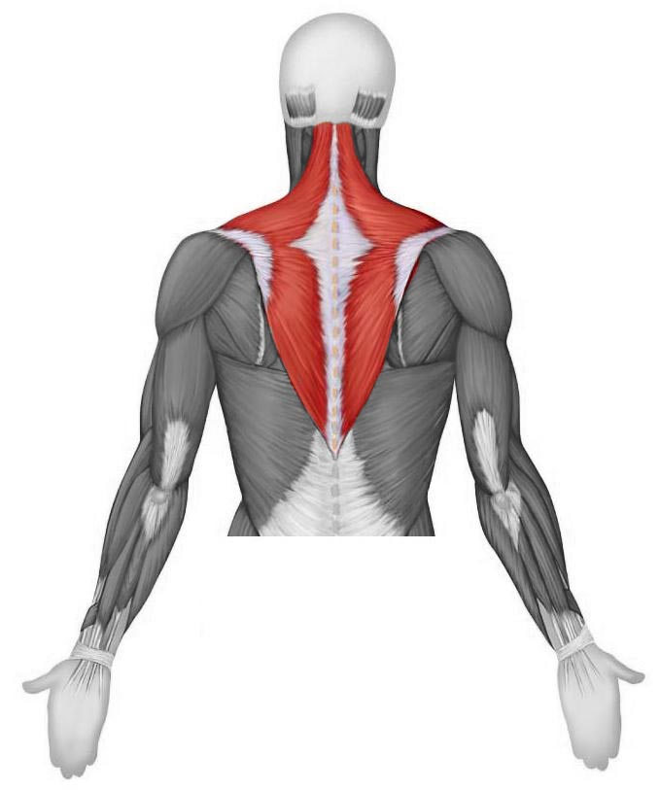

1. What are the names of the protein fibers   
   within the muscle cell that are   
   responsible for muscle contraction?   
   They are sometimes referred to as   
   thick and thin fibers, and they take part   
   in the sliding filament process   
   for muscle contraction. Name both proteins.

**Station Three**

1. Identify this bone
2. Identify this feature of the bone
   1. Spinous process
   2. Anterior turbercle
   3. Transverse foramina
   4. Articulating facet
   5. Pedicle

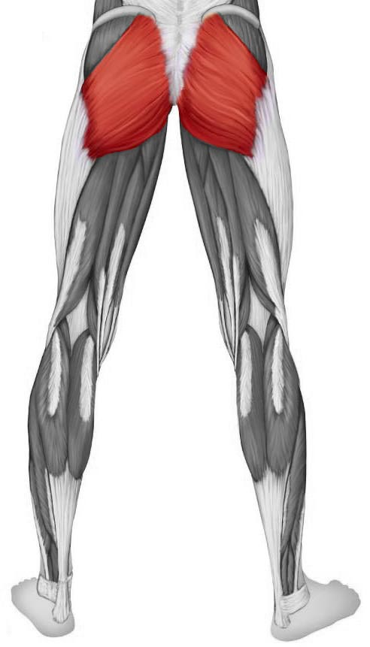**Station Four**

1. This muscle is responsible for thigh extension  
   Which muscle is it?

**Station Five**

1. **Microscope**: Identify the tissue present in the field of view
2. What are the structures present (in the tissue from #7) that allow a rapid communication between cells?
   1. Desmosomes
   2. Tight junctions
   3. Sarcomeres
   4. Calveoli
   5. Intercalated discs

**Station Six**

1. 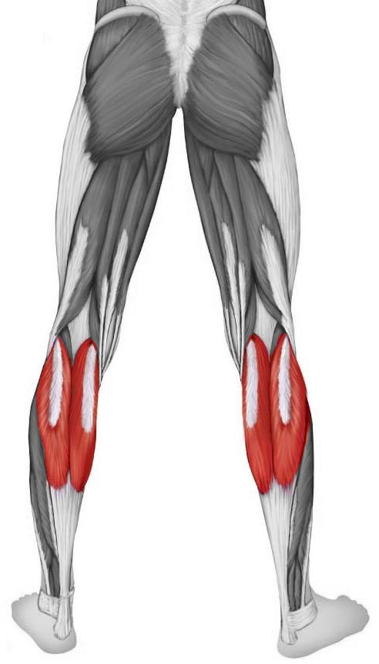 Identify the muscle
   1. Gastrocnemius muscle
   2. Peronei brevis muscle
   3. Fibularis longus muscle
   4. Posterior tibialis muscle
   5. Soleus muscle
2. What type of motion can we expect   
   to see with a contraction of this muscle?
   1. Eversion of the foot
   2. Flexion at the knee
   3. Plantarflexion
   4. Dorsiflexion
   5. Protraction

**Station Seven**

1. Identify this bone
2. Which feature is marked?
   1. Olecranon process
   2. Radial head
   3. Styloid process of ulna
   4. Lateral malleolus
   5. Tibial tuberosity

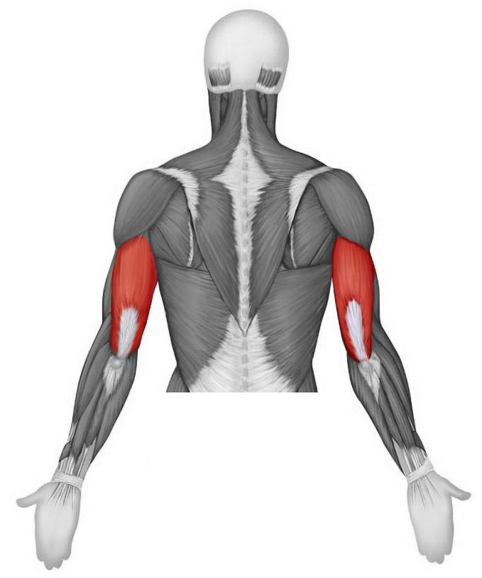**Station Eight**

1. Identify this muscle
2. When would this muscle (from #13)  
   demonstrate a **concentric** contraction?
   1. Elbow extension while holding a weighted object
   2. Arm abduction while holding a weighted object
   3. Elbow flexion while holding a weighted object
   4. Circumduction at the shoulder while holding a weighted object
   5. Attempted elbow flexion with a weight that is too heavy to lift

**Station Nine**

1. Microscope: Identify the tissue type
2. Which region of the spine will have a vertebra that has a bifid spinous process, as well as transverse processes with foramen?
   1. Cervical
   2. Thoracic
   3. Lumbar
   4. Sacral
   5. Coccygeal

**Station Ten**

1. Identify this bone
2. Into which part of the coxae would this bone articulate?
   1. Iliac crest
   2. Obdurator foramen
   3. Anterior superior iliac spine
   4. acetabulum
   5. this bone does not articulate with the coxae

**Station Eleven**

1. Which region is this vertebrae from
2. Which feature of the scapula divides the posterior aspect into superior and inferior portions?

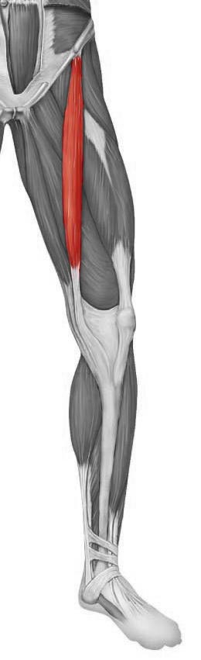**Station Twelve**

1. Identify this muscle
2. What is the inferior-most point of the sternum?
   1. Styloid process
   2. Manubrium
   3. Body
   4. Sternal spine
   5. Xiphoid process

**Station Thirteen**

1. Identify this bone
2. Is this the anterior or posterior surface?

**Station Fourteen**

1. Identify the structure
   1. Trochlea
   2. Capitulum
   3. Styloid process
   4. Glenoid fossa
   5. Medial epicondyle

Name________________________________

1. Bone: ___________________________________________
2. Circle one: a b c d e
3. _________________________________________________
4. _________________________________________________
5. Circle one: a b c d e
6. ________________________________________________
7. ________________________________________________
8. Circle one: a b c d e
9. Circle one: a b c d e
10. Circle one: a b c d e
11. ­­­­­­­­­­­­­­­ Bone: __________________________________________
12. Circle one: a b c d e
13. _______________________________________________
14. Circle one: a b c d e
15. _______________________________________________
16. Circle one: a b c d e
17. Bone: __________________________________________
18. Circle one: a b c d e
19. _______________________________________________
20. ________________________________________________
21. ________________________________________________
22. Circle one: a b c d e
23. Bone: ___________________________________________
24. ________________________________________________
25. Circle one: a b c d e

**Station Five**

1. **Microscope**: Identify the tissue present in the field of view

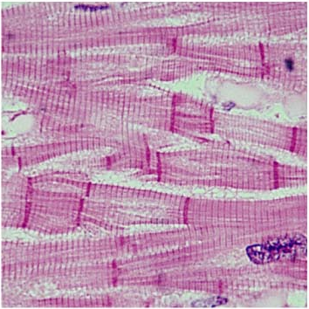

1. What are the structures present (in the tissue from #7) that allow a rapid communication between cells?
   1. Desmosomes
   2. Tight junctions
   3. Sarcomeres
   4. Calveoli
   5. Intercalated discs

**Station Nine**

1. Microscope: Identify the tissue type

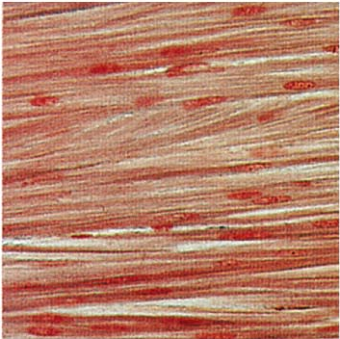

1. Which region of the spine will have a vertebra that has a bifid spinous process, as well as transverse processes with foramen?
   1. Cervical
   2. Thoracic
   3. Lumbar
   4. Sacral
   5. Coccygeal