Instructor Set-up:

**Station One:**

**Bone: radius**

**Station Two:**

Gluteus maximus muscle image (provided)

Question: Actin/myosin

**Station Three**

**Bone: 2nd Cervical vertebrae**

Identify bone

**Marker:** odontoid process/dens

**Station Four**

Platysma muscle image (provided)

**Station five:**

**Microscope: Cardiac tissue slide**

**Station six:**

Gastroc muscle image (provided)

**Station seven**

Bone: fibula

Marker: lateral malleolus

**Station eight**

Triceps brachii image (provided)

**Station nine**

**Microscope**: Smooth muscle

Station ten:

Station Eleven:

Station Twelve

Station Thirteen

Station Fourteen

Station Fifteen

Station Sixteen

TA Answer key

1. Radius
2. (b) Gluteus maximus muscle
3. Actin and myosin (must have both for full credit. No partial credit for a partial response.)
4. C2 or Axis
5. (c) odontoid process
6. (d) platysma muscle
7. Cardiac muscle
8. (e) intercalated discs
9. (a) gastrocs
10. (c) plantarflexion
11. Fibula
12. (d) lateral malleolus
13. Triceps brachii (just triceps is fine)
14. (a) elbow extension with a weighted object
15. Smooth muscle
16. (b) thoracic
17. Femur
18. (e) rectus femoris

Station One:

1. Identify this bone

Station Two

1. Identify this muscle
   1. 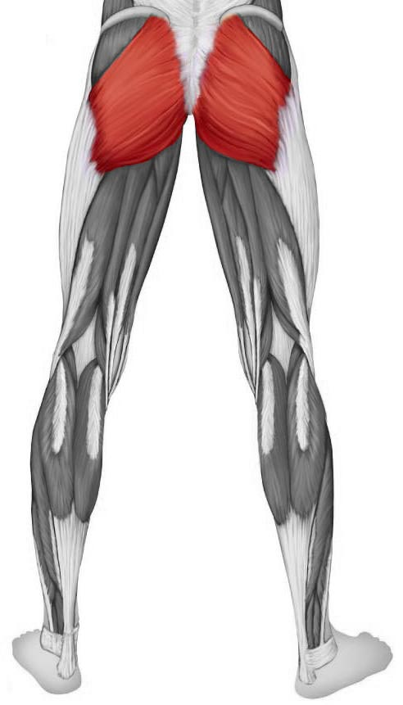Rectus femoris muscle
   2. Gluteus maximus muscle
   3. Biceps femoris muscle
   4. Gluteus minimus muscle
   5. Adductor magnus muscle
2. What are the names of the protein fibers  
   that are responsible for muscle contraction?   
   They are sometimes referred to as   
   thick and thin fibers, and they take part   
   in the sliding filament process   
   for muscle contraction.

Station Three

1. Identify this bone
2. Identify this feature of the bone
   1. Spinous process
   2. Transverse process
   3. Odontoid process
   4. Superficial process
   5. Pedicle

Station Four

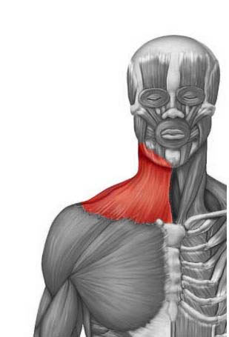

1. Identify this muscle
   1. Sternocleidomastoid muscle
   2. Pectoralis major muscle
   3. Deltoid muscle
   4. Platysma muscle
   5. Anterior scalene muscle

Station Five

1. **Microscope**: Identify the tissue present in the field of view
2. What are the structures present that allow a rapid communication between cells?
   1. Desmosomes
   2. Tight junctions
   3. Sarcomeres
   4. Calveoli
   5. Intercalated discs

Station Six

1. 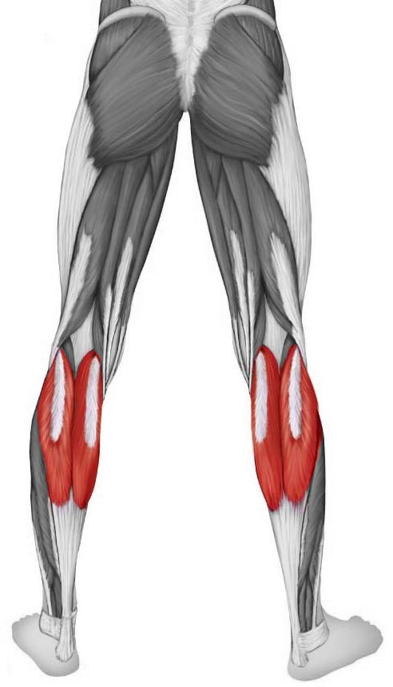 Identify the muscle
   1. Gastrocnemius muscle
   2. Peronei brevis muscle
   3. Fibularis longus muscle
   4. Posterior tibialis muscle
   5. Soleus muscle
2. What type of motion can we expect   
   to see with a contraction of this muscle?
   1. Eversion of the foot
   2. Flexion at the knee
   3. Plantarflexion
   4. Dorsiflexion
   5. Protraction

Station Seven

1. Identify this bone
2. Which feature is marked?
   1. Olecranon process
   2. Radial head
   3. Styloid process of ulna
   4. Lateral malleolus
   5. Tibial tuberosity

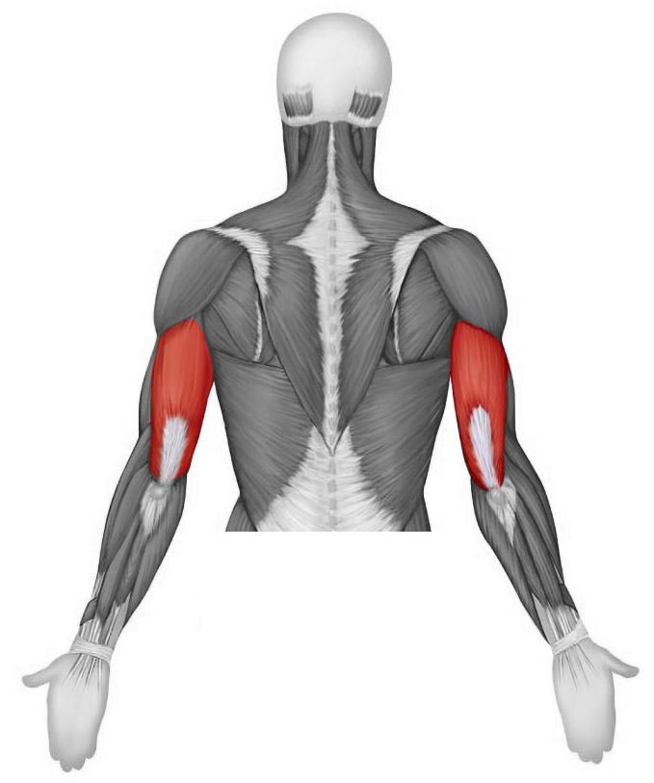Station Eight

1. Identify this muscle
2. When would this muscle   
   demonstrate a **concentric** contraction?
   1. Elbow extension while holding a weighted object
   2. Arm abduction while holding a weighted object
   3. Elbow flexion while holding a weighted object
   4. Circumduction at the shoulder while holding a weighted object
   5. Attempted elbow flexion with a weight that is too heavy to lift

Station Nine

1. Microscope: Identify the tissue type
2. Which region of the spine will have a vertebra that has a lengthy spinous process that points sharply inferiorly?
   1. Cervical
   2. Thoracic
   3. Lumbar
   4. Sacral
   5. Coccygeal

Station Ten

1. Identify this bone
2. Which muscle would be found along the anterior aspect of this bone?
   1. Semitendinosus
   2. Biceps brachii
   3. Biceps femoris
   4. Soleus
   5. Rectus femoris

Station Eleven

1. Which region is this vertebrae from

Station Twelve

Station Thirteen

Station Fourteen

Station Fifteen

Station Sixteen