Instructor Set-up:

**Station One:**

**Bone: ulna**

**Station Two:**

Lat. Dorsi muscle image (provided)

Question: Actin/myosin

**Station Three**

**Bone: 2nd Cervical vertebrae**

Identify bone

**Marker:** odontoid process/dens

**Station Four**

SCM (image provided)

**Station five:**

**Microscope: Cardiac tissue slide**

**Station six:**

Gastroc muscle image (provided)

**Station seven**

Bone: fibula

Marker: lateral malleolus

**Station eight**

Triceps brachii image (provided)

**Station nine**

**Microscope**: Smooth muscle

**Station ten:**

**Bone: femur**

**Station Eleven:**

**Bone: lumbar vertebrae**

**Station Twelve**

Sartorius muscle image (provided)

**Station Thirteen**

**Bone: sacrum**, marker on anterior surface

**Station Fourteen**

Marker: trochlea of humerus

TA Answer key

1. Ulna
2. (c) Lat. dorsi
3. Actin and myosin (must have both for full credit. No partial credit for a partial response.)
4. C2 or Axis
5. (c) odontoid process
6. SCM or sternocleidomastoid (be forgiving on the spelling)
7. Cardiac muscle
8. (e) intercalated discs
9. (a) gastrocs
10. (c) plantarflexion
11. Fibula
12. (d) lateral malleolus
13. Triceps brachii (just triceps is fine)
14. (a) elbow extension with a weighted object
15. Smooth muscle
16. (a) cervical
17. Femur
18. (d) acetabulum
19. Lumbar region
20. Spine, or scapular spine
21. Sartorius muscle
22. (e) xiphoid process
23. Sacrum
24. Anterior
25. (a) trochlea

**Station One:**

1. Identify this bone

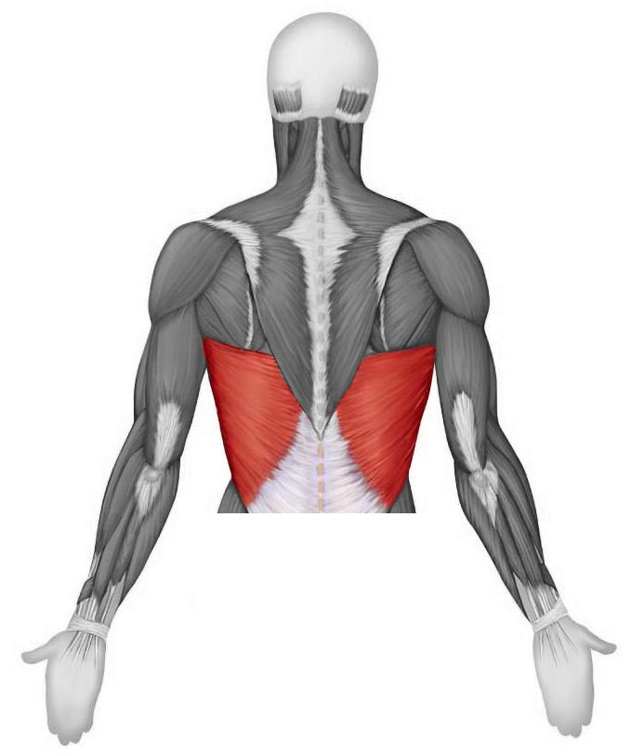**Station Two**

1. Identify this muscle
   1. Trapezius
   2. Triquetrum
   3. Latissimus Dorsi
   4. Longissimus
   5. Rhomboid major
2. What are the names of the protein fibers   
   within the muscle cell that are   
   responsible for muscle contraction?   
   They are sometimes referred to as   
   thick and thin fibers, and they take part   
   in the sliding filament process   
   for muscle contraction. Name both proteins.

**Station Three**

1. Identify this bone
2. Identify this feature of the bone
   1. Spinous process
   2. Transverse process
   3. Odontoid process
   4. Superficial process
   5. Pedicle

**Station Four**

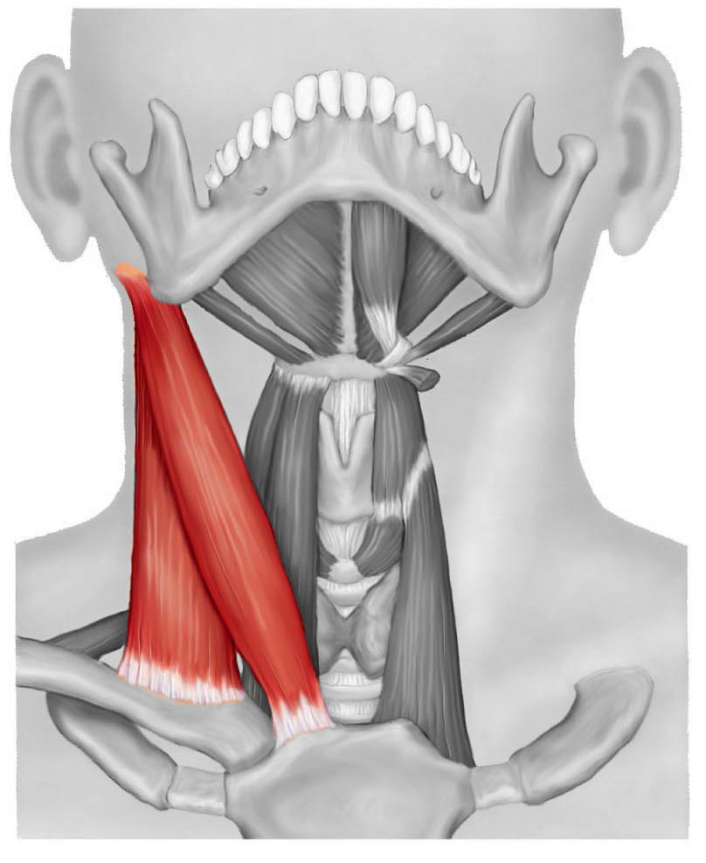

1. This muscle has an insertion on the   
   mastoid process, and the origins on the   
   clavicle and manubrium.   
   Which muscle is it?

**Station Five**

1. **Microscope**: Identify the tissue present in the field of view
2. What are the structures present (in the tissue from #7) that allow a rapid communication between cells?
   1. Desmosomes
   2. Tight junctions
   3. Sarcomeres
   4. Calveoli
   5. Intercalated discs

**Station Six**

1. 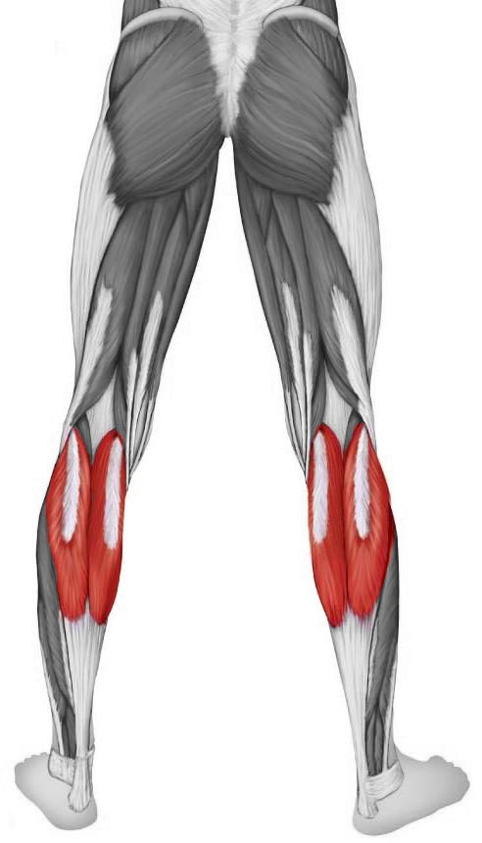 Identify the muscle
   1. Gastrocnemius muscle
   2. Peronei brevis muscle
   3. Fibularis longus muscle
   4. Posterior tibialis muscle
   5. Soleus muscle
2. What type of motion can we expect   
   to see with a contraction of this muscle?
   1. Eversion of the foot
   2. Flexion at the knee
   3. Plantarflexion
   4. Dorsiflexion
   5. Protraction

**Station Seven**

1. Identify this bone
2. Which feature is marked?
   1. Olecranon process
   2. Radial head
   3. Styloid process of ulna
   4. Lateral malleolus
   5. Tibial tuberosity

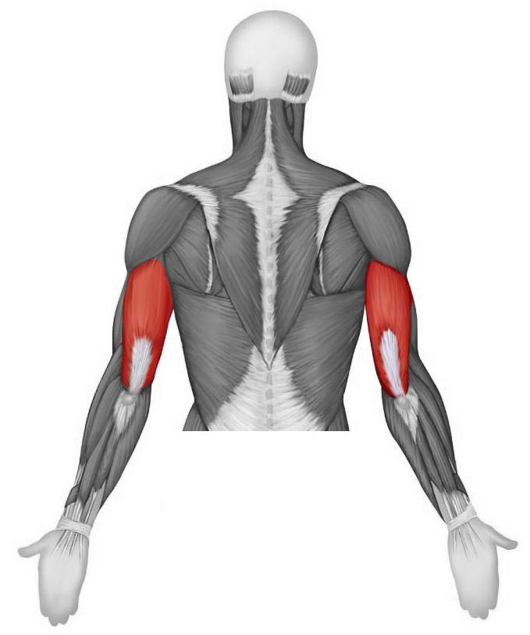**Station Eight**

1. Identify this muscle
2. When would this muscle (from #13)  
   demonstrate a **concentric** contraction?
   1. Elbow extension while holding a weighted object
   2. Arm abduction while holding a weighted object
   3. Elbow flexion while holding a weighted object
   4. Circumduction at the shoulder while holding a weighted object
   5. Attempted elbow flexion with a weight that is too heavy to lift

**Station Nine**

1. Microscope: Identify the tissue type
2. Which region of the spine will have a vertebra that has a bifid spinous process, as well as transverse processes with foramen?
   1. Cervical
   2. Thoracic
   3. Lumbar
   4. Sacral
   5. Coccygeal

**Station Ten**

1. Identify this bone
2. Into which part of the coxae would this bone articulate?
   1. Iliac crest
   2. Obdurator foramen
   3. Anterior superior iliac spine
   4. acetabulum
   5. this bone does not articulate with the coxae

**Station Eleven**

1. Which region is this vertebrae from
2. Which feature of the scapula divides the posterior aspect into superior and inferior portions?

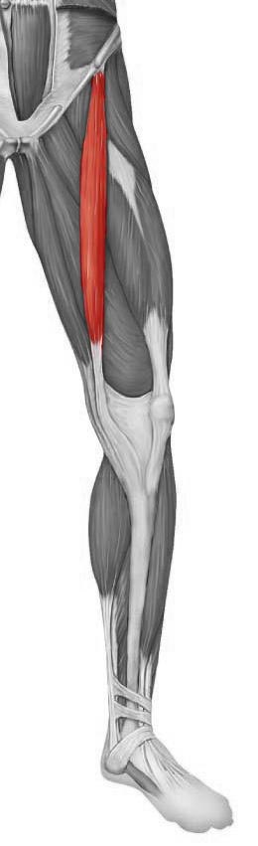**Station Twelve**

1. Identify this muscle
2. What is the inferior-most point of the sternum?
   1. Styloid process
   2. Manubrium
   3. Body
   4. Sternal spine
   5. Xiphoid process

**Station Thirteen**

1. Identify this bone
2. Is this the anterior or posterior surface?

**Station Fourteen**

1. Identify the structure
   1. Trochlea
   2. Capitulum
   3. Styloid process
   4. Glenoid fossa
   5. Medial epicondyle

Name________________________________

1. Bone: ___________________________________________
2. Circle one: a b c d e
3. _________________________________________________
4. _________________________________________________
5. Circle one: a b c d e
6. ________________________________________________
7. ________________________________________________
8. Circle one: a b c d e
9. Circle one: a b c d e
10. Circle one: a b c d e
11. ­­­­­­­­­­­­­­­ Bone: __________________________________________
12. Circle one: a b c d e
13. _______________________________________________
14. Circle one: a b c d e
15. _______________________________________________
16. Circle one: a b c d e
17. Bone: __________________________________________
18. Circle one: a b c d e
19. _______________________________________________
20. ________________________________________________
21. ________________________________________________
22. Circle one: a b c d e
23. Bone: ___________________________________________
24. ________________________________________________
25. Circle one: a b c d e

**Station Five**

1. **Microscope**: Identify the tissue present in the field of view

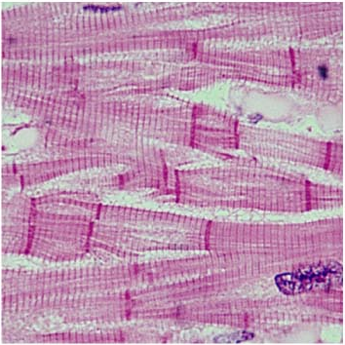

1. What are the structures present (in the tissue from #7) that allow a rapid communication between cells?
   1. Desmosomes
   2. Tight junctions
   3. Sarcomeres
   4. Calveoli
   5. Intercalated discs

**Station Nine**

1. Microscope: Identify the tissue type

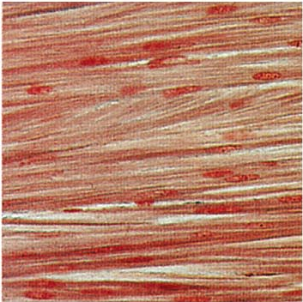

1. Which region of the spine will have a vertebra that has a bifid spinous process, as well as transverse processes with foramen?
   1. Cervical
   2. Thoracic
   3. Lumbar
   4. Sacral
   5. Coccygeal