Station One

* 1. Identify the tissue in the field of view

Description: This tissue has round, centrally located nuclei. It is commonly found in areas for secretion and absorption. This tissue type can be found in the kidneys

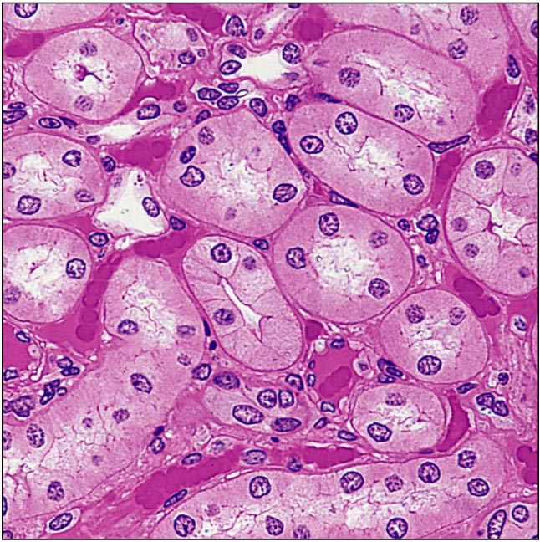

Station Two

* 1. Identify the tissue in the field of view

Description: This tissue’s arrangement allows for it to stretch. It can be found in the ureters

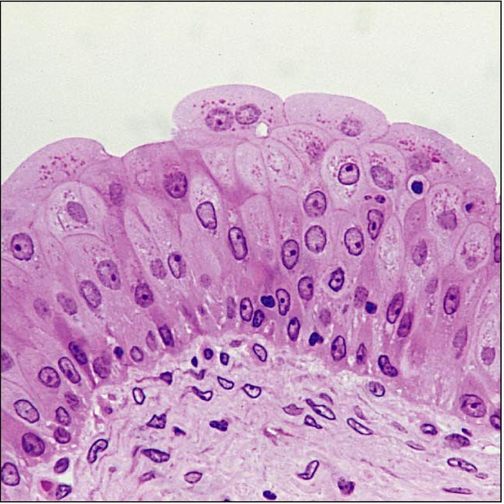

Station Three

* 1. Identify the tissue in the field of view

Description: This tissue can be found in the ear and epiglottis

1. Hyaline cartilage
2. Transitional epithelium
3. Dense irregular connective tissue
4. Elastic cartilage
5. 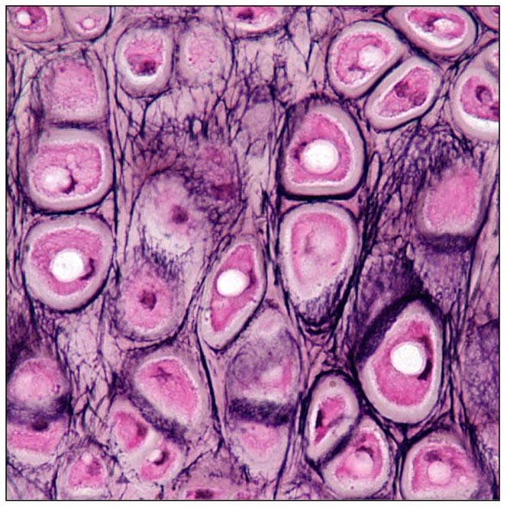 Fibrocartilage

Station Five

* 1. Identify the stage of mitosis seen on the slide

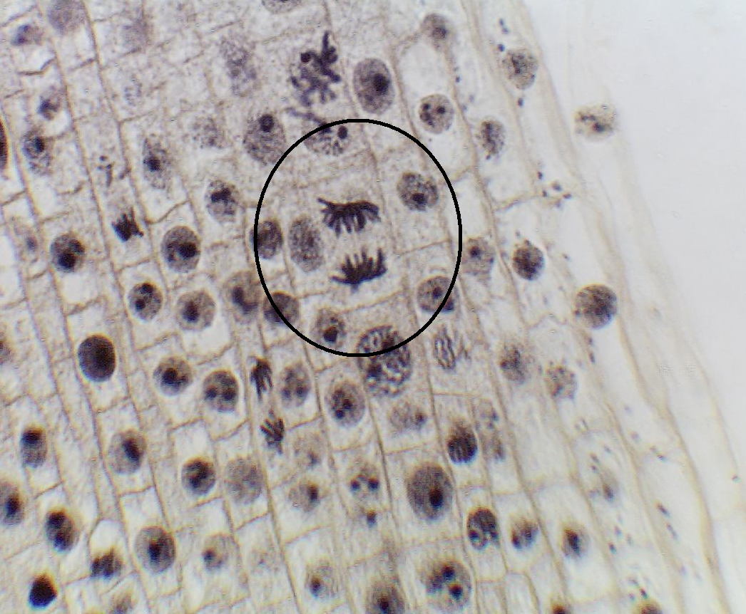

Station Six:

* 1. Identify the stage of mitosis seen on the slide

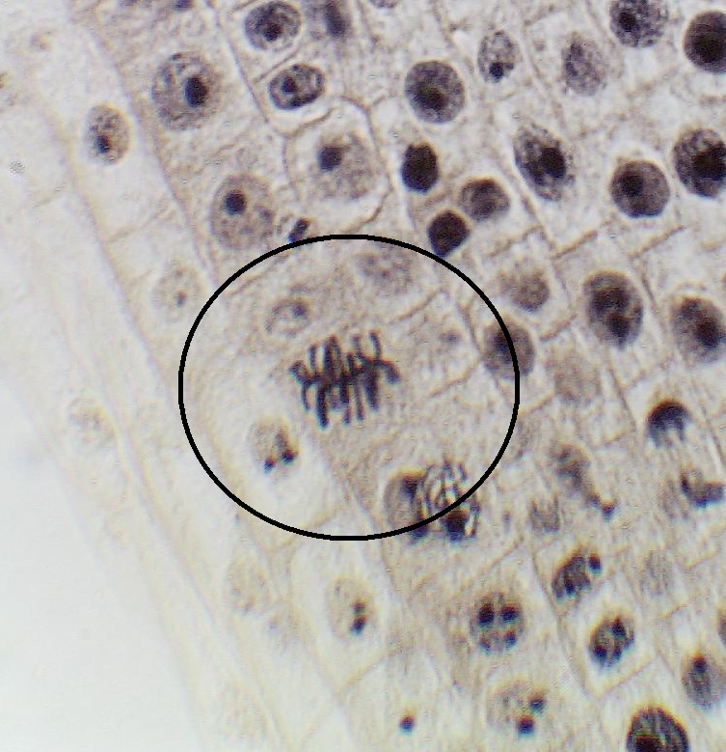

Station Seven

* 1. Identify the tissue in the field of view

Description: This tissue contains a protein called keratin to help prevent abrasions

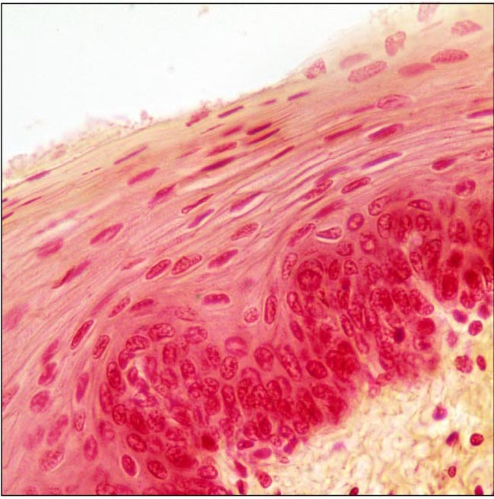

Station Fifteen

1. Identify the tissue in the field of view
2. What is the name of the structure located in the middle of each unit which allows for blood vessels to pass through?

