Quiz Three: Instructor Set-Up

Station One: Image: pons

Station Two: brain, marker indicating longitudinal fissure

Station three: brain, marker indicating occipital lobe

Station Four: Image: choroid plexus

Station Five: brain, marker at optic chiasma

Station Six: brain, marker at pineal body

Station Seven: Image: dorsal root ganglion

Station Eight: brain, marker at corpus callosum

Station nine: image: perineurium

Station ten: questions

Station eleven: image: gray matter

Station twelve: image: dendrites

Station thirteen: microscope: pacinian corpuscle

Station fourteen: image: epidural space

Station fifteen: brain, marker at arbor vitae

Key:

1. (d) Pons
2. (a) longitudinal fissure
3. Occipital lobe
4. (c) retina and olfactory epithelium
5. Choroid plexus
6. Optic chiasma or optic chiasm
7. (b)Pineal body
8. Schwann Cell
9. Dorsal root ganglion
10. (c) unipolar neurons
11. Corpus callosum
12. Function: connects cerebral hemispheres
13. (a) perineurium
14. (e) oligodendrocyte
15. (b) Lumbar spine
16. (a) quadriceps muscle
17. (d) gray matter
18. (a) cell bodies
19. Dendrites
20. Dura mater, arachnoid mater, pia mater (Note: no partial credit. They need all three.) If they are close on spelling, give it to them. They don’t need the word “mater” for credit.
21. Pacinian corpuscle (again, if they are close with the spelling, give it to them)
22. (c) touch
23. (b) epidural space
24. (d) pituitary gland
25. Arbor vitae

Station One:

1. Identify the structure
2. Medulla oblongata
3. Hypothalamus
4. Thalamus
5. Pons
6. Pituitary gland

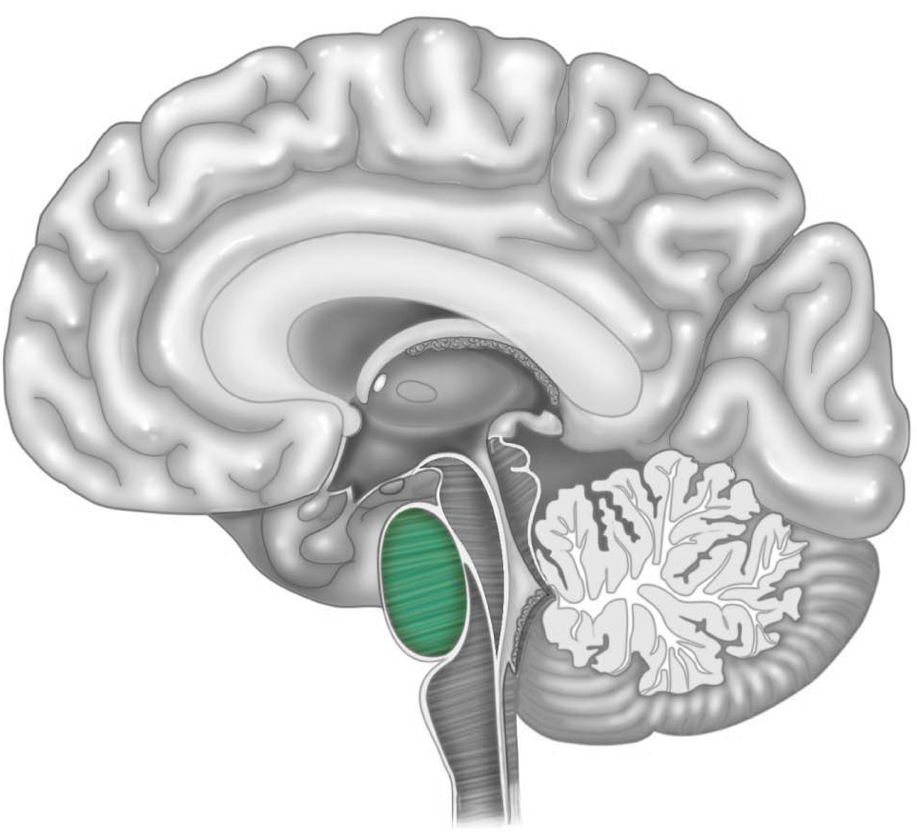

Station Two:

1. Identify the structure on the brain
2. Longitudinal fissure
3. Transverse fissure
4. Lateral fissure
5. Cerebral fissure
6. Cerebellar fissure

Station Three:

1. Indicate the lobe of the brain
2. Where do we commonly find bipolar neurons?
3. Insular lobe of the brain
4. Descending spinal cord
5. Retina and olfactory epithelium
6. Dorsal root ganglia
7. Gut-brain

Station Four

1. These structures are responsible for the production of cerebrospinal fluid. What are they?

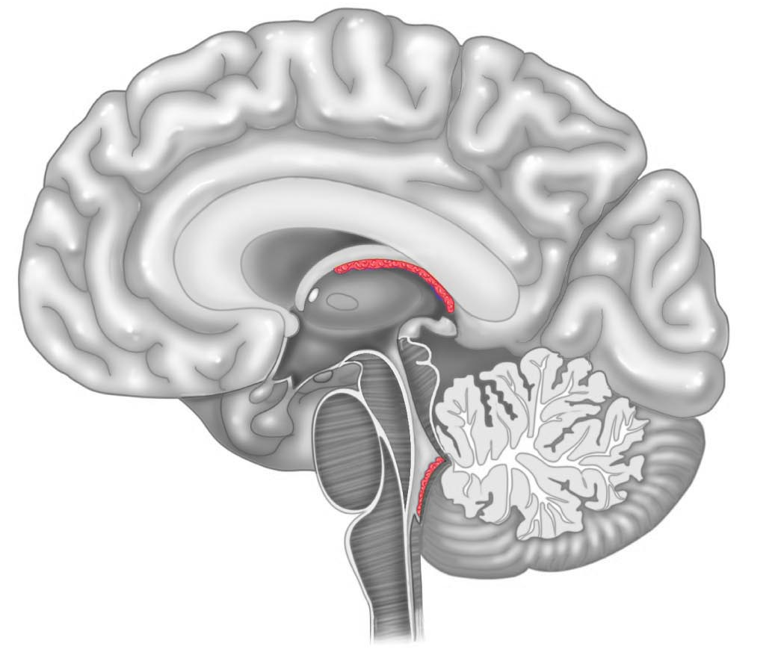

Station Five

1. Identify this structure on the brain

Station Six:

1. Identify the structure indicated
2. Pituitary gland
3. Pineal gland
4. Hypothalamus
5. Pons
6. Ganglion
7. Which type of cell is responsible for creating the myelin sheath in a peripheral nerve?

Station Seven

1. Identify the structure on the image

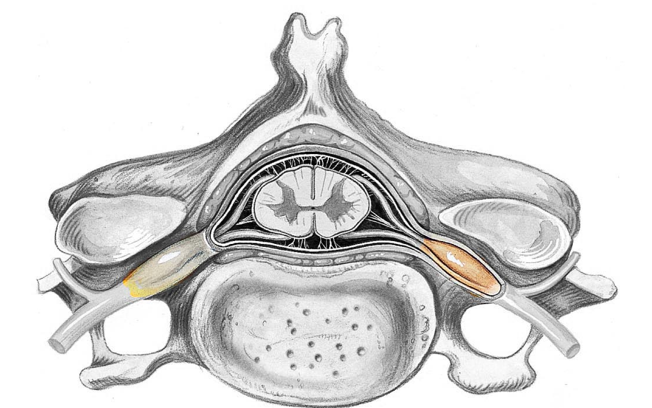

1. In the above structure, which type of neuron is associated with it?
2. Multipolar neuron
3. Bipolar neuron
4. Unipolar neuron
5. Motor neuron
6. Efferent neuron

Station Eight

1. Identify the structure on the brain
2. What is the function of the structure labeled above?

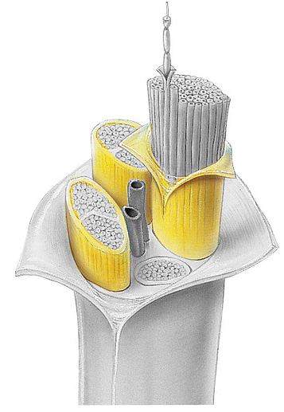Station Nine:

1. Identify the structure
2. Perineurium
3. Endoneurium
4. Epineurium
5. Endomysium
6. perimysium
7. Which cell in the central nervous system is responsible for the mylenation of axons?
   1. Schwann cell
   2. Astrocyte
   3. Ependymal cell
   4. Microglia
   5. Oligodendrocyte

Station Ten

1. The synapse in the patellar reflex (a monosynaptic reflex) takes place where?
   1. Sacral spine
   2. Lumbar spine
   3. Thoracic spine
   4. Cervical spine
   5. Cerebral cortex
2. In the patellar reflex, the motor (efferent) nerve fiber runs to which muscle/group as the effector (prime mover)?
   1. Quadriceps
   2. Hamstrings
   3. Iliopsoas
   4. Erector spinae
   5. Tibialis anterior

Station Eleven

1. What structure is represented in the image?
2. White matter
3. Red matter
4. Dura mater
5. Gray matter
6. Arachnoid mater

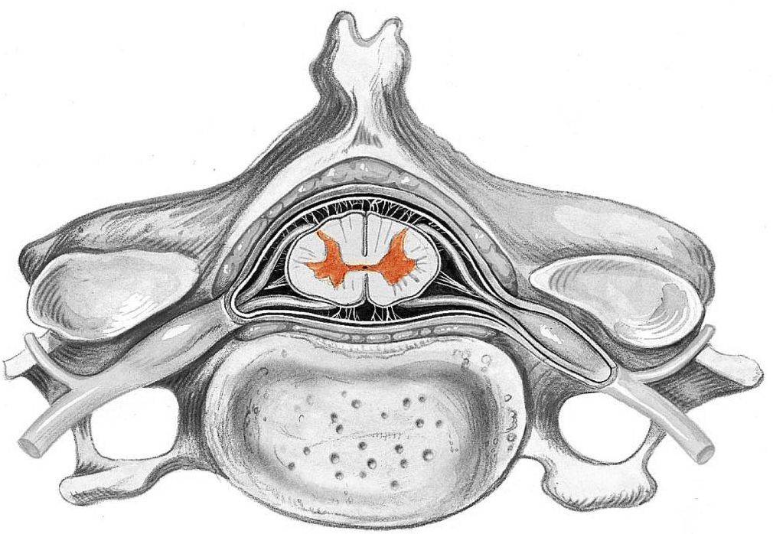

1. Of what material is this structure composed?
   1. Nerve cell bodies
   2. Dendrites only
   3. Mylenated fibers
   4. Ascending fibers
   5. Ependymal cells

Station Twelve

1. Identify the structure

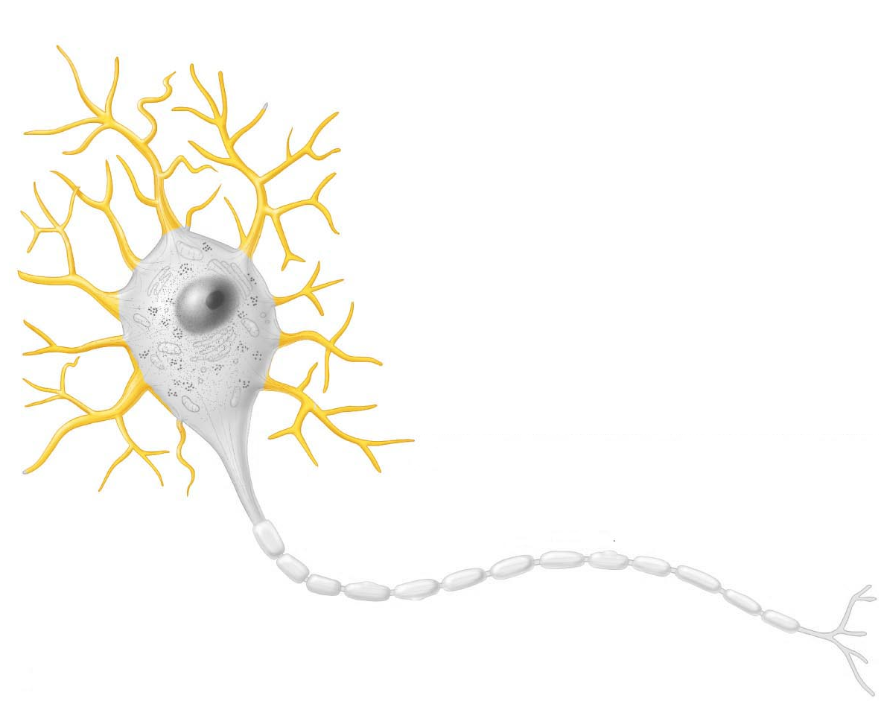

1. What are the three meningeal layers that surround the brain and spinal cord? List all three meninges for credit.

Station Thirteen

1. Identify the structure on the microscope’s field of view.
2. What is the function of this structure
   1. Receptor for sense of taste
   2. Receptor for sense of smell
   3. Receptor for touch
   4. Receptor for hearing
   5. Receptor for vision

Station Fourteen

1. Identify the image
2. Subdural space
3. Epidural space
4. Subarachnoid space
5. Endodural space
6. Epiploic space

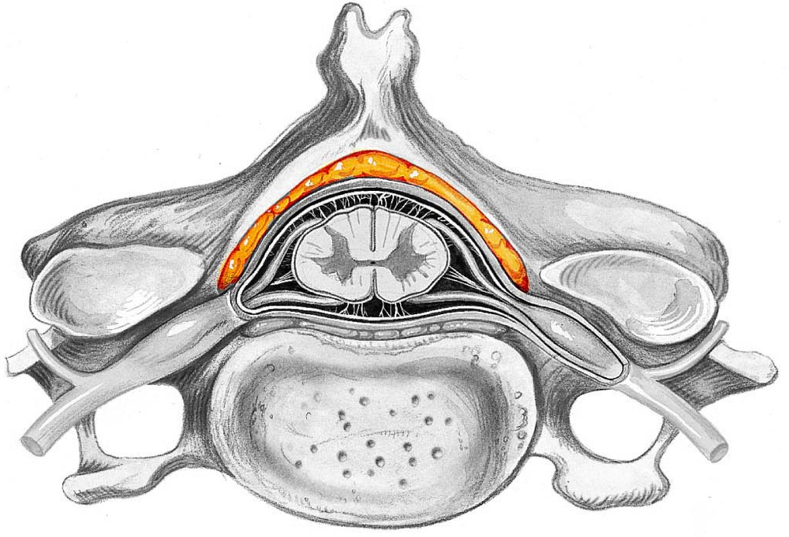

1. Which region is NOT part of the diencephalon?
   1. Hypothalamus
   2. Thalamus
   3. Epithalamus
   4. Pituitary gland

Station Fifteen

1. Identify the structure found within the cerebellum

Name_____________________________________________________

Quiz Three

1. Circle one: a b c d e
2. Circle one: a b c d e
3. ____________________________________________________
4. Circle one: a b c d e
5. ____________________________________________________
6. ____________________________________________________
7. Circle one: a b c d e
8. ____________________________________________________
9. ____________________________________________________
10. Circle one: a b c d e
11. ____________________________________________________
12. ____________________________________________________
13. Circle one: a b c d e
14. Circle one: a b c d e
15. Circle one: a b c d e
16. Circle one: a b c d e
17. Circle one: a b c d e
18. Circle one: a b c d e
19. ____________________________________________________
20. ____________________________________________________  
    ____________________________________________________  
    ____________________________________________________
21. ____________________________________________________
22. Circle one: a b c d e
23. Circle one: a b c d e
24. Circle one: a b c d e
25. ____________________________________________________