Quiz Three: Instructor Set-Up

Station One: Image: thalamus

Station Two: brain, marker indicating central sulcus

Station three: brain, marker indicating parietal lobe

Station Four: Image: choroid plexus

Station Five: brain, marker at olfactory bulb(s)

Station Six: brain, marker at pituitary gland. (If you don’t have a preserved pituitary gland, the question should be clear enough to get away without a brain.)

Station Seven: Image: ventral root

Station Eight: brain, marker at corpus callosum

Station nine: image: epineurium

Station ten: questions

Station eleven: image: white matter

Station twelve: image: nodes of Ranvier

Station thirteen: microscope: pacinian corpuscle

Station fourteen: image: subarachnoid space

Station fifteen: brain, marker at arbor vitae

Key:

1. (d) thalamus
2. (a) central sulcus
3. Parietal lobe
4. (c) retina and olfactory epithelium
5. Choroid plexus
6. Olfactory bulb
7. (b) pituitary gland
8. Oligodendrocyte. (Be forgiving on the spelling.)
9. Ventral root
10. (c) motor neurons
11. Corpus callosum
12. Function: connects cerebral hemispheres
13. (a) epineurium
14. (e) gustatory cell
15. (b) Lumbar spine
16. (a) quadriceps muscle
17. (d) white matter
18. (a) myelinated fibers
19. Nodes of Ranvier
20. Dura mater, arachnoid mater, pia mater (Note: no partial credit. They need all three.) If they are close on spelling, give it to them. They don’t need the word “mater” for credit.
21. Pacinian corpuscle (again, if they are close with the spelling, give it to them)
22. (c) touch
23. (b) subarachnoid space
24. (d) unipolar
25. Arbor vitae

Station One:

1. Identify the structure
2. Pituitary gland
3. Medulla oblongata
4. Hypothalamus
5. Thalamus
6. Pons

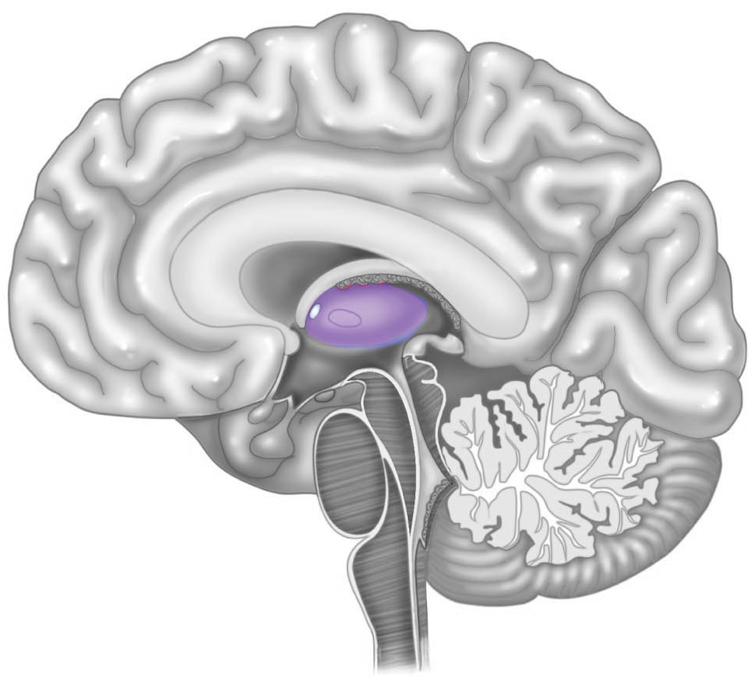

Station Two:

1. Identify the structure on the brain
2. Central sulcus
3. Transverse fissure
4. Lateral sulcus
5. Cerebral sulcus
6. Prefrontal gyrus

Station Three:

1. Indicate the lobe of the brain
2. Where do we commonly find bipolar neurons?
3. Insular lobe of the brain
4. Descending spinal cord
5. Retina and olfactory epithelium
6. Dorsal root ganglia
7. Gut-brain

Station Four

1. These structures are responsible for the production of cerebrospinal fluid. What are they?

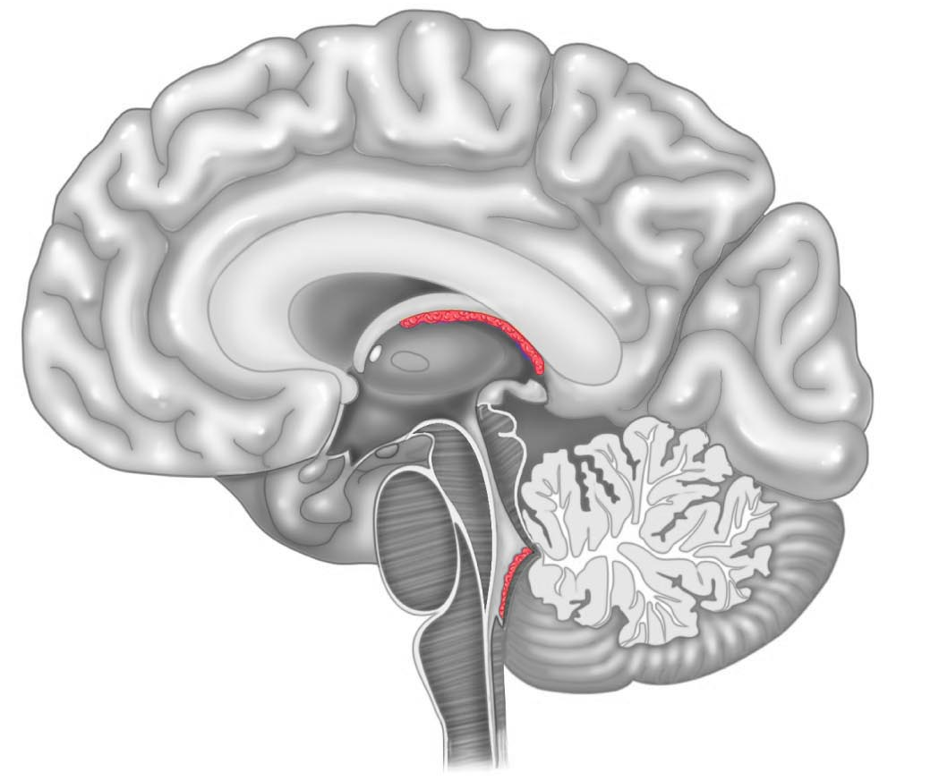

Station Five

1. Identify this structure on the brain

Station Six:

1. This structure is attached to the hypothalamus by the infindibulum. Often times it is lost in the sheep/cow brains as they are prepared and preserved.
2. Pineal gland
3. Pituitary gland
4. Hypothalamus
5. Pons
6. Ganglion
7. Which type of cell is responsible for creating the myelin sheath in the central nervous system?

Station Seven

1. Identify the structure on the image

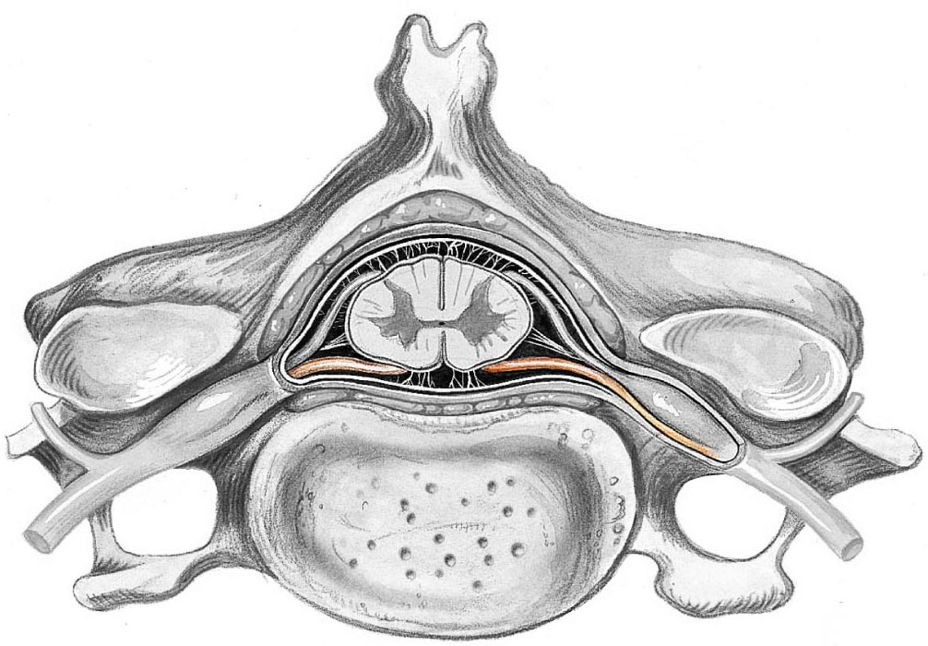

1. In the above structure, which type of neuron is associated with it?
2. Monosynaptic neuron
3. Bipolar neuron
4. Motor neuron
5. Unipolar neuron
6. Afferent neuron

Station Eight

1. 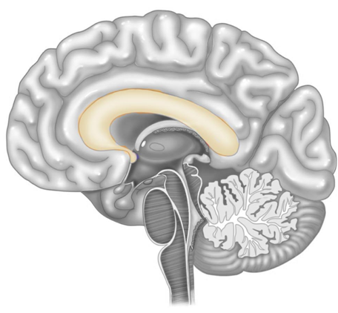Identify the structure on the brain
2. What is the function of the structure labeled above?

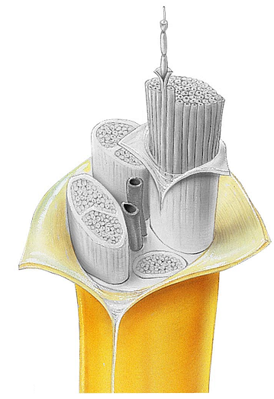Station Nine:

1. Identify the structure
2. Epineurium
3. Perineurium
4. Endoneurium
5. Endomysium
6. perimysium
7. What is another term for a taste cell?
   1. Effector cell
   2. Dermal papilla
   3. Deglutition cell
   4. Glial cell
   5. Gustatory cell

Station Ten

1. The synapse in the patellar reflex (a monosynaptic reflex) takes place where?
   1. Thalamus
   2. Lumbar spine
   3. Thoracic spine
   4. Cervical spine
   5. Cerebral cortex
2. In the patellar reflex, the motor (efferent) nerve fiber runs to which muscle/group as the effector (prime mover)?
   1. Quadriceps
   2. Hamstrings
   3. Iliopsoas
   4. Erector spinae
   5. Tibialis anterior

Station Eleven

1. What structure is represented in the image?
2. 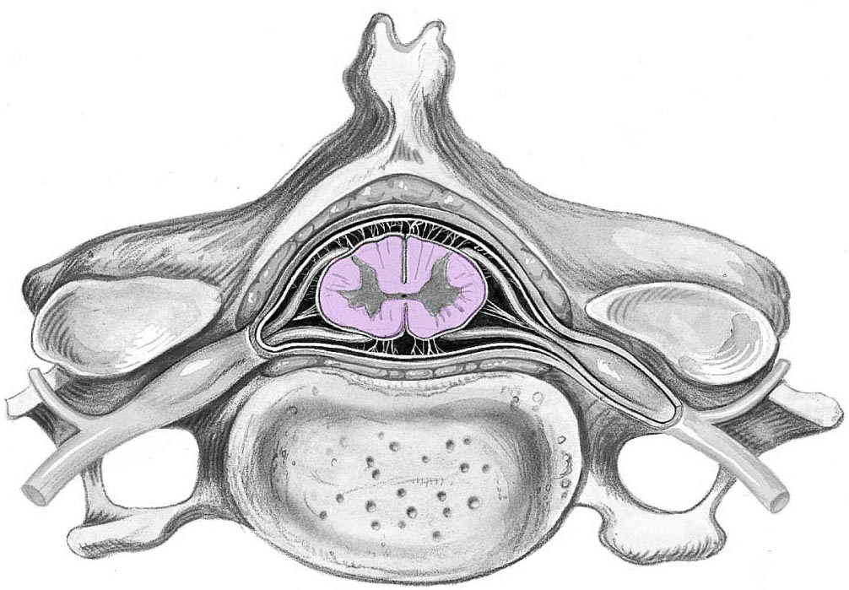White matter
3. Red matter
4. Dura mater
5. Gray matter
6. Arachnoid mater
7. Of what material is this structure composed?
   1. Mylenated fibers
   2. Nerve cell bodies
   3. Dendrites only
   4. Transverse fibers only
   5. Ependymal cells

Station Twelve

1. Identify the structure highlighted in yellow. Name the structures formed by the spaces/gaps, not the type of fiber.
2. What are the three meningeal layers that surround the brain and spinal cord? List all three meninges for credit.

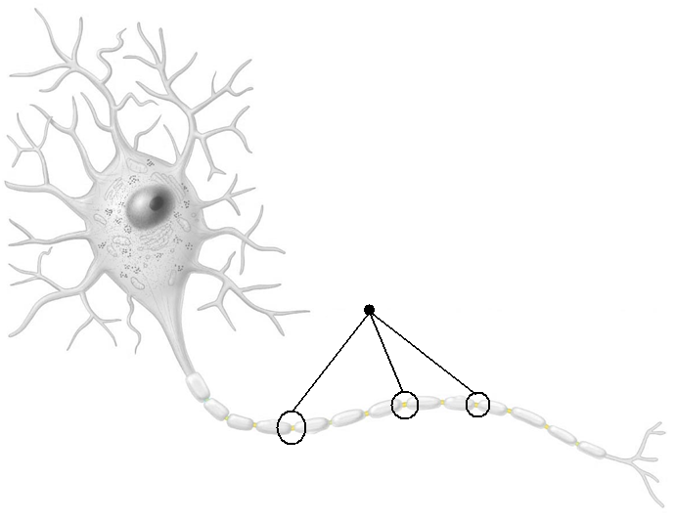

Station Thirteen

1. Identify the structure on the microscope’s field of view.
2. What is the function of this structure
   1. Receptor for sense of taste
   2. Receptor for sense of smell
   3. Receptor for touch
   4. Receptor for hearing
   5. Receptor for vision

Station Fourteen

1. Identify the image
2. Endodural space
3. 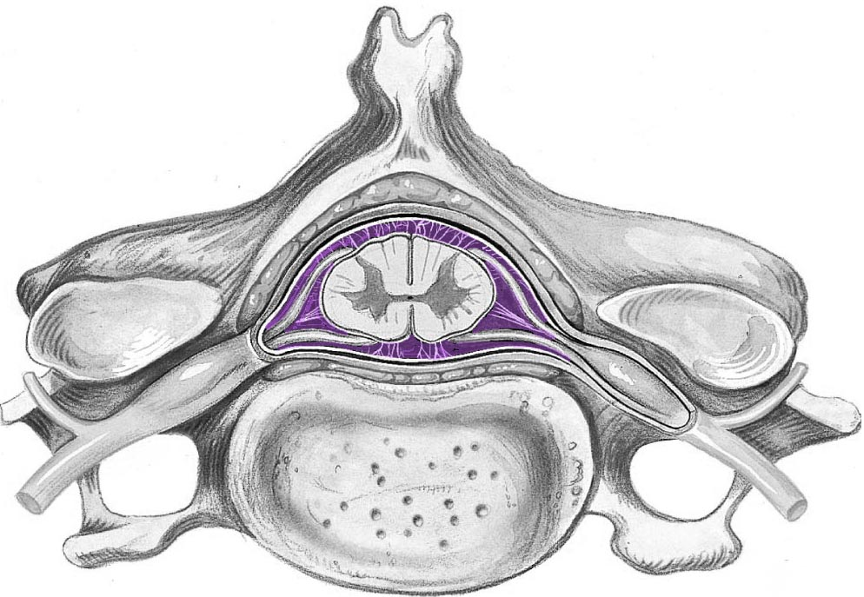Subarachnoid space
4. Subdural space
5. Epidural space
6. Epiploic space
7. The Dorsal Root Ganglion houses the cell bodies of afferent fibers. What classification of neuron is associated with the Dorsal Root Ganglion
   1. Multipolar
   2. bipolar
   3. Oligopolar
   4. Unipolar
   5. Motor

Station Fifteen

1. Identify the structure found within the cerebellum

Name_____________________________________________________

Quiz Three

1. Circle one: a b c d e
2. Circle one: a b c d e
3. ____________________________________________________
4. Circle one: a b c d e
5. ____________________________________________________
6. ____________________________________________________
7. Circle one: a b c d e
8. ____________________________________________________
9. ____________________________________________________
10. Circle one: a b c d e
11. ____________________________________________________
12. ____________________________________________________
13. Circle one: a b c d e
14. Circle one: a b c d e
15. Circle one: a b c d e
16. Circle one: a b c d e
17. Circle one: a b c d e
18. Circle one: a b c d e
19. ____________________________________________________
20. ____________________________________________________  
    ____________________________________________________  
    ____________________________________________________
21. ____________________________________________________
22. Circle one: a b c d e
23. Circle one: a b c d e
24. Circle one: a b c d e
25. ____________________________________________________

21. Identify the image in the field of view.

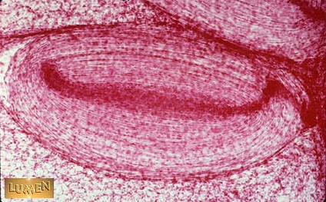

22. What is the function of this structure

* 1. Receptor for sense of taste
  2. Receptor for sense of smell
  3. Receptor for touch
  4. Receptor for hearing
  5. Receptor for vision