Station One: questions

Station two: eye, marker at cornea

Station three: eye, marker at medial rectus muscle, question

Station four: Microscope: Monkey retina slide, question

Station five: questions

Station six: eye, marker indicating sclera, question

Station seven: image provided

Station eight: image provided

Station nine: image provided

Station ten: image provided

Station eleven: questions

Station twelve: image provided

Station thirteen: image provided

Station fourteen: question

Answer key

1. D produces aqueous humor
2. C tapetum lucidum
3. Cornea
4. Medial rectus muscle
5. B Oculomotor nerve (Cranial Nerve III)
6. Retina (monkey retina)
7. Lens
8. B vascular tunic
9. sclera
10. E Lateral geniculate nucleus
11. A Facial VII
12. E Hypoglossal XII
13. D scala vestibule
14. E grainy crystals
15. B pharyngotympanic tube
16. Cochlea
17. E spiral ganglion
18. D lateral rectus
19. B
20. No photoreceptors on disc means no impulses sent from that location. In the student answers, look to see that they have the idea that the disc lacks receptors.
21. C holds retina
22. C tarsal glands
23. B helix
24. D buccinators = facial VII
25. Cranial Nerve I is the olfactory nerve responsible for smell. To test it, offer someone something to smell and ask them to identify it. (If they’ve boiled it down to “smell something,” that’s fine.)

Name_________________________________________________

1. Circle one: a b c d e
2. Circle one: a b c d e
3. ________________________________________________________________
4. ________________________________________________________________
5. Circle one: a b c d e
6. ________________________________________________________________
7. ________________________________________________________________
8. Circle one: a b c d e
9. ________________________________________________________________
10. Circle one: a b c d e
11. Circle one: a b c d e
12. Circle one: a b c d e
13. Circle one: a b c d e
14. Circle one: a b c d e
15. Circle one: a b c d e
16. _______________________________________________________________
17. Circle one: a b c d e
18. Circle one: a b c d e
19. Circle one: a b c d e
20. ________________________________________________________________
21. Circle one: a b c d e
22. Circle one: a b c d e
23. Circle one: a b c d e
24. Circle one: a b c d e

**Station One**

1. What is the function of the ciliary body?
   1. Produces vitreous humor
   2. Anchors the retina
   3. Produces a dark environment
   4. Produces aqueous humor
   5. Provides an area for acute vision
2. Which layer of the eye is responsible for the glowing eyes seen in animals?
   1. Retina
   2. Sclera
   3. Tapetum lucidum
   4. Basement membrane
   5. Conjunctiva

**Station Two**

1. Identify the structure marked on the eye. In a living organism, this structure is clear and aids in protecting the eye.

**Station Three**

1. There are six extrinsic eye muscles: this extrinsic muscle causes the eye to turn toward the nose.
2. Which cranial nerve is responsible for the muscle identified in question 4?
   1. Optic
   2. Oculomotor
   3. Trochlear
   4. Abducens
   5. Trigeminal

**Station Four**

1. Identify the image on the slide

**Station Five**

1. Identify the highlighted structure below:

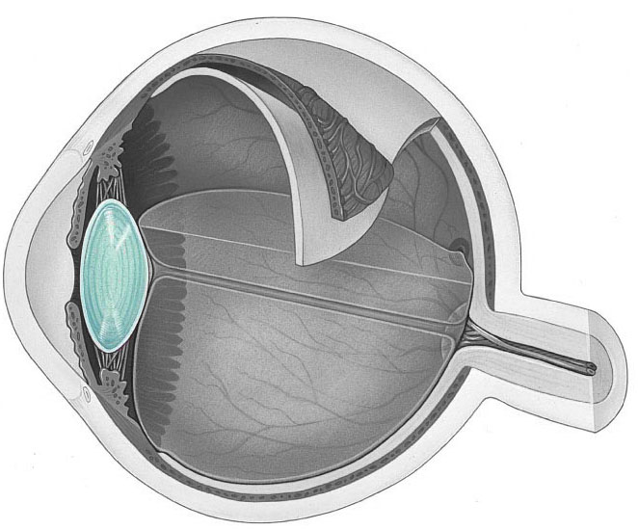

1. Identify the highlighted structure below
   1. Fibrous tunic
   2. Vascular tunic
   3. 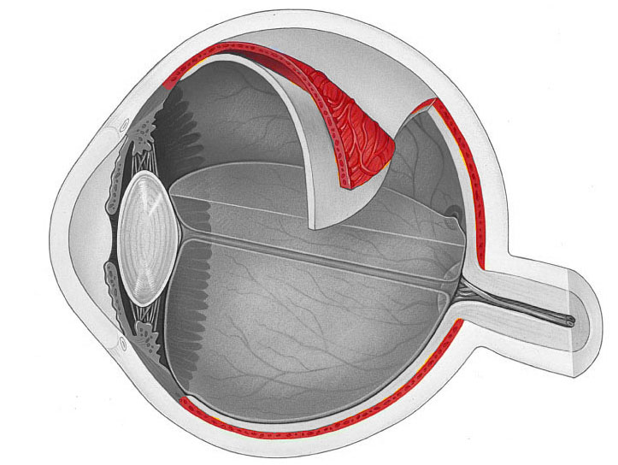Cotton tunic
   4. Neural tunic
   5. iTunic

**Station Six**

1. Identify the structure indicated
2. Which structure is not part of the auditory pathway?
   1. Cochlear nuclei
   2. Superior olivary nucleus
   3. Inferior colliculus
   4. Temporal cortex
   5. Lateral geniculate nucleus

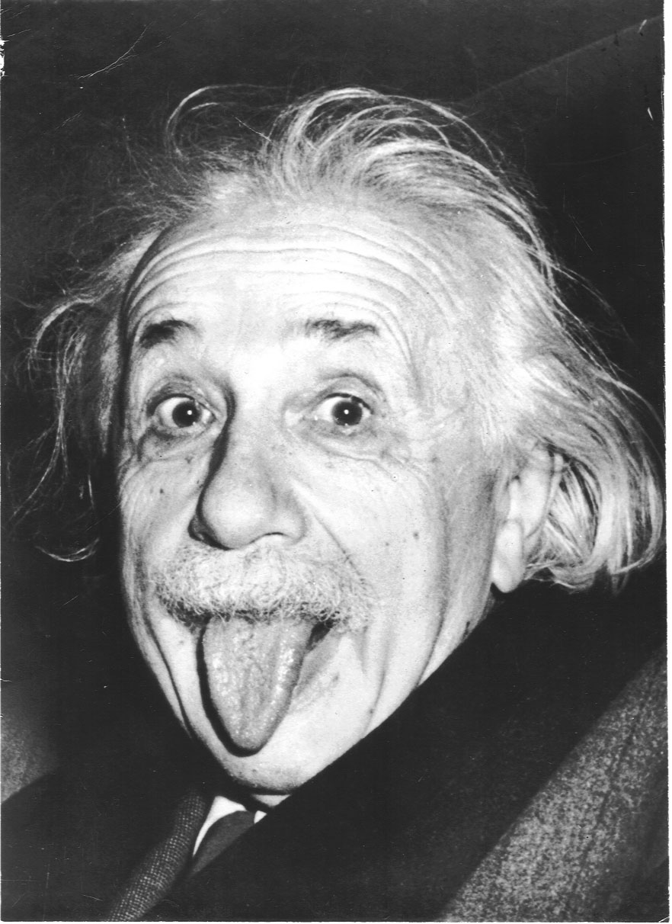**Station Seven**

1. In the above image, Einstein is using his Frontalis muscle to lift his eyebrows. Which cranial nerve is innervating the Frontalis muscle?
   1. Facial VII
   2. Trigeminal V
   3. Oculomotor III
   4. Trochlear IV
   5. Glossopharyngeal IX
2. In the image, Einstein is also sticking his tongue out. Which cranial nerve is responsible for this?
   1. Vestibulocochlear VIII
   2. Glossopharyngeal IX
   3. Vagus X
   4. Spinal Accessory XI
   5. Hypoglossal XII

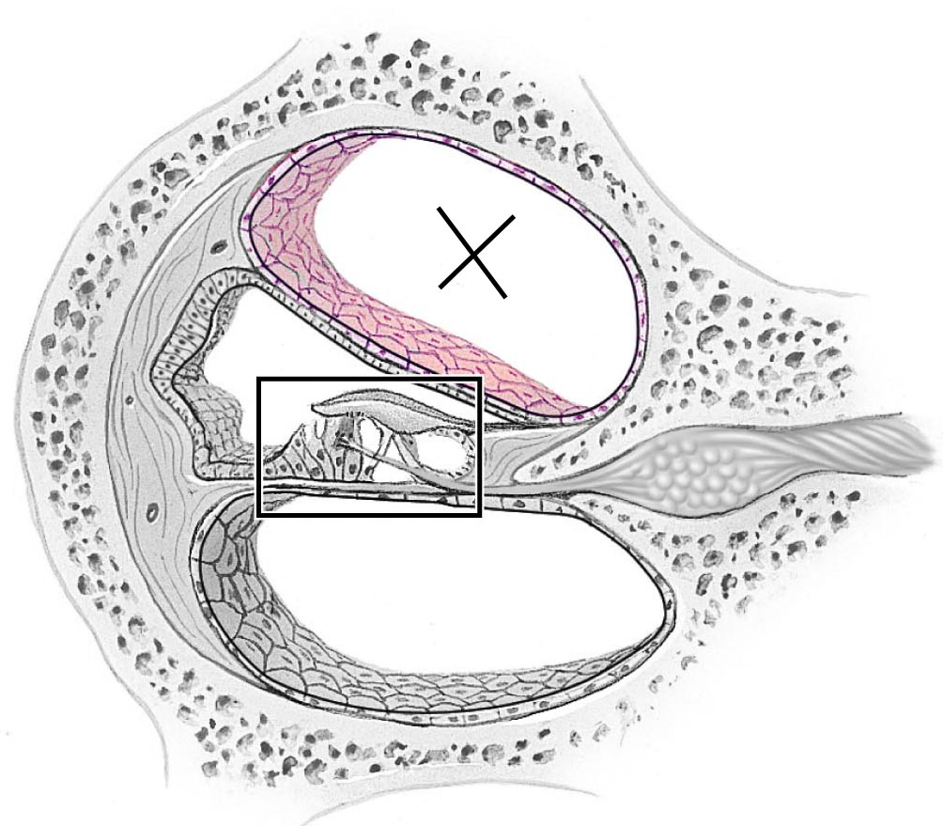

**Station Eight**

1. The “x” in the above image is located in which region?
   1. Tympanic membrane
   2. Stapes
   3. Scala media
   4. Scala vestibuli
   5. Scala tympani
2. What are the otoliths?
   1. The small bones responsible for conveying sound from the tympanic membrane to the cochlea
   2. The region of the inner ear responsible for balance
   3. The region of the inner ear responsible for sensing vertical movement
   4. The region of the middle ear that adapts to loud noises
   5. The small grainy crystals that are found in the utricle and saccule

**Station Nine**

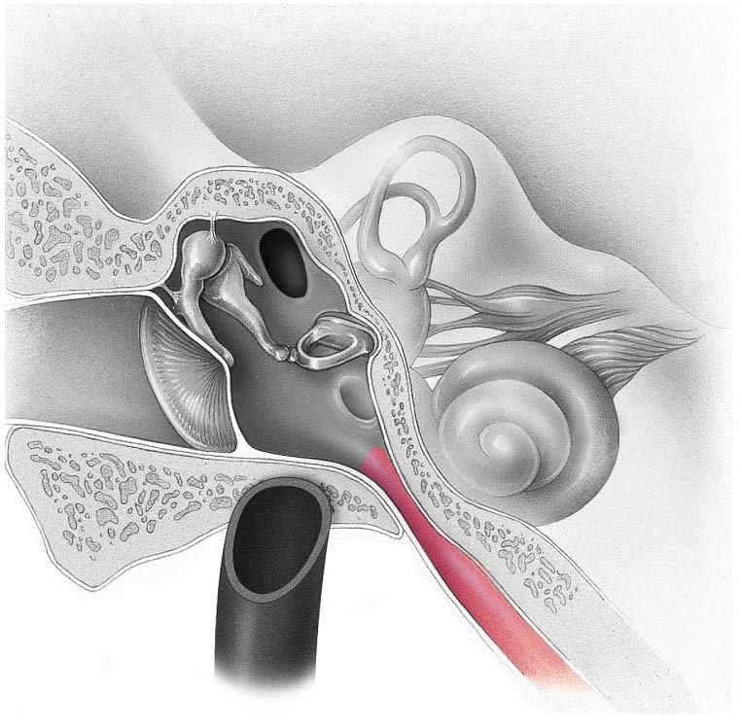

1. Identify the structure leading out of the middle ear
   1. Bony labyrinth
   2. Pharyngotympanic tube
   3. Cochlear egress
   4. Round window
   5. Auditory nerve
2. 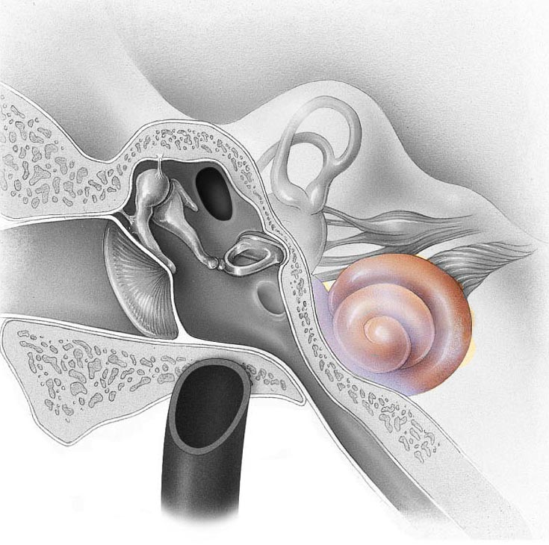 Identify the structure in the image below

**Station Ten**

1. 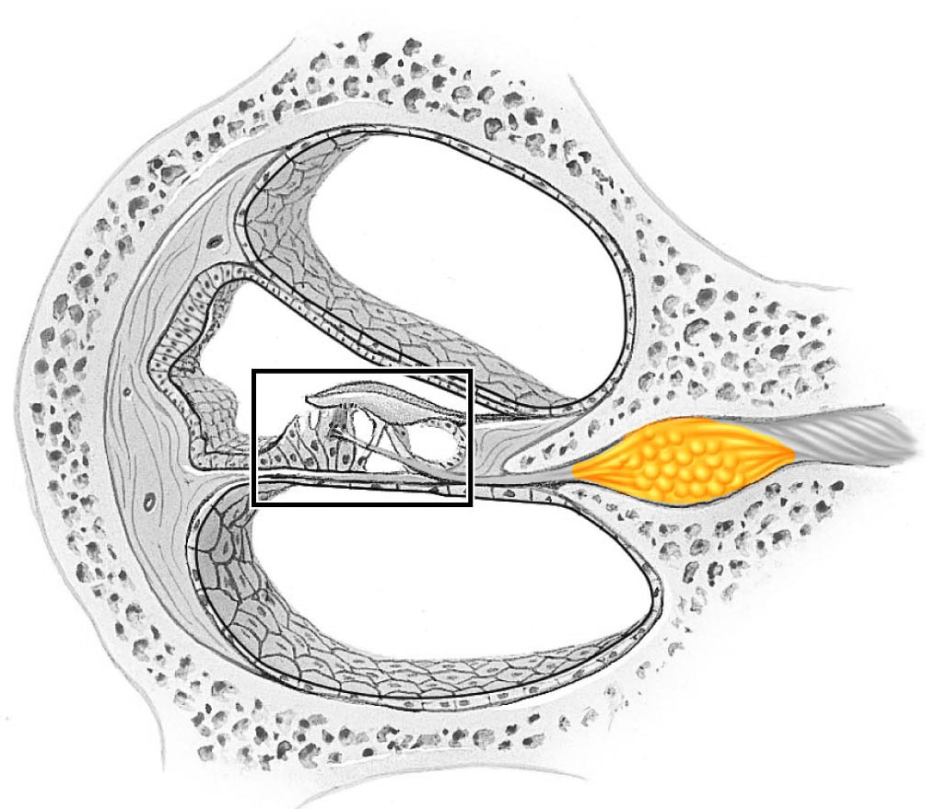 Identify the structure below (yellow)
   1. Basement membrane
   2. Stereocilia
   3. Kinocilia
   4. Vestibular nerve
   5. Spiral ganglion
2. Which eye muscle is innervated by Abducens VI?
   1. Superior rectus
   2. Superior oblique
   3. Medial rectus
   4. Lateral rectus
   5. Inferior oblique

**Station Eleven**

1. When you asked your lab partner to open their mouth and say “Aaahhh”, which cranial nerve was responsible for moving the soft palate and uvula?
   1. Vestibulocochlear VIII
   2. Glossopharyngeal IX
   3. Vagus X
   4. Spinal Accessory XI
   5. Hypoglossal XII
2. How does the optic disc contribute to a blind spot in our field of view?

**Station Twelve**

1. What is the function of the fluid found in the posterior chamber of the eye
   1. Provides nutrients to the cornea
   2. Holds the pupil open
   3. Presses the retina against the inner walls of the eye
   4. Provides an antibody-rich material to protect the eye
   5. Keeps the cornea moist and lubricated
2. 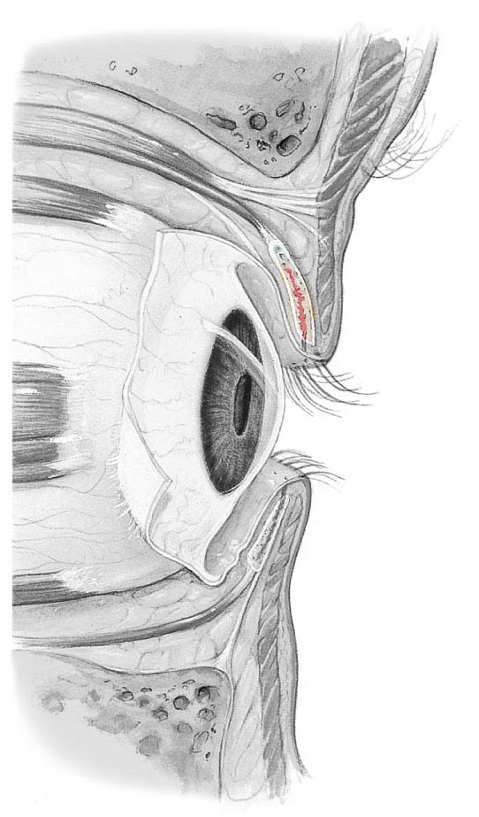 Locate the colored image in the superior palpebra. What are the glandular structures within this plate called?
   1. Meibomian glands
   2. Cystic glands
   3. Tarsal glands
   4. Ciliary glands
   5. Alveolar glands

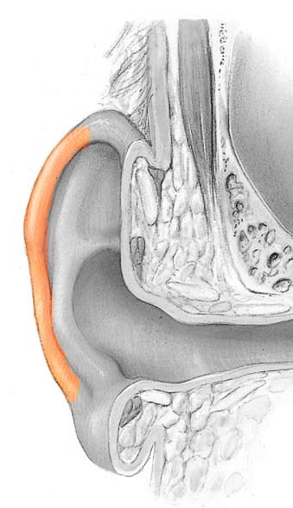**Station Thirteen**

1. Identify the structure
   1. Tragus
   2. Helix
   3. Antihelix
   4. Codon
   5. Lobe
2. Which of the following statements below is true
   1. The masseter muscle is innervated by the facial nerve
   2. The lateral pterygoid is responsible for closing the jaw
   3. The orbicularis oculi muscle is responsible for pursing the lips
   4. The buccinator muscle is innervated by the facial nerve
   5. The zygomaticus muscles are innervated by the trigeminal nerve

**Station Fourteen**

1. How would you test cranial nerve I?