Station One: questions

Station two: eye, marker at cornea

Station three: eye, marker at medial rectus muscle, question

Station four: Microscope: Monkey retina slide, question

Station five: questions

Station six: eye, marker indicating sclera, question

Station seven: image provided

Station eight: image provided

Station nine: image provided

Station ten: image provided

Station eleven: questions

Station twelve: image provided

Station thirteen: image provided

Station fourteen: question

Answer key

1. D produces aqueous humor
2. C tapetum lucidum
3. Cornea
4. Medial rectus muscle
5. B Oculomotor nerve (Cranial Nerve III)
6. Retina (monkey retina)
7. Lens
8. B vascular tunic
9. sclera
10. E Lateral geniculate nucleus
11. A Facial VII
12. E Hypoglossal XII
13. D scala vestibule
14. E grainy crystals
15. B pharyngotympanic tube
16. Cochlea
17. E spiral ganglion
18. E defect in cornea
19. B
20. No photoreceptors on disc means no impulses sent from that location. In the student answers, look to see that they have the idea that the disc lacks receptors.
21. C holds retina
22. D air conduction > bone conduction
23. B helix
24. D buccinators = facial VII
25. Cranial Nerve I is the olfactory nerve responsible for smell. To test it, offer someone something to smell and ask them to identify it. (If they’ve boiled it down to “smell something,” that’s fine.)

Name_________________________________________________

1. Circle one: a b c d e
2. Circle one: a b c d e
3. ________________________________________________________________
4. ________________________________________________________________
5. Circle one: a b c d e
6. ________________________________________________________________
7. ________________________________________________________________
8. Circle one: a b c d e
9. ________________________________________________________________
10. Circle one: a b c d e
11. Circle one: a b c d e
12. Circle one: a b c d e
13. Circle one: a b c d e
14. Circle one: a b c d e
15. Circle one: a b c d e
16. _______________________________________________________________
17. Circle one: a b c d e
18. Circle one: a b c d e
19. Circle one: a b c d e
20. ________________________________________________________________
21. Circle one: a b c d e
22. Circle one: a b c d e
23. Circle one: a b c d e
24. Circle one: a b c d e

**Station One**

1. What is the function of the ciliary body?
   1. Produces vitreous humor
   2. Anchors the retina
   3. Produces a dark environment
   4. Produces aqueous humor
   5. Provides an area for acute vision
2. Which layer of the eye is responsible for the glowing eyes seen in animals?
   1. Retina
   2. Sclera
   3. Tapetum lucidum
   4. Basement membrane
   5. Conjunctiva

**Station Two**

1. Identify the structure marked on the eye. In a living organism, this structure is clear and aids in protecting the eye.

**Station Three**

1. There are six extrinsic eye muscles: this extrinsic muscle causes the eye to turn toward the nose.
2. Which cranial nerve is responsible for the muscle identified in question 4?
   1. Optic
   2. Oculomotor
   3. Trochlear
   4. Abducens
   5. Trigeminal

**Station Four**

1. Identify the image on the slide

**Station Five**

1. Identify the highlighted structure below:

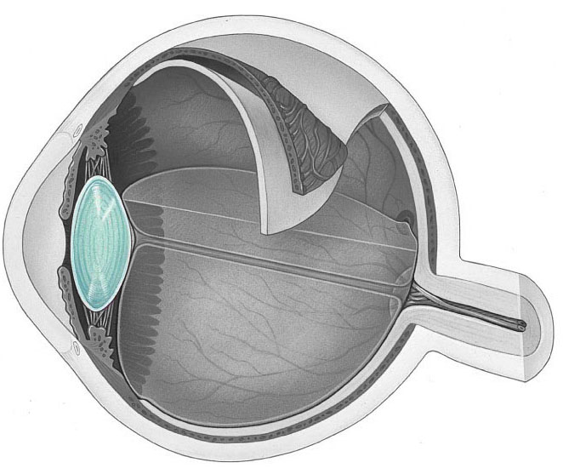

1. Identify the highlighted structure below
   1. Fibrous tunic
   2. Vascular tunic
   3. 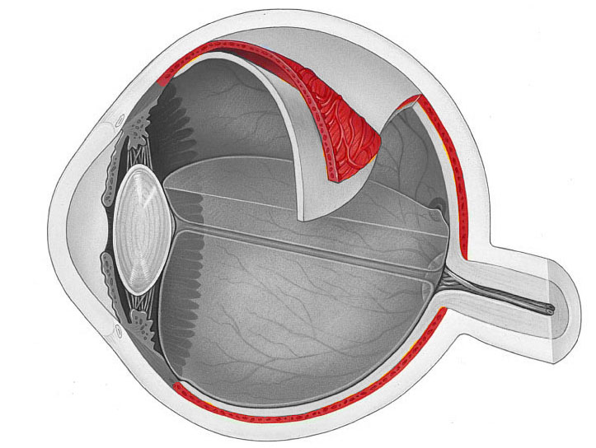Cotton tunic
   4. Neural tunic
   5. iTunic

**Station Six**

1. Identify the structure indicated
2. Which structure is not part of the auditory pathway?
   1. Cochlear nuclei
   2. Superior olivary nucleus
   3. Inferior colliculus
   4. Temporal cortex
   5. Lateral geniculate nucleus

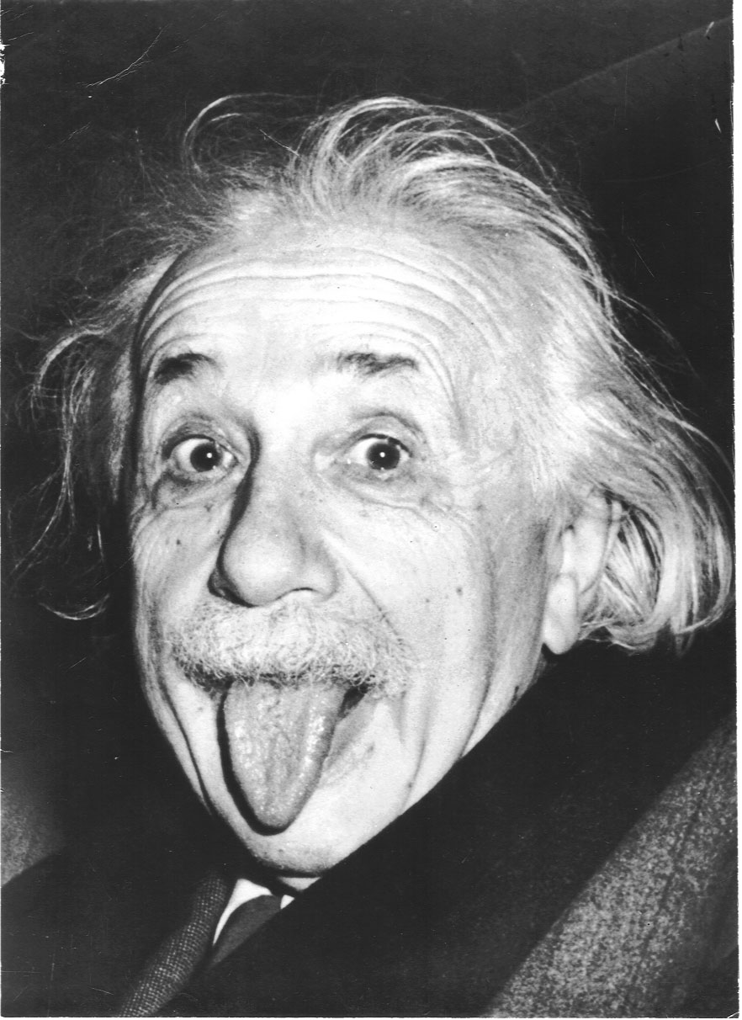**Station Seven**

1. In the above image, Einstein is using his Frontalis muscle to lift his eyebrows. Which cranial nerve is innervating the Frontalis muscle?
   1. Facial VII
   2. Trigeminal V
   3. Oculomotor III
   4. Trochlear IV
   5. Glossopharyngeal IX
2. In the image, Einstein is also sticking his tongue out. Which cranial nerve is responsible for this?
   1. Vestibulocochlear VIII
   2. Glossopharyngeal IX
   3. Vagus X
   4. Spinal Accessory XI
   5. Hypoglossal XII

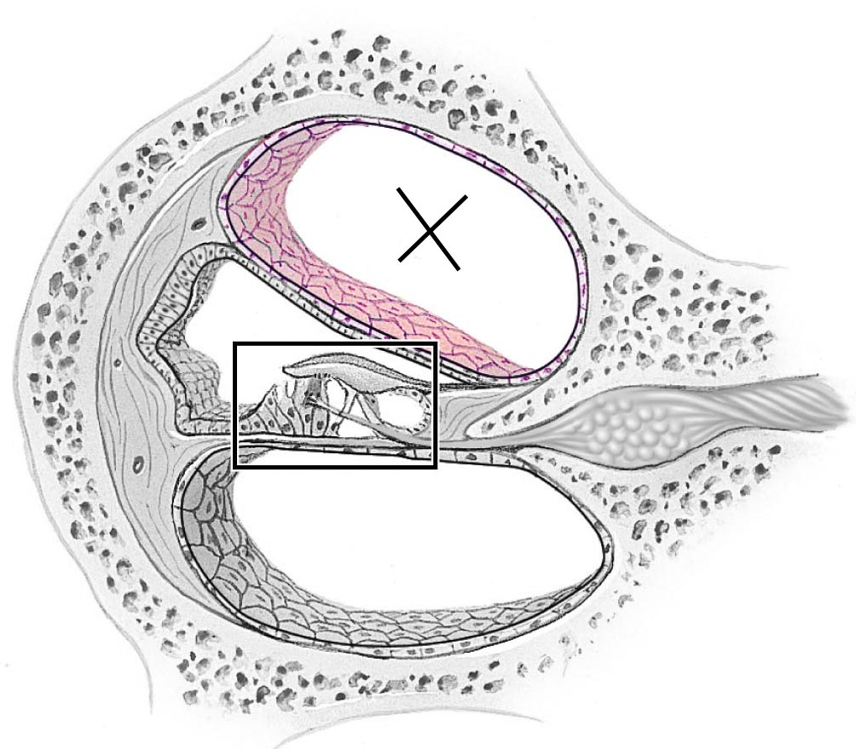

**Station Eight**

1. The “x” in the above image is located in which region?
   1. Tympanic membrane
   2. Stapes
   3. Scala media
   4. Scala vestibuli
   5. Scala tympani
2. What are the otoliths?
   1. The small bones responsible for conveying sound from the tympanic membrane to the cochlea
   2. The region of the inner ear responsible for balance
   3. The region of the inner ear responsible for sensing vertical movement
   4. The region of the middle ear that adapts to loud noises
   5. The small grainy crystals that are found in the utricle and saccule

**Station Nine**

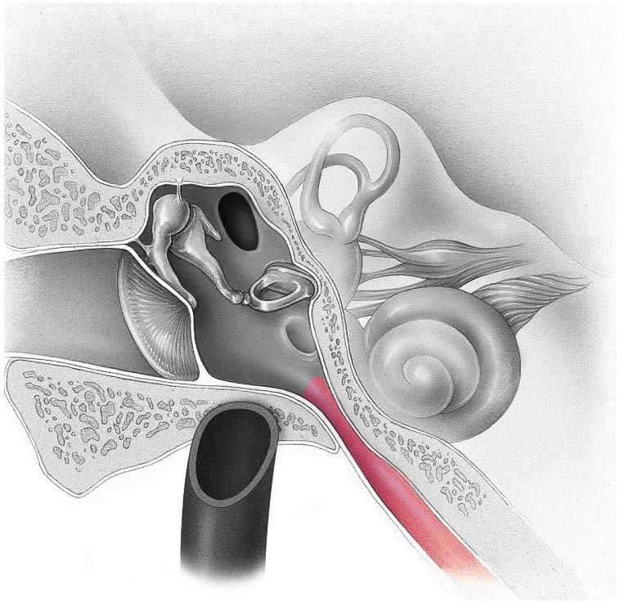

1. Identify the structure leading out of the middle ear
   1. Bony labyrinth
   2. Pharyngotympanic tube
   3. Cochlear egress
   4. Round window
   5. Auditory nerve
2. Identify the structure in the image below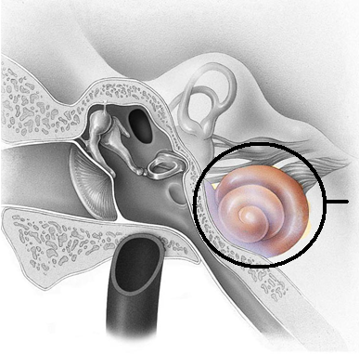

**Station Ten**

1. Identify the structure below (yellow)
   1. Basement membrane
   2. Stereocilia
   3. 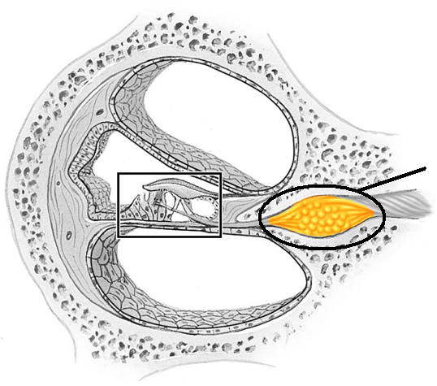Kinocilia
   4. Vestibular nerve
   5. Spiral ganglion
2. Astigmatism is a result of
   1. Loss of sensitivity at the retina
   2. Eyeball too short
   3. Eyeball too long
   4. Detached ciliary body
   5. Defect in cornea

**Station Eleven**

1. When you asked your lab partner to open their mouth and say “Aaahhh”, which cranial nerve was responsible for moving the soft palate and uvula?
   1. Vestibulocochlear VIII
   2. Glossopharyngeal IX
   3. Vagus X
   4. Spinal Accessory XI
   5. Hypoglossal XII
2. How does the optic disc contribute to a blind spot in our field of view?

**Station Twelve**

1. What is the function of the fluid found in the posterior chamber of the eye
   1. Provides nutrients to the cornea
   2. Holds the pupil open
   3. Presses the retina against the inner walls of the eye
   4. Provides an antibody-rich material to protect the eye
   5. Keeps the cornea moist and lubricated
2. In Rinne’s test, you used a tuning fork at the mastoid process and then in front of the ear canal. Which is true regarding a normal Rinee’s test?
   1. It’s an excellent test to distinguish conductive impairment from sensory deafness
   2. Bone conduction should be louder than air conduction
   3. The stem of the tuning fork should be placed at the chin
   4. Air conduction should be louder than bone conduction
   5. Air conduction and bone conduction should be equal

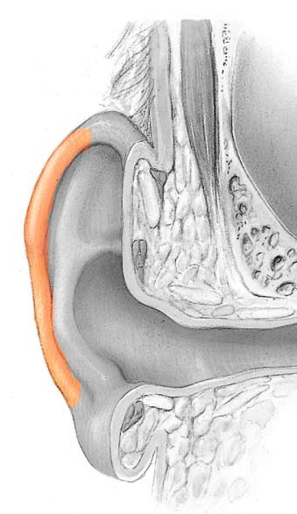**Station Thirteen**

1. Identify the structure
   1. Tragus
   2. Helix
   3. Antihelix
   4. Codon
   5. Lobe
2. Which of the following statements below is true about the photopupillary reflex
   1. CN I carries sensory input to the CNS; CNII causes pupil to constrict
   2. CNII caries sensory input to the CNS; CN II causes pupils to constrict
   3. CN III caries sensory input to the CNS; CN III causes pupils to constrict
   4. CN II carries sensory input the CNS; CN III causes pupils to constrict
   5. CN III caries sensory input to the CNS; CN II causes pupils to constrict

**Station Fourteen**

1. How would you test cranial nerve I?

Comment: For version two of the lab quiz, all of the markers/anatomy questions have remained the same. If you want to add in a different structure to identify, you are welcome to.

Station One: questions

Station two: eye, marker at cornea

Station three: eye, marker at medial rectus muscle, question

Station four: Microscope: taste bud, question

Station five: questions

Station six: eye, marker indicating sclera, question

Station seven: image provided

Station eight: image provided

Station nine: image provided

Station ten: image provided

Station eleven: questions

Station twelve: image provided

Station thirteen: image provided

Station fourteen: question

Answer key

1. D provides vascular supply: oxygen and nutrients
2. C tapetum lucidum
3. Cornea
4. Lateral rectus
5. B Abducens VI
6. Retina (monkey retina)
7. Ciliary body
8. B neural tunic
9. sclera
10. E Lateral geniculate nucleus
11. A Facial VII
12. E Facial VII
13. D scala tympani
14. E tiny bones
15. B vestibule
16. Vestibular nerve. Do not accept vestibulocochlear, auditory, or cochlear.
17. E organ of corti
18. E 20/100
19. B Hypoglossal XII
20. Cones. They contribute to acute vision
21. C holds retina
22. C conjunctiva
23. B lobe
24. D conductive/sensory
25. Inferior oblique: makes the eye look up

Name_________________________________________________

1. Circle one: a b c d e
2. Circle one: a b c d e
3. ________________________________________________________________
4. ________________________________________________________________
5. Circle one: a b c d e
6. ________________________________________________________________
7. ________________________________________________________________
8. Circle one: a b c d e
9. ________________________________________________________________
10. Circle one: a b c d e
11. Circle one: a b c d e
12. Circle one: a b c d e
13. Circle one: a b c d e
14. Circle one: a b c d e
15. Circle one: a b c d e
16. _______________________________________________________________
17. Circle one: a b c d e
18. Circle one: a b c d e
19. Circle one: a b c d e
20. ________________________________________________________________
21. Circle one: a b c d e
22. Circle one: a b c d e
23. Circle one: a b c d e
24. Circle one: a b c d e

**Station One**

1. What is the function of the choroid layer of the eye?
   1. Produces vitreous humor
   2. Anchors the retina
   3. Produces aqueous humor
   4. Provides the oxygen and nutrients to the retina
   5. Produces cerebrospinal fluid
2. Which layer of the eye is responsible for the glowing eyes seen in animals?
   1. Retina
   2. Sclera
   3. Tapetum lucidum
   4. Basement membrane
   5. Conjunctiva

**Station Two**

1. Identify the structure marked on the eye. In a living organism, this structure is clear and aids in protecting the eye.

**Station Three**

1. There are six extrinsic eye muscles: this muscle causes the eye to look away from midline
2. Which cranial nerve is responsible for the muscle identified in question 4?
   1. Optic
   2. Abducens
   3. Oculomotor
   4. Trochlear
   5. Trigeminal

**Station Four**

1. Identify the image on the slide

**Station Five**

1. Identify the highlighted structure below:

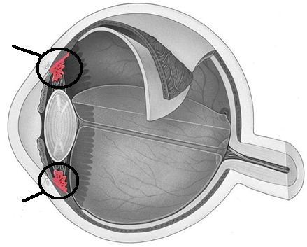

1. Identify the highlighted structure below
   1. Fibrous tunic
   2. Neural tunic
   3. Vascular tunic
   4. Cotton tunic
   5. 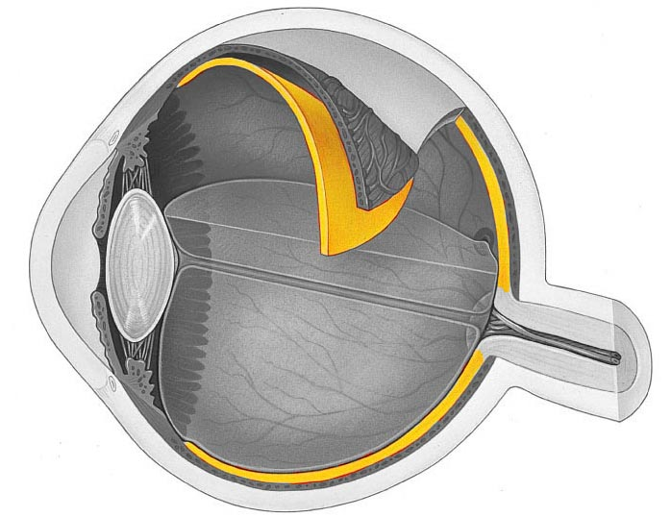iTunic

**Station Six**

1. Identify the structure indicated
2. Which structure is not part of the auditory pathway?
   1. Cochlear nuclei
   2. Superior olivary nucleus
   3. Inferior colliculus
   4. Temporal cortex
   5. Lateral geniculate nucleus

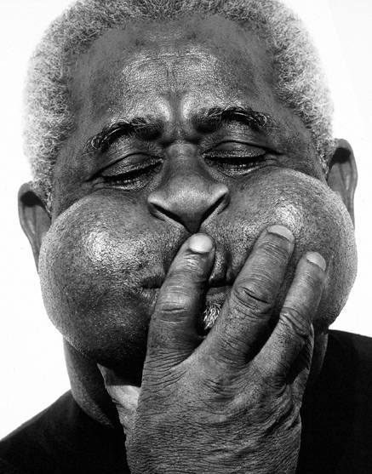**Station Seven**

1. In the above image, Dizzy Gillespie is using his orbicularis oculi muscle to close his eyes. Which cranial nerve is innervating this muscle?
   1. Facial VII
   2. Trigeminal V
   3. Oculomotor III
   4. Trochlear IV
   5. Glossopharyngeal IX
2. In the image, Dizzy Gillespie is also puffing out his cheeks and pursing his lips. The buccal muscle and the orbicularis oris allow this to happen. Which cranial nerve is responsible?
   1. Trigeminal V
   2. Glossopharyngeal IX
   3. Vagus X
   4. Spinal Accessory XI
   5. Facial VII

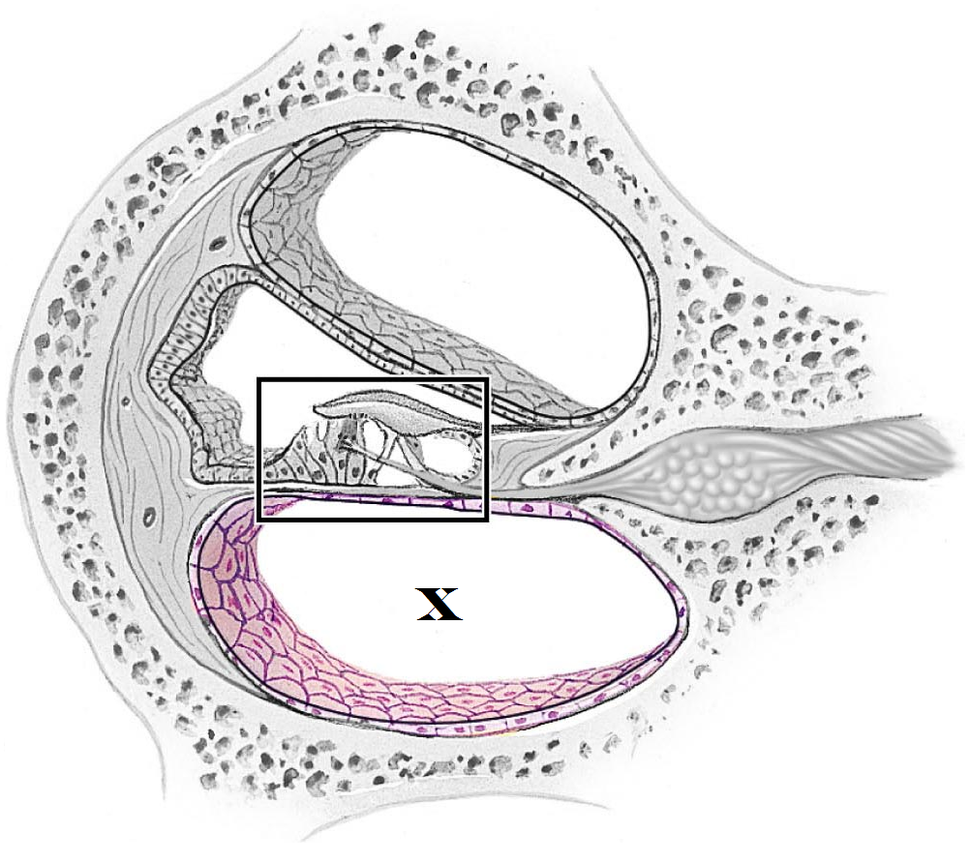

**Station Eight**

1. The “x” in the above image is located in which region?
   1. Tympanic membrane
   2. Stapes
   3. Scala media
   4. Scala tympani
   5. Scala vestibuli
2. What are the ossicles?
   1. The small grainy crystals that are found in the utricle and saccule
   2. The region of the inner ear responsible for balance
   3. The region of the inner ear responsible for sensing vertical movement
   4. The region of the middle ear that adapts to loud noises
   5. The small bones responsible for conveying sound from the tympanic membrane to the cochlea

**Station Nine**

1. Identify the structure in the inner ear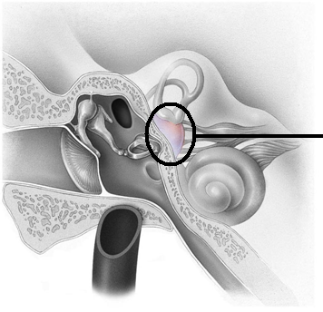
   1. Bony labyrinth
   2. Vestibule
   3. Cochlear egress
   4. Macula
   5. Auditory nerve
2. Identify the structure in the image below

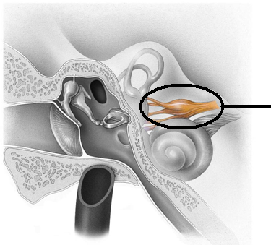

**Station Ten**

1. Identify the structure in the box below
   1. Modiolus
   2. Stereocilia
   3. Tunica media
   4. Vestibular nerve
   5. 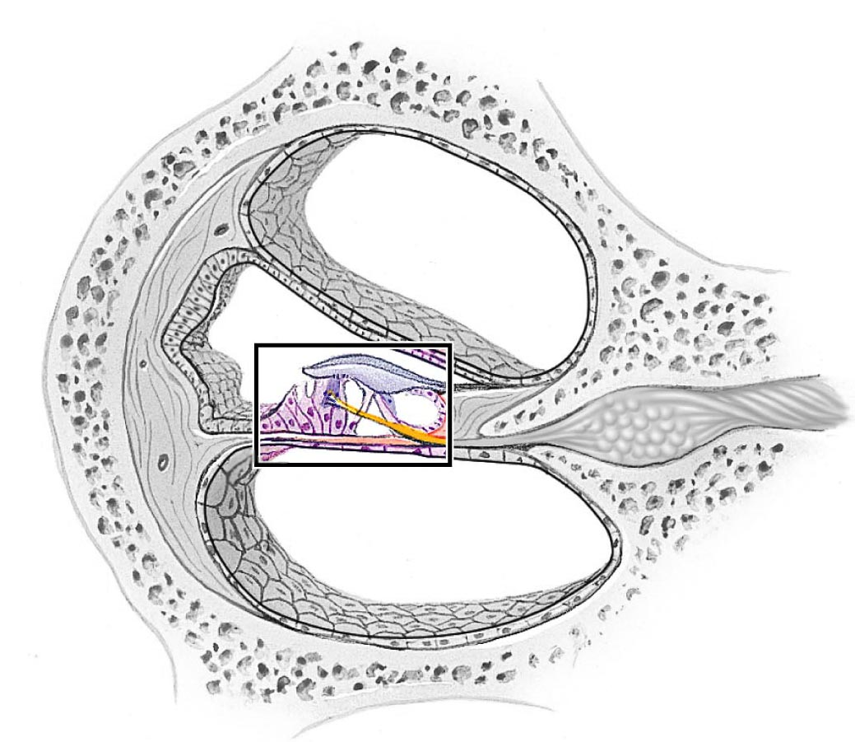Organ of corti
2. If the options below reflect the scores from a visual acuity test, which one has the worst vision?
   1. 20/20
   2. 20/15
   3. 20/5
   4. 20/30
   5. 20/100

**Station Eleven**

1. When you asked your lab partner to stick out their tongue, which cranial nerve was being tested?
   1. Vestibulocochlear VIII
   2. Hypoglossal XII
   3. Glossopharyngeal IX
   4. Vagus X
   5. Spinal Accessory XI
2. Which cranial nerve is responsible for pain and temperature from the face (forehead, cheek, etc)?

**Station Twelve**

1. What is the function of the fluid found in the posterior chamber of the eye
   1. Provides nutrients to the cornea
   2. Holds the pupil open
   3. Presses the retina against the inner walls of the eye
   4. Provides an antibody-rich material to protect the eye
   5. Keeps the cornea moist and lubricated
2. 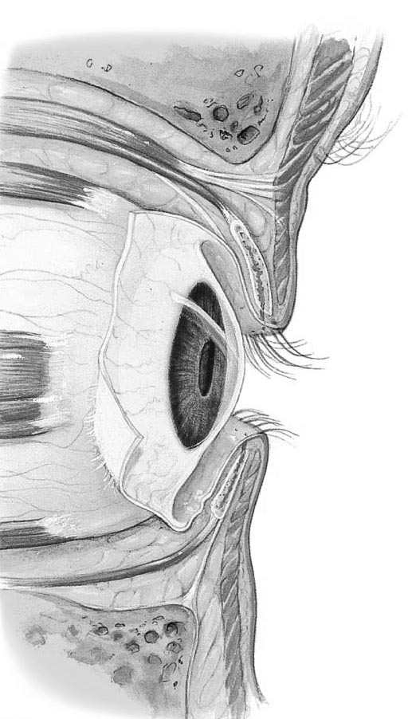 Identify the structure that covers the surface of the eye as well as the eyelids
   1. Cornea
   2. Sclera
   3. Conjunctiva
   4. Canal of Schlemm
   5. Iris

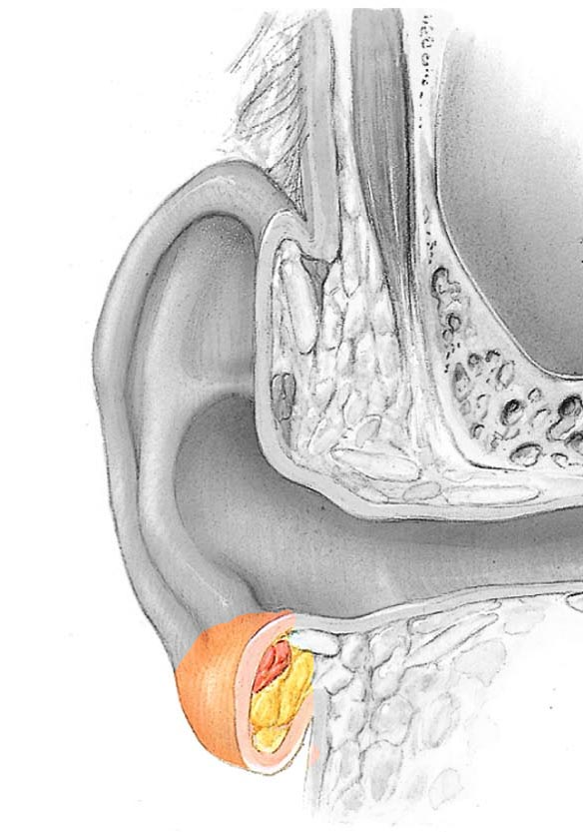**Station Thirteen**

1. Identify the structure
   1. Tragus
   2. Lobe
   3. Helix
   4. Antihelix
   5. Codon
2. Weber’s test had you place a tuning fork on a mid-line structure of your lab partner’s head. What was it testing for?
   1. To see if there was a visual deficit
   2. To see if air conduction was greater than bone conduction
   3. To see if bone conduction was greater than air conduction
   4. To see if hearing loss is a result of conductive impairment or a sensory deafness
   5. Olfactory acuity

**Station Fourteen**

1. Which direction would the inferior oblique muscle cause the eye to move?