Comment: For version two of the lab quiz, all of the markers/anatomy questions have remained the same. If you want to add in a different structure to identify, you are welcome to.

Station One: questions

Station two: eye, marker at cornea

Station three: eye, marker at medial rectus muscle, question

Station four: Microscope: Monkey retina slide, question

Station five: questions

Station six: eye, marker indicating sclera, question

Station seven: image provided

Station eight: image provided

Station nine: image provided

Station ten: image provided

Station eleven: questions

Station twelve: image provided

Station thirteen: image provided

Station fourteen: question

Answer key

1. D provides vascular supply: oxygen and nutrients
2. C tapetum lucidum
3. Cornea
4. Lateral rectus
5. B Abducens VI
6. Retina (monkey retina)
7. Ciliary body
8. B neural tunic
9. sclera
10. E Lateral geniculate nucleus
11. A Facial VII
12. E Facial VII
13. D scala tympani
14. E tiny bones
15. B vestibule
16. Vestibular nerve. Do not accept vestibulocochlear, auditory, or cochlear.
17. E organ of corti
18. E 20/100
19. B Hypoglossal XII
20. Cones. They contribute to acute vision
21. C holds retina
22. C conjunctiva
23. B lobe
24. D conductive/sensory
25. Cranial Nerve V: Trigeminal: Answer can be either sensory to the face (light touch) or muscles of mastication: clenching jaw, imitate chewing. Any answer that suggests one of the functions limited to the Trigeminal nerve is fine. They do not have to have a sensory AND a motor test.

Name_________________________________________________

1. Circle one: a b c d e
2. Circle one: a b c d e
3. ________________________________________________________________
4. ________________________________________________________________
5. Circle one: a b c d e
6. ________________________________________________________________
7. ________________________________________________________________
8. Circle one: a b c d e
9. ________________________________________________________________
10. Circle one: a b c d e
11. Circle one: a b c d e
12. Circle one: a b c d e
13. Circle one: a b c d e
14. Circle one: a b c d e
15. Circle one: a b c d e
16. _______________________________________________________________
17. Circle one: a b c d e
18. Circle one: a b c d e
19. Circle one: a b c d e
20. ________________________________________________________________
21. Circle one: a b c d e
22. Circle one: a b c d e
23. Circle one: a b c d e
24. Circle one: a b c d e

**Station One**

1. What is the function of the choroid layer of the eye?
   1. Produces vitreous humor
   2. Anchors the retina
   3. Produces aqueous humor
   4. Provides the oxygen and nutrients to the retina
   5. Produces cerebrospinal fluid
2. Which layer of the eye is responsible for the glowing eyes seen in animals?
   1. Retina
   2. Sclera
   3. Tapetum lucidum
   4. Basement membrane
   5. Conjunctiva

**Station Two**

1. Identify the structure marked on the eye. In a living organism, this structure is clear and aids in protecting the eye.

**Station Three**

1. There are six extrinsic eye muscles: this muscle causes the eye to look away from midline
2. Which cranial nerve is responsible for the muscle identified in question 4?
   1. Optic
   2. Abducens
   3. Oculomotor
   4. Trochlear
   5. Trigeminal

**Station Four**

1. Identify the image on the slide

**Station Five**

1. Identify the highlighted structure below:

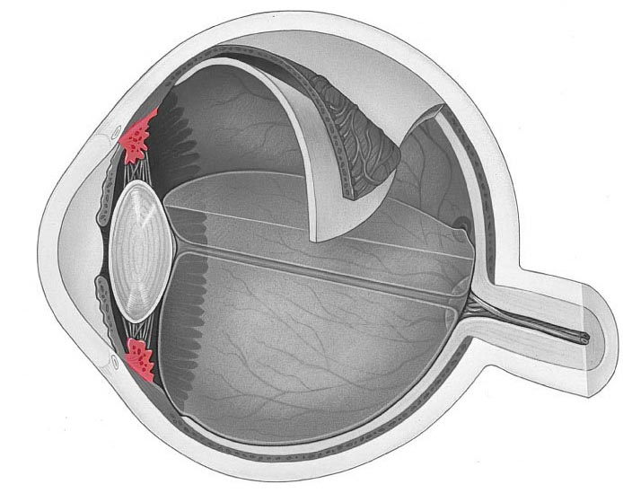

1. Identify the highlighted structure below
   1. Fibrous tunic
   2. Neural tunic
   3. Vascular tunic
   4. Cotton tunic
   5. 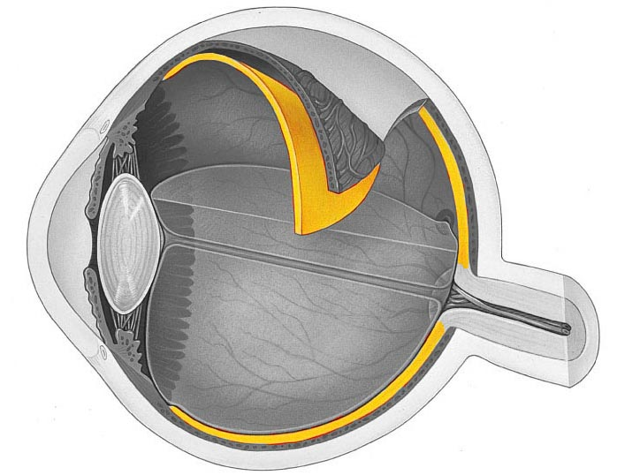iTunic

**Station Six**

1. Identify the structure indicated
2. Which structure is not part of the auditory pathway?
   1. Cochlear nuclei
   2. Superior olivary nucleus
   3. Inferior colliculus
   4. Temporal cortex
   5. Lateral geniculate nucleus

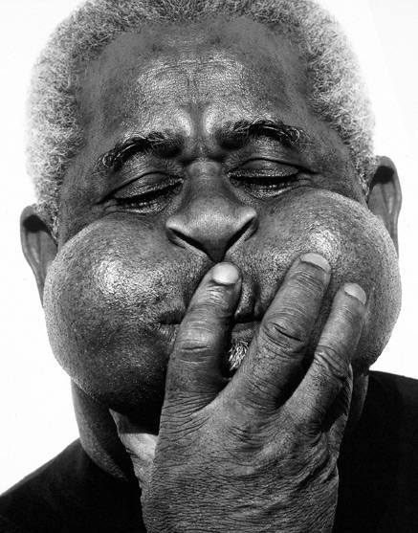**Station Seven**

1. In the above image, Dizzy Gillespie is using his orbicularis oculi muscle to close his eyes. Which cranial nerve is innervating this muscle?
   1. Facial VII
   2. Trigeminal V
   3. Oculomotor III
   4. Trochlear IV
   5. Glossopharyngeal IX
2. In the image, Dizzy Gillespie is also puffing out his cheeks and pursing his lips. The buccal muscle and the orbicularis oris allow this to happen. Which cranial nerve is responsible?
   1. Trigeminal V
   2. Glossopharyngeal IX
   3. Vagus X
   4. Spinal Accessory XI
   5. Facial VII

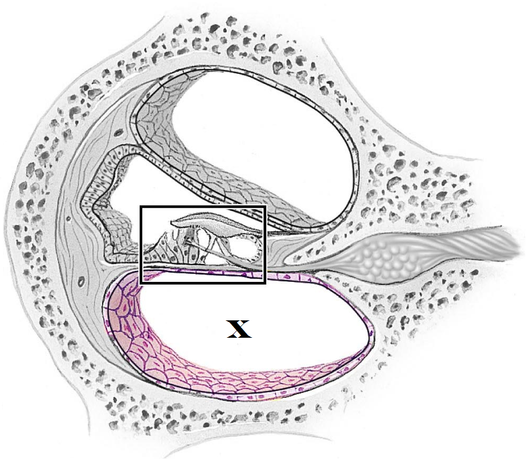

**Station Eight**

1. The “x” in the above image is located in which region?
   1. Tympanic membrane
   2. Stapes
   3. Scala media
   4. Scala tympani
   5. Scala vestibuli
2. What are the ossicles?
   1. The small grainy crystals that are found in the utricle and saccule
   2. The region of the inner ear responsible for balance
   3. The region of the inner ear responsible for sensing vertical movement
   4. The region of the middle ear that adapts to loud noises
   5. The small bones responsible for conveying sound from the tympanic membrane to the cochlea

**Station Nine**

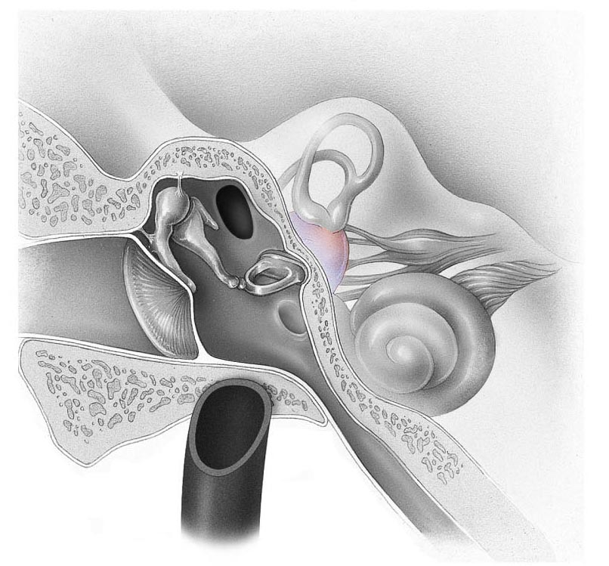

1. Identify the structure in the inner ear
   1. Bony labyrinth
   2. Vestibule
   3. Cochlear egress
   4. Macula
   5. Auditory nerve
2. Identify the structure in the image below

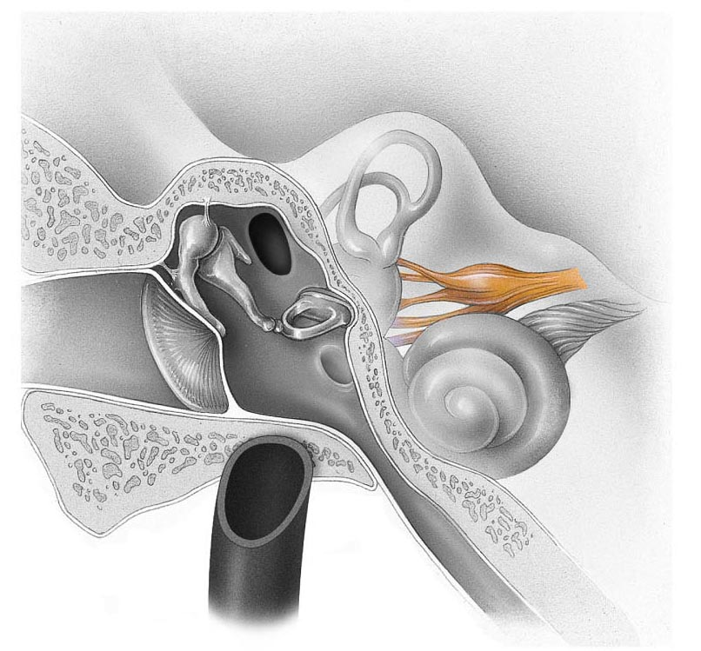

**Station Ten**

1. Identify the structure in the box below
   1. Modiolus
   2. Stereocilia
   3. Tunica media
   4. Vestibular nerve
   5. 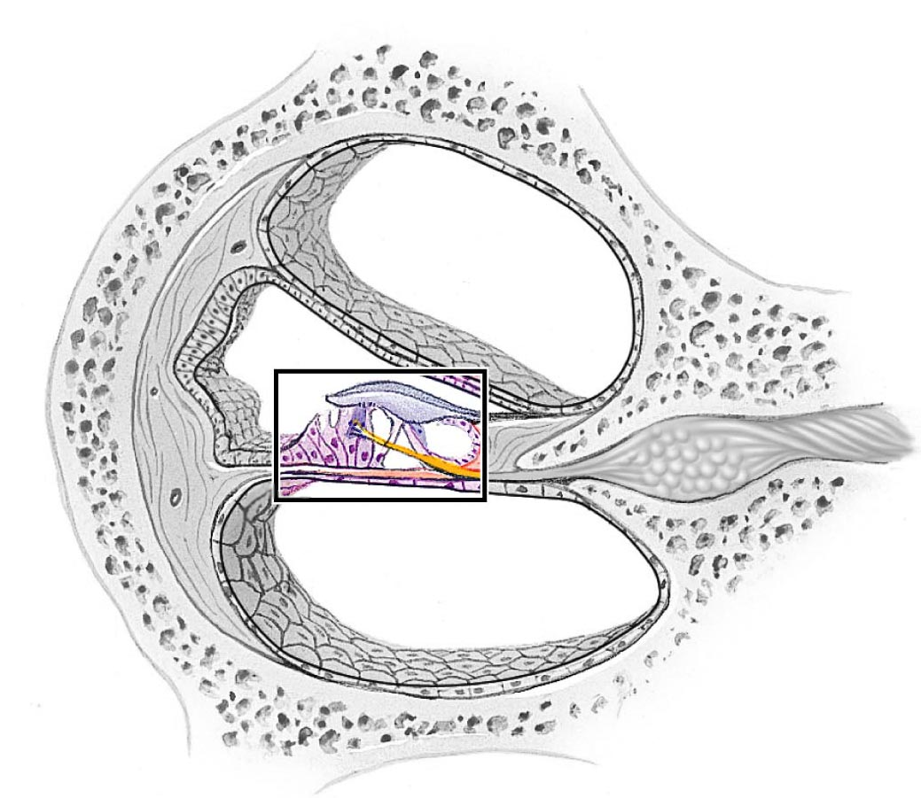Organ of corti
2. If the options below reflect the scores from a visual acuity test, which one has the worst vision?
   1. 20/20
   2. 20/15
   3. 20/5
   4. 20/30
   5. 20/100

**Station Eleven**

1. When you asked your lab partner to stick out their tongue, which cranial nerve was being tested?
   1. Vestibulocochlear VIII
   2. Hypoglossal XII
   3. Glossopharyngeal IX
   4. Vagus X
   5. Spinal Accessory XI
2. What structures within the fovea centralis allow for acute vision?

**Station Twelve**

1. What is the function of the fluid found in the posterior chamber of the eye
   1. Provides nutrients to the cornea
   2. Holds the pupil open
   3. Presses the retina against the inner walls of the eye
   4. Provides an antibody-rich material to protect the eye
   5. Keeps the cornea moist and lubricated
2. 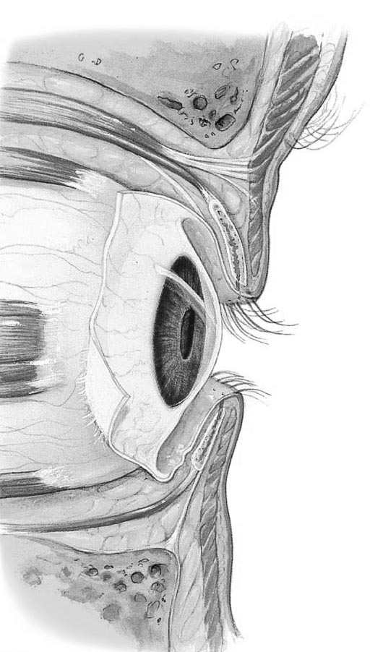 Identify the structure that covers the surface of the eye as well as the eyelids
   1. Cornea
   2. Sclera
   3. Conjunctiva
   4. Canal of Schlemm
   5. Iris

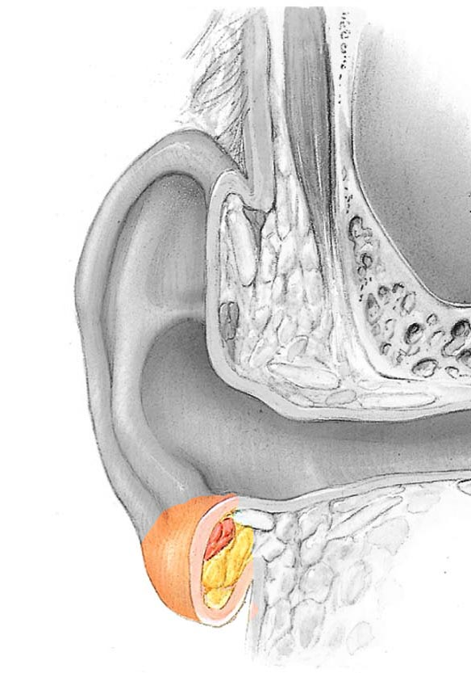**Station Thirteen**

1. Identify the structure
   1. Tragus
   2. Lobe
   3. Helix
   4. Antihelix
   5. Codon
2. Weber’s test had you place a tuning fork on a mid-line structure of your lab partner’s head. What was it testing for?
   1. To see if there was a visual deficit
   2. To see if air conduction was greater than bone conduction
   3. To see if bone conduction was greater than air conduction
   4. To see if hearing loss is a result of conductive impairment or a sensory deafness
   5. Olfactory acuity

**Station Fourteen**

1. How would you test cranial nerve V?

Station Four

Question 6

Identify the image:

