Instructor Set-up:

Station One:

Slide of simple cuboidal epithelium

* 1. Identify the tissue

Description: This tissue has round, centrally located nuclei. It is commonly found in areas for secretion and absorption. This tissue type can be found in the kidneys

Station Two:

Slide of Transitional epithelium

1. Identify the tissue

Description: This tissue’s arrangement allows for it to stretch. It can be found in the ureters

Station Three

Slide of Hyaline Cartilage

1. Identify the tissue

Description: This tissue can be found on the articular surface of bones.

Station Four

Slide of Hyaline Cartilage

Questions based on hyaline cartilage slide:

1. What is the major cell type located in this type of connective tissue?
2. What is the name of the structure in which the cell is located?

Station five:

Slide of Onion Root Tip: Metaphase

1. Identify the stage of mitosis

Station six:

Slide of onion root tip: Prophase

1. Identify the stage of mitosis

Station seven

Slide of stratified squamous epithelium

1. Identify the tissue

Description: This tissue contains a protein called keratin to help prevent abrasions

Station eight

Microscope: Indicate the ocular lens

1. Identify this structure of the microscope

Question based on the ocular lens

1. What is the magnification of this lens alone?

Station nine

Microscope: Indicate the coarse adjust knob

1. Identify this structure on the microscope

Question based on coarse adjust knob

1. At which magnification(s) can the above adjustment knob be used?

Station ten:

Provided Image: Anatomical region: (Patellar)

1. Identify this anatomical region

Question

1. The diaphragm is ________ to the urinary bladder

Station Eleven:

Provided Image: Anatomical region: (antecubital)

1. Identify this anatomical region

Question

1. Consider the cell cycle. At what stage of interphase does DNA replication take place?

Station Twelve

Provided image: Section: (Transverse)

1. Identify the type of section

Question

1. Where is fibrocartilage located?

Station Thirteen

Provided image: Anatomical region: (gluteal)

1. Identify this anatomical region

Question:

1. The wrist is _____________ to the elbow

Station Fourteen

Provided image: Anatomical region: (Lumbar)

1. Identify this anatomical region

Question

1. The heart is _____________ to the lungs

Station Fifteen

Slide of bone/osteon

1. Identify this tissue

Question based on bone slide

1. What is the space in the middle of each Haversian system that allows for blood vessels?

Station Sixteen

Provided image: Anatomical region: (axillary)

1. Identify this anatomical region

Station One

* 1. Identify the tissue in the field of view

Description: This tissue has round, centrally located nuclei. It is commonly found in areas for secretion and absorption. This tissue type can be found in the kidneys

Station Two

* 1. Identify the tissue in the field of view

Description: This tissue’s arrangement allows for it to stretch. It can be found in the ureters

Station Three

* 1. Identify the tissue in the field of view

Description: This tissue can be found on the articular surface of bones.

Station Four

Observe the tissue in the field of view and answer the following questions based on it

* 1. What is the major cell type located in this type of connective tissue?
  2. What is the name of the structure in which the cell is located?

Station Five

* 1. Identify the stage of mitosis seen on the slide

Station Six:

* 1. Identify the stage of mitosis seen on the slide

Station Seven

* 1. Identify the tissue in the field of view

Description: This tissue contains a protein called keratin to help prevent abrasions

Station Eight

* 1. Identify the structure indicated on the microscope
  2. What is the magnification of this lens alone?

Station Nine

* 1. Identify this structure on the microscope
  2. At which magnification(s) can the above adjustment knob be used?

1. 10X
2. 40X
3. 100X
4. 400X
5. 1000X

Station Ten

* 1. Identify the anatomical region shown below

1. popliteal
2. sural
3. crural
4. tarsal
5. 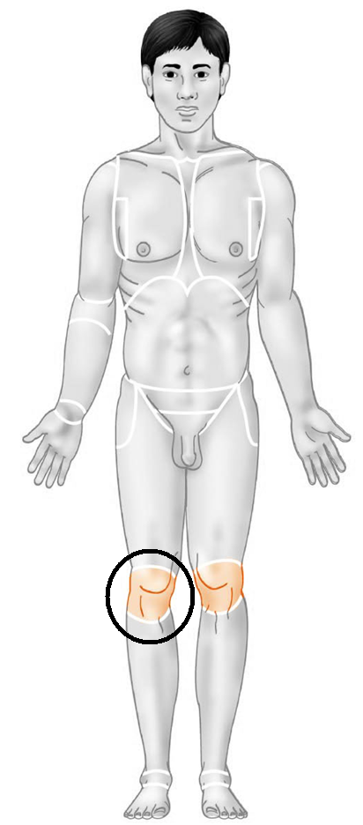patellar
   1. The diaphragm is ____________ to the bladder
6. Inferior
7. Superior
8. Lateral
9. Medial
10. Distal

Station Eleven

* 1. Identify the anatomical region shown below

a. Cubital

b. Axillary

1. Antebrachial
2. Antecubital
3. Carpal
   1. 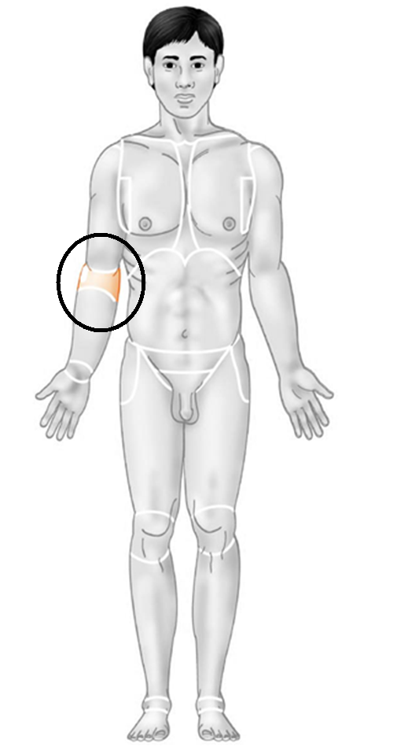 Consider the cell cycle.   
      At what stage of interphase does DNA replication take place?
4. S
5. G1
6. G2
7. Cytokinesis
8. Prophase

Station Twelve

* 1. Identify the section (plane) in the image below
  2. Where is fibrocartilage located?

1. In the nose
2. Pinna of the ear
3. 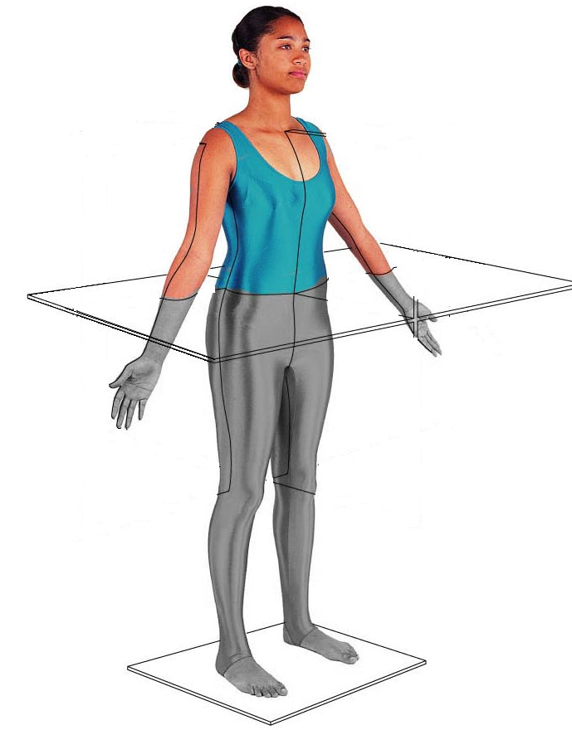Intervertebral disks
4. Epiglottis
5. Small intestine

Station Thirteen

* 1. Identify the anatomical region below

1. Hamstring
2. Lumbar
3. 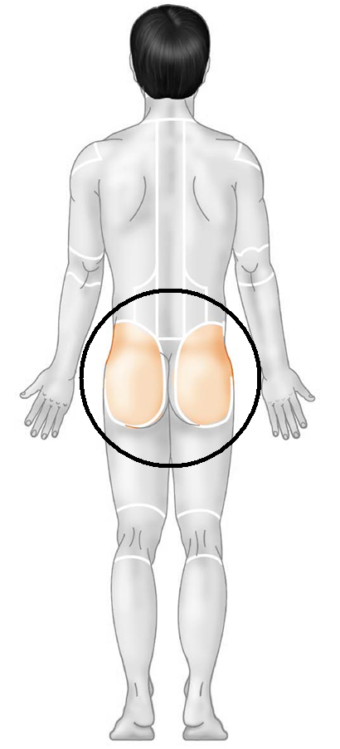Groin
4. Gluteal
5. Posterior
   1. The wrist is __________ to the elbow
6. Superior
7. Distal
8. Medial
9. Proximal
10. Deep

Station Fourteen

* 1. Identify the anatomical region below:

1. Vertebral
2. 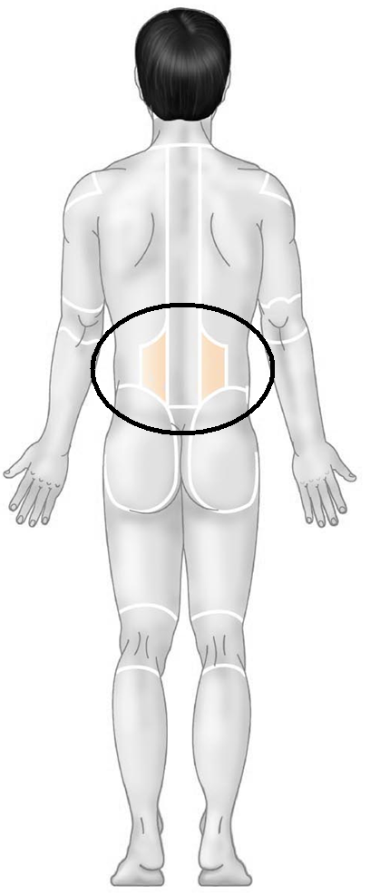Lumbar
3. Gluteal
4. Flank
5. Hypodorsal
   1. The heart is ________ to the lungs
6. Superficial
7. Deep
8. Inferior
9. Medial
10. Lateral

Station Fifteen

* 1. Identify the tissue in the field of view
  2. What is the name of the structure located in the middle of each unit which allows for blood vessels to pass through?

Station Sixteen

25. Identify this anatomical region

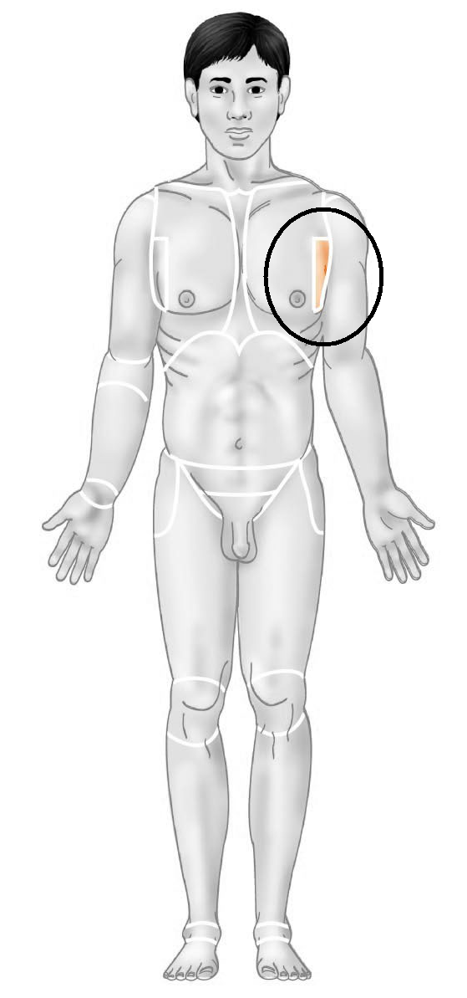a. apical

b. acromial

c. axillary

d. antebrachial

e. pectoral