Instructor Set-up:

Station One:

Slide of simple cuboidal epithelium

Station Two:

Slide of Transitional epithelium

Station Three

Slide of Elastic Cartilage

Station Four

Question: “parfocal”

Question: Special connective tissues

Station five:

Slide of Onion Root Tip: Anaphase

Station six:

Slide of onion root tip: Metaphase

Station seven

Slide of stratified squamous epithelium

Station eight

Microscope: Indicate the ocular lens

Question based on the ocular lens

Station nine

Microscope: Indicate the coarse adjust knob

Question based on coarse adjust knob

Station ten:

Provided Image: Anatomical region: sternal

Question

Station Eleven:

Provided Image: Anatomical region: (femoral)

Question

Station Twelve

Provided image: Section: (Transverse)

Question

Station Thirteen

Provided image: Anatomical region: (gluteal)

Question:

Station Fourteen

Provided image: Anatomical region: (olecranal)

Question

Station Fifteen

Slide of bone/osteon

Question based on bone slide

Station Sixteen

Provided image: Anatomical region: (pelvic)

Quiz One Answer Key

Please write all responses as clearly as possible.

1. ____simple cuboidal epithelium___________________
2. ____transitional epithelium_______________________
3. Circle one: d
4. Circle One: d
5. __accept one: bone, blood, or cartilage_____________
6. __anaphase___________________________________
7. _________metaphase___________________________
8. _____stratified squamous epithelium_______________
9. ___ocular lens_________________________________
10. __Magnification of 10X_________________________
11. __Coarse adjust knob___________________________
12. Circle One: b
13. Circle One: c
14. Circle One: b
15. ______femoral. Do not accept “thigh”_____________
16. Circle One: b
17. ___transverse_________________________________
18. Circle One: c
19. Circle One: a
20. Circle One: b
21. Circle One: d
22. Circle One: d
23. _bone________________________________________
24. _Central canal or Haversian canal__________________
25. Circle One: c

Quiz One Name_______________________________________

Date_____________

Please write all responses as clearly as possible.

1. ______________________________________________
2. _____________________________________________
3. Circle one: a b c d e
4. Circle One: a b c d e
5. _____________________________________________
6. _____________________________________________
7. _____________________________________________
8. _____________________________________________
9. _____________________________________________
10. _____________________________________________
11. _____________________________________________
12. Circle One: a b c d e
13. Circle One: a b c d e
14. Circle One: a b c d e
15. _____________________________________________
16. Circle One: a b c d e
17. _____________________________________________
18. Circle One: a b c d e
19. Circle One: a b c d e
20. Circle One: a b c d e
21. Circle One: a b c d e
22. Circle One: a b c d e
23. _____________________________________________
24. _____________________________________________
25. Circle One: a b c d e

Station One

* 1. Identify the tissue in the field of view

Description: This tissue has round, centrally located nuclei. It is commonly found in areas for secretion and absorption. This tissue type can be found in the kidneys

Station Two

* 1. Identify the tissue in the field of view

Description: This tissue’s arrangement allows for it to stretch. It can be found in the ureters

Station Three

* 1. Identify the tissue in the field of view

Description: This tissue can be found in the ear and epiglottis

1. Hyaline cartilage
2. Transitional epithelium
3. Dense irregular connective tissue
4. Elastic cartilage
5. Fibrocartilage

Station Four

* 1. The microscopes you use in lab are parfocal. What does this mean?

1. They have two ocular lenses
2. They have three objective lenses
3. They automatically correct an inverted image
4. They can go from one objective lens to the next with minimal focusing
5. They can go from one objective lens to the next without diminishing the light source
   1. Connective tissues are divided into “Connective tissue proper” and “Special.” Name **one** of the special connective tissues.

Station Five

* 1. Identify the stage of mitosis seen on the slide

Station Six:

* 1. Identify the stage of mitosis seen on the slide

Station Seven

* 1. Identify the tissue in the field of view

Description: This tissue contains a protein called keratin to help prevent abrasions

Station Eight

* 1. Identify the structure indicated on the microscope
  2. What is the magnification of this lens alone?

Station Nine

* 1. Identify this structure on the microscope
  2. At which magnification(s) can the above adjustment knob be used?

1. 10X
2. 40X
3. 100X
4. 400X
5. 1000X

Station Ten

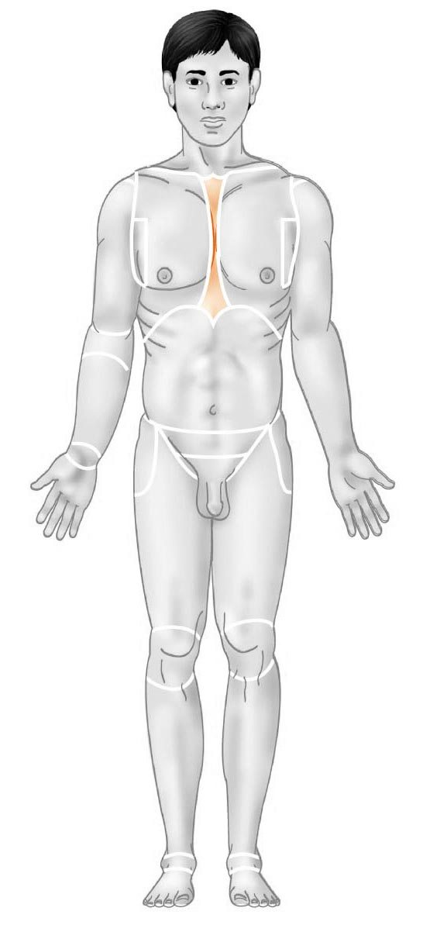

* 1. Identify the anatomical region shown

1. pectoral
2. sural
3. sternal
4. tarsal
5. mental
   1. The diaphragm is ____________ to the bladder
6. Inferior
7. Superior
8. Lateral
9. Medial
10. Distal

Station Eleven

* 1. 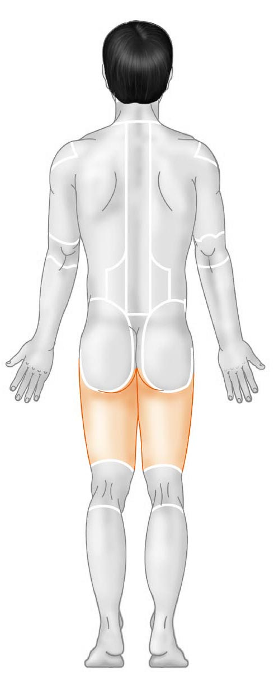 Identify the anatomical region shown
  2. At which stage do the chromosomes first begin to appear in mitosis?

1. Cytokinesis
2. Prophase
3. Metaphase
4. G1 of interphase
5. Anaphase I

Station Twelve

* 1. Identify the section (plane) in the image below
  2. Where is fibrocartilage located?

1. 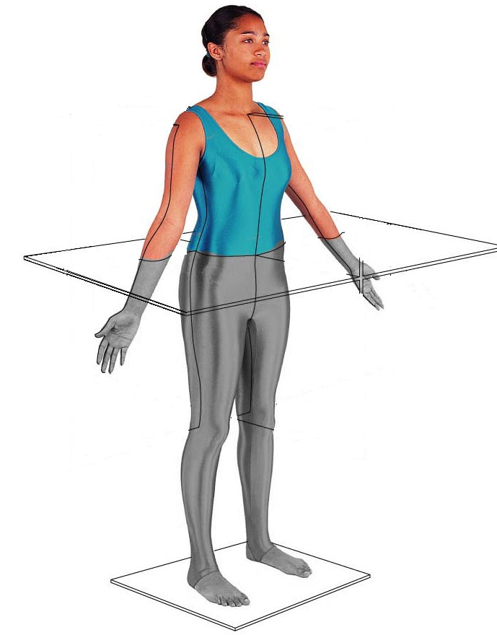 In the nose
2. Pinna of the ear
3. Intervertebral discs
4. Epiglottis
5. Small intestine

Station Thirteen

* 1. Identify the anatomical region below

1. Gluteal
2. Posterior
3. Hamstring
4. Lumbar
5. 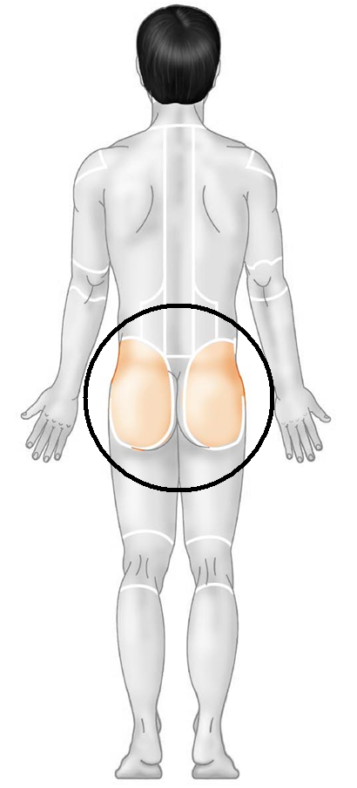Groin
   1. The elbow is __________ to the shoulder
6. Superior
7. Distal
8. Medial
9. Proximal
10. Deep

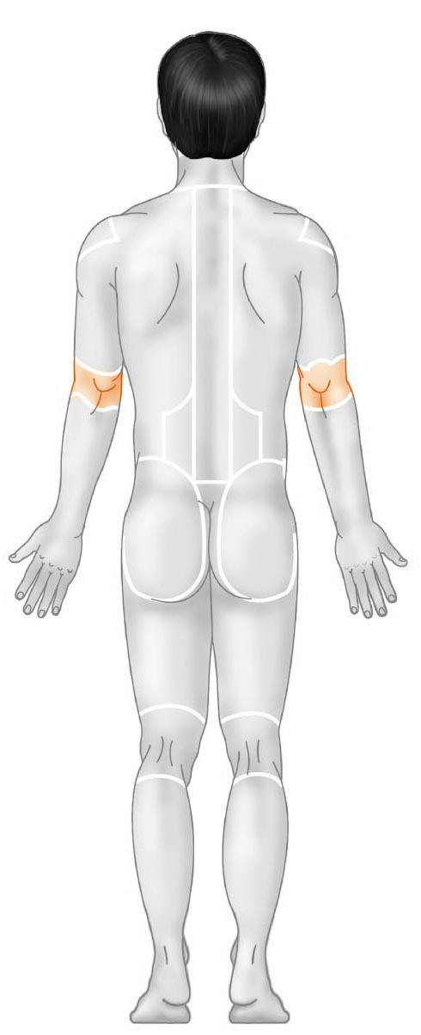Station Fourteen

* 1. Identify the anatomical region:

1. Cubital
2. Antecubital
3. Hypobrachial
4. Olecranal
5. Antebrachial
   1. The heart is ________ to the lungs
6. Superficial
7. Deep
8. Inferior
9. Medial
10. Lateral

Station Fifteen

* 1. Identify the tissue in the field of view
  2. What is the name of the structure located in the middle of each unit which allows for blood vessels to pass through?

Station Sixteen

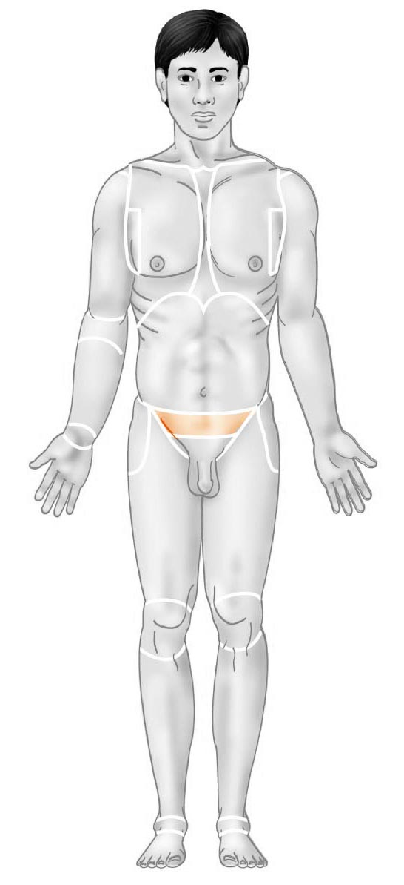

25. Identify this anatomical region

* 1. inguinal
  2. abdominal
  3. pelvic
  4. hypogastric
  5. pubic