**BSC 182**

**Exam Three**

Reminder: There is **one correct answer for each question**. All questions are weighted equally. Please keep your exam and Op-scan as covered as possible.

1. Which of the following is **true** for lymphatic capillaries?
2. lymphatic capillaries dump directly into the right collecting duct
3. the lymphatic are more permeable than circulatory capillaries
4. a high interstitial tissue pressure will draw fluid out of the lymphatic capillaries
5. lymphatic capillaries are found in bones, marrow, and the central nervous system
6. lymphatic capillaries are not found in the extremities
7. This collecting duct is the larger and longer of the two. It begins around the level of the second lumbar vertebra.
8. Right Lymphatic Duct
9. Thoracic Duct
10. Left Lymphatic Duct
11. Azygous Duct
12. Rubber Duct
13. **Skeletal muscle contraction** aids in lymph movement by
14. decreasing abdominal pressure and increasing thoracic pressure
15. Increasing heart rate
16. Causing a decrease in interstitial pressure
17. Resulting in the release of epinephrine which results in lympho-constriction
18. Causing pressure to be placed on the lymph vessels, squeezing lymph from one valved section to the next.
19. **Germinal Centers,** whether in diffuse lymphoid tissue or in a lymph node will have contain which material?
20. erythrocytes
21. Thymosins
22. eosinophils
23. B cells
24. activated NK cells
25. The thymus
26. produces hormones associated with lipid metabolism
27. is the location where the neutrophils are formed
28. is a rigid structure located near the spleen
29. loses immune function as we age
30. educates the lymphocytes that will become B cells
31. Which is the largest **lymphatic** organ?
32. liver
33. spleen
34. lymph node
35. skin
36. thymus
37. Which antibody composes 80% of the immunoglobulins in circulation?
38. IgA
39. IgM
40. IgE
41. IgD
42. IgG
43. Which **two** types of white blood cells are going to be most often found in lymph nodes? (Identify the correctly numbered responses and find them in the five lettered options below.

1. Eosinophil

2. Basophil

3. Macrophage

4. Lymphocyte

5. Erythrocyte

1. 1 & 2
2. 3 & 5
3. 2 & 4
4. 4 & 5
5. 3 & 4
6. The red pulp of the spleen contains
7. Dendritic cells
8. Red blood cells and Macrophages
9. Eosinophils
10. Red blood cells only
11. Monocytes
12. With regards to a lymph node, there will be
13. Many afferent lymph vessels; one (or two) efferent lymph vessels
14. Many afferent lymph vessels; no efferent lymph vessels
15. One afferent lymph vessel; many efferent lymph vessels
16. Many afferent lymph vessels; many efferent lymph vessels
17. One afferent lymph vessel; one efferent lymph vessel
18. Which of the following is a non-specific (innate) defense?
19. interferon
20. fever
21. enzyme action
22. phagocytosis
23. all of the above
24. Which of the following is true of fever? (Identify the correctly numbered responses and find them in the five lettered options below.
25. iron becomes more abundant
26. iron becomes sequestered
27. zinc becomes more abundant
28. phagocytic cells increase their activity
29. phagocytic cells decrease their activity
    1. 1, 3, & 5
    2. 2,3, & 5
    3. 1 & 3
    4. 2 & 4
    5. 4
30. A hapten
31. stimulates the innate defenses only
32. causes a strong autoimmune response
33. is an incomplete antigen
34. stimulates the Regulator T cells
35. causes a strong immune response
36. With regards to T cells, which of the following is true? Identify the correctly numbered responses and find them in the five lettered options below.
37. Named for where they develop in the thyroid
38. Are one of the agranulocytic white blood cells
39. Compose about 80% of the monocytes
40. Can be located in white pulp of lymph node
41. Named for where they develop in the thymus
    1. 1, 2, 4
    2. 1, 3
    3. 2, 3, 4
    4. 2, 5
    5. 2, 4, 5

1. Which antibody can pass through the placental barrier and provide __________________ for a fetus?
2. IgD; humoral immunity
3. IgG; active immunity
4. IgA; passive immunity
5. IgM; active immunity
6. IgG; passive immunity
7. Inflammation results in the body responding in the following sequence to allow phagocytosis:
   1. Chemotaxis, margination, Leukocytosis, diapedesis
   2. Leukocytosis, margination, chemotaxis, diapedesis
   3. Diapedesis, Leukocytosis, chemotaxic, margination
   4. Margination, diapedesis, chemotaxis, Leukocytosis
   5. Leukocytosis, margination, diapedesis, chemotaxis
8. With a **secondary** immune response, how long before antibodies **peak**?
9. From three to five years
10. Two or three days
11. Ten to fourteen days
12. More than two weeks
13. antibodies will not be released with a secondary immune response, but antigens will
14. Which of the following is true regarding **antigens**? Identify the correctly numbered responses and find them in the five lettered options below. You will indicate **only ONE letter** for a correct response.

1. all parts of an antigen are immunogenic

2. no part of an antigen is immunogenic

3. foreign antigens can stimulate lymphocytes and antibodies

4. foreign antigens must be able to interact with the lymphocytes and antibodies

5. all antigens are considered both complete and foreign.

1. 1, 3, 5
2. 1, 3
3. 2, 5
4. 3, 4
5. 4, 5
6. During a T cell’s education, if it does not attack **self**-antigens,
   1. it will be destroyed immediately
   2. it will be destroyed if it comes in contact with an APC.
   3. it will be kept if it can recognize MHC
   4. it will be kept if it does not recognize MHC
   5. it will be destroyed if it recognizes MHC
7. Which type of cell is responsible for producing and releasing antibodies?
   1. Helper T cell
   2. Plasma cells
   3. NK cells
   4. Suppressor B cell
   5. Lymphoctyes
8. Which chemicals released by the Helper T cell will stimulate the B cell to become activated and begin the cloning process
   1. lysosymes
   2. defensins
   3. cytokines
   4. perforins
   5. interferons
9. Reed-Sternberg cells are associated with which disorder?
   1. Lymphedema
   2. Hodgkin’s Disease
   3. Mononucleosis
   4. Elephantiasis
   5. Non-Hodgkin’s Lymphoma
10. Receiving a flu shot that has viral antigens or an attenuated virus is an example of
11. artificially acquired active immunity
12. artificially acquired passive immunity
13. naturally acquired active immunity
14. naturally acquired passive immunity
15. Which of the following is true with regards to memory cells?
    1. They used to be called suppressor cells
    2. are responsible for the rapid, amplified response following a second exposure
    3. Only B cells make them.
    4. Only T cells make them
    5. They are stored in the thyroid for activation
16. Where are the Peyers Patches located?
    1. At the base of the tongue
    2. In the esophageal lining
    3. In the mucosa of the small intestine.
    4. Along the mucosa of the respiratory system
    5. In the submucosa of the reproductive system
17. Which of the following is true with regards to IgD
    1. it is responsible for blood agglutination
    2. it is located on the B cell surface
    3. it activates the complement in the plasma
    4. it is found in breast milk
    5. it is found in digestive secretions
18. MHC class I proteins are found ______; MHC class II proteins are found _______
    1. On all B cells, on all T cells
    2. On almost all macrophages, on almost all neutrophils
    3. On almost all body cells, on immune cells
    4. On almost all mucosal cells, on all submucosal cells
    5. On APCs; on Helper T cells
19. Which **two types** of Ig formations can exist as something other than a monomer? Identify the correctly numbered responses and find them in the five lettered options below. You will indicate **only ONE letter** for a correct response.

1. IgG

2. IgA

3. IgM

4. IgE

5. IgD

1. 1, 4
2. 2, 3
3. 5
4. 3, 4
5. 2, 5
6. Neutralization is
7. something that antibodies do to viruses and bacteria to reduce their toxicity
8. something that T cells do to increase phagocytosis
9. something that antibodies do to get soluble materials to come out of solution
10. something that NK cells do to destroy an infected body cell
11. something that B cells do to go back to their resting state
12. The complement proteins, when activated by the antibodies, destroy cells by
    1. apoptosis
    2. stopping mitosis
    3. lysis
    4. precipitation
    5. excessive flattery
13. Interleukin 1 causes _______ while Interleukin 2 causes ________
    1. enzyme release, cell growth
    2. cell growth, activation of suppressor cells
    3. more receptors for IL-2 to be made, T cell division
    4. suppression of repressor cells; activation of enzymes
    5. cloning; cloning to be stopped.
14. Cytotoxic T cells attack and destroy
15. bacteria directly
16. parasitic worms
17. viruses only
18. body cells that have bacteria or viruses infecting them
19. everything with a foreign antigen
20. Mononucleosis is a great example of a cell mediated response because
21. our infected B cells attack our T cells
22. our plasma cells release antibodies against our infected B cells
23. our T cells attack our infected B cells
24. our NK cells attack our Helper T cells
25. mononucleosis does not demonstrate any kind on cell mediated responses.
26. Elephantiasis is caused by
    1. reverse transcriptase
    2. the pachydermatitis complex
    3. parenchymal reabsorption
    4. a parasitic roundworm
    5. idiopathic edema
27. Cells with the CD4 receptor will become
    1. Helper T cells
    2. Cytotoxic T cells
    3. Natural Killer Cells
    4. Plasma Cells
    5. Antigen Presenting Cells
28. How does interferon affect the surrounding cells?
    1. activates the manufacture of antiviral proteins in nearby cells
    2. 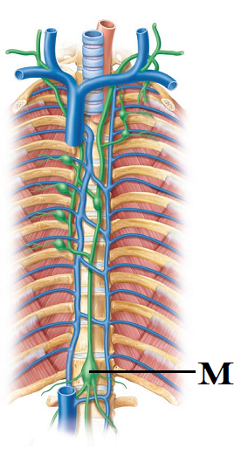causes the transformation of a Helper T cell into a Cytotoxic T cell
    3. stimulates the proliferation of plasma cells
    4. sequesters iron
    5. causes the degeneration the original viral components
29. What’s a lacteal?
30. specialized lymphatic vessel found in mammary glands
31. specialized structure in which red blood cells mingle with the lymph fluids to provide oxygen
32. the new lymphatic vessels formed in wound repair
33. lymphatic tissue specific to cancer growth
34. the location in the digestive system into which fats are absorbed
35. Identify “M”
    1. Crista Terminalis
    2. Corpus callosum
    3. Hemizygous trunk
    4. Cisterna chyle
    5. Glottal sinus
36. Which structure is responsible for embryonic hematopoesis? (makes the blood cells in an embryo)
    1. Red bone marrow
    2. Placenta
    3. Thymus
    4. Spleen
    5. Yellow bone marrow
37. Rex has received transplanted tissue from his identical twin. What type of procedure did he have?
    1. Autograft
    2. Xenograft
    3. Allograft
    4. Isograft
    5. Stefigraft
38. The function of a regulatory T cell is to
    1. Encourage B cell proliferation
    2. Control the rate of interleukin released from APCs
    3. Manage the number of clones transitioning to plasma cells
    4. Dampen the overall immune response
    5. Stimulate glucose release into the blood stream
39. The four steps of an antibody’s function are listed as its “plan” of attack. Which of the following is **incorrectly** paired?
    1. P = Precipitation
    2. L = Lysis by compliment
    3. A = Activation of Granzymes
    4. N = Neutralization
    5. all of the above options are correct
40. Which of the following cells can act as an Antigen Presenting Cell?

1. Natural Killer Cell

2. Mast Cell

3. Fibroblast

4. Macrophage

5. Dendritic Cell

1. 1, 3, 4
2. 2, 4, 5
3. 4
4. 4, 5
5. 1, 2
6. As NK cells circulate, what signs of abnormality will they respond to?

1. Antibodies that have tagged a cell

2. Any type of foreign antigen

3. MHC II

4. body cells missing mitochondria

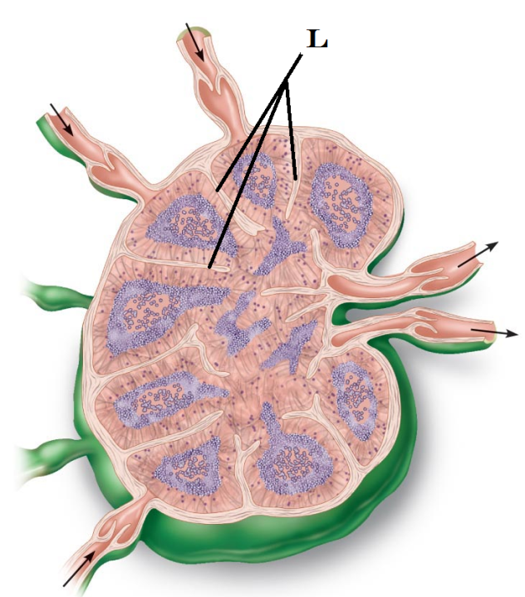 5. cells that appear stressed and have altered markers

1. 1, 2, 4, 5
2. 2, 4, 5
3. 2, 3
4. 1, 5
5. 2, 3, 4
6. Identify “L”
   1. Trabeculae
   2. Splenic sinus
   3. Tunica Germinativum
   4. Medulla
   5. Intralymphatic capillaries
7. The **lymphatic trunks**
8. will dump lymphatic fluid into two collecting ducts
9. will dump lymphatic fluid directly into the left atrium
10. will dump lymphatic fluid into the Left Subclavian Vein
11. will dump lymphatic fluid into four collecting ducts
12. will dump lymphatic fluid directly into the right atrium
13. If a T cell is described as being “immunocompetent,” what does that mean?
14. That it has never been exposed to a pathogen
15. That it is able to recognize and bind to a specific antigen
16. It is able to immediately manufacture antibodies upon stimulation
17. It has only MHC class I receptors on its cell surface
18. It has the ability to suppress autoimmune responses.
19. Cytotoxic T cells (Tc)and NK cells use similar methods to destroy altered cells. Identify the **false** statement in the list below.
    1. Tc cells bind to cells with antigens and release destruktin
    2. Tc cells bind to cells with antigens and release granzymes
    3. Tc cells bind to cells with antigens and release perforin
    4. Tc cells bind to cells with antigens and cause apoptosis
    5. The chemicals that Tc release reacts with calcium to create pores in the cell
20. The first step of T cell activation is binding to the antigen on the APC. The second step of activation is
    1. Co-stimulatory signal from an antigen
    2. Co-stimulatory signal from the APC
    3. Recognition of the MHC
    4. Release of complement proteins from the cell
    5. The destruction of the antigen on the APC
21. Your child (or little sister/brother) has a mild/moderate fever. From what you’ve learned in class, which steps should be taken? Even thought this was not specifically covered in the notes, apply what you’ve learned about fever and the immune response to answer the question.

1. Immediately give antibiotics to kill the bacteria

2. Wait about three days before giving antibiotics when needed

3. Never give antibiotics to children

4. Immediately reduce a mild/moderate fever

5. Give the child aspirin

6. Make the child comfortable, monitor the fever, and let it run its course

1. 1, 5
2. 2, 4
3. 2, 6
4. 3, 5
5. 5, 6

**Please double check to make sure your name and information in on your OpScan form. Double check to make sure both your name and ID are bubbled in on the form. Enjoy the rest of your afternoon.**