**BSC 182**

**Exam Four**

1. The only *external visible* part of the respiratory system is the
   1. Glottis
   2. Thyroid cartilage
   3. True vocal folds
   4. Oropharynx
   5. Nose
2. Dyspnea means ____, and apnea means _____
   1. fast breathing; slow breathing
   2. difficulty breathing; no breathing
   3. slow breathing; fast breathing
   4. controlled breathing; uneven breathing
   5. no breathing; difficulty breathing
3. Which of the following are true
4. Internal respiration takes place at the lungs
5. External respiration takes place at the lungs
6. Internal respiration takes place at a body cell
7. External respiration takes place at a body cell
8. External respiration is the movement of air in to and out of the lungs
   1. 1 and 4
   2. 2 and 3
   3. 1 and 2
   4. 3 and 4
   5. 3 and 5
9. This tube of skeletal muscle runs from the base of the skull to the sixth cervical vertebra. It connects to the nasal cavity and mouth superiorly and to the esophagus and larynx inferiorly
   1. Strap muscles
   2. Paranasal sinuses
   3. Pharynx
   4. Hyoid
   5. Trachea
10. Which the following is **not** a paired laryngeal cartilage?
    1. Corniculate cartilage
    2. Arytenoids cartilage
    3. Epiglottic cartilage
    4. Cuneiform cartilage
11. The medial opening between the true vocal cords is called
    1. Glottis
    2. Fauces
    3. Laryngeal vestibule
    4. Tracheal foramen
    5. Epiglottis
12. “**Structure 1**” indicates which of the following features?
    1. Supralingual salivary gland
    2. Carina
    3. 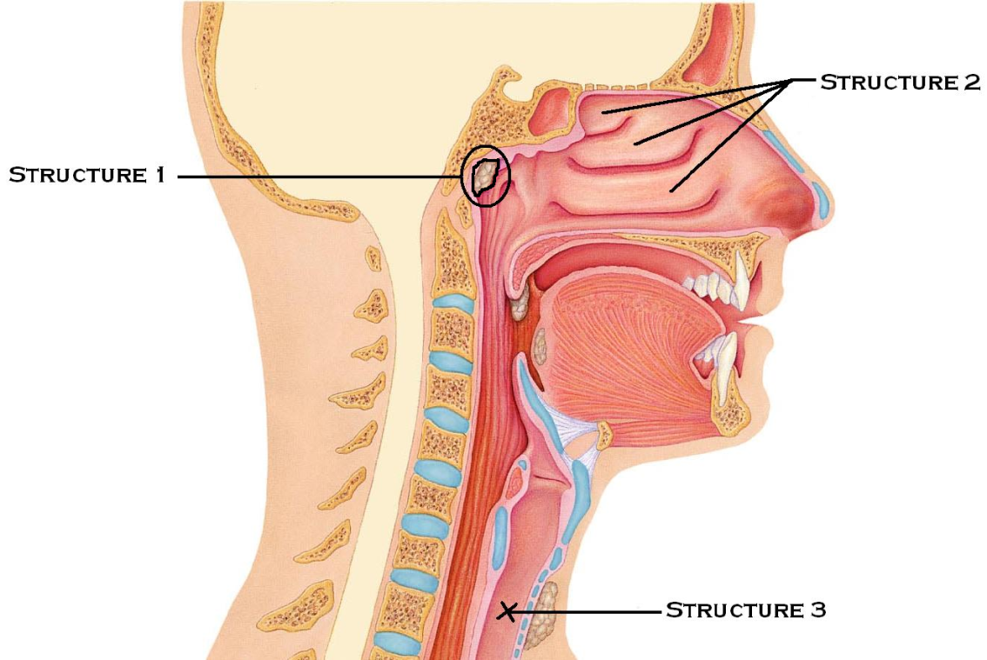Pharyngeal tonsil
    4. Palatine tonsil
    5. Lingual tonsil
13. “**Structure 2**” indicates which of the following?
    1. Paranasal sinuses
    2. Nasopharynx
    3. Nasolabial fold
    4. Nasal conchae
    5. Nasal vestibule
14. “**Structure 3**” is
    1. Oropharynx
    2. Esophagus
    3. Laryngopharynx
    4. Trachea
    5. Nasopharynx
15. Identify the **false** statement regarding the lungs
    1. The left lung has two lobes
    2. Both lungs are lined with visceral pleura
    3. The right lung has three lobes
    4. Both lungs have an oblique fissure
    5. The right lung has a cardiac notch
16. ________ is determined by the length and tension of the vocal folds, whereas _____ is determined by the force of the air passing across them.
    1. Projection; loudness
    2. Speech; pitch
    3. Loudness; pitch
    4. Pitch; loudness
    5. Volume; frequency
17. Which of the following is true with regards to the bronchioles within the conducting zone?
    1. Composed of cuboidal epithelium
    2. Lacks smooth muscle
    3. Composed mainly of cartilage
    4. Produces large amounts of mucus
    5. Composed of pseudostratified epithelium
18. Within the alveolar walls, one would expect to find
    1. Transitional epithelium
    2. Surfactant-secreting cells
    3. 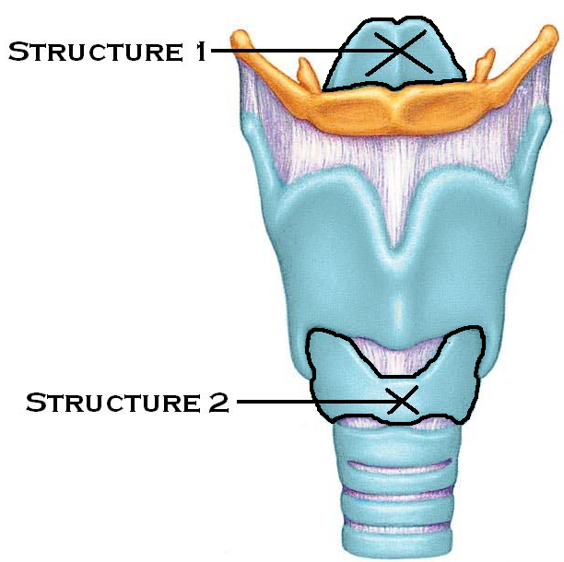Basophils
    4. Stratified columnar epithelium
    5. An osmosis-driven exchange of gasses
19. “Structure 1” is
    1. Glottis
    2. Cricoid cartilage
    3. Hyoid bone
    4. Epiglottis
    5. Thyroid cartilage
20. “Structure 2” is
    1. Cricoid cartilage
    2. Hyoid bone
    3. Glottis
    4. Epiglottis
    5. Thyroid cartilage
21. Emphysema results in
22. improved alveolar gas exchange
23. decreased surface area for gas exchange
24. blockage of bronchioles
25. increase lung flexibility
26. increased lung compliance
27. Which two factors encourage the lungs to collapse?
28. A negative intrapulmonary pressure
29. The elastic nature of the lungs
30. Surfactant
31. Surface tension of alveolar fluid
32. The rigidity of the thoracic wall
    1. 2 and 4
    2. 3 and 5
    3. 1 and 3
    4. 4 and 5
    5. 1 and 5
33. Which blood vessels bring the deoxygenated blood into the lungs for gas exchange?
    1. Pleural arteries
    2. Pleural veins
    3. Costal arteries
    4. Pulmonary veins
    5. Pulmonary arteries
34. _________ describes the pressure within the alveoli
    1. Intrapleural pressure
    2. Interpleural pressure
    3. Intrapulmonary pressure
    4. Intracostal pressure
    5. Interpulmonary pressure
35. _______ is always a negative pressure which helps to ______
    1. Intrapulmonary pressure; promote lymphatic drainage
    2. Intracostal pressure; build lung volume
    3. Interpulmonary pressure; prevent lung collapse
    4. Intrapleural pressure; prevent lung collapse
    5. Interpleural pressure; encourage lung elasticity
36. In a scenario where the **pH** of the blood has begun to **drop**, the bicarbonate ions will do what to correct it?
    1. Dissociate carbonic acid to release H+ and bicarbonate ions
    2. Bind H+ with bicarbonate ions to form carbonic acid
    3. The buffer system will not be able to handle shifts in pH and the renal system will be the first route for correction.
    4. Produce more bicarbonate ions
    5. Remove carbon dioxide by transporting it into neighboring cells
37. Which muscles are responsible for the elevation of the rib cage?
    1. Internal intercostal muscles
    2. Pulmonary muscles
    3. External intercostal muscles
    4. Digastric muscle
    5. Diaphragm
38. An inhalant such as Primatine or Albuterol can be used during an asthma attack to promote ______ in order to ______
    1. Bronchospasm: increase bronchial airway resistance
    2. Vasodilation; increase peripheral resistance
    3. Bronchodilation; reduce bronchial airway resistance
    4. Bronchodilation: reduce lung compliance
    5. Vasoconstriction; reduce peripheral resistance
39. Which of the following factors would increase lung compliance? (make it easier for the lung to expand)
    1. Ossification of costal cartilage
    2. Decreased surfactant
    3. Scar tissue
    4. Increased surfactant
    5. Increased mucus production
40. __________ is the amount of air able to be forced out following the deepest inspiration possible.
41. residual volume
42. tidal volume
43. vital capacity
44. inspiratory reserve volume
45. inspiratory capacity
46. ____________________ is the amount of air taken into the lungs with a normal inspiration and blown out during a normal expiration
47. residual volume
48. inspiratory reserve volume
49. vital capacity
50. inspiratory capacity
51. tidal volume
52. After a resting breath in and a resting exhalation, what is the term for the air remaining in the lungs?
    1. Residual capacity
    2. Residual Volume
    3. Functional Residual Volume
    4. Functional Residual Capacity
    5. Anatomic dead space volume
53. Healthy alveolar dead space and anatomic dead space have this in common
    1. Type II cells producing angiotensin
    2. No gas exchange taking place
    3. Filled with mucus
    4. Efficient gas exchange
    5. Flexible compliance
54. What parameters would be best for **decreasing** hemoglobin’s affinity to oxygen.
55. Decreased salinity
56. Increased osmotic pressure
57. Increased acidity
58. Decreased temperature
59. Increased BPG
    1. 1, 2, and 4
    2. 3 and 5
    3. 1 and 5
    4. 2 and 3
    5. 3, 4, and 5
60. This enzyme helps to convert carbon dioxide and water into carbonic acid. The enzyme _________ is present in _________.
    1. Carbonic anhydrase: cytoplasm of RBCs
    2. Cholinesterase: plasma
    3. Oxyhemoglobinase; hemoglobin
    4. Plasmic hydrolase: cytoplasm of WBCs
    5. 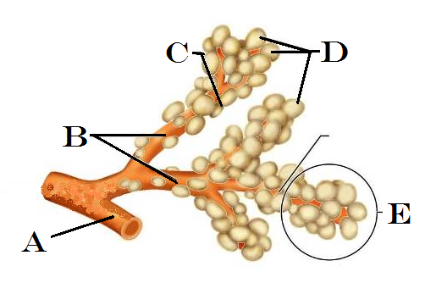Acetylhydrase; liver cells
61. Indicate the letter in the image to the right that is a conducting pathway only. No gas exchange.
    1. A
    2. B
    3. C
    4. D
    5. E
62. The aortic and carotid bodies are
    1. Central chemoreceptors sensitive to oxygen
    2. Peripheral chemoreceptors sensitive to oxygen
    3. Central chemoreceptors sensitive to carbon dioxide
    4. Peripheral chemoreceptors sensitive to carbon dioxide
    5. Pressoreceptors sensitive to carbon monoxide
63. Which of the following theories regarding respiratory control is false?
    1. Inspiratory neurons act as pacemakers
    2. Stretch receptors can establish a respiratory rhythm
    3. The control region of the Pons is responsible for transitions
    4. Oxygen concentration within the lungs determines rate
    5. Inspiratory neurons are both automatic and rhythmic
64. Hering-Bruer (The Inflation Reflex) works by
    1. Sensing the ratio of oxygen to carbon dioxide within the lungs
    2. Sensing tissue temperature to prevent lung damage
    3. Sensing lung irritants and coughing to remove them
    4. Sensing tissue stretch to prevent over-inflation of the lungs
    5. Initiating tissue damage to control oxygen pressure
65. In the higher brain centers, which region can alter breathing rates based on emotions
    1. Limbic region
    2. Prefrontal cortex
    3. Thalamus
    4. Wernicke’s area
    5. Insula of Reil
66. Which of the following are true with regards to acidosis
67. The pH is above normal
68. The pH is below normal
69. Carbon dioxide levels are high
70. Carbon dioxide levels are low
71. Can be seen in Diabetes Mellitus patients where the amino acids are depressed
    1. 1, 4, and 5
    2. 2, 3, and 5
    3. 2 and 3
    4. 1 and 4
    5. 2 and 4
72. This type of lung cancer arises in the bronchi and easily metastasizes
    1. Bronchosarcoma
    2. Type II cell lymphoma
    3. Small cell carcinoma
    4. Adenocarcinoma
    5. Squamous cell carcinoma
73. Within the respiratory system, the conducting zone
    1. Contains the alveoli
    2. Provides the route for ventilation, but no gas exchange
    3. Houses the respiratory bronchioles
    4. Is the location for gas exchange
    5. All of the above
74. The bronchospasms in asthma are stimulated by the release of which chemicals?
    1. IgA
    2. interleukins
    3. Substance P
    4. enkephalins
    5. ATP
75. Consider ventilation/perfusion coupling. If there is increased ventilation and decreased perfusion, what steps will be taken to restore an efficient exchange?
    1. Bronchodilation
    2. Dilation of pulmonary arterioles
    3. Constriction of pulmonary arterioles
    4. Dilation of pulmonary venules
    5. Constriction of pulmonary venules
76. The shallow vertical groove located inferior to the apex of the nose is the
    1. Nares
    2. Nasolabial fold
    3. Phloem
    4. Philbert
    5. Philtrum
77. Bronchial arteries carry ____, while pulmonary arteries carry ____
    1. oxygenated blood; oxygenated blood
    2. deoxygenated blood; deoxygenated blood
    3. deoxygenated blood; oxygenated blood
    4. oxygenated blood; deoxygenated blood
78. What is the common name for “vibrissae?”
    1. Vocal cords
    2. Nose hairs
    3. Nostrils
    4. Alveoli
    5. surfactant
79. Explain how resting exhalation is a passive process where no muscles are activated to contract.
    1. The low abdominal pressure causes air to be removed from the thoracic region
    2. As the inspiratory muscle relax, they begin to recoil and increase the pressure in the thoracic cavity
    3. The expiratory muscles are activated during a resting exhalation, but need no ATP (energy) to function
    4. The diaphragm contracts upward into the thoracic cavity, pushing the air out of the lungs. Skeletal muscle involvement is minimal.
    5. The intrapleural pressure becomes positive: higher than the intrapulmonary pressure, and it forces the air out of the lungs because of the pressure difference.
80. The purpose of the chloride shift is
81. to balance negative ions moving into the alveoli
82. to balance positive ions moving into the RBC
83. to balance negative ions moving out of the RBC
84. to balance positive ions moving into the alveoli
85. to counteract the influx of sodium ions during respiration
86. Which of the following are true with regards to Carbon Dioxide?
87. It attaches to the same binding site on hemoglobin as oxygen does
88. It can undergo a rapid transition into a bicarbonate ion inside the RBC
89. As C02 increases, the pH increases
90. C02 stimulates the peripheral osmoreceptors as a primary stimulus for breathing
91. C02 will diffuse out of body cells and into blood cells based on concentration gradients.
    1. 1, 2, 3, 5
    2. 1, 2, 5
    3. 2, 3, 4
    4. 2, 4, 5
    5. 2, 5
92. Which of the following would be considered non-respiratory air movements?

a. sneezing

b. coughing

c. crying

d. hiccupping

e. all of these are non-respiratory air movements

1. Which statement is true regarding hemoglobin?

a. found within white blood cells

b. carries oxygen and carbon dioxide at the same location

c. delivers about 25% of its oxygen during one circulatory event

d. creates a strong and stable bond with oxygen

e. degrades into two heme groups and biliverden

1. Let’s say you have a friend who has been out drinking one night. Upon his return, he “falls asleep.” You don’t know how much he’s been drinking, but you suspect it was a lot. You need to be able to discern “drunk” from “alcohol poisoning.” At what point should you become alarmed and call for help? (This question doesn’t come directly from the notes, but applies what you’ve learned from this material.)
   1. Breathing is deep and even
   2. His snoring becomes disruptive to your sleep
   3. Respirations drop below 10 breaths per minute
   4. Respirations are around 14 – 16 breaths per minute
   5. He wakes up when you yell, but does not wake up when you shave off one of his eyebrows
2. What is the carina?
   1. The midpoint of the nasal septum
   2. The term for the largest of the conchae
   3. The location where nerves and large blood vessels enter the lungs
   4. The site where conduction pathways transition to respiratory pathways
   5. The point at which the trachea splits into bronchi