**BSC 182**

**Exam Four**

1. The only *external visible* part of the respiratory system is the
   1. Thyroid cartilage
   2. True vocal folds
   3. Oropharynx
   4. Nose
   5. Glottis
2. Dyspnea means ____, and apnea means _____
   1. controlled breathing; uneven breathing
   2. no breathing; difficulty breathing
   3. difficulty breathing; no breathing
   4. fast breathing; slow breathing
   5. slow breathing; fast breathing
3. Which of the following are true
4. Internal respiration takes place at the lungs
5. External respiration takes place at the lungs
6. Internal respiration takes place at a body cell
7. External respiration takes place at a body cell
8. External respiration is the movement of air in to and out of the lungs
   1. 1 and 4
   2. 3 and 4
   3. 3 and 5
   4. 1 and 2
   5. 2 and 3
9. Which the following is **not** a paired laryngeal cartilage?
   1. Corniculate cartilage
   2. Epiglottic cartilage
   3. Cuneiform cartilage
   4. Arytenoids cartilage
10. The medial opening between the true vocal cords is called
    1. Glottis
    2. Tracheal foramen
    3. Epiglottis
    4. Fauces
    5. Laryngeal vestibule
11. ________ is determined by the length and tension of the vocal folds, whereas _____ is determined by the force of the air passing across them.
    1. Loudness; pitch
    2. Pitch; loudness
    3. Volume; frequency
    4. Projection; loudness
    5. Speech; pitch
12. “Structure 1” indicates which of the following features?
    1. Pharyngeal tonsil
    2. Palatine tonsil
    3. 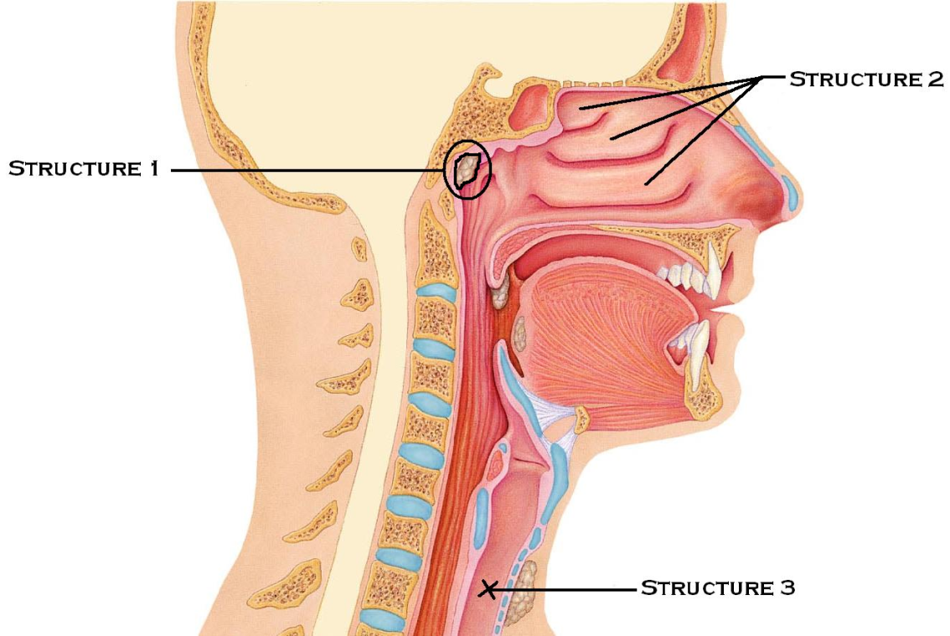Lingual tonsil
    4. Supralingual salivary gland
    5. Carina
13. “Structure 2” indicates which of the following?
    1. Paranasal sinuses
    2. Nasopharynx
    3. Nasolabial fold
    4. Nasal conchae
    5. Nasal vestibule
14. “Structure 3” is
    1. Laryngopharynx
    2. Trachea
    3. Nasopharynx
    4. Oropharynx
    5. 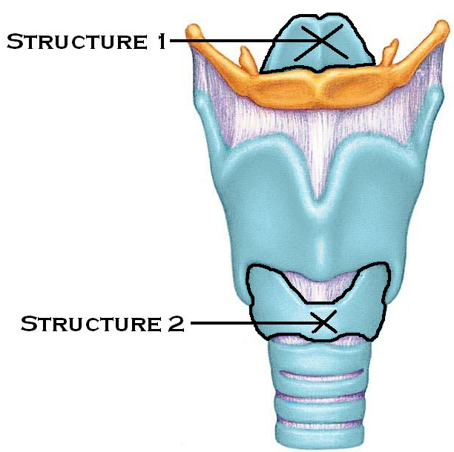Esophagus
15. Which of the following is true with regards to the bronchioles within the conducting zone?
    1. Composed of pseudostratified epithelium
    2. Lacks smooth muscle
    3. Composed mainly of cartilage
    4. Produces large amounts of mucus
    5. Composed of cuboidal epithelium
16. “Structure 1” is
    1. Glottis
    2. Epiglottis
    3. Thyroid cartilage
    4. Cricoid cartilage
    5. Hyoid bone
17. “Structure 2” is
    1. Hyoid bone
    2. Glottis
    3. Epiglottis
    4. Thyroid cartilage
    5. Cricoid cartilage
18. Emphysema results in
19. improved alveolar gas exchange
20. increase lung flexibility
21. increased lung compliance
22. decreased surface area for gas exchange
23. blockage of bronchioles
24. Which two factors encourage the lungs to collapse?
25. A negative intrapulmonary pressure
26. The elastic nature of the lungs
27. Surfactant
28. Surface tension of alveolar fluid
29. The rigidity of the thoracic wall
    1. 1 and 3
    2. 4 and 5
    3. 1 and 5
    4. 2 and 4
    5. 3 and 5
30. Which blood vessels bring the deoxygenated blood into the lungs for gas exchange?
    1. Pleural arteries
    2. Pulmonary veins
    3. Pulmonary arteries
    4. Pleural veins
    5. Costal arteries
31. _________ describes the pressure within the alveoli
    1. Intrapleural pressure
    2. Intracostal pressure
    3. Interpulmonary pressure
    4. Interpleural pressure
    5. Intrapulmonary pressure
32. _______ is always a negative pressure which helps to ______
    1. Intrapulmonary pressure; promote lymphatic drainage
    2. Intracostal pressure; build lung volume
    3. Interpulmonary pressure; prevent lung collapse
    4. Intrapleural pressure; prevent lung collapse
    5. Interpleural pressure; encourage lung elasticity
33. In a scenario where the **pH** of the blood has begun to **drop**, the bicarbonate buffer system will do what to correct it?
    1. Dissociate carbonic acid to release H+ and bicarbonate ions
    2. Bind H+ with bicarbonate ions to form carbonic acid
    3. The buffer system will not be able to handle shifts in pH and the renal system will be the first route for correction.
    4. Produce more bicarbonate ions
    5. Remove carbon dioxide by transporting it into neighboring cells
34. Which muscles are responsible for the elevation of the rib cage?
    1. Pulmonary muscles
    2. External intercostal muscles
    3. Digastric muscle
    4. Internal intercostal muscles
    5. Diaphragm
35. An inhalant such as Primatine or Albuterol can be used during an asthma attack to promote ______ in order to ______
    1. Bronchospasm: increase bronchial airway resistance
    2. Vasodilation; increase peripheral resistance
    3. Bronchodilation; reduce bronchial airway resistance
    4. Bronchodilation: reduce lung compliance
    5. Vasoconstriction; reduce peripheral resistance
36. Which of the following factors would increase lung compliance? (make it easier for the lung to expand)
    1. Ossification of costal cartilage
    2. Increased surfactant
    3. Increased mucus production
    4. Decreased surfactant
    5. Scar tissue
37. __________ is the amount of air able to be forced out following the deepest inspiration possible.
38. vital capacity
39. inspiratory reserve volume
40. inspiratory capacity
41. residual volume
42. tidal volume
43. ____________________ is the amount of air taken into the lungs with a normal inspiration and blown out during a normal expiration
44. residual volume
45. inspiratory capacity
46. tidal volume
47. inspiratory reserve volume
48. vital capacity
49. After a resting breath in and a resting exhalation, what is the term for the air remaining in the lungs?
    1. Residual capacity
    2. Residual Volume
    3. Functional Residual Volume
    4. Functional Residual Capacity
    5. Anatomic dead space volume
50. Healthy alveolar dead space and anatomic dead space have this in common
    1. Type II cells producing angiotensin
    2. No gas exchange taking place
    3. Filled with mucus
    4. Efficient gas exchange
    5. Flexible compliance
51. This enzyme helps to convert carbon dioxide and water into carbonic acid. The enzyme _________ is present in _________.
    1. Carbonic anhydrase: cytoplasm of RBCs
    2. Cholinesterase: plasma
    3. Oxyhemoglobinase; hemoglobin
    4. Plasmic hydrolase: cytoplasm of WBCs
    5. Acetylhydrase; liver cells
52. What parameters would be best for **decreasing** hemoglobin’s affinity to oxygen.
53. Decreased salinity
54. Increased osmotic pressure
55. Increased acidity
56. Decreased temperature
57. Increased BPG
    1. 1, 2, and 4
    2. 3 and 5
    3. 1 and 5
    4. 2 and 3
    5. 3, 4, and 5
58. The aortic and carotid bodies are
    1. Central chemoreceptors sensitive to oxygen
    2. Peripheral chemoreceptors sensitive to oxygen
    3. Central chemoreceptors sensitive to carbon dioxide
    4. Peripheral chemoreceptors sensitive to carbon dioxide
    5. Pressoreceptors sensitive to carbon monoxide
59. Hering-Bruer (The Inflation Reflex) works by
    1. Sensing the ratio of oxygen to carbon dioxide within the lungs
    2. Sensing tissue temperature to prevent lung damage
    3. Sensing lung irritants and coughing to remove them
    4. Sensing tissue stretch to prevent over-inflation of the lungs
    5. Initiating tissue damage to control oxygen pressure
60. In the higher brain centers, which region can alter breathing rates based on emotions
    1. Limbic region
    2. Prefrontal cortex
    3. Thalamus
    4. Wernicke’s area
    5. Insula of Reil
61. This type of lung cancer arises in the bronchi and easily metastasizes
    1. Bronchosarcoma
    2. Type II cell lymphoma
    3. Small cell carcinoma
    4. Adenocarcinoma
    5. Squamous cell carcinoma
62. Within the respiratory system, the conducting zone
    1. Contains the alveoli
    2. Provides the route for ventilation, but no gas exchange
    3. Houses the respiratory bronchioles
    4. Is the location for gas exchange
    5. All of the above
63. Which of the following are true with regards to acidosis
64. The pH is above normal
65. The pH is below normal
66. Carbon dioxide levels are high
67. Carbon dioxide levels are low
68. Can be seen in Diabetes Mellitus patients where the amino acids are depressed
    1. 1, 4, and 5
    2. 2, 3, and 5
    3. 2 and 3
    4. 1 and 4
    5. 2 and 4
69. The bronchospasms in asthma are stimulated by the release of which chemicals?
    1. Enkephalins
    2. IgD
    3. Heparin
    4. Interleukins
    5. Defensins
70. If a person has hypercapnia, what is happening?
    1. Elevated levels of Erythropoietin
    2. Elevated levels of Carbon Dioxide
    3. Elevated levels of Oxygen
    4. Elevated levels of Capni
    5. Elevated levels of Carbon Monoxide
71. Consider ventilation/perfusion coupling. If there is increased ventilation and decreased perfusion, what steps will be taken to restore an efficient exchange?
    1. Bronchodilation
    2. Dilation of pulmonary arterioles
    3. Constriction of pulmonary arterioles
    4. Dilation of pulmonary venules
    5. Constriction of pulmonary venules
72. The shallow vertical groove located inferior to the apex of the nose is the
    1. Nares
    2. Nasolabial fold
    3. Phloem
    4. Philbert
    5. Philtrum
73. Bronchial arteries carry ____, while pulmonary arteries carry ____
    1. oxygenated blood; oxygenated blood
    2. deoxygenated blood; deoxygenated blood
    3. deoxygenated blood; oxygenated blood
    4. oxygenated blood; deoxygenated blood
74. At high altitudes, how do the kidneys help a person to acclimate to the lower oxygen environment?
    1. Releases Aldosterone
    2. Releases Angiotensin Converting Enzyme
    3. Releases Erythropoietin
    4. Releases Antidiuretic Hormone
    5. Releases Oxytocin
75. What is the common name for “vibrissae?”
    1. Vocal cords
    2. Nose hairs
    3. Nostrils
    4. Alveoli
    5. surfactant
76. Explain how resting exhalation is a passive process where no muscles are activated to contract.
    1. The low abdominal pressure causes air to be removed from the thoracic region
    2. As the inspiratory muscle relax, they begin to recoil and increase the pressure in the thoracic cavity
    3. The expiratory muscles are activated during a resting exhalation, but need no ATP (energy) to function
    4. The diaphragm contracts upward into the thoracic cavity, pushing the air out of the lungs. Skeletal muscle involvement is minimal.
    5. The intrapleural pressure becomes positive: higher than the intrapulmonary pressure, and it forces the air out of the lungs because of the pressure difference.
77. The purpose of the chloride shift is
78. to balance negative ions moving into the alveoli
79. to balance positive ions moving into and out of the RBC
80. to balance negative ions moving into and out of the RBC
81. to balance positive ions moving into the alveoli
82. to counteract the influx of sodium ions during respiration
83. Which of the following are true with regards to Carbon Dioxide?
84. It attaches to the same binding site on hemoglobin as oxygen does
85. It can undergo a rapid transition into a bicarbonate ion inside the RBC
86. As C02 increases, the pH increases
87. C02 stimulates the peripheral osmoreceptors as a primary stimulus for breathing
88. C02 will diffuse out of body cells and into blood cells based on concentration gradients (partial pressure).
    1. 1, 2, 3, 5
    2. 1, 2, 5
    3. 2, 3, 4
    4. 2, 4, 5
    5. 2, 5
89. Which of the following would be considered non-respiratory air movements?

a. sneezing

b. coughing

c. crying

d. hiccupping

e. all of these are non-respiratory air movements

1. Which of the following diseases or disorders are consistent with the following symptoms:

* Fever
* Night sweats
* Weight loss
* Racking cough
  1. Asthma
  2. Emphysema
  3. Chronic Bronchitis
  4. Small Cell carcinoma
  5. Tuberculosis

1. Which statement is true regarding hemoglobin

a. found within white blood cells

b. carries oxygen and carbon dioxide at the same location

c. delivers about 25% of its oxygen during one circulatory event

d. creates a strong and stable bond with oxygen

e. degrades into two heme groups and biliverden

1. Let’s say you have a friend who has been out drinking one night. Upon his return, he “falls asleep.” You don’t know how much he’s been drinking, but you suspect it was a lot. You need to be able to discern “drunk” from “alcohol poisoning.” At what point should you become alarmed and call for help? (This question doesn’t come directly from the notes, but applies what you’ve learned from this material.)
   1. Breathing is deep and even
   2. His snoring becomes disruptive to your sleep
   3. Respirations drop below 10 breaths per minute
   4. Respirations are around 14 – 16 breaths per minute
   5. He wakes up when you yell, but does not wake up when you shave off one of his eyebrows
2. What is the carina
   1. The midpoint of the nasal septum
   2. The term for the largest of the conchae
   3. The location where nerves and large blood vessels enter the lungs
   4. The site where conduction pathways transition to respiratory pathways
   5. The point at which the trachea splits into bronchi

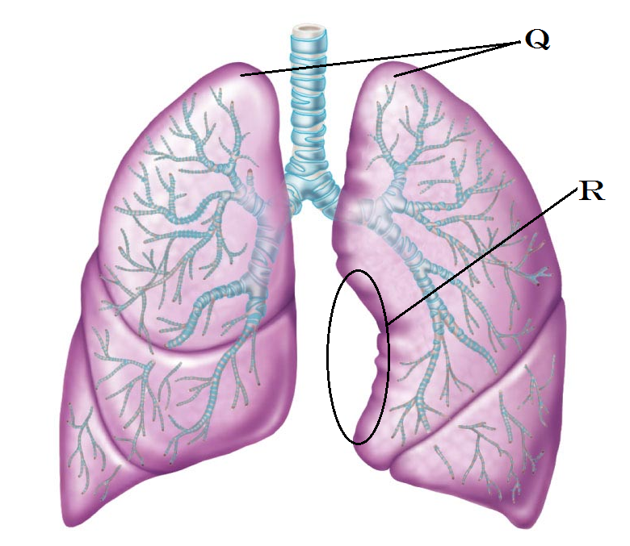

1. Identify “Q”
   1. Apex
   2. Base
   3. Philtrum
   4. Nare
   5. Superior Angle
2. Identify “R”
   1. Jugular notch
   2. Cardiac notch
   3. Mediastinum
   4. Sternal notch
   5. Costal notch