BSC 182 Anatomy and Physiology

Examination II

**Please indicate all answers on your OpScan sheet. Remember that each question will have ONLY one best response*.*  If you have a conflict with a question, go into detail on the back of this exam form. Please remember to set it aside in a separate pile if you’d like me to read your comments.**

1. Which of the following is true
   1. The visceral pericardium and the endocardium are continuous
   2. The visceral epicardium extends along the cardiac surface as well as the pericardial surface without changing its name.
   3. The parietal pericardium and the visceral pericardium are continuous
   4. The myocardium and the parietal pericardium are continuous
   5. The fibrous pericardium and the epicardium are continuous
2. The valve present between the right atrium and the right ventricle is the
3. tricuspid valve
4. pulmonary semilunar valve
5. aortic semilunar valve
6. mitral valve
7. bicuspid valve
8. A **Foramen ovale** is an opening that allows fetal blood to bypass the lungs. In which structure is it located?
9. atrioventricular septum
10. Articulated septum
11. Interventricular septum
12. Interatrial septum
13. Aortopulmonary septum
14. What are the structures that anchor the semilunar valves to the ventricular walls?
15. microvilli
16. carina
17. chordae tendinae
18. papillary muscles
19. the semilunar valves do not anchor to the ventricular walls
20. Which of the following arteries are responsible for the blood supply to the heart?
21. iliac artery
22. left anterior descending artery
23. right coronary artery
24. splanchic artery
25. right lobar artery
    1. 2, 3, and 4 are correct
    2. 1, 2, and 5 are correct
    3. 3 and 5 are correct
    4. 1 and 3 are correct
    5. 2 and 3 are correct
26. The “LUBB” sound is primarily created from
27. the closing of the aortic semilunar valve
28. blood regurgitating back into the atria
29. the opening of the tricuspid valve
30. the opening of the mitral valve
31. the closing of the mitral valve
32. The myocardium
    1. Is the innermost layer of the pericardium
    2. Is continuous with the pericardial space
    3. Is the middle layer of the pericardium
    4. Is the middle layer of the heart
    5. Is the innermost layer of the heart

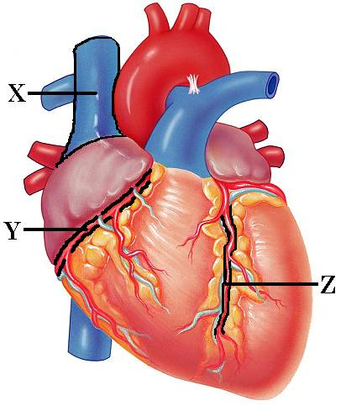

1. Identify “X”
   1. Superior Vena Cava
   2. Right Pulmonary Vein
   3. Aorta
   4. Pulmonary Trunk
   5. Inferior Vena Cava
2. Identify “Y”
   1. Left Atrium
   2. Right Coronary Artery
   3. Left Posterior Interventricular Artery
   4. Circumflex artery
   5. Azygous artery
3. Identify “Z”
   1. Marginal artery
   2. Right coronary Artery
   3. Left Posterior Interventricular Artery
   4. Circumflex artery
   5. Anterior Interventricular artery
4. An EKG is
5. a reading of the muscular contraction in the heart
6. a reading of the blood perfusion of the heart
7. a reading of the electrical activity of the heart
8. a reading of the nervous stimulation to the diaphragm
9. a means of monitoring brain waves
10. The addition of Acetylcholine will make the heart rate ________________________ while the absence of Acetylcholine will make the heart rate ______________________.

a. increase, increase

b. decrease, decrease

c. increase, decrease

d. decrease, increase

e. Acetylcholine will have absolutely no effect on the rate or force of heart contractions

1. 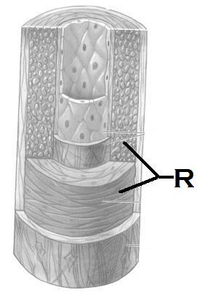In capillaries, biochemicals cross in the following means. Which of the following is the **most important**?
2. osmosis
3. diffusion
4. endocytosis
5. filtration
6. perfusion
7. Identify the “R”
   1. Tunica intima of a vein
   2. Tunica inima of an artery
   3. Tunica media of a vein
   4. Tunica media of an artery
   5. Tunica externa of a vein
8. Which type of vessel structure acts as a blood reservoir?
9. artery
10. arteriole
11. vein
12. precapillary sphincter
13. capillary
14. These capillaries are the most common type and are found in skin and muscles.
    1. Continuous
    2. 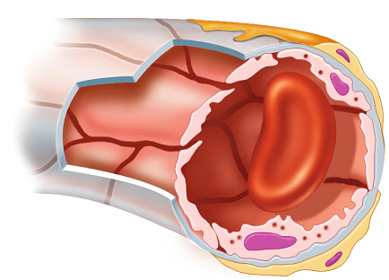Muscular
    3. Sinusoidal
    4. Discontinuous
    5. Fenestrated
15. Central Venous Pressure:
16. is measured at the right atrium
17. is measured at the right ventricle
18. is measured at the aorta
19. increases with a weak heart beat
20. increases with a strong heart beat

a. 1 and 2 are correct

b. 2 and 5 are correct

c. 1, 2, and 4 are correct

d. 1 and 4 are correct

e. 3 and 5 are correct

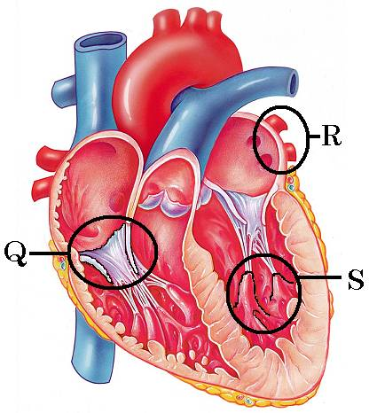

1. Identify Q
   1. Mitral valve
   2. Tricuspid valve
   3. Pulmonary valve
   4. Aortic valve
   5. Triquetral valve
2. Identify “R”
   1. Pulmonary Trunk
   2. Right pulmonary artery
   3. Left pulmonary artery
   4. Right pulmonary vein
   5. Left pulmonary vein
3. Identify “S”
   1. Crista terminalis
   2. Pectinate muscle
   3. Papillary muscle
   4. Aortic semilunar valve
   5. Bundle of His
4. Indicate which **two options** represent **arterial blood pressure** (Identify the correctly numbered responses and find them in the five lettered options below. You will indicate **only ONE letter** for a correct response.)
5. diastolic over systolic
6. systolic over diastolic
7. the pressure of ventricular contraction over ventricular relaxation
8. the pressure of ventricular relaxation over ventricular contraction
9. has nothing to do with ventricular contraction or relaxation
   1. 2 and 5 are correct
   2. 2 and 3 are correct
   3. 1 and 3 are correct
   4. 2 and 4 are correct
   5. 1 and 5 are correct

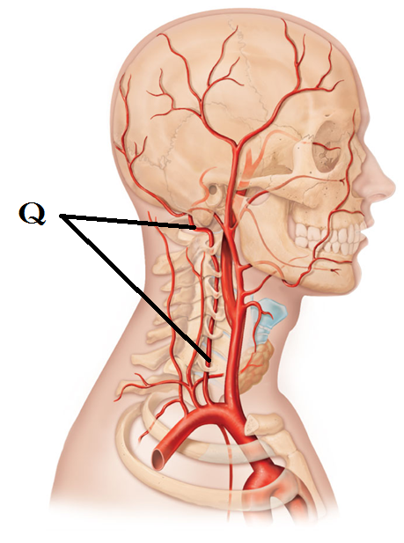

1. Identify Q
   1. Basilar artery
   2. Vertebral artery
   3. Internal carotid artery
   4. External carotid artery
   5. Jugular artery
2. Viscosity (is)
3. increased with anemia
4. defined as the ease/difficulty with which molecules flow past one another
5. decreased with polycythemia
6. defined as the heat produced with blood flow
7. defined as the ease/difficulty with which the lungs expand with inhalation
8. Vasoconstriction (Identify the correctly numbered responses and find them in the five lettered options below. You will indicate **only ONE letter** for a correct response.)
9. is a response of the sympathetic system
10. 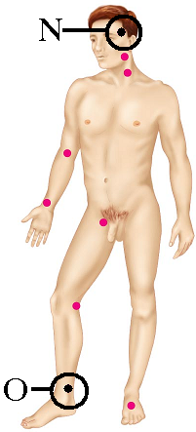is a response of the intersplanchnic system
11. results in the vessel diameter becoming larger
12. results in the vessel diameter becoming smaller
13. none of the above are correct
    1. 2 and 4 are correct
    2. 1 and 4 are correct
    3. 1 and 3 are correct
    4. 1, 2, and 3 are correct
    5. 5 is the only correct statement
14. Which pulse can be palpated at “N”
    1. Carotid
    2. Radial
    3. Inguinal
    4. Femoral
    5. Superficial temporal
15. Which pulse can be palpated at “O”
    1. Dorsalis pedis
    2. Calcaneal
    3. Anterior tibial
    4. Posterior tibial
    5. Tarsal
16. If you were to listen to a heart beat with a stethoscope, where would you best hear it? Where is the PMI?
    1. Right sternal border, 5th intercostal space
    2. Right sternal border, 2nd intercostal space
    3. 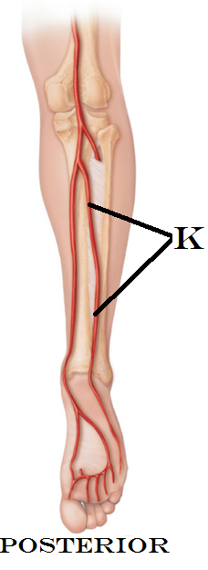Left sternal border, 2nd intercostal space
    4. Left sternal border, 5th intercostal space
    5. Midclavicular line, 5th intercostal space
17. Vagal tone
18. Is part of the intrinsic regulation of the heart rate
19. Is part of the extrinsic regulation of the heart rate
20. Refers to the sympathetic fibers running in the Phrenic nerve
21. Refers to the parasympathetic fibers running in the Vasomotor nerve
22. Works by increasing the SA node’s pace
23. Identify the artery at K
    1. Superficial crural artery
    2. Posterior tibial artery
    3. Fibular artery
    4. Patellar aretery
    5. Lateral malleolar artery
24. Which of the following is true with regards to **Hyperkalemia**?
25. Increases the heart irritability
26. Causes spastic heart contractions
27. Is a result of elevated calcium in the blood
28. Causes a feeble and irregular heartbeat
29. Interferes with cardiac depolarization and can lead to cardiac arrest
30. Which of the following is going to **increase** peripheral resistance? (Identify the correctly numbered responses and find them in the five lettered options below. You will indicate **only ONE letter** for a correct response.)
31. Increased viscosity
32. Decreased viscosity
33. Blood traveling through a very long vessel
34. Blood traveling through a very short vessel
35. A vessel with a large diameter
36. A vessel with a very small diameter
    1. 1, 3, and 5 are correct
    2. 2, 4, and 5 are correct
    3. 1 and 3 are correct
    4. 2, 3, and 6 are correct
    5. 1, 3, and 6 are correct
37. The neurons of the vasomotor center are located
38. In the pons
39. In the medulla oblongata
40. In the renal medulla
41. In the adrenal cortex
42. In the cerebral cortex
43. In the carotid and aortic sinuses, there are ________________ that are sensitive to the pressure of blood
44. Thermoreceptors
45. Neuroreceptors
46. Chemoreceptors
47. Baroreceptors
48. Altoreceptors
49. 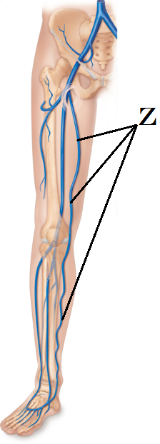 Identify the structure at Z
    1. Femoral Vein
    2. Deep Femoral Artery
    3. Internal iliac Artery
    4. External iliac Vein
    5. Great Saphenous Vein
50. Renin is responsible for
51. Converting angiotensinogen into angiotensin I
52. Converting plasminogen into plasmin
53. Converting angiotensin I into angiotensin II
54. Converting angiotensin II into Aldosterone
55. Converting Aldosterone into ACE
56. Aldosterone causes changes in the blood pressure by
57. Increasing the rate of adrenal activity
58. Retaining sodium, which in turn retains water
59. Excretes (loses) sodium, which in turn loses water
60. Altering the blood calcium concentrations
61. Stimulating ADH release
62. Which of the following is true about the femoral pulse?
63. femoral artery branches from the internal iliac
64. femoral artery branches from the internal carotid artery
65. femoral artery branches from the external cardiac artery
66. This pulse is palpated at the mid-inguinal point
67. This pulse is palpated at the level of the mid thigh
68. Which type of circulatory shock occurs when the blood volume is normal and is not related to heart damage?
69. Hypervolemic shock
70. Intrinsic shock
71. Vascular shock
72. Cardiogenic shock
73. Hypovolemic shock
74. The transient (temporary) drop in blood pressure that occurs with a positional change is
75. Hypertrophic proprioception
76. Hypovolemic shock
77. Transient ischemia
78. Orthoscopic hypertension
79. Orthostatic hypotension
80. Where would you locate the crista terminalis?

a. In the aortic tunica media

b. separating anterior and posterior atria

c. attached to the chordae tendinae

d. anchoring the pericardial sac to the surrounding anatomy

e. at the end of the purkinje fibers

1. Given the **Right Pulmonary Vein** as a starting point, which three structures would the blood flow through next (in order)

a. Pulmonary Trunk 🡪 Lung 🡪 Left Pulmonary Artery

b. Left atrium 🡪 Mitral Valve 🡪 Left Ventricle

c. Right ventricle 🡪 Bicuspid valve 🡪 Left ventricle

d. Right atrium 🡪 Tricuspid Valve 🡪 Right Ventricle

e. Lung 🡪 Left Pulmonary Artery 🡪 Left Atrium

1. Which statement describes the location of the AV node?
   1. inferior interatrial septum
   2. carotid bodies
   3. superior interventricular sulcus
   4. right atrium near the opening of the Superior Vena Cava
   5. medullary rhythmicity center

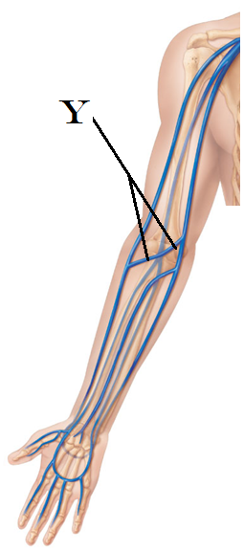

1. In an EKG, which event(s) immediately follows atrial depolarization
   1. ventricular repolarization
   2. atrial repolarization and ventricular depolarization
   3. atrial repolarization and ventricular repolarization
   4. a moment of rest between cycles
   5. ventricular hyperpolarization
2. Identify the vein at Y
   1. Axillary vein
   2. Brachial vein
   3. Antecubital vein
   4. Median cubital vein
   5. Basilic vein
3. If a person has low blood pressure, which statement would be a means of correcting it?
   1. ADH is released. Water is reabsorbed at the kidney.
   2. ADH is released. Water is lost at the kidney
   3. ADH is released. It causes the secretion of sodium.
   4. ADH is released. It causes the production of erythropoietin
   5. ADH is released. Water is reclaimed from the venous reservoirs.
4. How might hyperthyroidism damage a person’s heart?
   1. Depletion of oxygenated blood damages the heart tissues
   2. Excess thyroid hormone damages the conduction system of the heart.
   3. A sustained increased heart rate from the elevated thyroid hormones can cause damage
   4. Excess thyroid hormone cause a feeble and irregular heart beat
   5. Thyroid hormones result in a failure of cardiac depolarization
5. How do the kidneys have a direct control on blood pressure?
   1. Control the amount of vasopressin released
   2. Control the amount of water kept/lost as urine
   3. Control the amount of ANP released
   4. Control the amount of cortisol released
   5. Control endorphin release
6. What is the coronary sinus?
   1. A space for coronary venous blood on its way to the right atrium
   2. A space for coronary arterial blood on its way to the left atrium
   3. The site at which the papillary muscles are anchored
   4. The space surrounding the heart in which fluid can be found
   5. The lymphatic tissue of the heart

An exam on Valentine’s Day? About the heart? What are the odds? Use the candy heart image below as if it were anatomically correct, and identify the regions for both “N” and “O”

1. 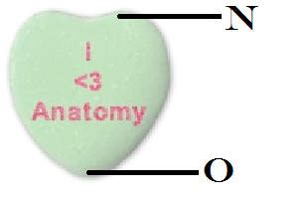 Identify “N”
   1. Apex
   2. Base
   3. Mediastinum
   4. Coronary sinus
   5. Interatrial septum
2. Identify “O”
   1. Apex
   2. Base
   3. Mediastinum
   4. Chorda tendinae
   5. Pectinate muscles

**Please turn in your OpScan form and Exam packet. If you have made a comment for me on your exam, please remember to place it in a separate pile at the front desk. Grades should be posted through Blackboard within 2 days. Enjoy the rest of your day.**