**BSC 182**

**Exam Five**

Reminder: There is one correct answer for each question. All questions are weighted equally. Please read and consider each question carefully.

1. **Simple columnar epithelium** can be found in which layer of the alimentary canal?
2. Submucosa
3. Muscularis
4. Serosa
5. Mucosa
6. Adventitia
7. Which layer of the alimentary canal is also known as the **visceral peritoneum?**
8. Submucosa
9. Muscularis
10. Serosa
11. 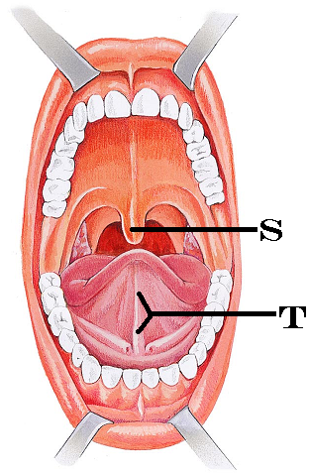Mucosa
12. Myomal
13. The cells that secrete **pepsinogen** are the:
14. mucous neck cells
15. parietal cells
16. acinal cells
17. chief cells
18. enteroendocrine cells
19. Identify “S”
    1. Hard palate
    2. Palatine tonsils
    3. Labial frenulum
    4. Epiglottis
    5. Uvula
20. Identify “T”
    1. Lingual frenulum
    2. Labial frenulum
    3. Submandibular gland
    4. Hypoglossal septum
    5. Stensen’s duct
21. The *lamina propria* is a member of which layer in the digestive tract?
    1. Mucosa
    2. Submucosa
    3. Laminaria
    4. Serosa
    5. Adventitia
22. Within the structure of the tooth, where are the nerves and blood vessels located?
    1. Crown
    2. Neck
    3. Dentin
    4. Pulp cavity
    5. Enamel
23. The **calcified plaque** that builds up on teeth and contributes to gingivitis is called tartar or
    1. Caries
    2. Calculus
    3. Calcaneous
    4. Calmodulin
    5. Calcitonin
24. This **hormone** triggers the release of **enzyme rich** pancreatic juice.
25. Renin
26. Cholecystokinin
27. Digestin
28. Gastrin
29. Bile
30. What are the three phases of **Gastric Secretion**?
31. Ileal, cecal, and haustric
32. Primary, secondary, tertiary
33. Gastric phase, parietal phase, chief phase
34. Cephalic phase, gastric phase, and intestinal phase
35. Duodenal phase, jejunal phase, ileal phase
36. Pepsinogen is an inactive protein-digesting enzyme. What **two** things will change it from pepsinogen into pepsin?
    * 1. Pepsinogen
      2. Pepsin
      3. Hydrochloric acid
      4. Gastric lipase
      5. Intrinsic factor
    1. 1, 4
    2. 3, 5
    3. 2, 3
    4. 4, 5
    5. 1, 3
37. Where is the pancreas located
38. Nestled within the C shaped curve of the duodenum
39. Nestled under the liver
40. A retroperitoneal structure near the appendix
41. Immediately inferior to the esophageal hiatus
42. Inferior to the hepatic flexure
43. Pancreatic amylase
44. Will have a similar function as salivary amylase
45. Will help to change the pH of the small intestine
46. Will assist in the emulsification of fats
47. Will split starch into simple sugars
48. Will split triglycerides into fatty acids
49. 1, 2, 4
50. 1, 4
51. 2, 5
52. 2, 4, 5
53. 3
54. Which organ’s secretion result in a **decrease of acidity** in the small intestine?
55. 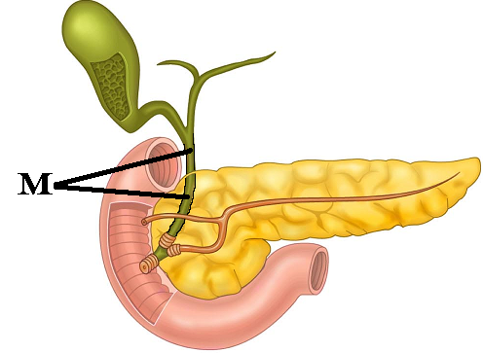Stomach
56. Liver
57. Gall bladder
58. Pancreas
59. Large intestine
60. Identify “M”
    1. Common hepatic duct
    2. Cystic duct
    3. Hepatopancreatic duct
    4. Bile duct
    5. Right hepatic duct
61. The function of the gallbladder is to
62. Concentrate bile
63. Store bile
64. Release bile
65. Manufacture bile
66. None of the above are correct

a. 1, 3

b. 2, 4

c. 2, 3

d. 1, 2, 3

e. 5

1. During the **gastroileal** reflex, presence of food in the stomach
2. Causes the chyme in the ileum to be moved into the cecum
3. Causes the chyme in the large intestine to be released
4. Causes the stomach to release chyme slowly into the small intestine
5. Causes the chyme in the duodenum to be moved into the ileum
6. Causes the chyme in the esophagus to be moved into the stomach
7. The large intestine is
8. Responsible for digesting fats
9. Responsible for removal of all bacteria
10. Responsible for absorbing fats
11. Responsible for water reabsorption
12. Responsible for waste storage

a. 1, 4, 5

b. 4, 5

c. 3

d. 2, 4

e. 2, 4, 5

1. Identify the **incorrect** pairing of food type and the region in which it gets **digested**
   1. Fats; small intestine
   2. Proteins; stomach
   3. Carbohydrates; stomach
   4. Nucleic acids; small intestine
2. Which materials are **absorbed** into the **lacteals**?
   1. Simple carbohydrates
   2. Cellulose
   3. Nucleic acids
   4. Polypeptides
   5. Lipids
3. What type of **mucus-producing cells** are located within the **crypts** of the large intestine?
   1. MALT
   2. Peyers Patches
   3. Goblet cells
   4. Acinar cells
   5. Chief cells
4. Which of the following reflexes are we able to **voluntarily** control?
5. gastroileal reflex
6. gastrocolic reflex
7. gastroenteral reflex
8. enterogastric reflex
9. defecation reflex
10. Which structures are likely to become hemorrhoids?
11. Superficial anal arteries
12. Superficial rectal veins
13. Superficial sigmoid veins
14. Deep rectal arteries
15. Deep anal arteries
16. In addition to breaking down cellulose, what other function do the bacterial flora provide?
    1. Produce vitamins C and E
    2. Produce vitamins E and K
    3. Produce vitamins D and B vitamins
    4. Produce vitamin A and K
    5. Produce K and B vitamins
17. **Adult celiac disease** is cause by ___, and results in ____.
    1. Gluten; malabsorption due to microvilli damage
    2. Globulin; autoimmune damage to large intestine
    3. Gluten; decreased mucus formation
    4. Fatty acid sensitivity; perforated intestines
    5. Carbohydrate allergy; inflammation of the serosal linings
18. Which of the following empties urine directly **into the renal pelvis**?
19. Ureter
20. renal papilla
21. major calyx
22. nephron loop
23. minor calyx
24. The ____ is part of the circulatory system, while the ___ is part of the nephron
    1. Minor calyx; loop of Henle
    2. 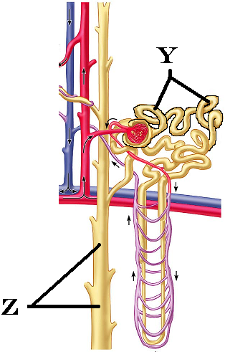Glomerulus; proximal convoluted tubule
    3. Distal convoluted tubule; collecting duct
    4. Peritubular capillaries; vas recta
    5. Ascending loop; Descending loop
25. Identify **Y**
    1. nephron loop
    2. Proximal convoluted tubule
    3. Distal convoluted tubule
    4. Glomerulus
    5. Collecting duct
26. Identify **Z**
    1. Descending nephron loop
    2. Proximal convoluted tubule
    3. Distal convoluted tubule
    4. Glomerulus
    5. Collecting duct
27. The **collecting ducts** are _____ to water when the hormone _____ is **present**.
    1. permeable, ADH
    2. permeable, aldosterone
    3. impermeable, ADH
    4. impermeable, aldosterone
    5. permeable, sodium
28. Which are the two components of the **juxtaglomerular apparatus**?
29. Juxtaglomerular cells and fovea centralis
30. Jejunum and densa deferens
31. Basiar hairs and stereocilia
32. Juxtaglomerular cells and macula densa
33. Cortical and Medullary nephrons
34. Which type of nephrons can extend deep into the medulla?
35. Cortical nephron
36. Juxtamedullary nephron
37. Pyramidal nephron
38. Distal convoluted nephron
39. Macromedullary nephron
40. Which of the following is **true**?
41. As filtration pressure increases, glomerular filtration rate (GFR) increases
42. As filtration pressure decreases, GFR increases
43. As filtration pressure increases, GFR decreases
44. GFR is controlled solely by the vasa recta
45. Filtration pressure has nothing to do with the GFR

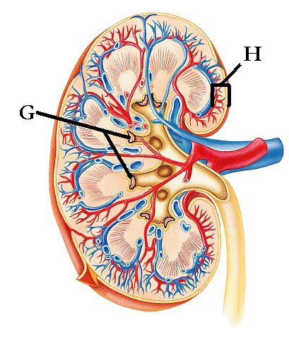

1. Identify “G”
   1. Renal papilla
   2. Renal column
   3. Renal cortex
   4. Major calyx
   5. Renal pelvis
2. Identify “H”
   1. Renal papilla
   2. Renal column
   3. Renal cortex
   4. Major calyx
   5. Renal pelvis
3. Atrial natriuretic peptide
4. Produced due to changes sensed at the heart
5. Produced due to changes sensed at the kidney
6. Stimulates potassium absorption
7. Causes the release of Renin
8. Will not affect blood pressure
9. ______ is the term for **swallowing** and ______ is the term for **urination**
10. Mastication; deglutition
11. Deglutition; mastication
12. Micturition; mastication
13. Deglutition; micturition
14. Micturition; deglutition
15. Antidiuretic Hormone
16. Is released from thyroid
17. Is produced in response to increased water volume in body
18. Increases the permeability of the proximal convoluted tubule
19. Increases the permeability of the collecting duct
20. Is responsible, when present, for the production of dilute urine
21. The **trigone** of the bladder is composed of
22. The opening of the left ureter, right ureter, and the urethra
23. The entrances of the left renal pelvis, right renal pelvis, and the calyx
24. Papillae and seminal vesicle
25. Glomerular capsule, left ureter, right ureter
26. Renal pyramid and transitional epithelium
27. What type of specialized epithelium does the bladder have that allows it to stretch?
28. Simple Squamous
29. Pseudostratified columnar
30. Cuboidal
31. Keratinized squamous
32. Transitional
33. Which of the following is true with regards to the **urethra**
34. Male and female urethra are the same length
35. Male and female urethra have both urinary and reproductive functions
36. Male and female urethra end as external urethral orifice
37. Male and female urethra pass through the prostate gland
38. The urethra enters the bladder superiorly
39. Which option reflects the correct sequence for urine formation
    1. Tubular filtration; tubular secretion; tubular reabsorption
    2. Glomerular filtration; tubular reabsorption; tubular secretion
    3. Glomerular filtration; tubular secretion; tubular reabsorption
    4. Tubular secretion; tubular filtration; capillary filtration
    5. Glomerular transmission; tubular relocation; tubular secretion
40. The afferent arteriole ________, and has a ______ diameter than the efferent arteriole
    1. Approaches the vasa recta; smaller
    2. Approaches the glomerulus; larger
    3. Approaches the glomerulus; smaller
    4. Approaches the loop of Henle; larger
    5. Approaches the hilus; smaller

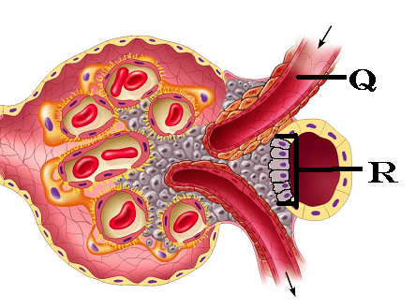

1. Identify “Q”
   1. Glomerular capillary
   2. Proximal renal tubule
   3. Distal renal tubule
   4. Afferent arteriole
   5. Efferent arteriole
2. Identify “R”
   1. Macula densa cells
   2. Podocytes
   3. Granular cells
   4. Juxtamedullary cells
   5. Juxtaglomerular cells

+

1. Consumption of **caffeine** will cause an increase in urinary output because
   1. ADH is stimulated
   2. ADH is inhibited
   3. Na+ reabsorption is inhibited
   4. Na+ reabsorption is stimulated
   5. It pushes glucose into the filtrate which draws water
2. Consumption of **alcohol** will cause an increase in urinary output because
   1. ADH is stimulated
   2. ADH is inhibited
   3. Na+ reabsorption is inhibited
   4. Na+ reabsorption is stimulated
   5. It pushes glucose into the filtrate which draws water
3. Which substance causes the adrenal cortex to release Aldosterone directly?
   1. Renin
   2. Angiotensinogen
   3. Angiotensin I
   4. Angiotensin II
   5. Angiotensin Converting Enzyme
4. **Ureters** link
   1. Aorta to the kidney
   2. Bladder to the outside of the body
   3. Digestive system to urinary system
   4. Kidney to bladder
   5. Urinary bladder to gall bladder
5. The male urethra is named for the regions it passes through. Which region listed below is **not correct**?
   1. Membranous urethra
   2. Penile urethra
   3. Spongy urethra
   4. Prostatic urethra
   5. Glans urethra

Please turn in both your Opscan forms and your exam packet.

If you have comments on a question, set your exam in a separate pile.

Enjoy the rest of your day.