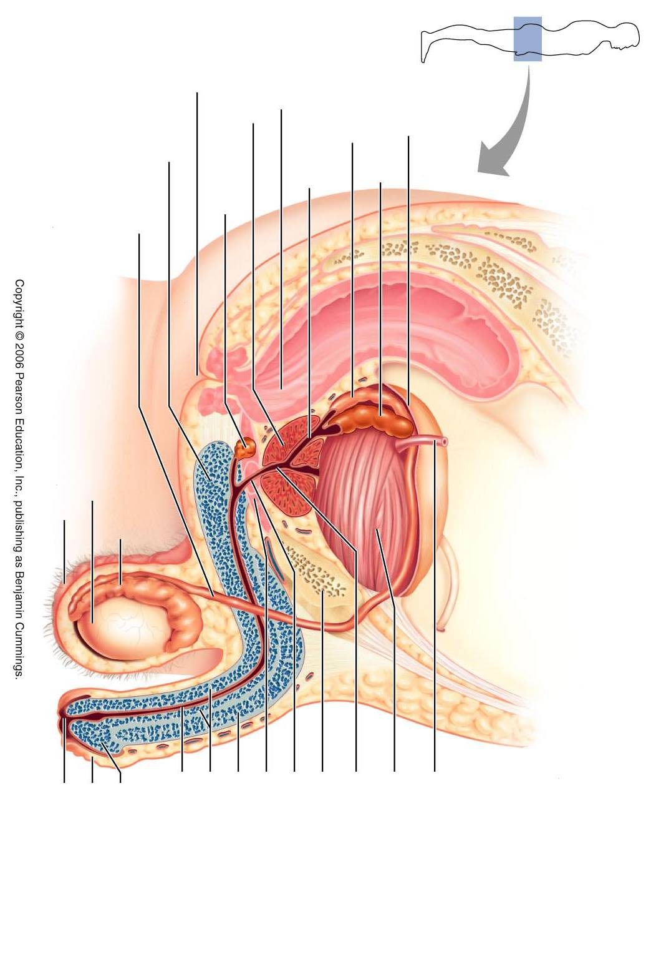
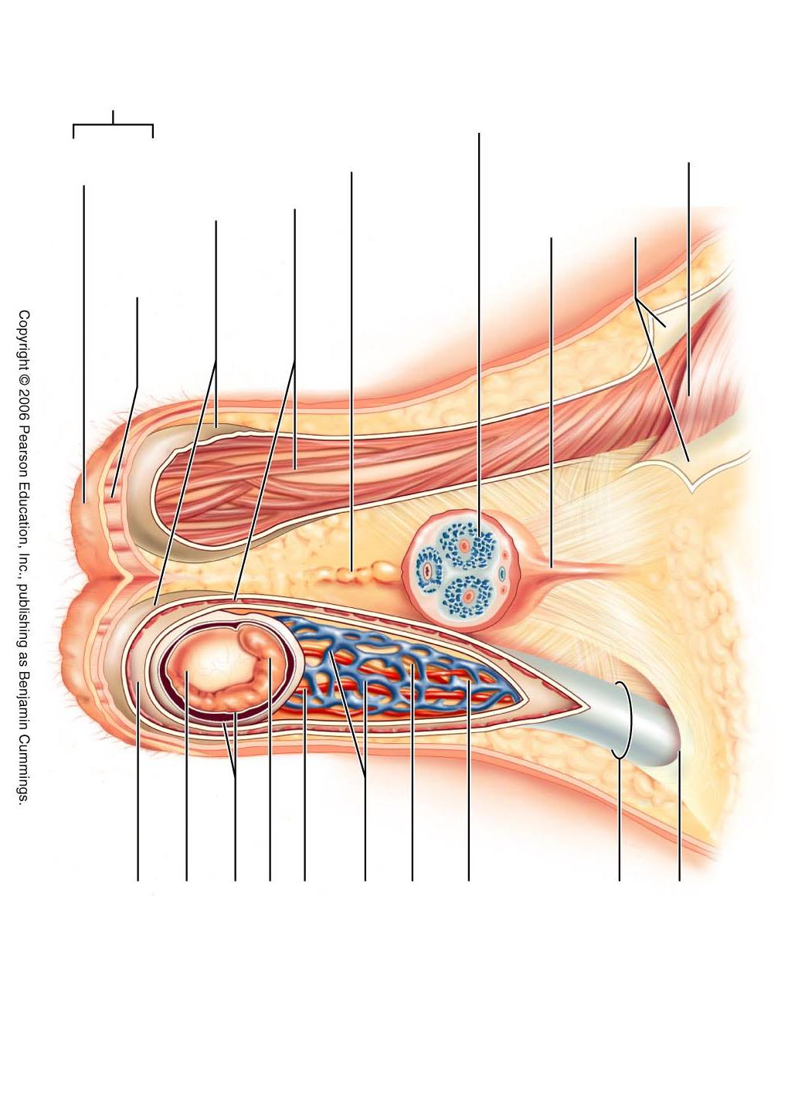

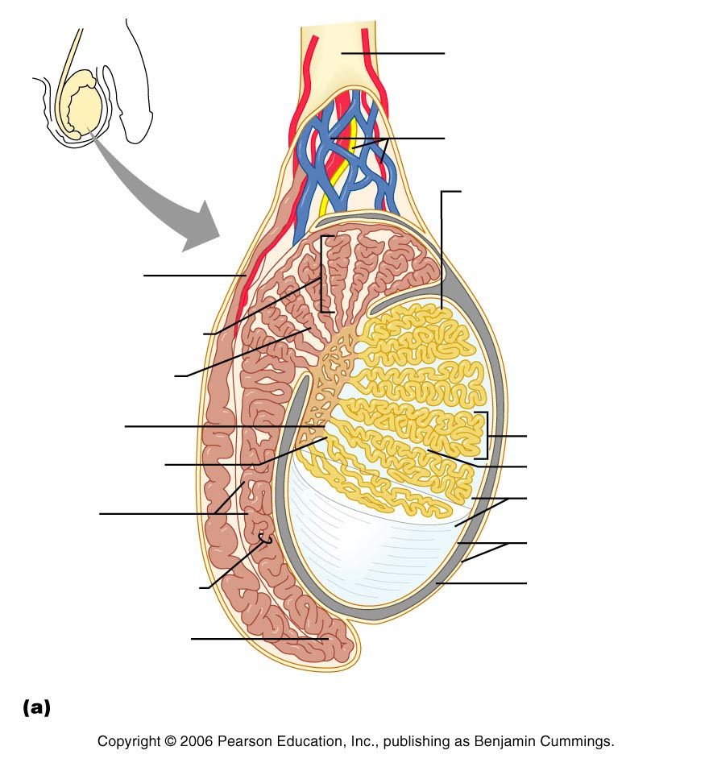

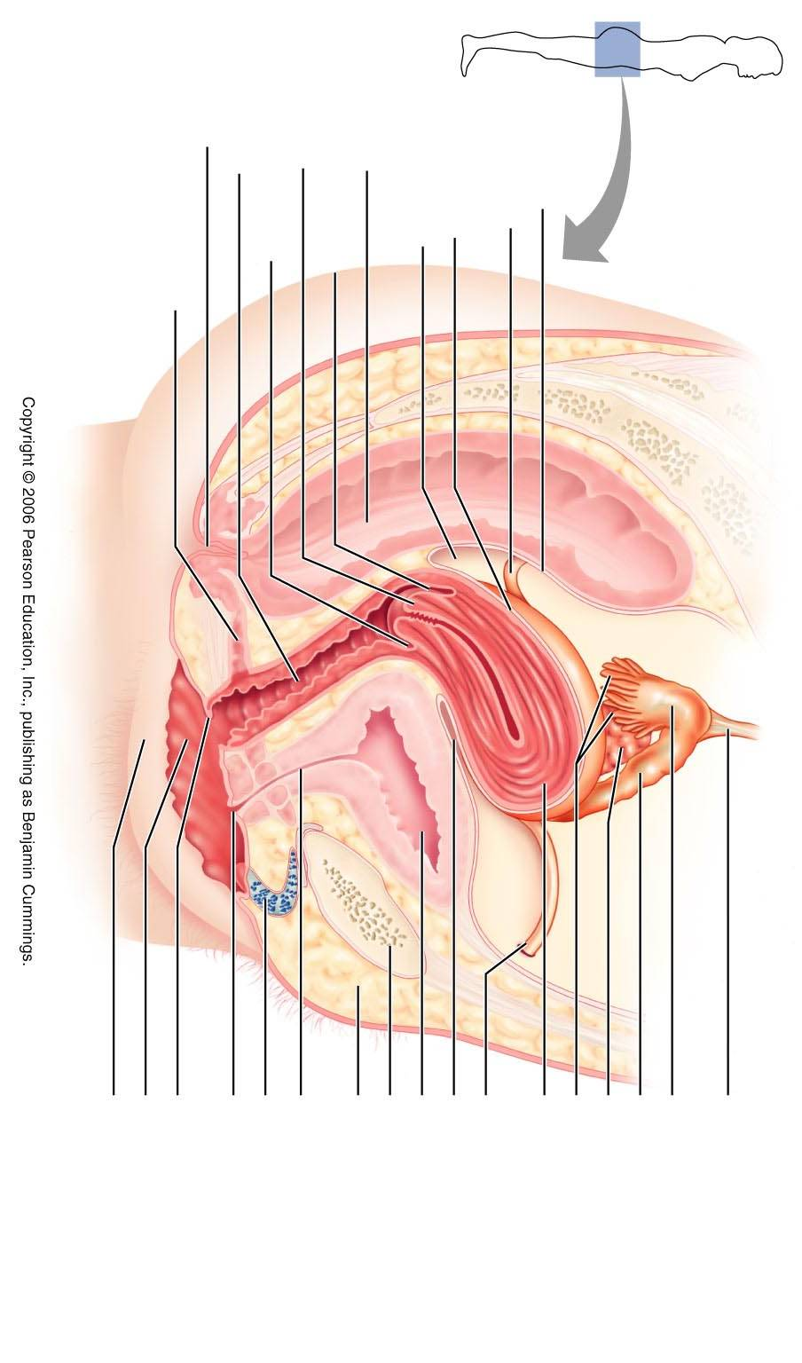
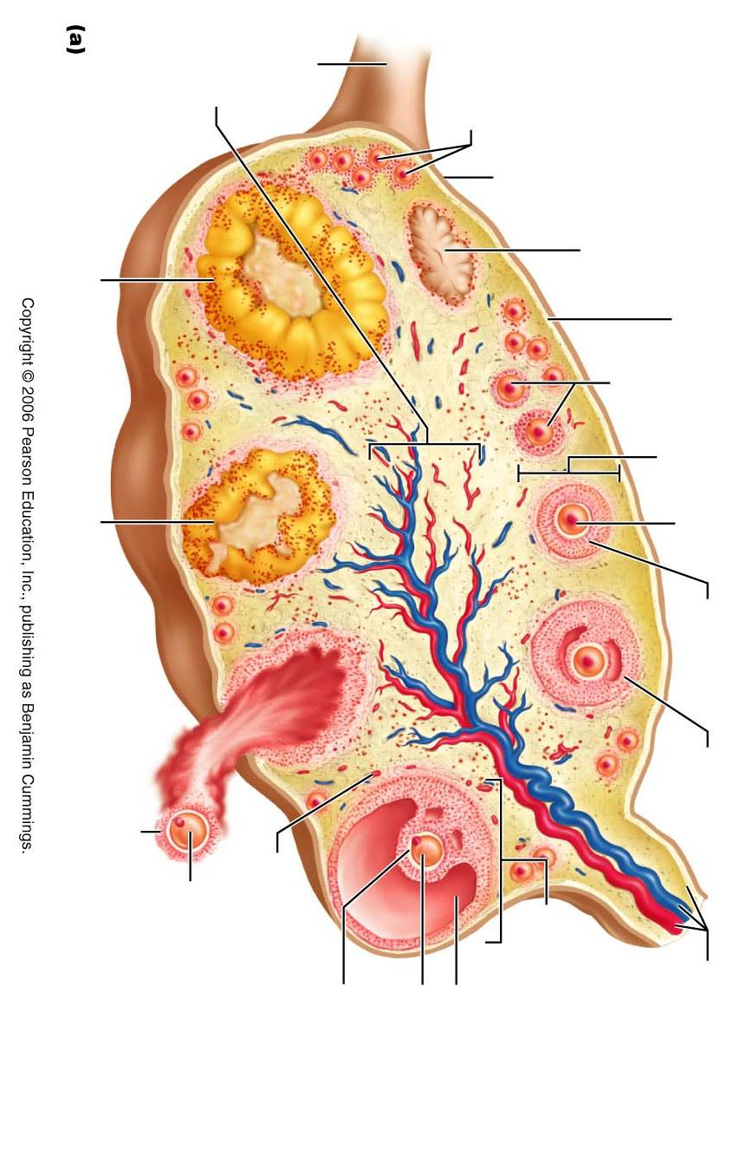

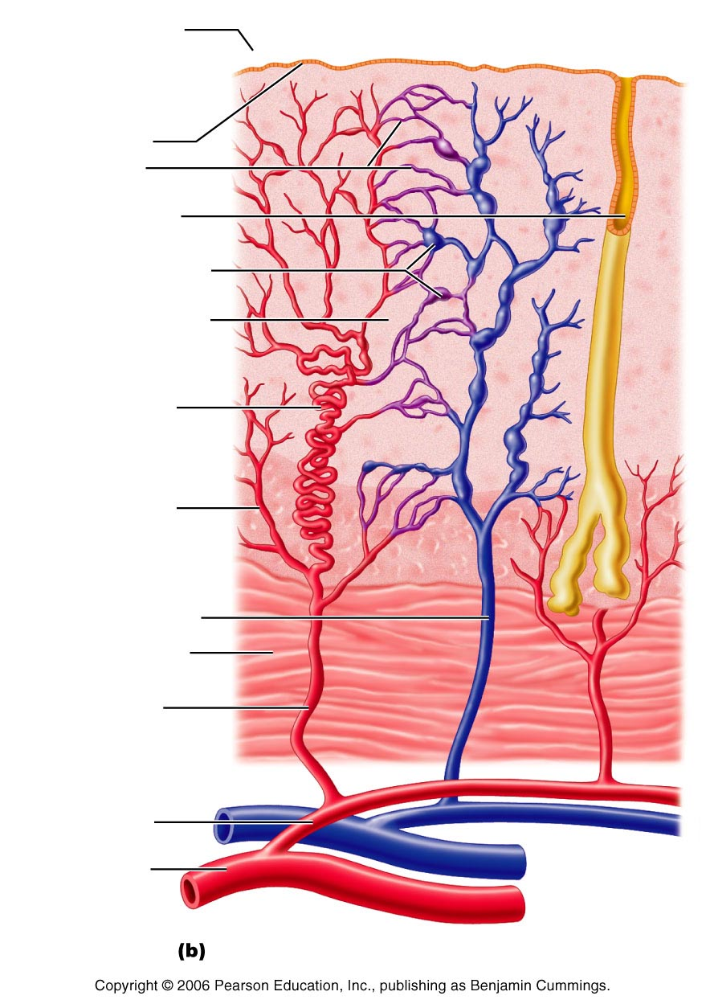

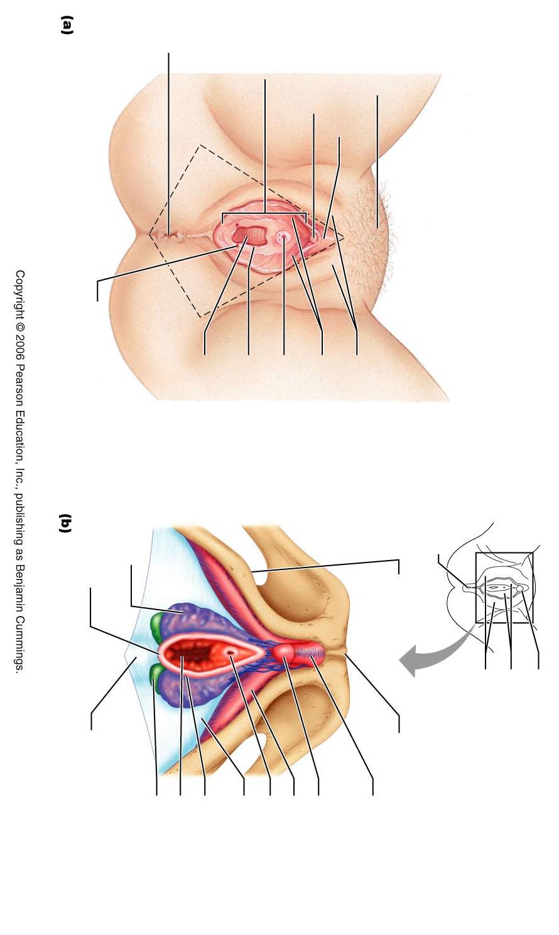

The following content contains a few things to review and consider. Please keep in mind that this review is not all-inclusive. It is to be used as a guide only.

Be familiar with

Gonads
Gametes
Male anatomy:
Scrotum and associated muscles
Penis and erectile tissues
Pathway for sperm
Glandular contributions to semen
Testes and seminiferous tubules
Epididymus
Ducts
Male sexual response
Parasympathetic contributions
Sympathetic contributions
Spermatogenesis
Where it takes place
When it takes place
Products
Phases of meiosis
Hormones
GnRH
FSH/LH
Testosterone
Inhibin

Female anatomy
Internal Anatomy
Ovaries
Fallopian Tubes
Uterus
Ligaments
Endometrial layers and blood vessels
Cervix
Internal/External Os
Vagina
External Anatomy
Vulva
Be familiar with homologous structures between male/female
Ovaries
Cortex
Medulla
Ligaments
Development of follicles

Mammary glands
Breast cancers
Oogenesis
Primary oocyte
Secondary oocyte
Meiosis I
Meiosis II
Ovarian cycle
Stages of the cycle
Hormones associated with the cycle
Hormones
GnRH
FSH
LH
Estrogen
Progesterone
Inhibin
Menstrual cycle
Stages of the cycle
Secondary sex characteristics
Female sexual response
Parasympathetic
Sympathetic
Function of orgasms

STDs
Be familiar with causes, symptoms/presentation, and treatments
Bacterial
Gonorrhea
Chlamydia
Syphilis
Viral
HPV
HSV
Disorders
PMS
Dysmenorrhea
Pelvic inflammatory disease
Endometriosis

Embryonic/fetal development and location of gonads
Homologous structures

Menopause
Acrosomal Reaction and Capacitation
Fertilization
Stages of division
Implantation
Trophoblast
Cytotrophoblast
Syncitiotrophoblast
Hormones
HCG
Placenta
Human placental lactogen
Relaxin
Human chorionic thyrotropin

Membranes: yolk sac, allantois, amnion, chorion,

Germ Layers
Ecto, Endo, Meso

Effects of pregnancy: physiological changes
Vagina
Breasts
Uterus
GI/Urinary/Respiratory/Cardio

Stages of Labor
Oxytocin/prostaglandins
Braxton Hicks
Dilation/Effacement
Expulsion

Apgar scores
Fetal blood vessels

Lactation
Hormones
Colostrum
Milk let-down
Advantages

