**Materials***:*

Microscope

Slides: Onion Root Tip

Mitosis/Meiosis Bead Kits

**Mitosis and Meiosis**

**Discussion/Prelab**

* Discuss the difference between mitosis and meiosis
* Discuss the chromosomes and their parts: chromatid, centromere, etc
* Have the students answer the questions during the lab
* initial the last page of the lab

**Part One: Intro**

**Part Two: Onion Root tip slides**

**Part Three: mitosis kit**

**Please Note:** Today’s lab deals with viewing several slides. Be sure to use appropriate microscope technique. Drop the stage to the lowest position before adding or removing a slide. Use the scanning power to locate and center an image before moving to a higher magnification. Use the course adjust knob ONLY with the scanning power, never with the low or high power lenses. Once you’ve upgraded to the low power (100X) or the high power (400X) be sure to use the fine adjust knob. If you have any questions regarding microscope usage, ask your TA.

**Mitosis:**

Mitosis is part of the cell cycle in which the contents of the nucleus are redistributed into two new nuclei. In a human body cell, there are 46 chromosomes. Following a mitotic division, there will be two cells, each having 46 chromosomes. In order to have a successful mitosis, there needs to be a successful interphase. During interphase, the cell prepares for the upcoming division process by doubling the amount of the DNA within the nucleus.

**Part Two:**

Using the onion root tip slides, you’ll be able to see and identify all of the stages below. Use the high power lens to best see the features (400X). The first cell stage (and most abundant) is interphase. Interphase is NOT part of mitosis, but includes a necessary preparation stage in which DNA duplication (replication) takes place.

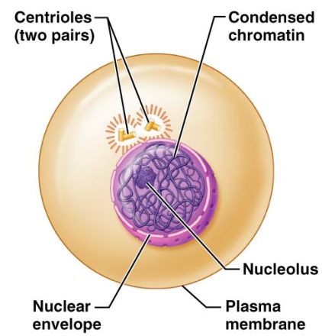Below is an illustration of interphase. Notice that the nucleus is intact and the nuclear contents are in the chromatin shape. Find a cell in interphase and draw it in the space provided. Label as many features as you can identify.

Mitotic stages: **Prophase**

The illustration below represents a cell in phophase (late prophase.) The nucleus has already broken down and the chromatin has all condensed into chromosomes. The spindle fibers are formed, and the centrioles have moved to the poles of the cell.

Identify a cell in prophase and draw it in the space provided. Label as many features as you can identify.

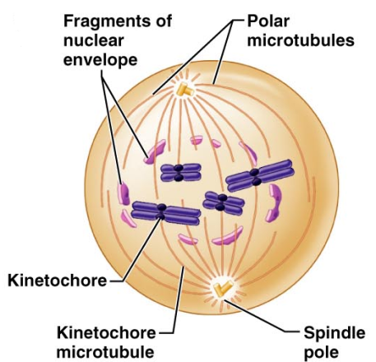

Mitosis: **Metaphase**:

During metaphase, the chromosome will line up with the centromeres (kinetochore) on the metaphase plate. The spindle fibers (microtubules) are attached to both the chromosomes and to the centriole (spindle pole) This stage is very brief, but visually distinct. Find a cell in metaphase and draw it in the space provided. Label as many features as you can identify.

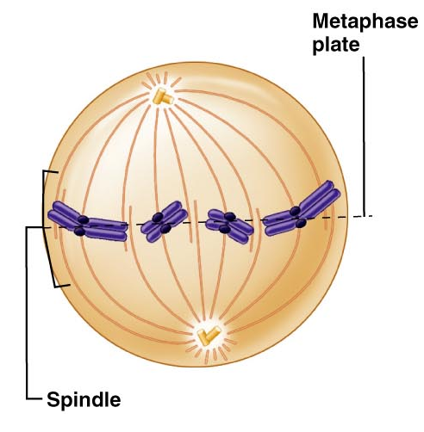

Mitosis: **Anaphase**

During Anaphase, the chromosomes start to split apart. The centromere (kinetochore) rips in two, allowing the now daughter chromosomes to move towards the poles. Also during anaphase, many animal cells start to demonstrate the “cleavage furrow” which is the beginning of cytokinesis. Since the slides you have are plant cells, you’ll not see this process. You may notice the beginnings of a new cell plate/cell wall used to separate the one cell into two. Find a cell in anaphase and draw it in the space provided. Label as many features as you can identify.

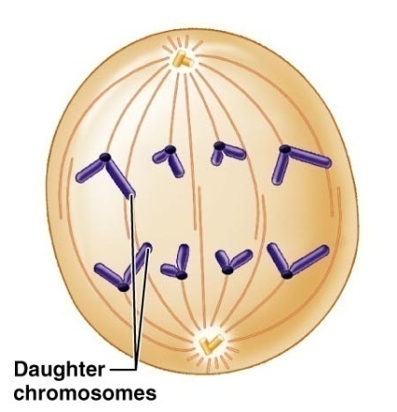

Mitosis: **Telophase**

In Telophase of mitosis, the daughter chromosomes have reached their destination. The nuclear membrane begins to reform and the spindle fibers start to break down. The chromosomes begin to relax back into chromatin. The nucleolus is replaced. Again, the illustration at the left is an animal cell in which the cleavage furrow can be seen. The plant cells (onion root tip) will not have a cleavage furrow. Find a cell in telophase and draw it in the space provided. Look for two smaller cells side by side, and you’ll likely have telophase. Label as many features as you can identify.

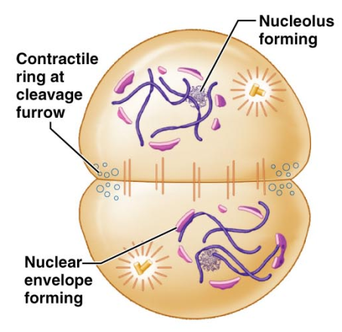

**Part Three: Mitosis Kit**

Points to consider as you consider mitosis

* The DNA is located in the nucleus of a cell
* Chromosomes are made up of DNA
* In order to reorganize the chromosomes during mitosis, the nucleus must be dismantled.
* Centrioles and spindle fibers will help to move the chromosomes around
* The cell has to double the DNA before it divides it in two.

Materials you will need:

40 red beads

40 yellow beads

2 red centromeres

2 yellow centromeres

4 plastic (clear) tubular centrioles

Paper towel(s)

**Interphase**

During interphase the cells must duplicate the DNA in the nucleus. If it did not, a cell going through mitosis would end up with only half of the DNA that it needs.

1. Create two strands of seven red beads. Use the red centromere to complete the chromosome.
2. Create two strands of yellow beads. Use the yellow centromere to complete the chromosome.
3. Open/unfold a paper towel and place it on your desk. The paper towel will represent the nucleus of the cell. During interphase, your chromosomes will be located on the paper towel.

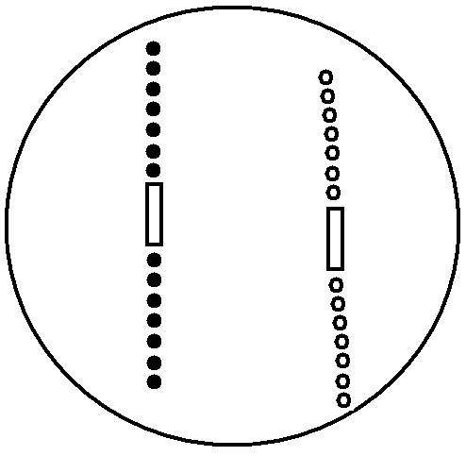

The chromosomes you’ve just created can be considered homologous chromosomes. They will be housed within the nucleus. At this point, your nucleus contains two chromosomes total (1 pairs). If this were a human cell, instead of two chromosomes, we’d have 46 (23 pair) chromosomes.

**Interphase: Replication**

1. DNA replication occurs during interphase. The nucleus remains intact and unchanged.
2. Construct another red chromosome identical to the first.
3. Construct another yellow chromosome identical to the first.
4. Link your two red chromosomes together to create a sister chromatid
5. Link your two yellow chromosomes together to create a sister chromatid

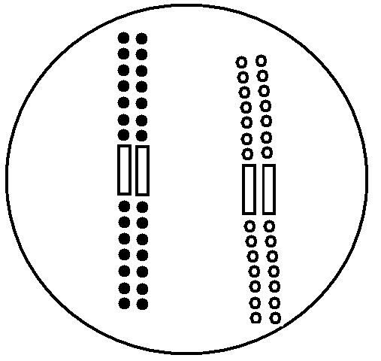

1. Find a pair of plastic centrioles. Place them outside of the napkin (nucleus). Recall that the centrioles exist in the cytoplasm, not the nucleus. They also will replicate to prepare for the upcoming mitotic division.

**Entering Mitosis**

During mitosis the nucleus disappears, the chromosomes divide and relocate, and then the nucleus is restored. Mitosis is divided into four stages: Prophase, Metaphase, Anaphase, and Telophase

**Prophase**

During prophase the centrioles take up “polar” positions. Spindle fibers begin to appear. Chromatin condenses to chromosomes. The nucleus starts to disappear.

1. Move your centrioles into their polar positions (North Pole/South Pole or you can do East/West poles). Keep the centrioles off the napkin/nucleus since they are in the cytoplasm.
2. Remove your napkin. Recall that during prophase the nuclear envelope breaks down. The chromosomes are now free to move about the cell.

**Draw what your materials look like at this stage:**

**Metaphase**

During metaphase the duplicated chromosomes (sister chromatids) will line up along the metaphase plate.

1. Imagine a line that runs between the two poles of your cell, much like the equator separates northern/southern hemispheres. This line is the metaphase plate.
2. Assemble your sister chromatids along the metaphase plate. Place the centromeres of the sister chromatids directly on the metaphase plate.

**Draw what your materials look like at this stage**

**Anaphase**

During anaphase, the sister chromatids will be split into two daughter chromosomes. The spindle fibers draw the chromatids away from the metaphase plate and towards the centrioles.

1. Pull apart your sister chromatids. Push the separated chromosomes toward their respective poles. Their final destination is the centrioles.

**Draw what your materials look like at this stage**

**Telophase**

During telophase, much of what was done in prophase is reversed: the spindle fibers disappear, the nuclear membrane is reformed, and the chromosomes relax into chromatin

1. Both red and yellow daughter chromosomes should be at a centriole.
2. Take two napkins (or split the one you used earlier in half). Place one napkin under each centriole, red, and yellow chromosome. This represents your nuclear membrane reforming.
3. Start pulling the pop-beads off your chromosomes and place them on the napkin. This represents your chromosome returning to chromatin.

**Draw what your materials look like at this stage**

Keep in mind that at this point, we have successfully divided the chromosomes (mitosis) but have not yet divided the cell. The process of **cytokinesis** will split the one cell that we started with into two new cells. Each new cell will be called a daughter cell.

**Questions**

Define homolgous chromosome Homologous chromosomes are pairs of chromosomes, one came from the mother, one from the father. They share a common shape, size, and gene sequence. However, they are not identical to one another.

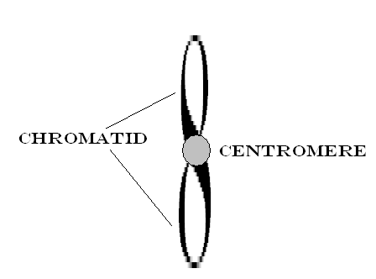What parts make up a chromosome? Draw a single chromosome and label the chromatid and the centromere. Chromosomes are made up of the centromere, which holds the chromatids, and the chromatids, which are the portions of DNA.

Which three events make up the cell cycle? Interphase, Mitosis, Cytokineses

Which four events make up mitosis? Prophase, Metaphase, Anaphase, Telophase

**Meiosis**

Meiosis is a special version of cell division. Instead of creating two cells that have identical DNA, meiosis creates four cells with half the chromosomal number of the original. In our human cells, we start with 46 chromosomes, but as we go through meiosis, we’ll create four cells with 23 chromosomes. We use this specialized division to create gametes: egg cells and sperm cells. Because there is twice that the division takes place, the first time through is Meiosis I (called a reduction division) and the second time is Meiosis II (called an equational division).

**Interphase I**

Just like interphase for mitosis, interphase I of meiosis results in the DNA duplicating (replicating).

1. Place a napkin down to represent your cell’s nucleus
2. Create two strands of five red beads. Use the red centromere to complete the chromosome.
3. Create two strands of five yellow beads. Use the yellow centromere to complete the chromosome.
4. Construct another red chromosome identical to the first.
5. Construct another yellow chromosome identical to the first.
6. Link your two red chromosomes together to create a sister chromatid
7. Link your two yellow chromosomes together to create a sister chromatid
8. Place the plastic centrioles off the napkin to represent their location in the cell’s cytoplasm.

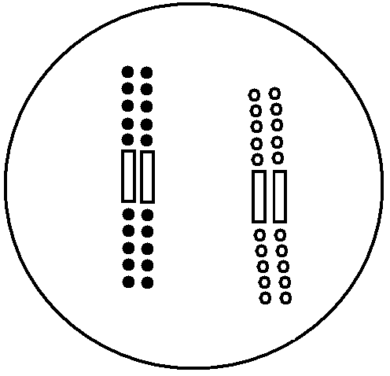

**Prophase I**

Much of Prophase I will be similar to Prophase of Mitosis. There will be a few differences.

During prophase the centrioles take up “polar” positions. Spindle fibers begin to appear. Chromatin condenses to chromosomes. The nucleus starts to disappear.

1. 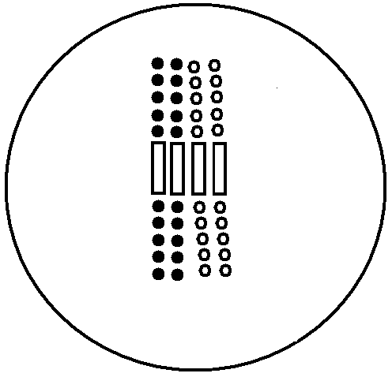 Move your centrioles into their polar positions (North Pole/South Pole or you can do East/West poles). Keep the centrioles off the napkin/nucleus since they are in the cytoplasm.
2. Remove your napkin. Recall that during prophase the nuclear envelope breaks down. The chromosomes are now free to move about the cell.
3. Make your chromosomes **synapse**. At this stage, each member of a homologous pair finds its partner and lies next to it. The structure is called a “tetrad.” Push your red sister chromatid and yellow sister chromatid next to one another to demonstrate this. This synapsing can take place anywhere in the “nucleus”; you do not line them up on the metaphase plate.

To encourage genetic diversity, we will see **crossing over** at this point.

1. 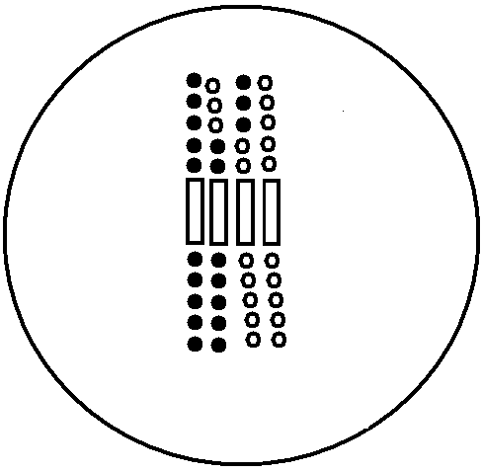Pull three of the red beads off of the red sister chromatid. Locate the yellow beads that are closest to where you pulled the red beads from. Pull three yellow beads off the sister chromatid.
2. Add your three yellow beads to the red strand. Add your three red beads to the yellow strand.
3. Notice at this point the chromosomes are no longer identical.

**Metaphase I**

During metaphase the duplicated chromosomes (sister chromatids) will line up along the metaphase plate in the tetrad form. The pair of chromosomes will span the metaphase plate, with one member of the homologous pair on one side and the other member of the pair on the opposite side. This is also where we’ll see independent assortment: for each tetrad, which sister chromatid ends up on which side of the metaphase plate is random.

1. Imagine a line that runs between the two poles of your cell, much like the equator separates northern/southern hemispheres. This line is the metaphase plate.
2. Assemble your tetrads along the metaphase plate. The red homologous pair should be on one side of the metaphase plate and the yellow pair should be on the other.
   1. This varies from metaphase of mitosis because the centromeres are not along the metaphase plate.

**Draw what your materials look like at this stage: Metaphase I**

**Anaphase I**

During Anaphase I, the spindle fibers will pull half of the tetrad towards one centriole and the other half of the tetrad towards the opposite centriole

1. Move the red sister chromatid towards one pole.
2. Move the yellow sister chromatid towards the opposite pole. Their final destination is the centrioles.

**Draw what your materials look like at this stage: Anaphase I**

**Telophase I**

During telophase I, much of what was done in prophase I is reversed: the spindle fibers disappear, the nuclear membrane is reformed, and the chromosomes relax into chromatin

1. The red sister chromatid should be at one centriole; the yellow should be at the other.
2. 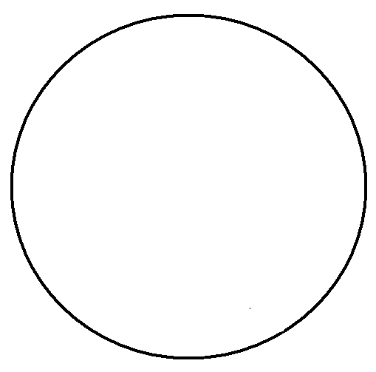Take two napkins (or split the one you used earlier in half). Place one napkin under each centriole, red, and yellow chromosome. This represents your nuclear membrane reforming.
3. Start pulling the pop-beads off your chromosomes and place them on the napkin. This represents your chromosome returning to chromatin.

**Draw what your materials look like at this stage: Telophase I**

**Cytokinesis**

At this stage, the first meiotic division is complete, but the cell still needs to split into two. Cytokinesis will divide the original cell into two new cells.

**NOTE**: Normally in mitosis, the cell would go into interphase. However, because we’ve completed only the first meiotic division, **there is no interphase before starting the second division.**

**Prophase II**

The main events are the same as prior: the centrioles take up “polar” positions. Spindle fibers begin to appear. Chromatin condenses to chromosomes. The nucleus starts to disappear.

1. Reassemble your sister chromatids as you saw them in Telophase I
2. Move your centrioles into their polar positions. Keep the centrioles off the napkin/nucleus since they are in the cytoplasm.
3. Remove your napkin. Recall that during prophase the nuclear envelope breaks down. The chromosomes are now free to move about the cell.
4. You will have two cells to deal with at this point. One cell will contain the red sister chromatid. The other cell will contain the yellow sister chromatid.

**Draw what your materials look like at this stage: Prophase II**

**Metaphase II**

During metaphase the sister chromatids will line up along the metaphase plate.

1. Imagine a line that runs between the two poles of your cell, much like the equator separates northern/southern hemispheres. This line is the metaphase plate.
2. Assemble your sister chromatid along the metaphase plate. Place the centromere of the sister chromatid directly on the metaphase plate.

**Draw what your materials look like at this stage: Metaphase II**

**Anaphase II**

During anaphase, the sister chromatid will be split into two daughter chromosomes. The spindle fibers draw the chromatids away from the metaphase plate and towards the centrioles.

1. Pull apart your sister chromatids. Push the separated chromosomes toward their respective poles. Their final destination is the centrioles.

**Draw what your materials look like at this stage: Anaphase II**

**Telophase II**

During Telophase II, much of what was done in prophase is reversed: the spindle fibers disappear, the nuclear membrane is reformed, and the chromosomes relax into chromatin

1. All daughter chromosomes should be at a centriole.
2. Take two napkins (or split the one you used earlier in half). Place one napkin under each centriole and chromosome. This represents your nuclear membrane reforming.
3. Start pulling the pop-beads off your chromosomes and place them on the napkin. This represents your chromosome returning to chromatin.

**Draw what your materials look like at this stage: Telophase II**

Following Telophase II, meiosis is done. However, the cell has not split. **Cytokinesis** must take place to divide the contents of the cytoplasm and create the two new cells. We had one cell as our starting point. After meiosis I we had two cells. Following meiosis II we have four cells. Within the nucleus we will find half of the amount of genetic material as before. Our starting cell had 46 chromosomes (23 pair) while each of our four final cells will have 23 chromosomes (no pairs).

**Epithelium**

**Discussion/Prelab**

* Encourage good drawings and labeling for the slides
* Remind students, if needed, not to use the coarse adjust with low or high power lenses.
* Have the students answer the questions during the lab
* initial the last page of the lab

**Materials***:*

Microscope

Slides

Simple Squamous: Lung

Simple cuboidal: kidney

Simple columnar: duodenum

Pseudostratified: trachea

Stratified squamous

Transitional

Epithelia are tissues that create linings or coverings. When looking at epithelia, you may see several cell types arranged to create a tissue.

Find a slide labeled **Simple Squamous: Lung Tissue**

In simple squamous tissue, there is one layer (simple) of flattened tile-like cells. Simple squamous tissues can be found in the alveoli of lungs and in the capillaries. In the image to the left, the alveoli demonstrate this very thin layer of cells. Locate the alveolar tissue on your microscope and compare it to the photomicrograph. Keep in mind that much of what you’ll be seeing is the air within the alveoli. The cellular structures are the thin borders of the alveolar sacs

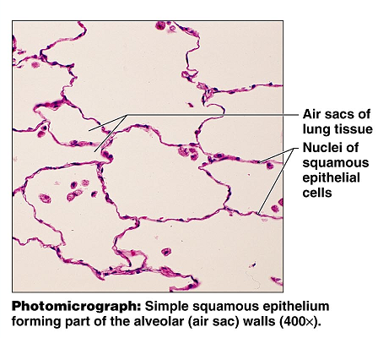

Find a slide labeled **Simple Cuboidal: Kidney Tissue**

The cuboid (square-ish) cells have the nuclei located in the center of the cell. In the photomicrograph below, the round glands are made up of a single layer of these square shaped cells. Even though there are several cuboid cells in each gland, there is only one layer of cells, making it simple cuboidal. Draw the simple cuboidal cells as you see them under the microscope (400X)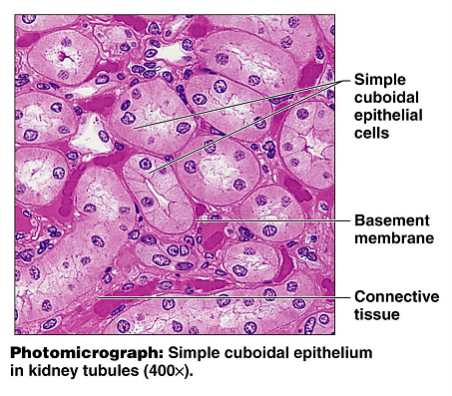

Find a slide labeled **Simple columnar: Duodenum**

Look for cells at the edge of the tissue selection that are longer than they are wide. They should have a round or oval nuclei located near their attachment to the basement membrane. The image below is of the stomach, and is at a greater magnification than what you’ll use for the duodenum. The duodenal tissue will also contain smooth muscle and other tissue types, so be aware that the simple columnar cells will be at the edge of the tissue selection. Draw and label the simple columnar cells that you see in the field of view. You may also see goblet cells. They are responsible for the production of mucus, and they have a flask-like shape.

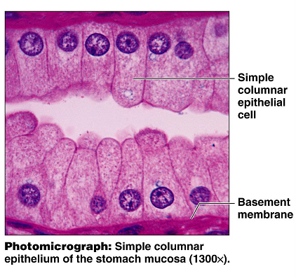

Find a slide labeled **pseudostratified epithelium: Trachea**

The pseudostratified epithelium is a single layer of cells that *appears* to have several layer based on the location of the nuclei. This tissue may be ciliated and have goblet cells, as seen in the image below. Locate the pseudostratified tissue in your field of view, and label the features.

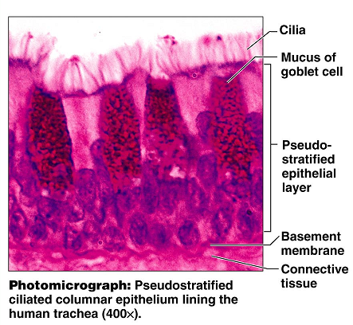

Locate the slide: **Stratified squamous epithelium**

This tissue is stratified (has multiple layers) of the squamous type cell. The basal cells (cells near the attachment site at the basement membrane) tend to have more of a cuboid appearance than the typical flattened appearance associated with the squamous cells. On the skin, the stratified squamous epithelium is keratinized. The protein keratin provides a toughness and water-proofing to protect the underlying layers. Stratified squamous is prevalent in areas that are likely to experience wear and abrasions. Draw the stratified squamous as you see it in the field of view (400X)

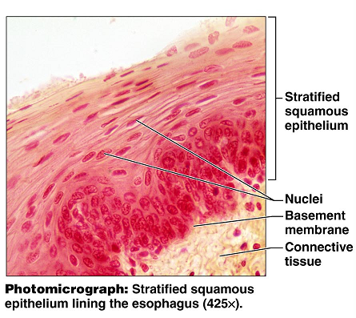

Locate the **transitional epithelium: urinary bladder**

Transitional epithelium is designed to stretch as the bladder and other urinary organs fill and empty. The basal cells (near the basement membrane) tend to have a cuboid appearance, while the surface cells can have a domed appearance or a squamous appearance, depending on the amount of stretch the tissue is under. Draw the transitional epithelium as viewed in the field of view under high power (400X).

