**Materials***:*

Bones of the

Skull

Vertebral column

Ribs

Sternum

Encourage the use of the disarticulated bones as well as viewing the articulated skeleton.

**Discussion/Prelab**

* Review answers to previous lab
* Consider discussing compact versus spongy bone
* Encourage usage of proper terminology: review vocab for facets, condyles, etc
* Before signing off on the student labs, consider asking them to show you a particular structure. They have to bring you the correct one before leaving.

**Axial Skeleton**

The human skeleton is divided into two main regions: axial and appendicular. The axial skeleton contains the skull, vertebrae, ribs, and sternum. The appendicular skeleton contains the bones of the upper and lower extremities, and the girdles that attach them to the axial skeleton.

For the purposes of this lab, we will not be spending a great deal of time on the skull. Be aware, though, that the skull has two divisions to it. It contains the **facial bones** as well as **the cranial bones**.

**Skull: Observe the bones of the skull.**

**Vertebral column**

Be able to locate and identify the features listed below on both the images and the actual bones.

* Vertebrae (all levels: cervical, thoracic, and lumbar)
  + Body
  + Spinous process
  + Vertebral foramen
  + Vertebral arch
  + Transverse process
  + Pedicle
  + Lamina
* Vertebrae: Cervical
  + Atlas
  + Axis
  + Dens/odontoid process
  + Transverse foramina
* Vertebrae: Thoracic
  + Articular facets
* Sacrum
  + Median sacral crest
  + Anterior/Posterior sacral foramina
  + Sacral promontory
  + Sacral hiatus
  + Sacral ala
  + Transverse ridges
  + Sacral canal
* Coccyx
* Ribs (note true versus false ribs)
  + Head
  + Neck
  + Tubercle
* Sternum
  + Xiphoid process
  + Manubrium
    - Jugular notch
  + Body

From your text book, label the following images:

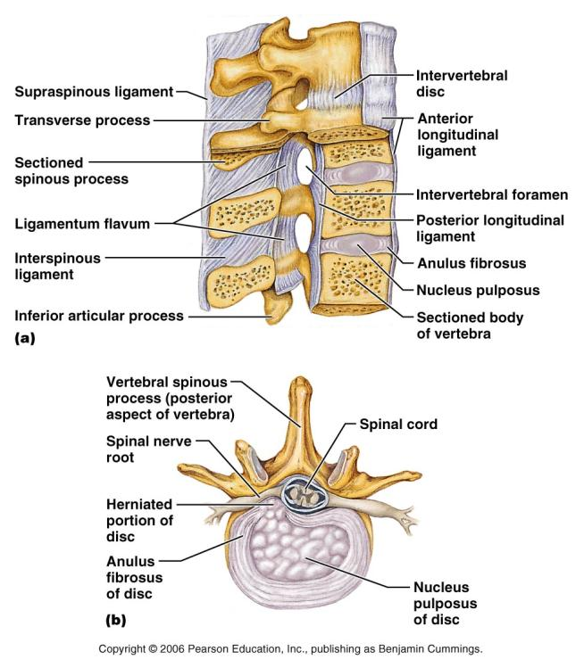

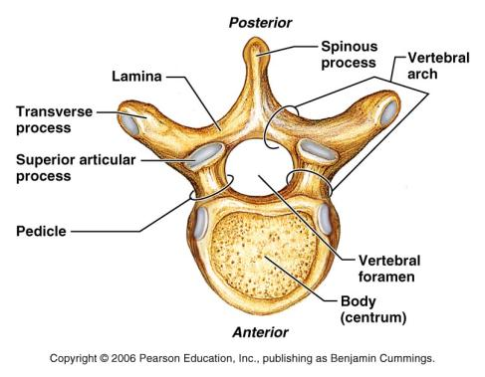

**Observe the first cervical vertebra**:  **C1**

This structure varies from the other vertebra in that it has a modified body. The shape of C1 allows rotation to take place with the skull, as well flexion and extension. Look at the smooth articular surfaces that form the joints with the occipital regions of the skull.

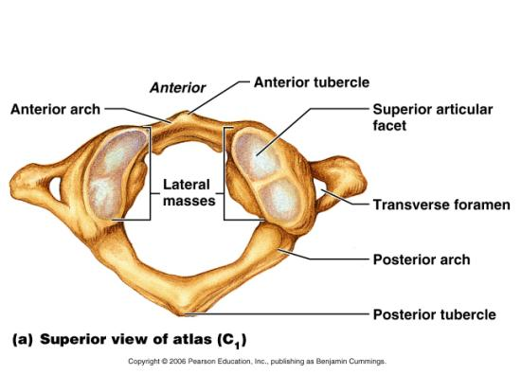

**Observe the second cervical vertebra: C2**

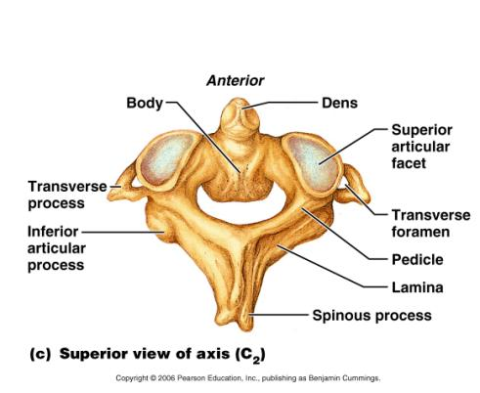Notice on the superior aspect is a bony protrusion called the dens or odontoid process. This process articulates with C1 and allow us to have a great deal of rotation at this level. Find a C1 and a C2 vertebra and fit them together properly to observe how their articulation allows for this pivoting to take place.

**Observe the remaining cervical vertebrae**. Notice the presence of the transverse foramina, which allow the arteries to run through a protected environment on their way to the brain.

Compare the bodies of the cervical vertebra to those of the thoracic vertebrae and those of the lumbar vertebra.

What do you notice in terms of shape? Cervical: smallest and lightest, body is oval-shaped. Thoracic: increasing size, body is heart shaped. Lumbar: largest, densest, bodies are kidney shaped.

What do you notice in terms of size? (see above)

Compare the cervical, thoracic, and lumbar vertebrae.

What do you notice about the spinous processes for each region? (indicate distinctions about shape, size, and orientation of the SP)

Cervical: spinous process is bifid, short, and projects posteriorly  
Thoracic: SP is long and points inferiorly  
Lumbar: SP is short and flat.

Compare the cervical, thoracic and lumbar vertebrae.

What do you notice with regards to the transverse processes for each region?  
Cervical: TP have transverse foramen which allow for the passage of the vertebral arteries.   
Thoracic: TPs are wide and have costal facets for articulations with the ribs  
Lumbar: TPs are thinner and tapered

What feature do the thoracic vertebrae have to accommodate the ribs? The Demifacets are the articulation sites for the head of the rib and the costal facets on the TPs articulate with the rib tubercle.

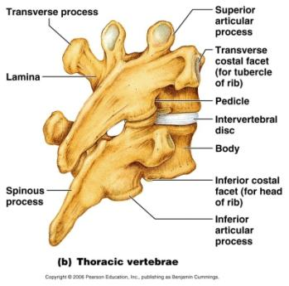

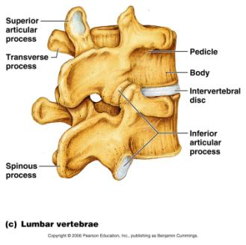

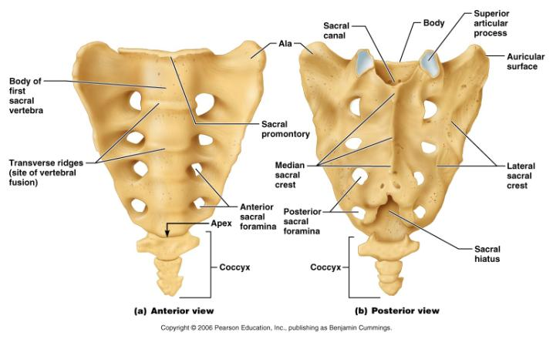

**Thoracic Cage:**

The thoracic cage is the protective environment that houses the delicate organs of the chest. It is composed of the sternum, the ribs, and the thoracic vertebrae, as well as the costal cartilage. As we breathe, our chest needs to be able to expand and contract. The articulations of the ribs at the vertebrae allow this to happen, as does the costal cartilage attachments to the sternum.

Observe the features of the thoracic cage and complete the labeling on the diagrams below.

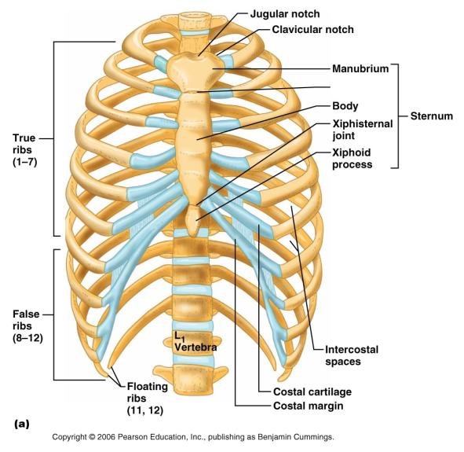

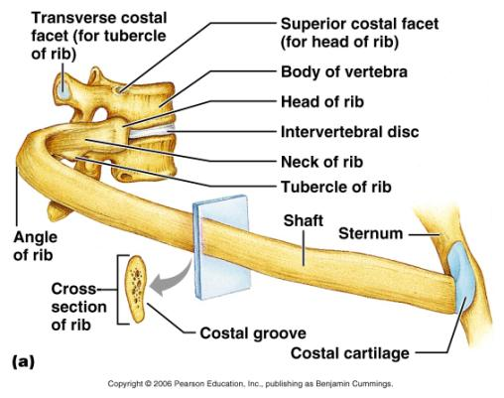

Define and be familiar with the terms below: Location: Chapter 6 and/or glossary

|  |  |
| --- | --- |
| Condyle | Rounded articular projection |
| Epicondyle | Raised area on or above a condyle |
| Facet | Smooth nearly flat articular surface |
| Fissure | Narrow, slit-like opening |
| Foramen | Round or oval opening |
| Fossa | Shallow basin-like depression |
| Fovea | a pit |
| head | Bony expansion carried on a narrow neck |
| Meatus | Canal-like passage way |
| Process | Any bony prominence |
| Spine | Sharp, slender, often pointed projection |
| Sulcus | Groove or furrow |
| trochanter | Very large, blunt, irregularly shaped process |
| tuberosity | Large rounded often times rough projection |
| tubercle | Small rounded projection or process |

Before leaving lab, be sure that you can **find and identify** each of the features on the **axial skeleton bones** that you were asked to label in the above images.

**Appendicular Skeleton**

**Materials***:*

Bones of the

Upper Extremity

Lower Extremity

Pectoral girdle

Pelvic girdle

Encourage the use of the disarticulated bones as well as viewing the articulated skeleton.

**Discussion/Prelab**

* Review answers to previous lab
* Consider discussing axial versus appendicular
* Before signing off on the student labs, consider asking them to show you a particular structure. They have to bring you the correct one before leaving.

Obtain the bones of **the upper extremity** and   
locate the following features and landmarks:

* Clavicle
  + Sternal end
  + Acromial end
* Scapula
  + Acromion process
  + Glenoid fossa
  + Coracoid process
  + Posterior features:
    - Scapular spine
    - Supraspinous fossa
    - Infraspinous fossa
  + Anterior features:
    - Subscapular fossa
* Humerus
  + Head
  + Greater tubercle
  + Lesser tubercle
  + Intertubercular groove
  + Deltoid tuberosity
  + Trochlea
  + Capitulum
  + Coronoid fossa
  + Olecranon fossa
* Ulna
  + Olecranon process
  + Coronoid process
  + Styloid process
  + Head
* Radius
  + Head
  + neck
  + Styloid process
* Wrist and hands
  + Carpal bones
  + Metacarpals
  + Proximal phalanges
  + Middle phalanges
  + Distal phalanges

Obtain bones of **the lower extremity** and located the features and landmarks

* Pelvis
  + Ilium
    - Iliac crest
    - Anterior superior iliac spine
    - Anterior inferior iliac spine
    - Posterior superior iliac spine
    - Posterior inferior iliac spine
    - ala
  + Ishium
    - Ramus
    - Ischial tuberuosity
  + Pubis
    - Superor and inferior ramus
    - Symphysis pubis
    - Obdurator foramen
    - Pubic arch
  + Acetabulum
* Femur
  + Fovea capitis
  + Head
  + Neck
  + Greater trochanter
  + Lesser trochanter
  + Lateral condyle
  + Medial condyle
  + Lateral epicondyle
  + Medial epicondyle
  + Patellar surface
* Patella
  + Apex
  + Facets
* Tibia
  + Intercondylar eminence
  + Lateral condyle
  + Medial condyle
  + Tibial tuberosity
  + Medial malleolus
* Fibula
  + Head
  + Lateral malleolus
* Ankle and Foot
  + Tarsal bones
    - Calcaneus
    - Talus
  + Metatarsals
  + phalange

Use the lab manual, your notes, or your textbook to answer the following questions. **These questions are to be answered before leaving lab.**

1. Which bones make up the pectoral girdle? Clavicle & scapula,
2. Which feature of the scapula divides the posterior aspect into superior and inferior portions?

Scapular spine

1. Identify the glenoid fossa of the scapula. With which bone will it articulate to form the shoulder joint? What type joint arrangement is this? The head of the humerus joins the glenoid fossa in a ball and socket synovial joint.
2. Which features of which bones form the hinge joint at the elbow? The olecranon process and the coronoid process create the trochlear notch of the ulna which fits around the trochlea of the humerus
3. Which feature of the ulna prevents hyperextension of the elbow? The olecranon process as it sits in the olecranon fossa of the humerus
4. Which features of which bones form the pivot joint at the elbow? The head of the radius fits against the capitulum of the humerus and articulates with the radial notch of the ulna
5. Which bones make up the pelvic girdle? A pair of coxae
6. What type of cartilage forms the pubic symphysis joint? fibrocartilage
7. 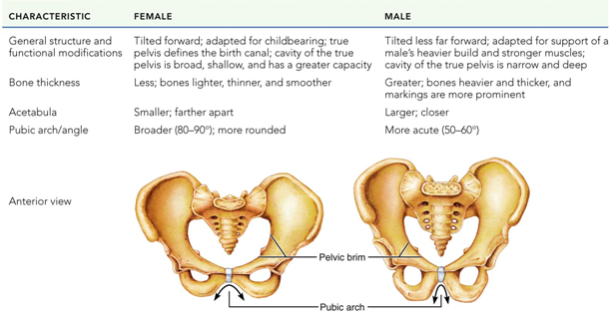What are **three** differences that can be seen in a male pelvis versus a female pelvis?
8. What are the functions of the greater and lesser trochanters in the femur. Attachment sites for the muscle of the thigh and buttocks.
9. Which bone contains the medial malleolus? Tibia
10. 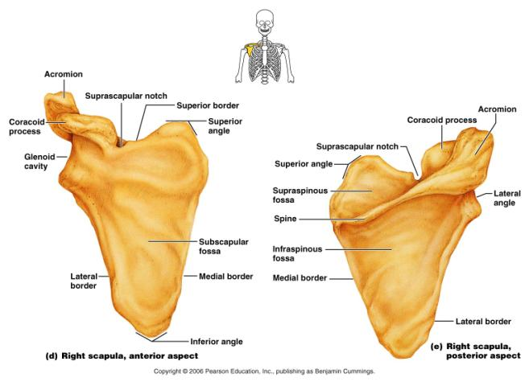Which bone contains the lateral malleolus? Fibula
11. How many metatarsals are in the foot? 5
12. How many phalanges are in the foot? 14

